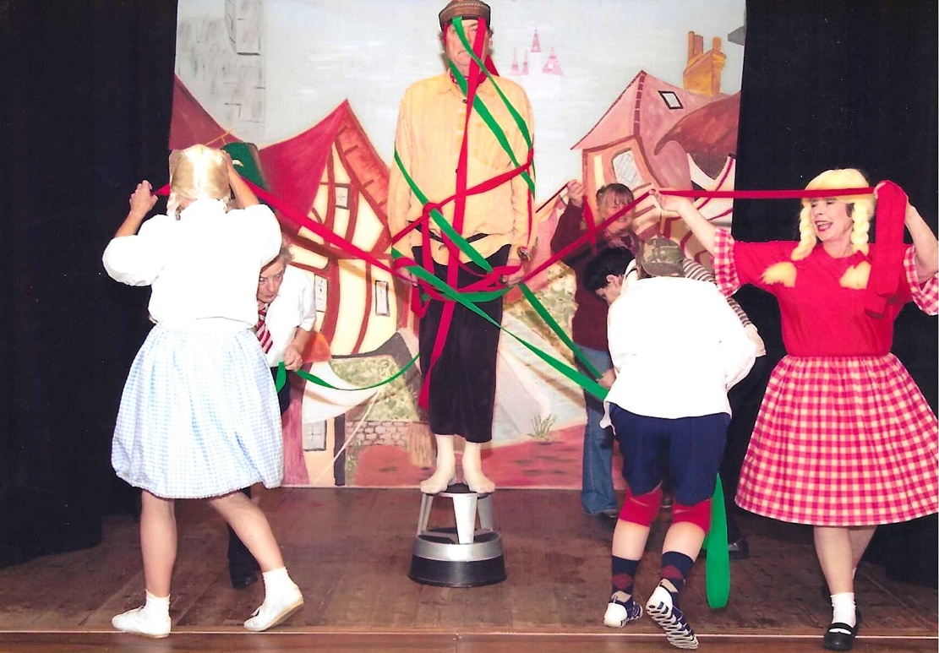
2009 Colander Girls

Maypole is Chris Bradley; Dancer with check skirt Emma Parker

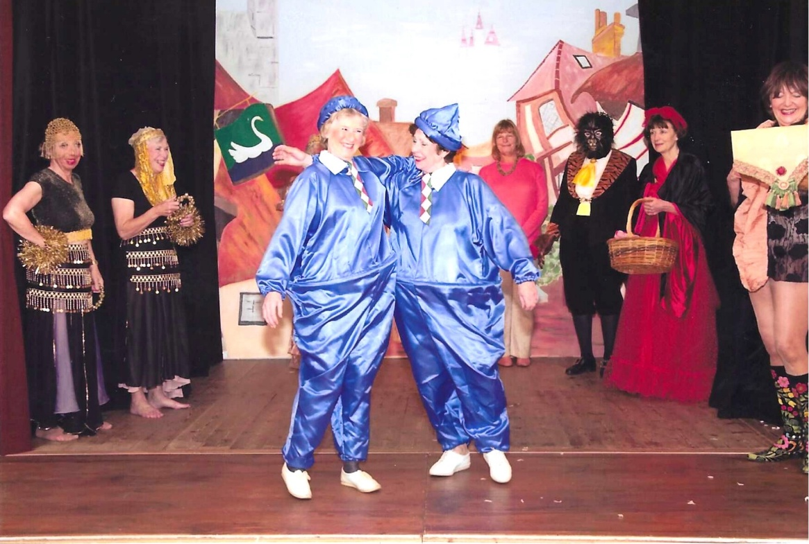
Belly Dancers:- Trish Davies & Christine Wilson
Clowns: - Yvette Steward & Pam Carter

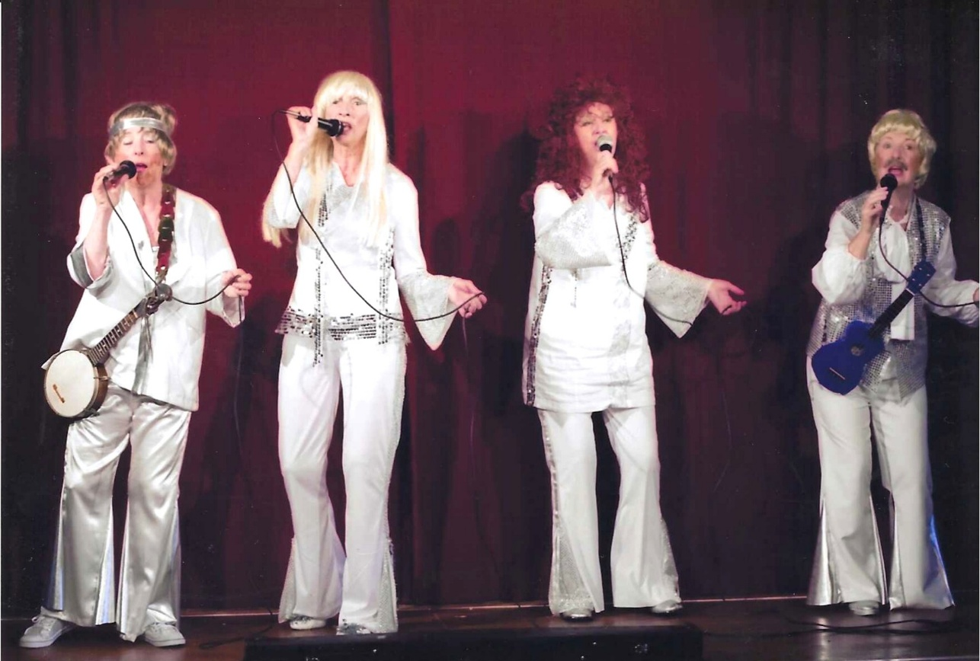
ABBA L-R Janet Cattenach, Brenda Merritt, Jane Barnett, Judith Stephenson

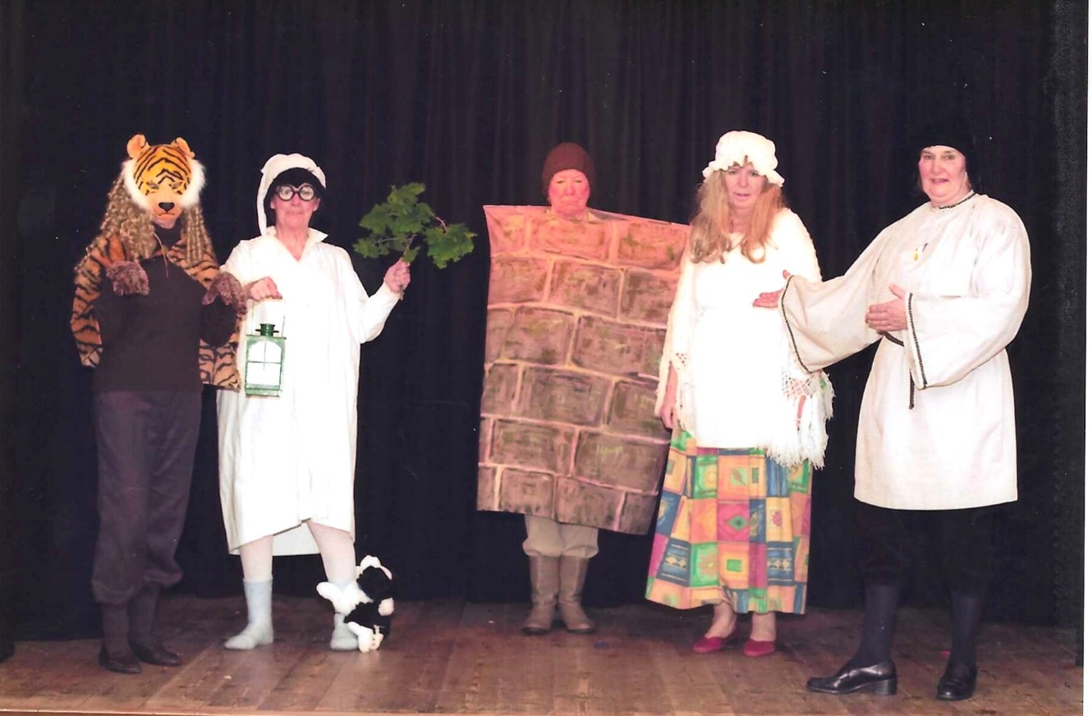
The Wall sketch : lion?, Jane Barnett, Anne Crawford as the wall, Kate Lawley, Jean Ellis
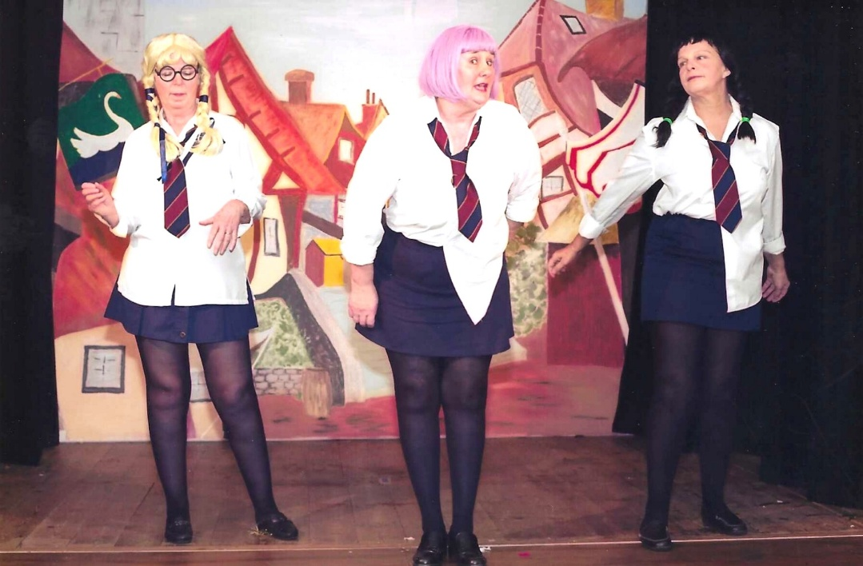

L-R Kate Lawley; Jean Ellis & Carol Williams

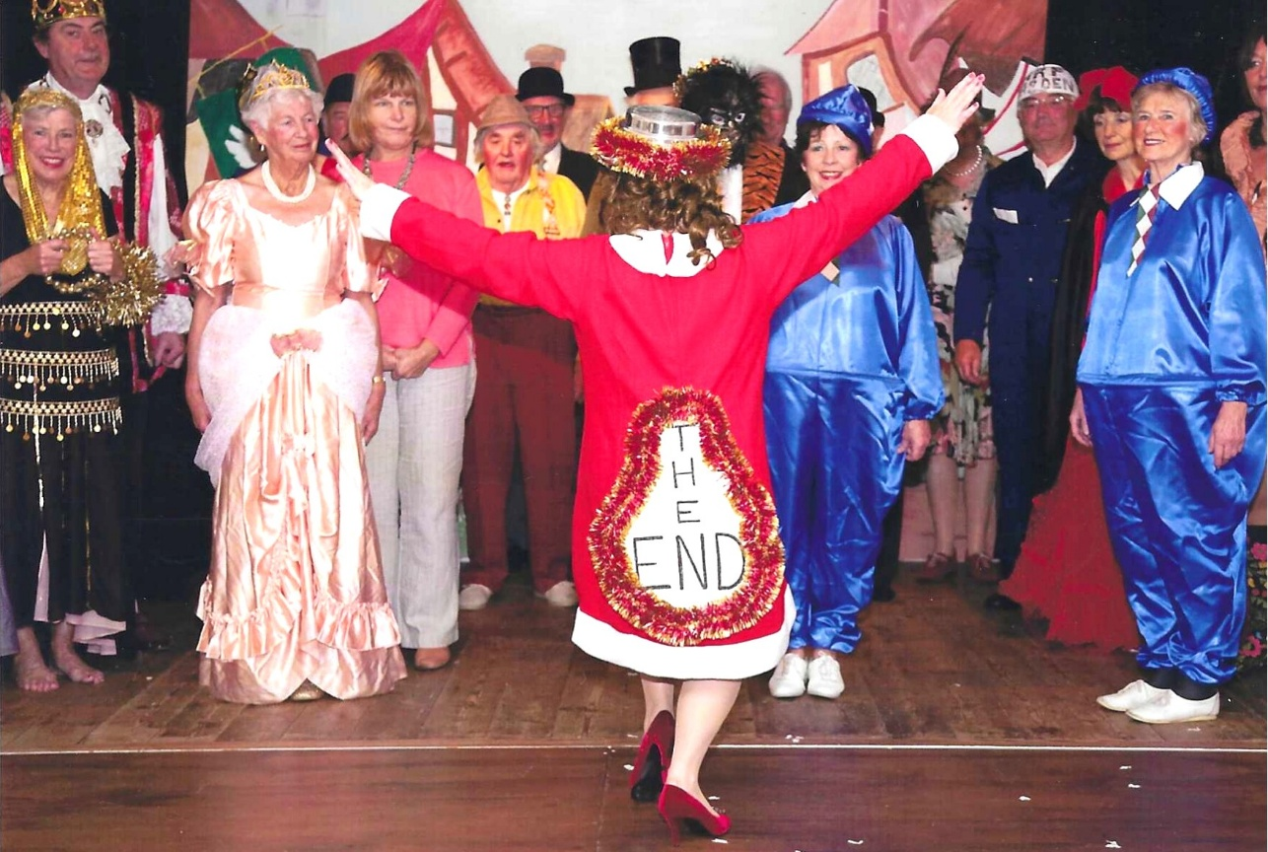

L-R Christine Wilson; Chris Bradbury; Judy Shore; Carol Williams; Pam Carter; Dick Page; Cathy Matthews; Yvette Steward. & with her back to us Emma Parker
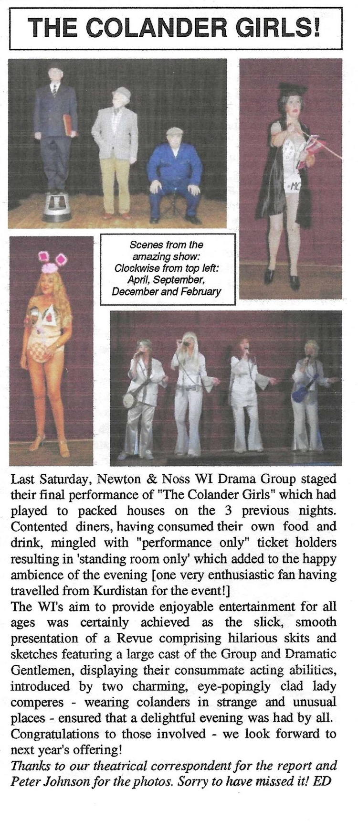

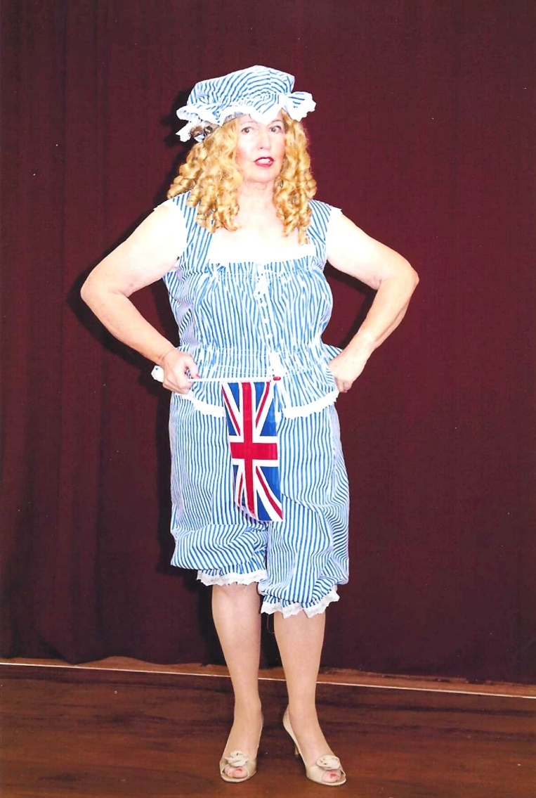
Emma Parker

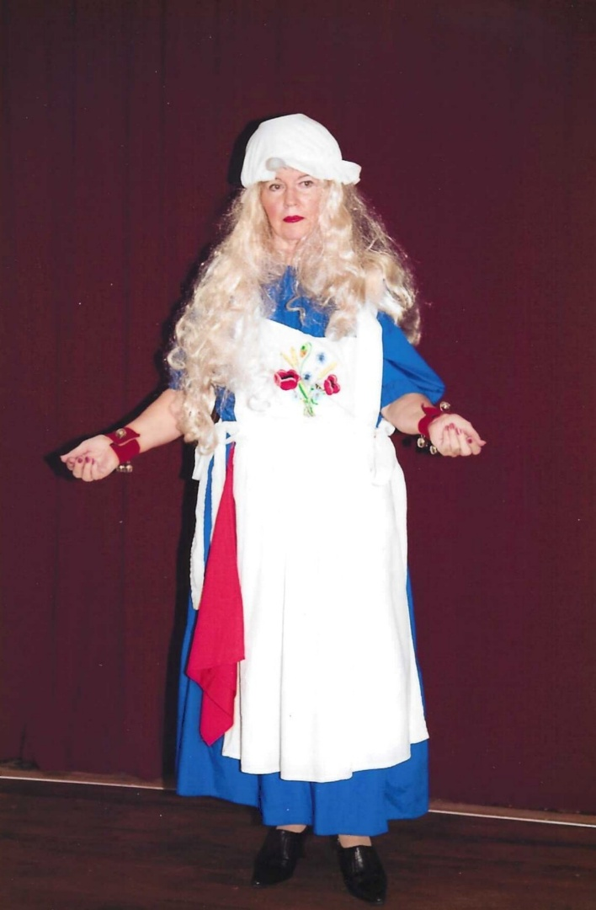

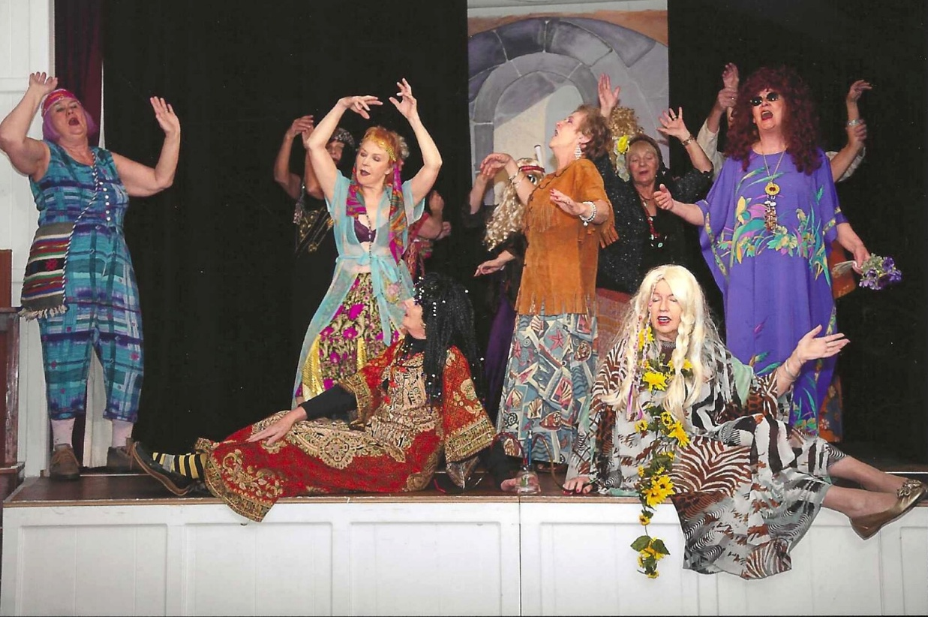

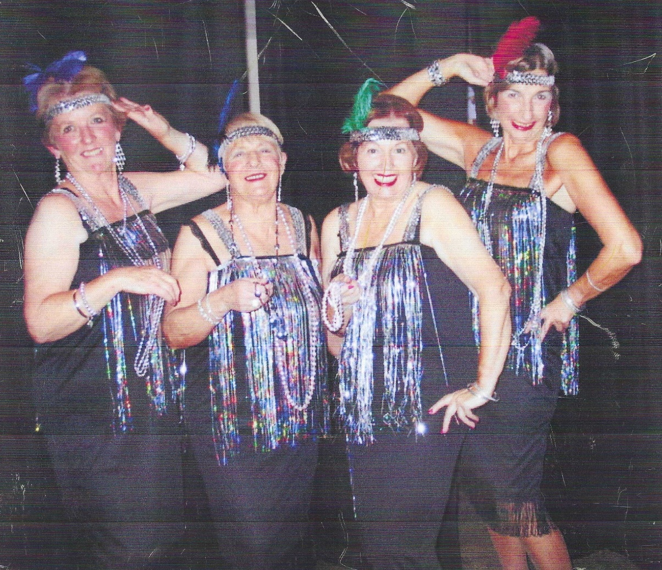

Janet Cattanach; Kate Lawley; Emma Parker & Brenda Merritt

