Lord Chamberlains Men present Othello
At Dartington Gardens

On 22nd July, Pat Middleton, Cathy Matthews, Jeanne Venning, Margaret Pritchard, Shirley Pegg, Gill Tune, Barbara Geddes & Lesley Dempsey went to Dartington Gardens to watch the Lord Chamberlains Men in Othello.
With a history stretching back to William Shakespeare's original company, they present this joyous play as he first saw it – in the open air, with an all-male cast and Elizabethan costumes, music and dance.
"I know my price, I am worth no worse a place."
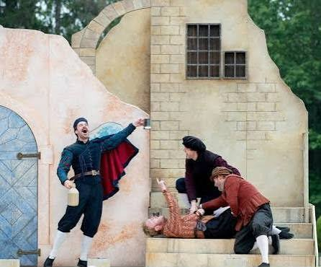
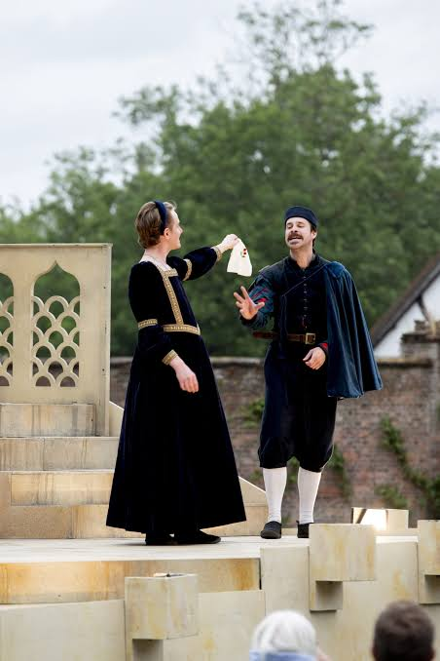
Othello, the Moor of Venice, a respected General in the Venetian army, promotes the young Cassio to be his Lieutenant over Iago, a soldier in his service. In doing so he unwittingly sparks Iago's deep-seated hatred into terrifying life and sets in motion a horrendous spiral of vengeance and destruction that sweeps away everyone before it. As Iago weaves his web and seeks his revenge he poisons Othello against Desdemona, daughter of a Venetian nobleman he has recently and secretly wedded, and turns the world upside down until Othello becomes unmoored from reality with devastating consequences.
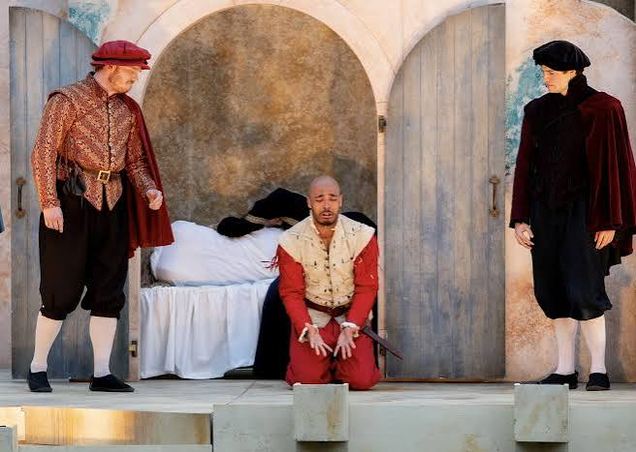
"Put out the light, and then put out the light."
A story of deception, jealousy and a man that loved not wisely but too well – this stunning and heartbreakingly poignant play
Thomas Delacourt’s riveting, unsubtle Iago and Mostyn Crawford’s heart-wrenching Othello, were brilliant. The brisk, thriller-like pacing, striking Elizabethan costumes, and clear diction that cut through the outdoor venue was as good as ever.

Once again we took our own chairs and picnic, and the weather was hot and dry.
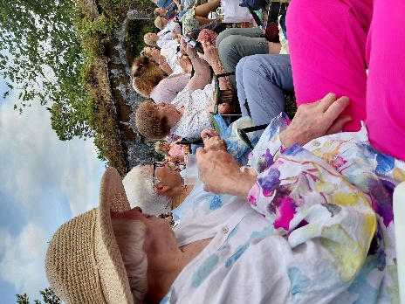
Barbara, Shirley & Gill

Jeanne, Cathy, Pat & Margaret sat 1 row in front of us.

