2015 November 26 – 28th Royal Variety Show
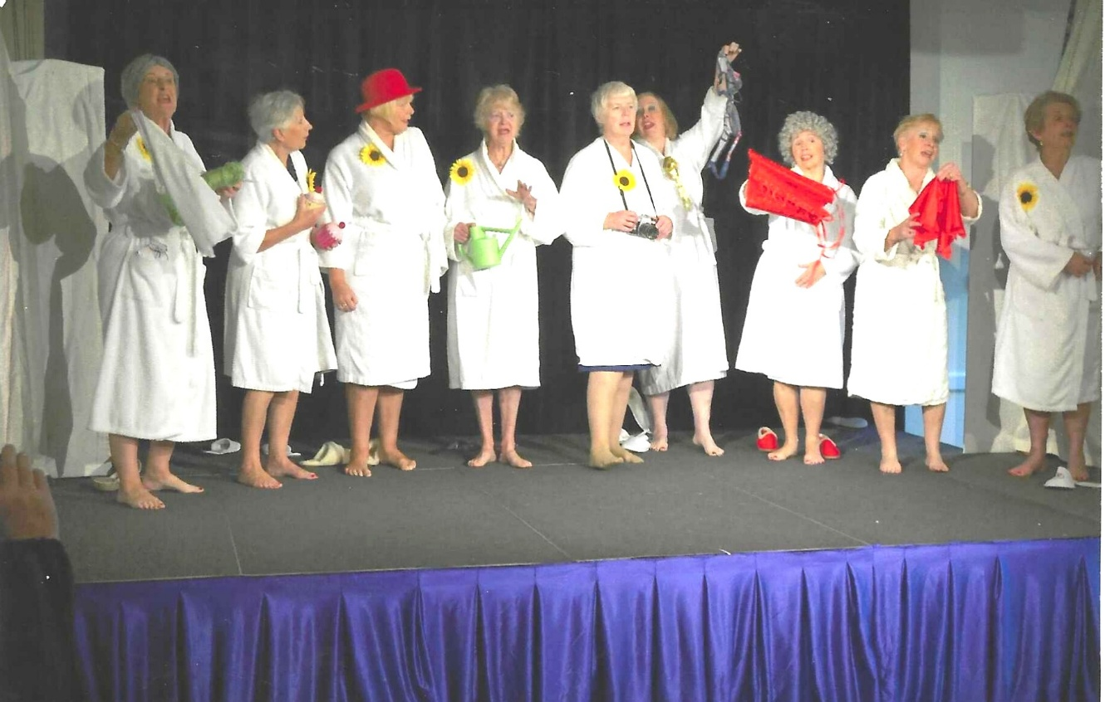
L-R: Janet Cattanach; ? Carol Williams; ?; /: Carrie Dixon; Pam Carter; Angela MacPherson; ?

L-R: Pam Carter; ? ; ?; John Alexander
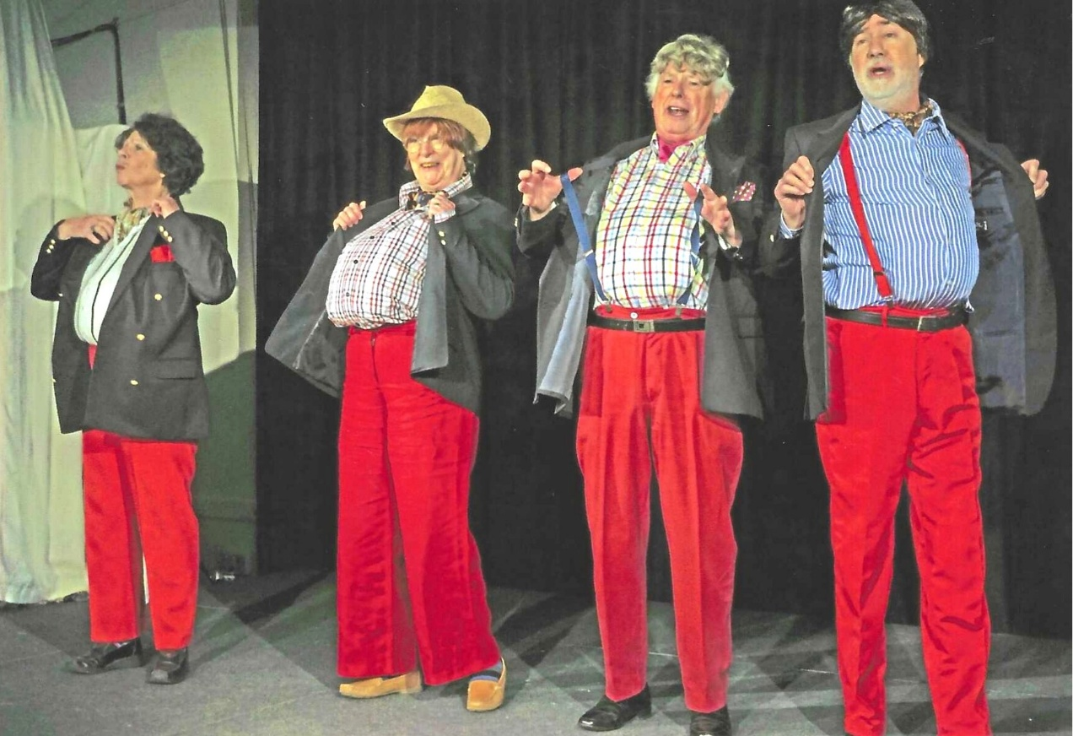
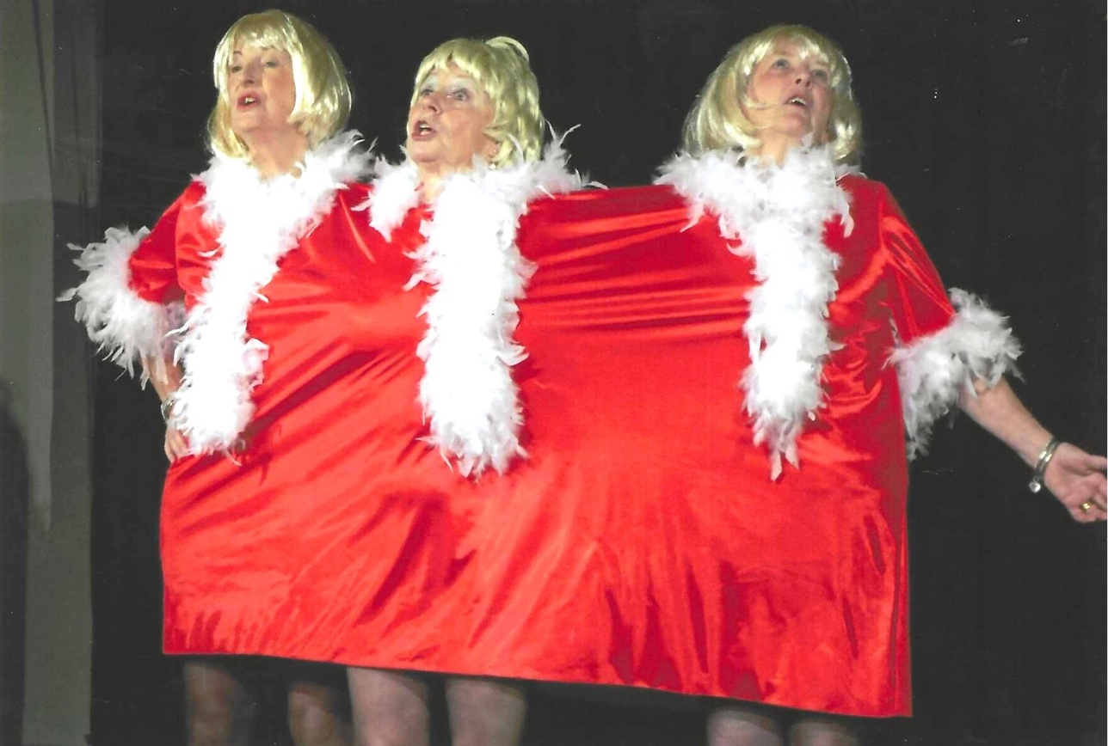
L-R:

L-R:
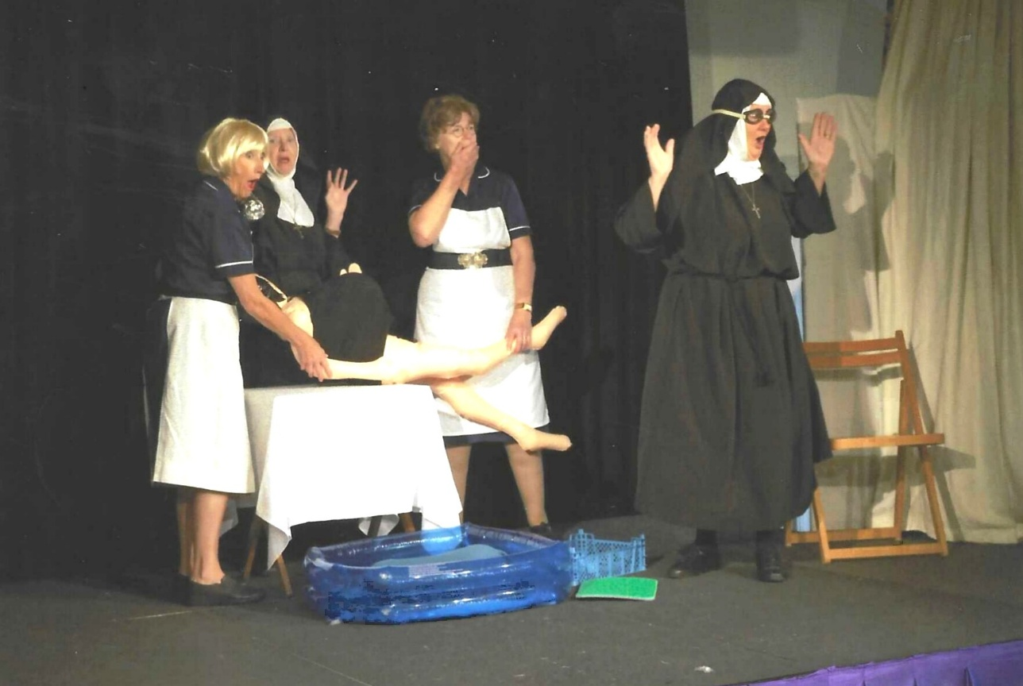
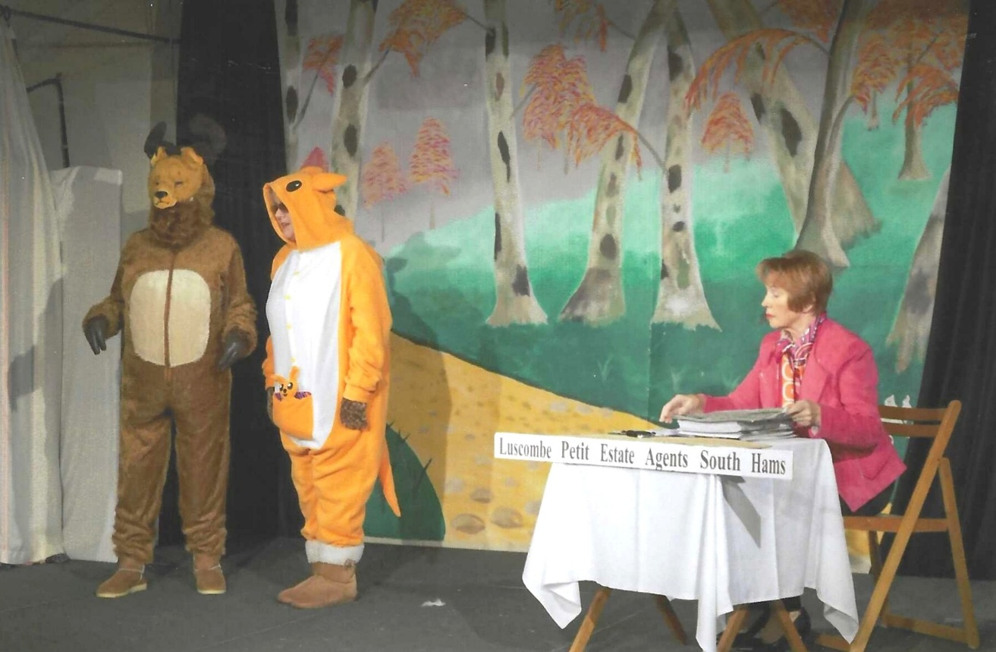
L-R: ?; ?; Emma Parker

L-R:
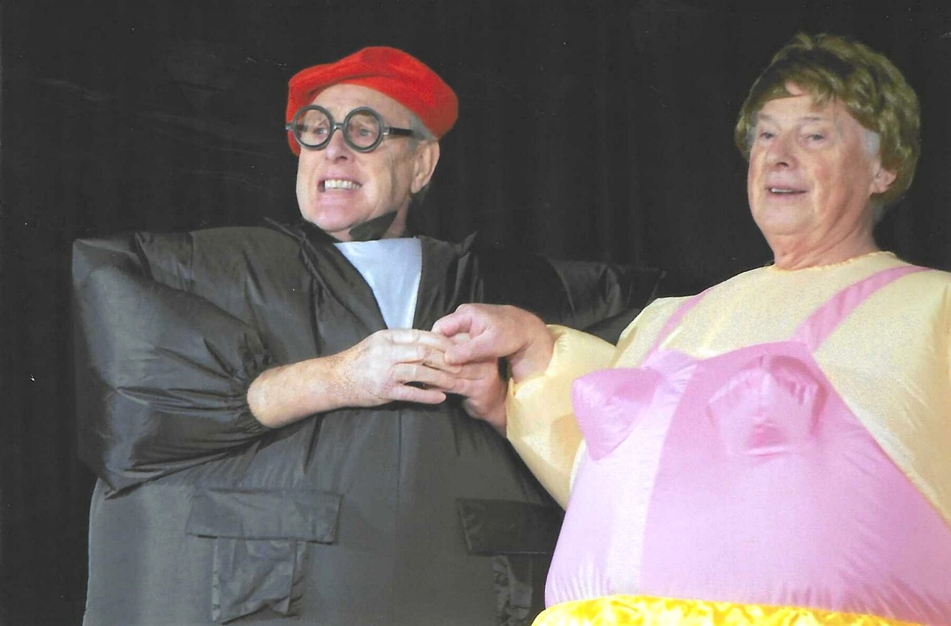
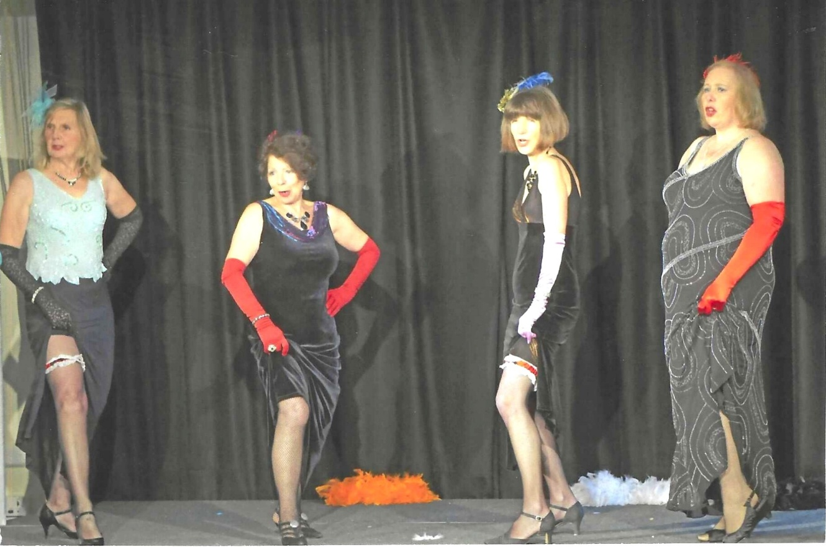
L-R Vickie Ingram; Pam Carter; Cathy Matthews & Carrie Dixon

L-R:
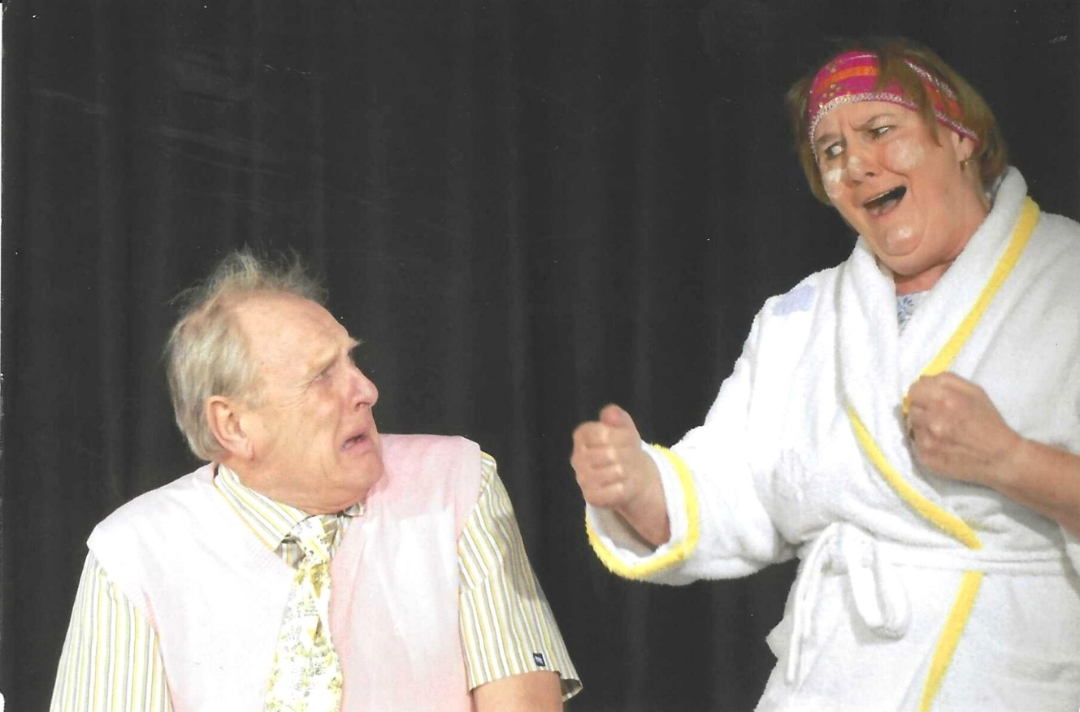
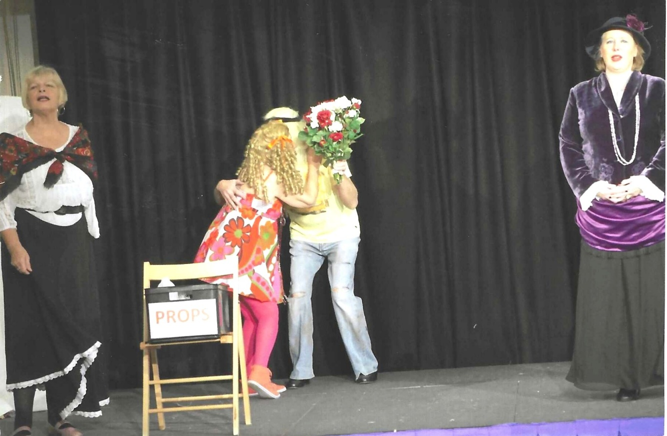
L-R: Carol Williams; ?; ?; Carrie Dixon

L-R: Vickie Ingram; ?; Cathy Matthews; Janet Cattanach; & ?
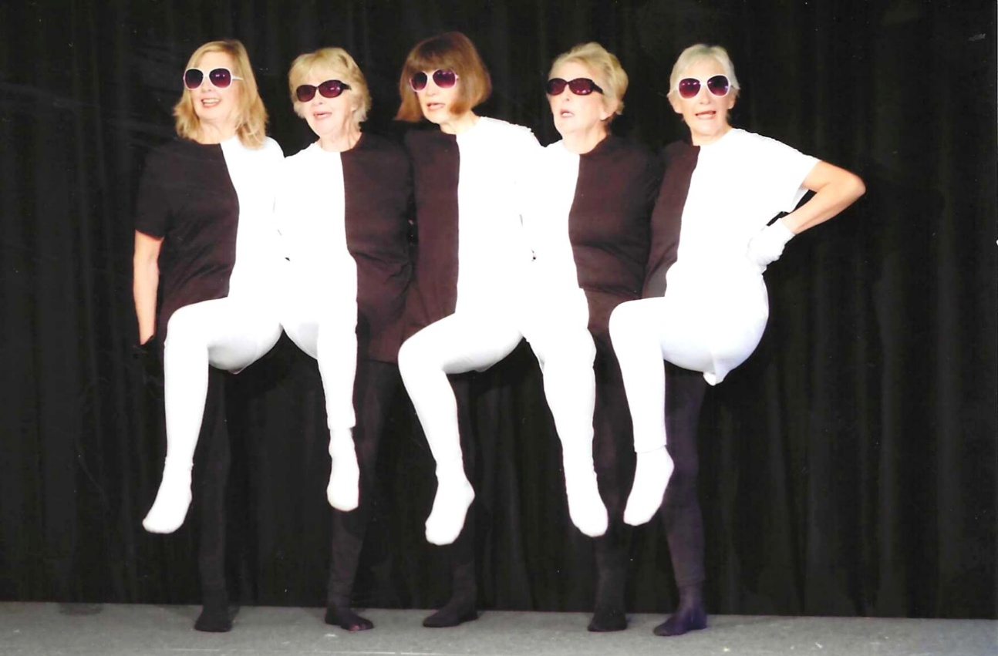
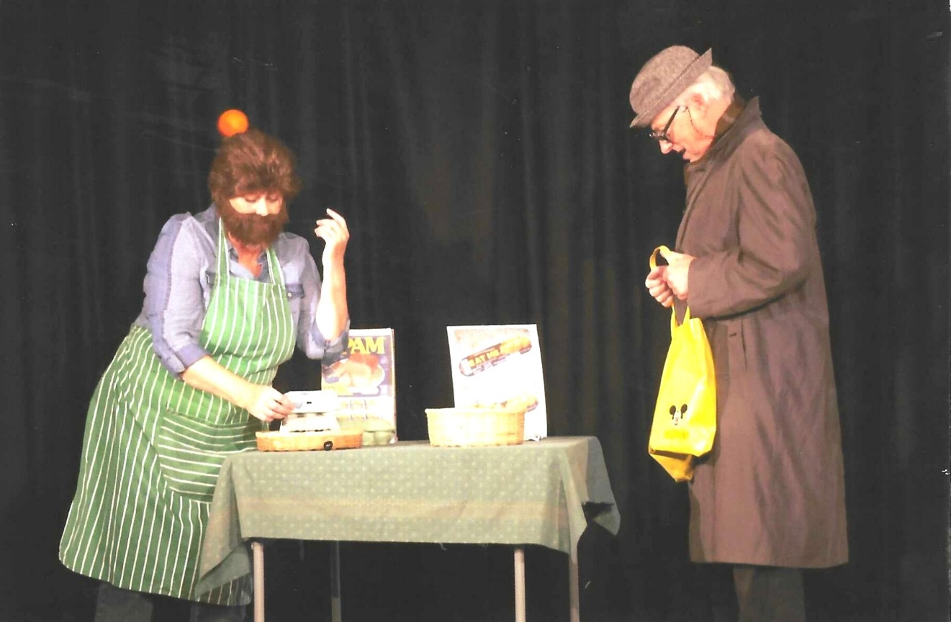
L-R:

L-R: Judith Stephenson; Carol Williams; Cathy Matthews &
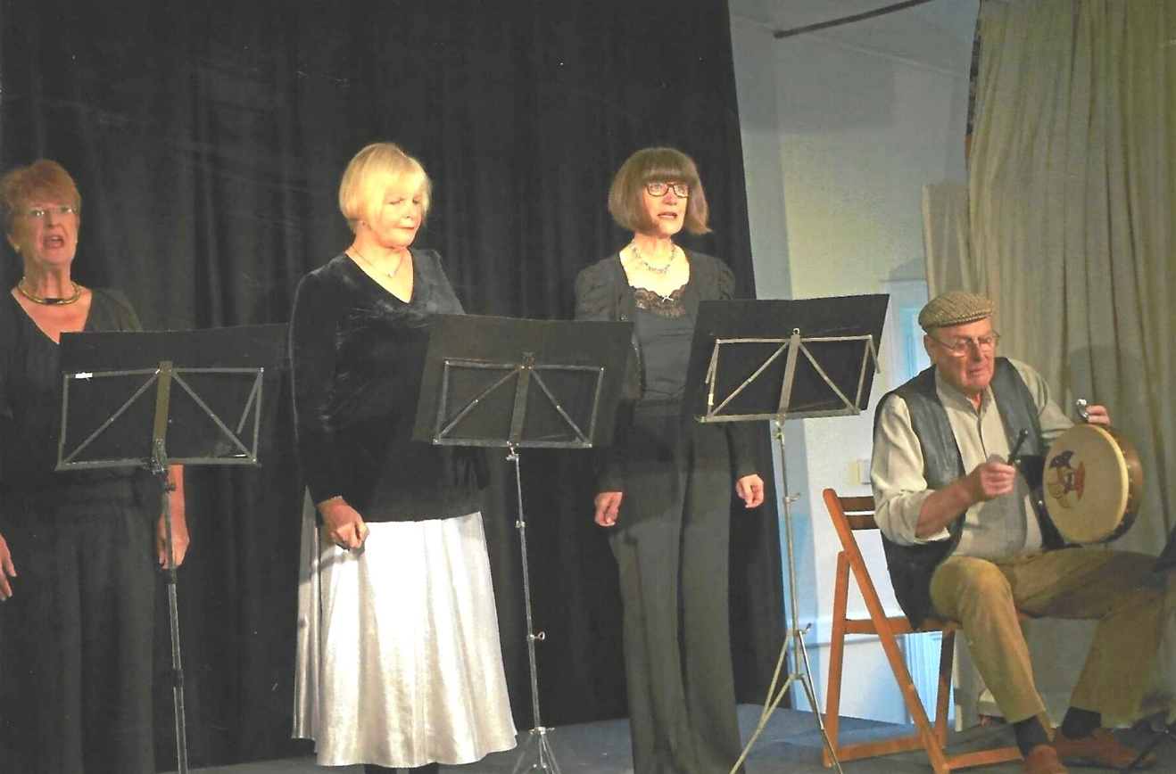
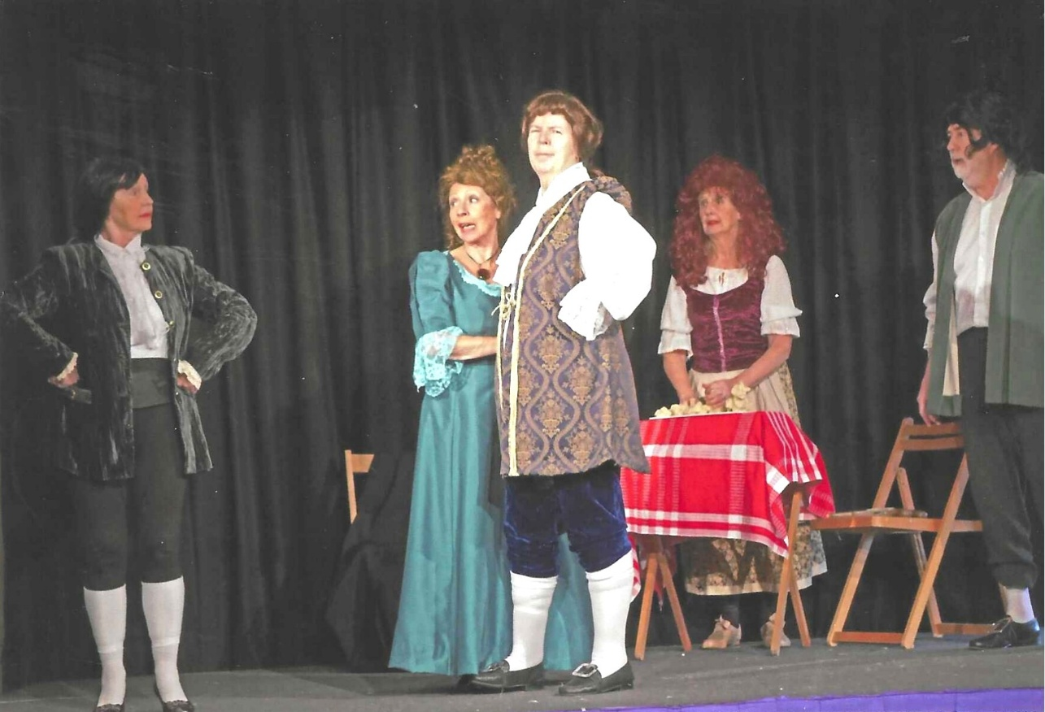
L-R:

L-R: Jean Ellis & Caroline Parsons
