2010 Summer Supper
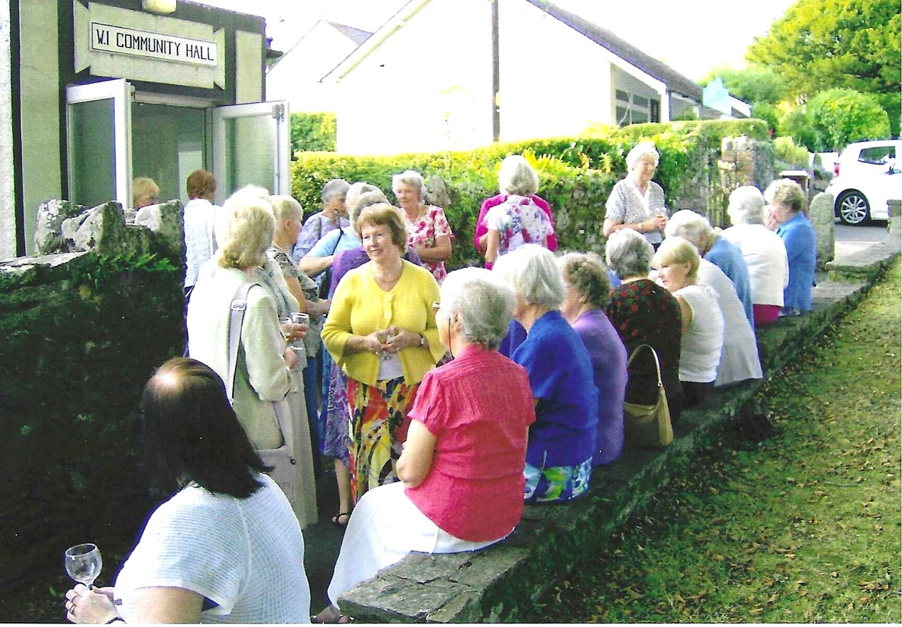

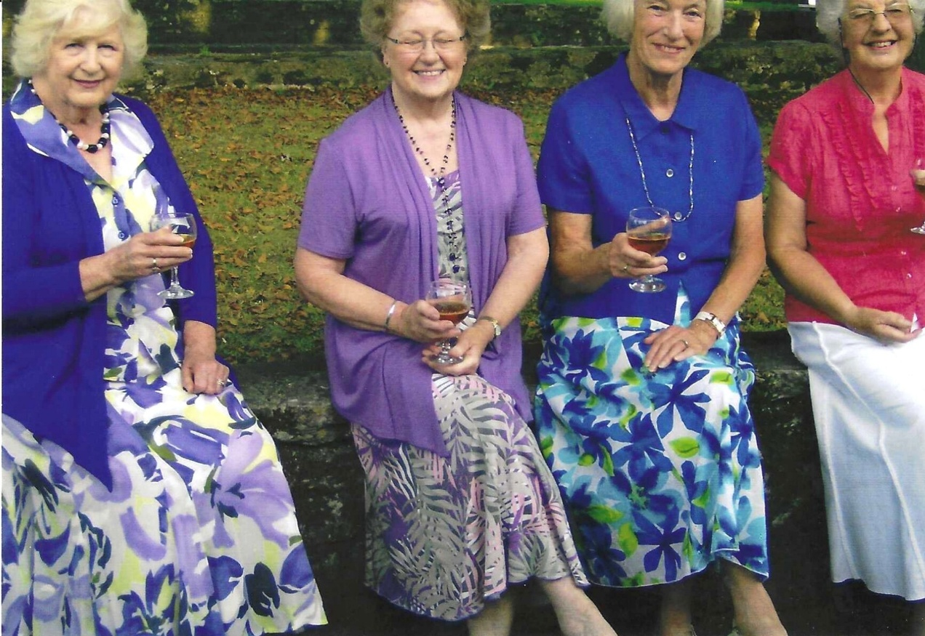

L-R Sylvia Hunt; Joan Westall; Nikki McDougal; & ?

L-R Margaret Pritchard; Janet Cattanach & Betty Christie
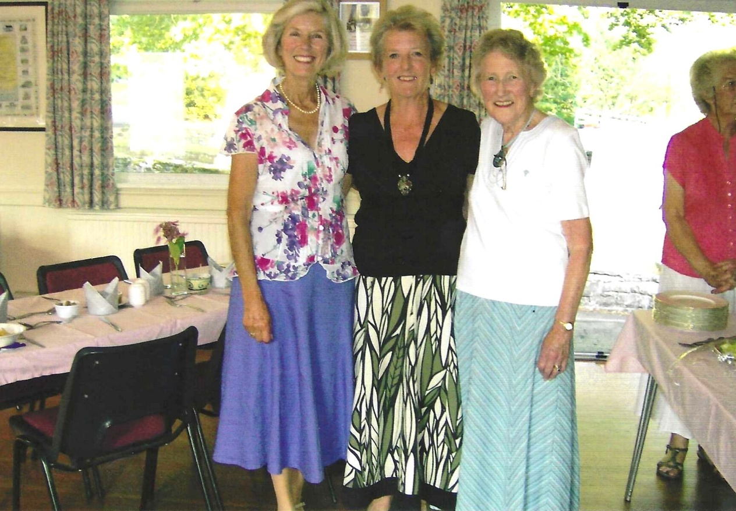

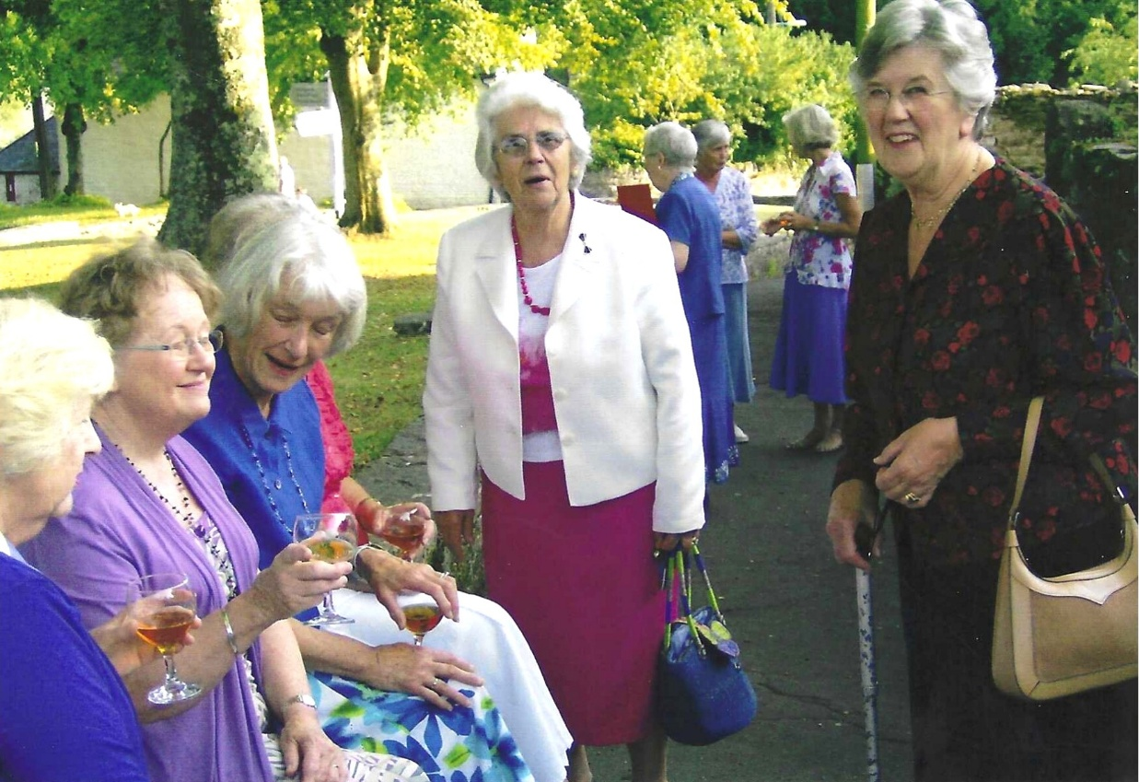

L-R Sylvia Hunt; Joan Westall; Nikki McDougal; ? ?

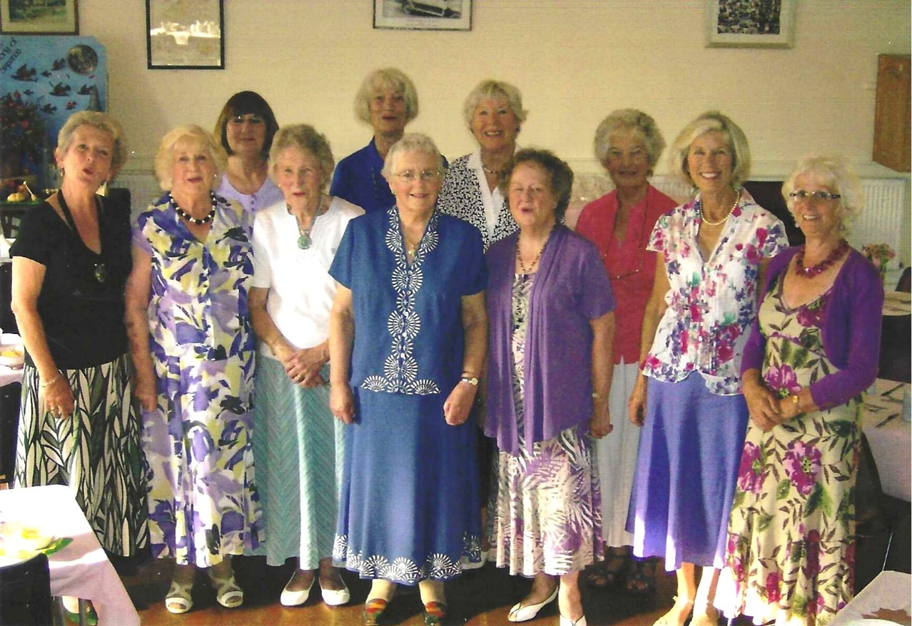

2010 Committee
L-R Janet Cattanach; Sylvia Hunt; Jean Ellis; Betty Christie; Nikki McDougal; Rosemary Furzeland; ? Joan Westall; ? Margaret Pritchard & Joyce Stickley

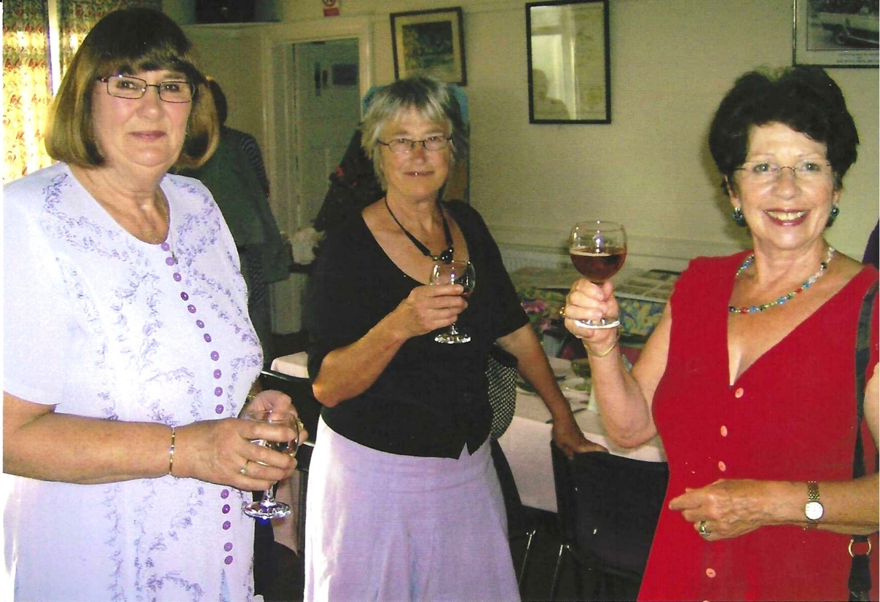
L-R Jean Ellis; ? Pam Carter
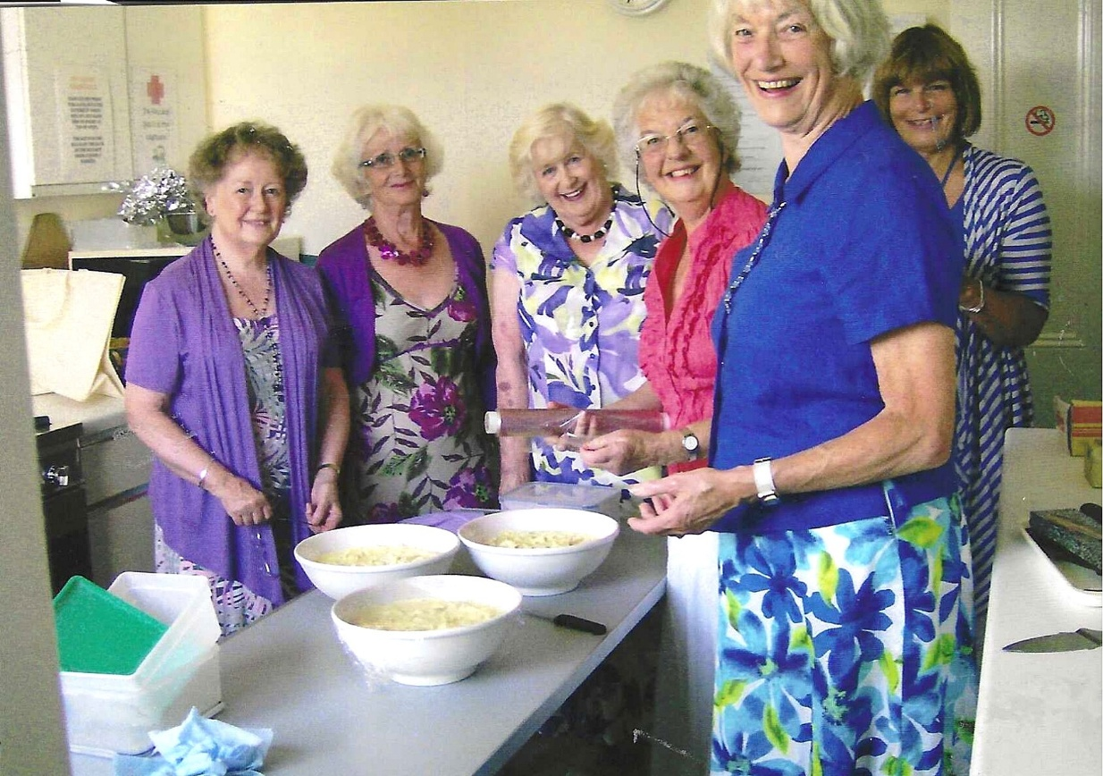

L-R Joan Westall; Joyce Stickley; Sylvia Hunt; Joan Miller; Nikki McDougal; Carol Williams

