Newton Ferrers and Noss Mayo WI

Newsletter

January 28th 2024

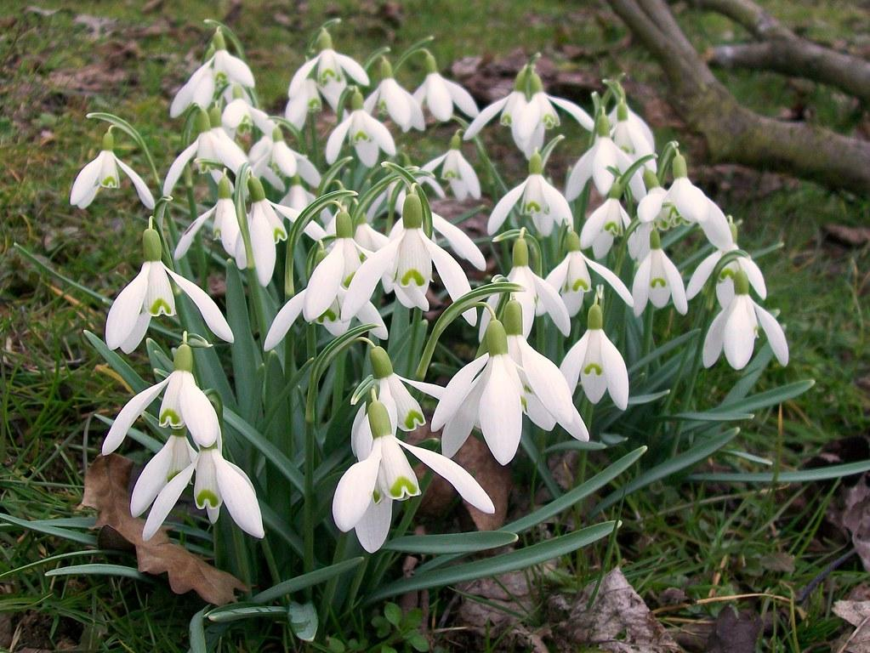

Hello everyone

I think we should all be awarded Honorary Doctorates in the theory and practice of weather management. Years of weather watching with daily shipping forecasts, weather maps, high and low-pressure systems, occluded fronts, cold fronts, warm fronts, anticyclones, inversions, conversions, jet streams, droughts, drizzle, arctic and Saharan winds, scattered showers, gales, sleet, snow, ice and floods surely qualify us all to step into David Braine’s shoes any day of the week. Between you and me it’s quite surprising that with all my years of barometer tapping, cloud reading, consideration and planning, I haven’t yet been called upon for my opinion. “Cold, wet and windy - don't go out” would have done for last Tuesday - brief and to the point. Tomorrow? Who knows…it could be anything. Fortunately, my static bike ride to John O’Groats progresses unaffected (I’m now north of Warrington). Meanwhile, the garden has battened down the hatches until the warmer weather arrives. The snowdrops though are beginning to appear - what better forecast of approaching spring.

Now on to other items…

Lesley and Jackie delivered a *huge* consignment of 132 Trauma Teddies to Greenbank Fire Station in December. They were gratefully received for general distribution to needy children in times of crisis. Lesley’s photo of the hand-over has been accepted by Devon WI News so watch out for it in the February edition! Many thanks and congratulations to all our WI members who took part in the initial knitting challenge and whose results will be spread far and wide. Jackie and others are still knitting Teds so do contact Jackie or Lesley if you’re keen to help.

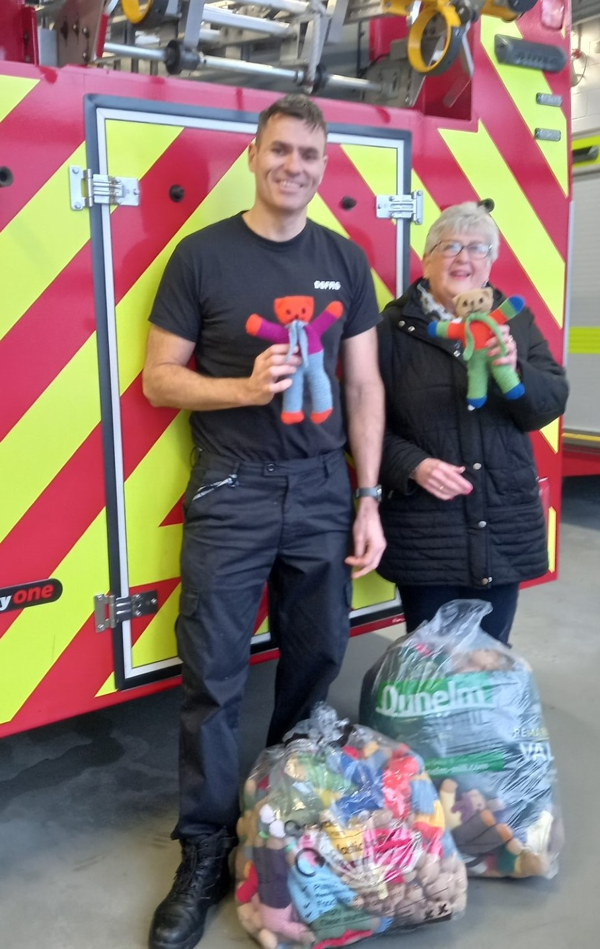

Our last meeting on 16th January featured Richard Haigh speaking about the Unification of Italy with biscuits. The history of unification is available online <https://en.wikipedia.org/wiki/Unification_of_Italy>

Just as importantly - the biscuits (Nice, Lady’s Finger, Viennese Whirl, Bourbon and wafer) were great! (He told us that Garibaldi biscuits were invented by Peek Freans after a visit from Garibaldi to South Shields in 1854).

**Our February meeting** is on Tuesday 20th February at 2 pm for 2.30 pm when Nigel Grist will be speaking about A Photographic History of Industrial Dartmoor. Come and bring a friend if you’d like.

**Our W.I’s Spring Fair on 6.4.24** is from 10 am to 12 noon at the WIC hall with the sale of good quality pre-loved homeware, clothing; Pre-loved toys, (proceeds to Ukraine), jewellery and accessories, cakes, savouries and preserves plus raffle. Please save any *good quality* items for the sale. We’ll be reminding members about cakes and bakes nearer the time. All contributions will be very much appreciated.

**DFWI:** Please see the latest copy of Devon WI News for DFWI events - it’s a quiet time for events but there are several Devon-wide competitions with closing dates in late February and late April. Details are on the members’ noticeboard at our monthly meetings.

DFWI events etc can also be reached at [https://www.devonwi.org.uk](https://www.devonwi.org.uk/) and NFWI at <https://mywi.thewi.org.uk/welcome-to-my-wi>

Denman at Home has been renamed The Learning Hub and can be found via MYWI at the email address above. Please let me know if you are not receiving your copy of WI Life and Devon WI News which are sent out online monthly and are also available in hard copy.

Our website, with all our news and events, is at the wi.online. It’s kindly managed by Lesley Dempsey.

**Groups and Visits:**

Book Group: **Next meeting Thursday March 21st at 3pm.**

Following their recent meeting, Judith writes “ A very big thank you all for your empathy and insightful comments at our meeting this afternoon. You coped with a difficult read and very harrowing details. We all seemed to appreciate the universality of human suffering wherever there are world conflicts. We, like Amal in the story, “feel sad for the boy bound to the killer. Sad for the youth betrayed by their leaders for symbols and flags and war and power.”

I decided we need a total change of subject matter for our next book! We agreed to look at Queen Camilla’s rather surprising book choice. The Lord’s Day by Michael Dobbs.

She reimagines members of the Royal Family and all the most important people of the land being held hostage. A tale about a security breach at the State Opening of Parliament. Have fun with this one! Love Judith.

NB Be careful to buy the correct book. There are different authors with the same title. Our book is by Michael Dobbs”.

For further details, book reviews etc, visit our website <https://www.thewi.online/book-club>

Craft Group: Recently met for a crochet afternoon, taught by Angela. Lesley writes “The next meeting is on 27th February, when we will be continuing with our beginners' crochet as members requested it. Other crafts are welcome.”

For more details, visit our website <https://www.thewi.online/craft-group-program>

The Choir is resting while Joyce recovers from recent surgery. They all wish Joyce a speedy recovery.

Visits: Jackie is our Visits Secretary so do contact her with any requests. She is currently planning to resume visits in the spring.

We are planning a brief monthly competition - just for fun - towards the end of the members’ meetings to complement the speaker’s subject with a small prize for the winner (drawn from the hat if there’s more than one).

Next year’s Committee: Cathy, Carrie, Gill and I will be stepping down from the committee at our next AGM on 21st May. We have all been in our roles for several years and have also served on previous WI committees. It is now time for a new group of officers to re-energise our WI leadership with fresh ideas and new ways of doing things. Lots of ongoing support and mentoring will be provided by us all (and is also available from the DFWI) but we need volunteers among our membership to come forward before the AGM in May. Please see any of us if you would like to learn more about, to join or lead the next committee. We will need to contact the DFWI soon which we are obliged to do if we cannot form a committee. *Please* help.

That’s all for this month - keep safe, keep dry and see you soon

Bye for now

Pat

