As New Sale May 2001


Left to Right -Alison Foster; Yvette Steward; Shirley Painter

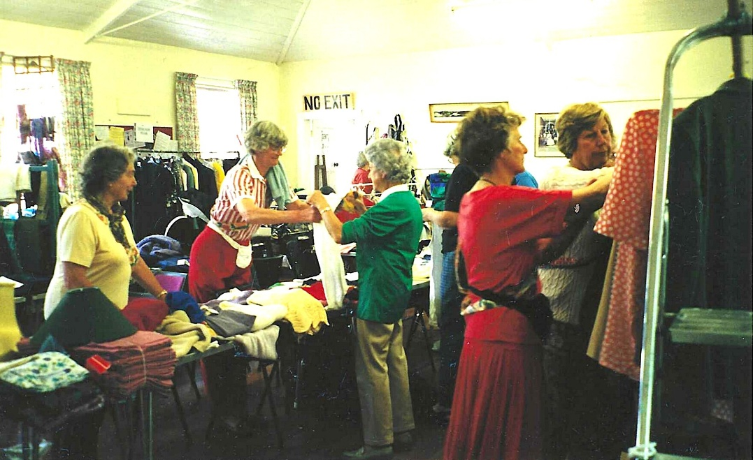

Lady in white and red striped shirt is Francis Jenny

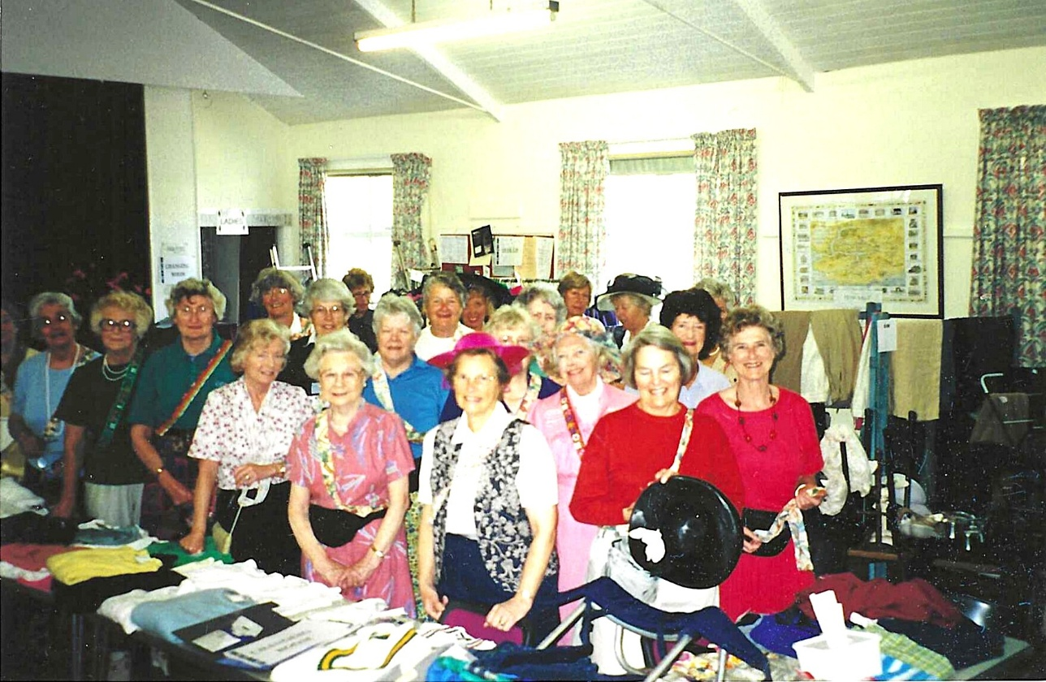

Front row: Clare Pead; Pat Hillier; Rosemary Watts; Wendy Plough; Mary Thomas; Enid Whiteman; Pat Endicott; Yvette Steward.
2nd row: Pat Hobb; Alison Forster

