Newton Ferrers and Noss Mayo WI

Newsletter

April 27th 2023

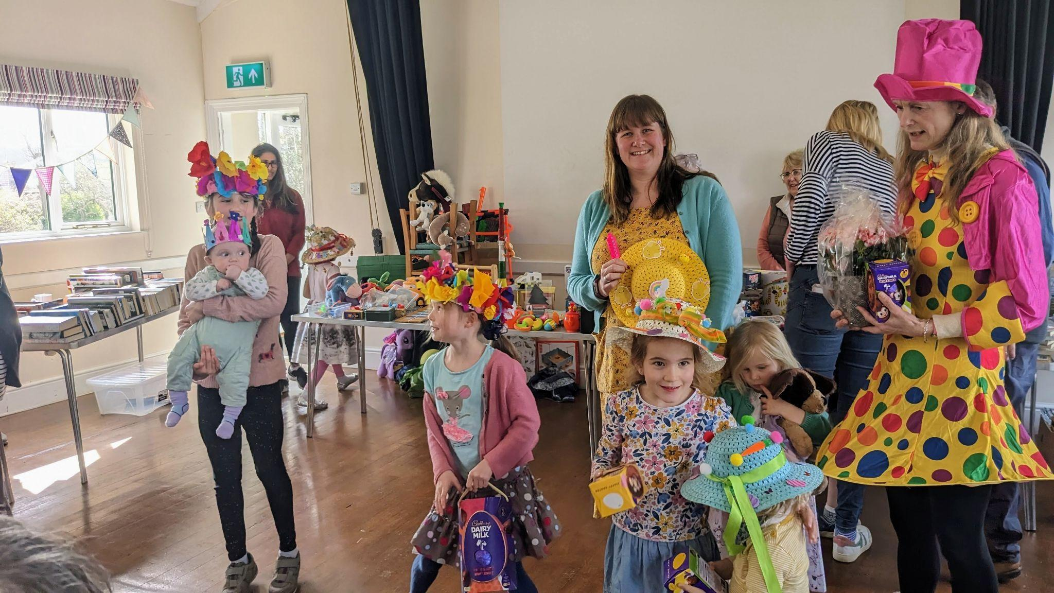

Easter Fair Hat Competition - prizes for all - April 8th

Hello everyone

It seems a while ago now, but our Easter Fair on Easter Saturday was a complete success - and it was all down to the overwhelming support from our fantastic members – and the committee who gave their all. The most wonderful contributions poured in so the tables were positively heaving with all manner of tempting, tasty, literary, playful, decorative or useful items. The cakes, savouries and preserves table, though completely laden, was sold out in the first hour - we could have made double and it all would have sold! Equally successful were the pre-loved gifts and home items, toys and books, and the craft table while the raffle (first prize a big basket of Easter eggs) was an unparalleled success. Many locals and holidaymakers stayed for coffee with Stella’s macaroons and my Easter biscuits strong competitors for any WI baking prize! (modest aren’t I). The children’s Easter hat competition, expertly judged by Trisha Glynn, was an equal feast of colour and millinery good taste (!) and all the children went home with something - usually chocolate. The few unsold items were happily received by Hugs for Henry Children’s charity. Cathy, the committee and I send a sincere Thank You for your help, support and generous donations. Our WI has benefited by £1045 but just as much from the teamwork this event generated.

Now on to other items:

Our last meeting on April 4th saw Mo Springall, from Project Linus talk to us and provide examples of handmade quilts the charity and its volunteers have made over the years for needy children under nineteen. It originated in the USA in 2000 and since then it has sent out over 500,000 quilts in the UK alone. Plymouth children have received over 200 so far this year. They may be asylum seekers or refugees, sick children or those who have lost a close relative. The comfort and reassurance of snuggling into a soft and familiar quilt do much to improve their mental health and anxiety. Referrals come from hospitals, the Women’s Refuge and the Trevi Centre, NSPCC, Barnadoes, children’s social care and the public. If you would either like to make a child’s quilt or make a referral, please contact Mo Springall at mospringall@gmail.com

Our fabulous website thewi.online is now the information hub for all we do in our WI while providing a record of meetings, minutes, events, and a photo gallery. It’s really very easy to use so please try it. Judith is always looking for your book reviews and recommendations too on the Book group page! Do let us know if you have any difficulty using the site or contact Lesley Dempsey, our web guru, at lesleyswp@live.co.uk.

For DFWI go to https://www.devonwi.org.uk/ and for NFWI go to https://mywi.thewi.org.uk/welcome-to-my-wi
For any difficulties with devices, remember there’s the digital drop-in from 10.30 am most Fridays at the WIC hall.

Forthcoming events:
Our A.G.M. and Coronation Celebration 2nd May 2023.

Cathy has asked that members aim to arrive at 7pm for teas and coffees when the signing-up board for the guided walk around Dartington Gardens on June 30th will be available and there will be time to read the noticeboard before we begin at 7.30 pm. Joyce has kindly offered to accompany the singing of “Jerusalem” to start the proceedings. We will briefly go through the monthly business meeting and then the AGM when we vote for our choice of President for the coming year. We have one volunteer to join the committee but we are losing two members. If you would like to join us, please come forward. We aim to get through the business speedily with brief reports from Cathy, Gill and me. Members will be served a glass of Prosecco or alternative and we will then toast the King. This will be followed by a fun quiz, a song from the choir and we will close with the National Anthem.

Change of Time and Week of our monthly members' meetings:
Following the vote in favour to change the winter meetings to daytime, this should be ratified at our AGM. If ratified, the change will start in June when we will still meet in the evening but it will be on the third Tuesday of the month instead of the first Tuesday, i.e. Tuesday 20th June and thereafter, 18th July, 15th August, 19th September. This avoids winter meetings coinciding with the first Tuesday lunch club. We will change the winter meeting times to the afternoon in October.

Yealm Group Spring Council meeting May 9th from 7.30pm. - hosted by Sir Joshua Reynolds WI at Harewood House, Plympton. A group of us are going and all tickets have been sold and car shares arranged. The guest speaker is Hilary Bracegirdle “Beryl Cook at Home” - a people’s painter who painted people.

Guided tour of the gardens at Dartington Hall with Rosemary Griggs and cream tea to follow. Friday 30th June 2pm. Free for RHS members. If there are more than ten in the group we will qualify for a concessionary entry to the gardens of £5 per person (with one payment for the group.) Cream tea extra. Car shares will be available. Sign up at the AGM next week.

Pentillie Castle is the setting for Romeo and Juliet with the Lord Chamberlain’s men on July 19th. As usual, bring your own picnic and car shares will be arranged - it’s always a great evening!

Groups:

Book Group: (taken from our website) Our next meeting ( for Book Group members only ) will be held on Thursday May 25th 2023 in the WI Hall at 2.45 for 3 pm start. A GENTLEMAN IN MOSCOW BY AMOR TOWLES
This is a “supremely uplifting book, elegant, witty and delightful…..much like the Count himself. Owing to the practicalities of a group discussion the number of members has had to be limited to sixteen and there is sometimes a waiting list. Any WI member may apply to have their name added to the waiting list by contacting Judith Stephenson Tel 872933

Choir: The choir meets each Wednesday during term time at 2 pm for a 2.15 pm start in the WIC hall. We sing a variety of modern and traditional songs led by Joyce on the piano. Apart from being a very uplifting and enjoyable hour or so, it’s good for the brain and fun to sing in two or three-part harmony. New members who enjoy singing are always welcome.

Craft Group: This is from Lesley:
25/04/2023. Bee Making for the Life on the Edge Project who are to restore viable populations of some of the UK’s rarest insects living on the coast between Berry head and Wembury (£1.50 Hall donation and refreshments)
​
09/05/2023. Felting for the Life on the Edge Project who are to restore viable populations of some of the UK’s rarest insects living on the coast between Berry head and Wembury (£1.50 Hall donation and refreshments )
​
23/05/2023. Bring your own project & chat (£1.50 Hall donation and refreshments)

DFWI - all available to view in more detail on the noticeboard
- Women's choir - Come and sing. 24th June. Christow hall with Matthew Cann. 10am - 12am. Bring your own refreshments. £6.00 Clsoing datge 31st May.
- Speakers’ Showcase 27th June 10am - 4pm Longdown Village Hall £6.00 Closing date 3rd June

- Morning Cycle Ride along River Exe July 4th £19 or £12 if bringing own bike. Closing date 9th June

- Bell Ringing Taster Day 1st August 10am - 4pm Buckfast Abbey. 10am - 1pm and 2pm-4pm £6.00 Closing date 4th July

- Federation Holiday to North Wales. 2nd-6th October Dinner, bed and breakfast. £435pp. Single room supplement £100. Local coach pick-ups.

All bookings please via me.

The NFWI Annual Meeting is at St David’s Hall in Cardiff on 25 May 2023 10am - 4.30pm. It’s a hybrid meeting, with both Zoom and in-person attendance offered. In-person tickets are £22 and online observer tickets are £5 and I think both are still available. Please let Cathy or me know if you would like to observe online - it may be possible to have a group of us observing during the day. Cathy will be representing Yealm Group with the vote for the chosen resolution.

That’s all for now so hope to see you at the AGM and other planned events this summer. Watch out for our WI scarecrow from Sunday. She’ll be stirring her mixing bowl on one of the seats outside the WIC hall making her Queen of Puddings - what else?!
Bye for now
Pat

