WI Christmas Lunch 2023
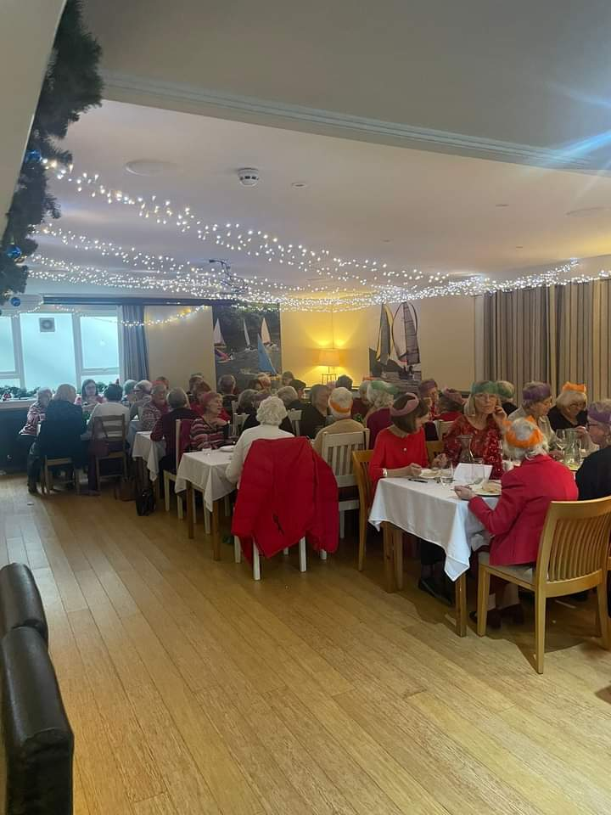
On the 19th December we descended to the Yacht Club for Christmas Lunch; a break away from the tradition of “doing it ourselves” in the village hall.
Lunch was lovely, Traditional Turkey and plenty of it on hot plates. Dessert was Panacotta and ice-cream or Chocolate tort with salted ice-cream for those who were gluten and dairy free.
The best bit? – no cooking, no clearing away, no washing up.
We had a quiz, the committee did a “rendition of the 12 days of Christmas” our way, and the choir entertained us. It was brilliant.
Looking at all the smiling faces it was a success

