2004 Annual report extract 2nd November
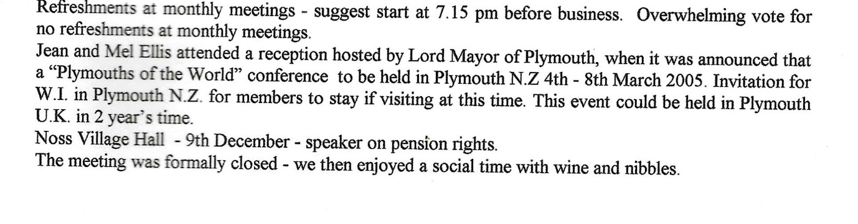
There is a photo album in the WI cupboard that was presented to the Newton & Noss WI by WI group from New Zealand.

