2007 July Ladies in Lavender entry for the Yealmpton Show
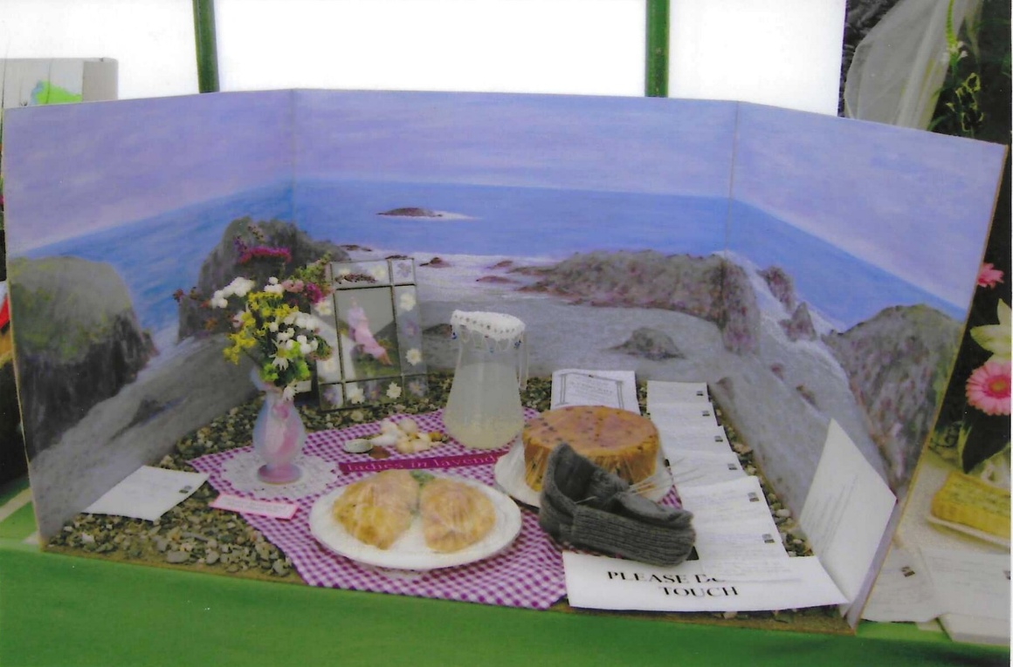

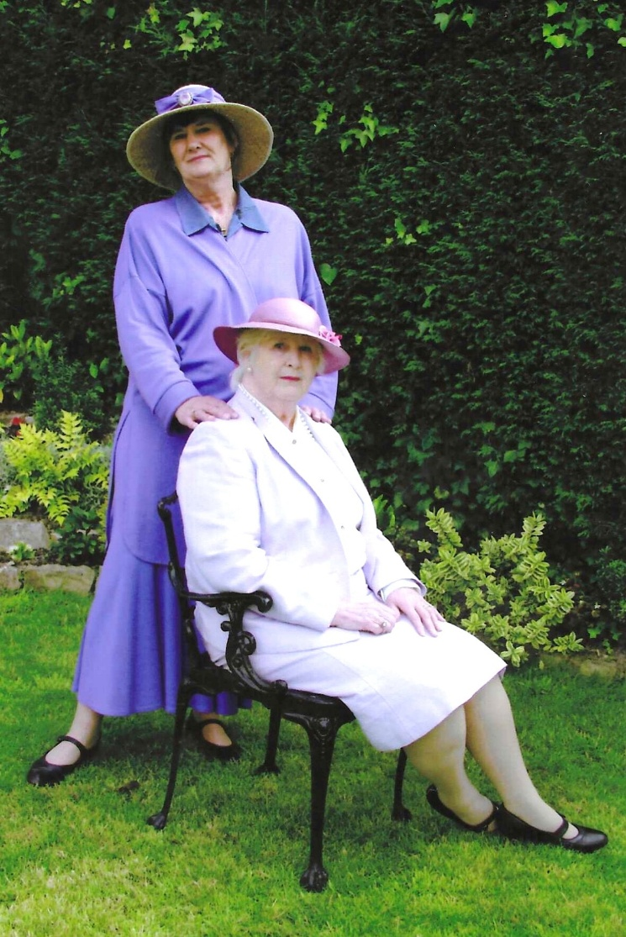
Standing Jean Ellis
Seated Sylvia Hunt

