2003 Holy Cross Flower Festival “Jerusalem”
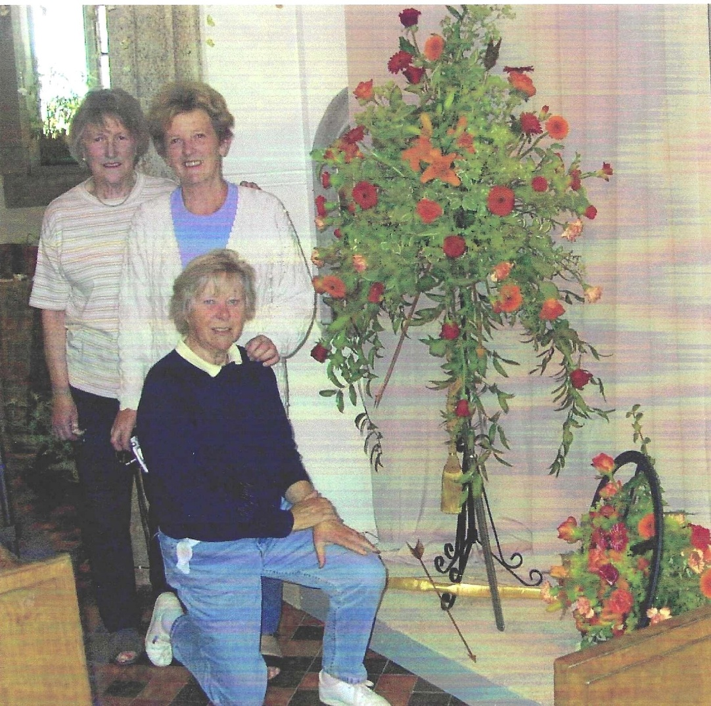

Betty Christie; Janet Cattanach; Leslie Davenport
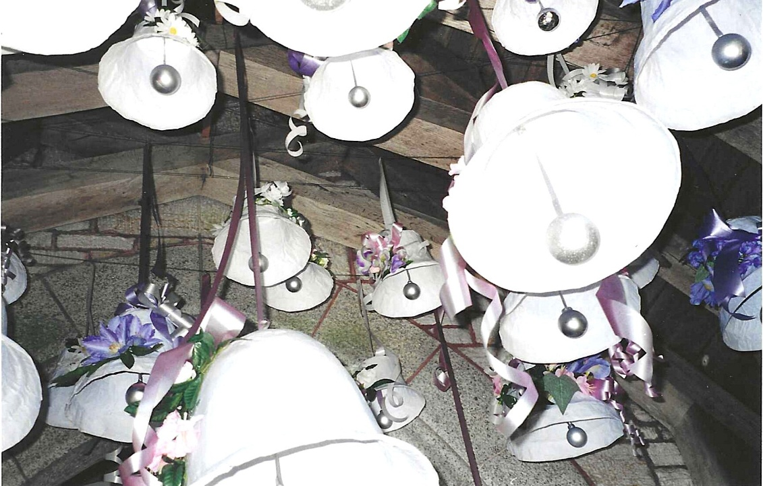
Craft Group Bells
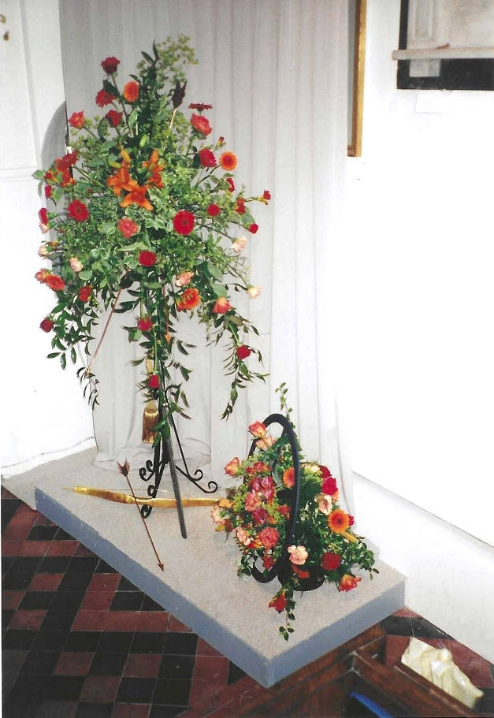
The Holy Cross Flower Festival was an event in which all the organisations in our villages took part. It was fantastic to see the church filled with amazing displays. The marquee was in the garden of the vicarage & food was on offer during the day & raised funds. The bottom photo is of Judy Shore, Nicky McDougal & Jane Hansford. The rota of helpers was made up of volunteers from all our villages organisations.

