Emily Hobhouse

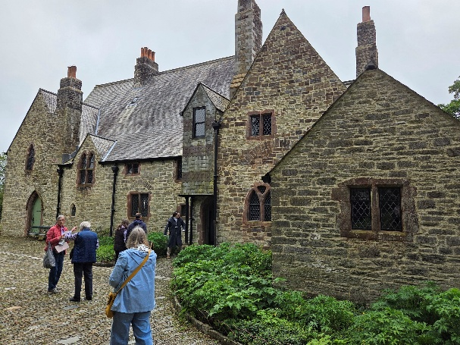
Ten ladies went to Emily Hobhouse on Friday 12th June 2026
We started off with a coffee in the restaurant which is all glass.
We were divided into 2 groups and 1 went to the Rectory and the other to the War Rooms.
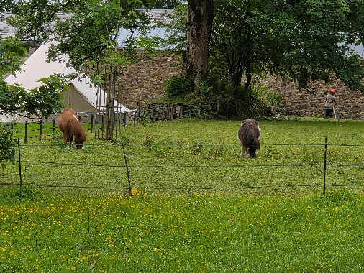
Emily's father was a reverend and the Rectory was where she lived with her parents and siblings in the 19th century. It still looks as it was when they were there. At the top of the house were the servant’s room, a room where you can dress up in the costumes of the day for photos.
There was also a sort of photographic studio with all the old cameras. We weren't allowed to take any photos in the rest of the house. There is an outside privy, stables, kitchen garden as well as little ponies, goats, chickens, ducks and bat houses.
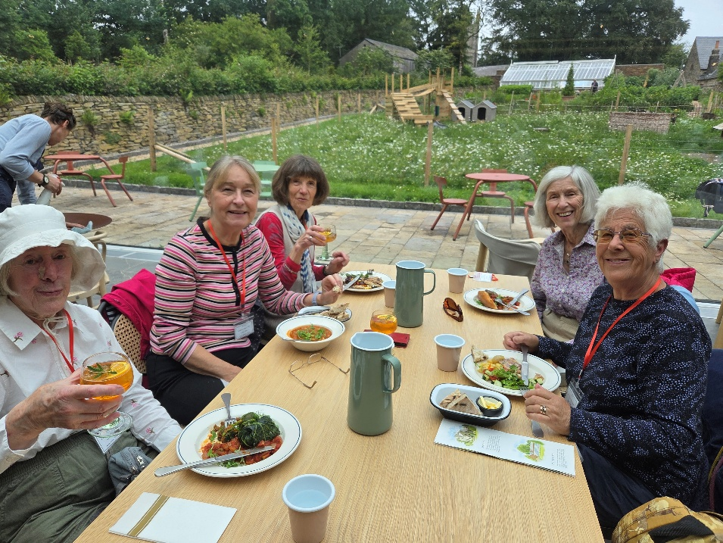

L to R Caroline Taylor, Pat Middleton, Cathy Matthews, Margaret Pritchard & Hilda Julien
We had an authentic South African meal before going to the War Rooms.

L to R Christine Wilson, Jackie Ross, Yvonne Mustoe, Jeanne Venning & Brenda Merrit
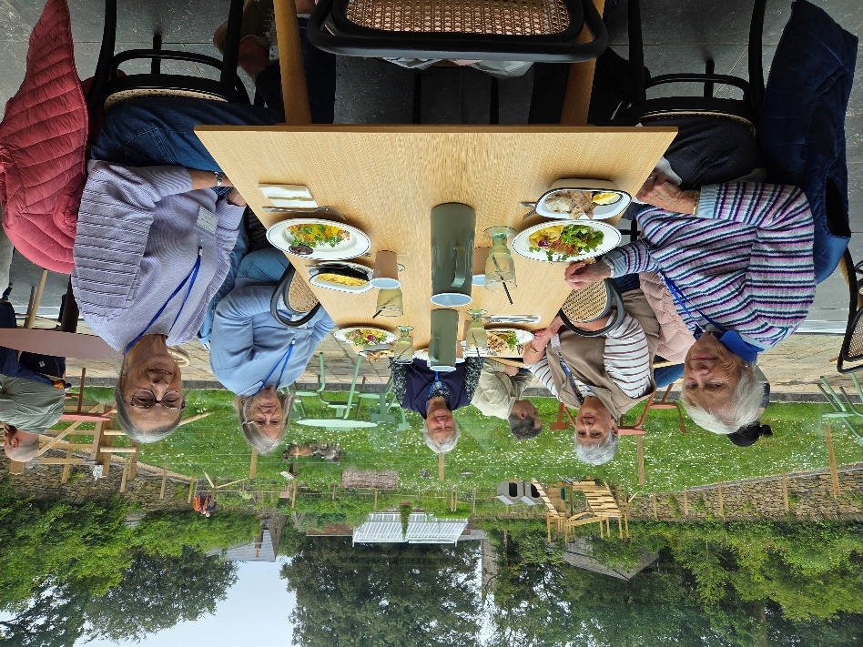
We were given coffee and rusks before entering the main section.
Here we experienced Emily's legacy in the Anglo-Boer war through immersion media and artifacts. We witnessed a typical Boer homestead, guerrilla warfare and a concentration camp ending with a reflection on her final words of farewell.
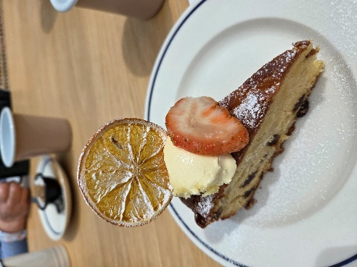
The whole experience was so impressive and a real eye opener.
Words& photos by Jackie Ross

Note:
Emily Hobhouse was a British welfare campaigner, anti-war activist, and pacifist. She is primarily remembered for bringing to the attention of the British public, and working to change, the deprived conditions inside the British concentration camps in South Africa built to incarcerate Boer and African civilians during the Second Boer War.

