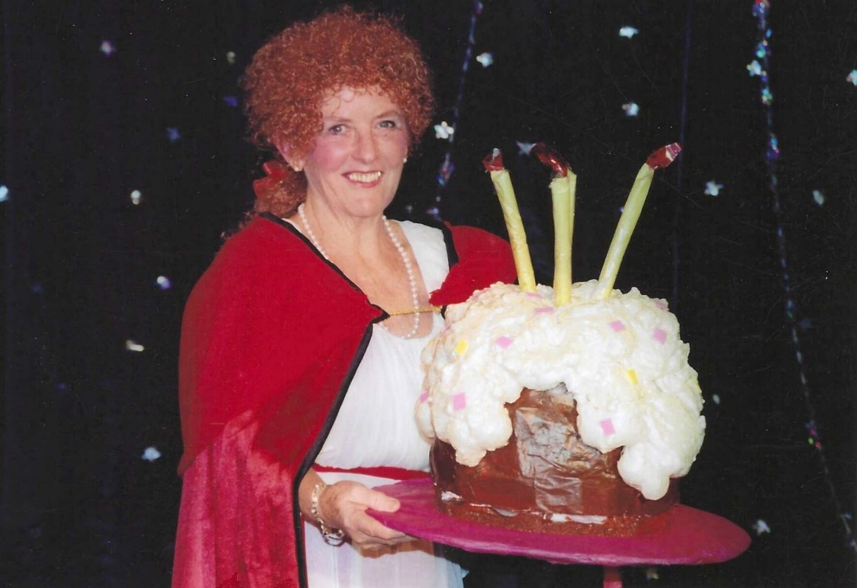
2005 Red Riding Hood

Janet Cattanach

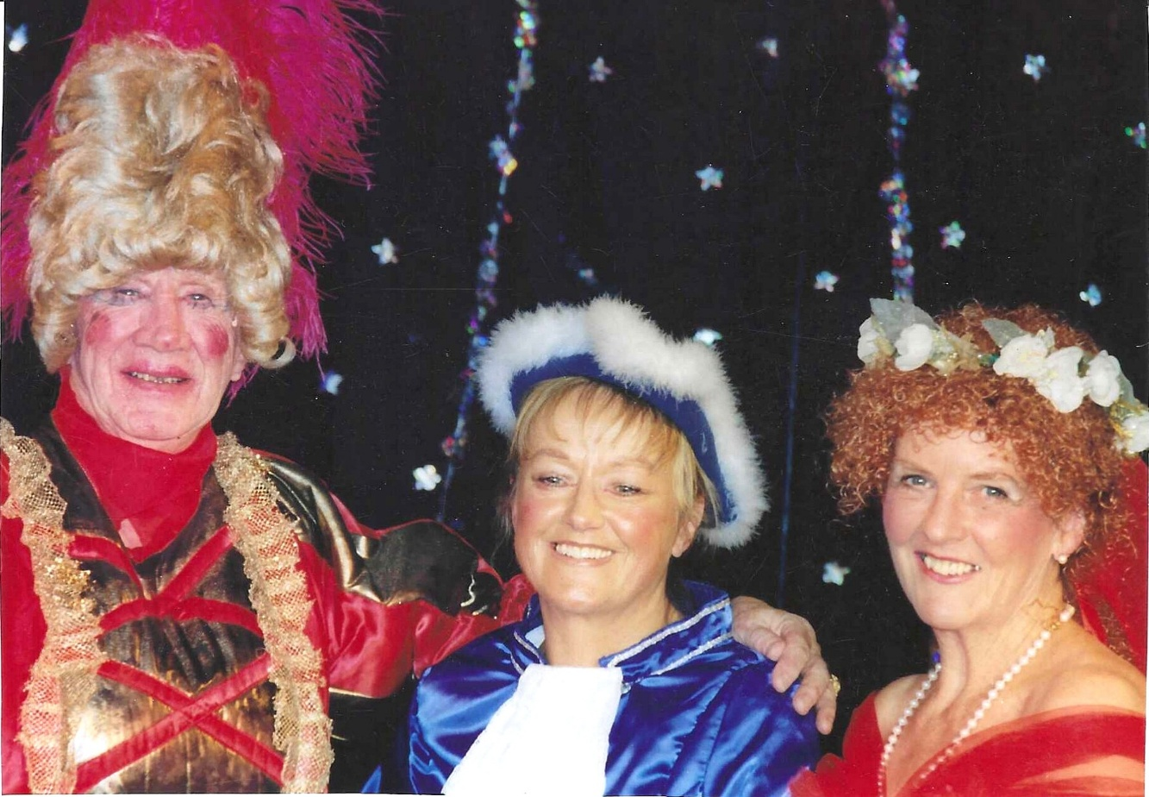

Mike Steward; Janet Martin & Janet Cattanach

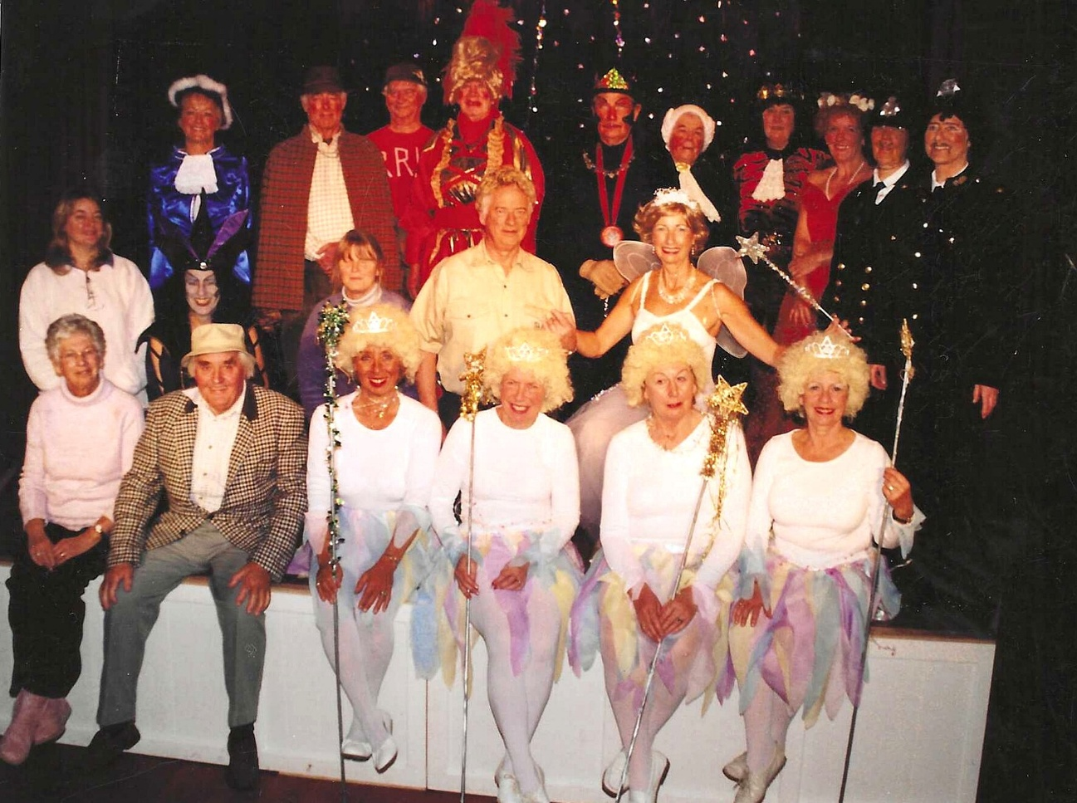

Front Row ?; Ron Carr?; Trish Davies; Christine Wilson; Alison Forster; Pam Carter
Middle row far right Brend Merritt
Back row: Janet Martin; ?;?; Mike Steward; Denis Shore;?; Jean Ellis; Janet Cattanach; Yvette Steward; Joan Thompson

