Dartmoor Prison Museum
6/09/2024
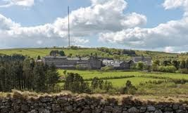
Five of us set off for Princetown, taking a leisurely route across the moors. It was a lovely day with blue skies. The cloud was low in the valley’s, allowing the hilltops to poke through like mountains.

Princetown
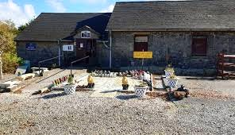

Museum

Once we had arrived and checked in, we were faced with centuries of history.
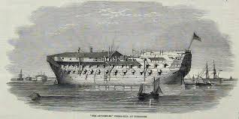
From 1803 to 1815 Britain was at war with Napoleonic France and many thousands of prisoners were taken. To help accommodate them redundant warships were commissioned as floating prisons known as ‘the hulks’. Several hulks were at anchor at Plymouth among other places and conditions were so bad with poor sanitary arrangements, little exercise, lack of fresh air and a poor diet, the death rate rose to an unacceptable level and a prison on land was decided upon. Princetown on Dartmoor was considered a suitable location and that is how Dartmoor Prison came to be built.
The first prisons were constructed from stones obtained by breaking up the boulders lying around the site supplemented by dressed stone from nearby Herne Hole quarry.
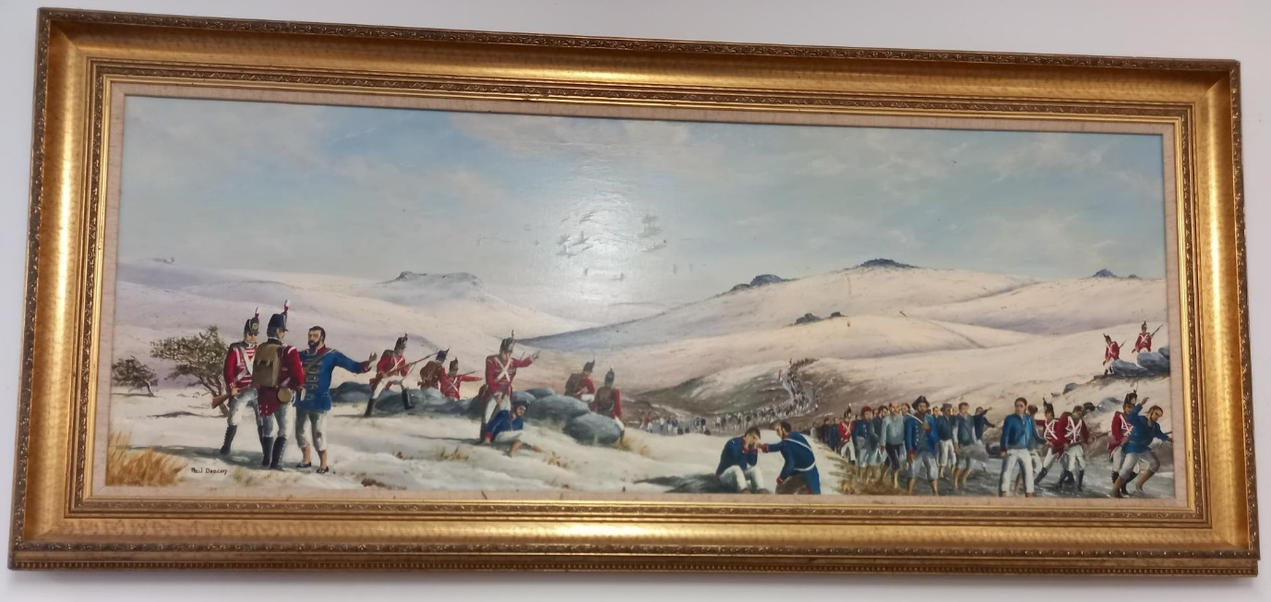
The first prisoners arrived in May 1809 and the prison was full by the end of the year. It soon became overcrowded and remained so. In April 1813 American prisoners began arriving and the overcrowding became worse. Outbreaks of diseases – pneumonia, typhoid, smallpox, etc. killed more than 11,000 Frenchmen and 271 Americans. Their graveyards and memorials are at the rear of the prison. The wars finally ended, and the prisoners were repatriated, the last of them leaving in early 1816. The prison then closed until opening again as a penal establishment for criminals in 1850.
The first convicts were transferred mainly from the convict prison ships on the Thames and at Gosport. Most of them were invalids, imbeciles, one armed and one-legged men, others with chest complaints who it was thought would benefit from the fresh Dartmoor air. Cast-iron cells arranged back-to-back were constructed by artisan convicts under the supervision of contractors. These were superseded by stone cells before finally the older prisons were demolished and replaced by the buildings we see today, also built by convicts under artisan warders’ supervision. They were occupied by the worst criminals in the land.
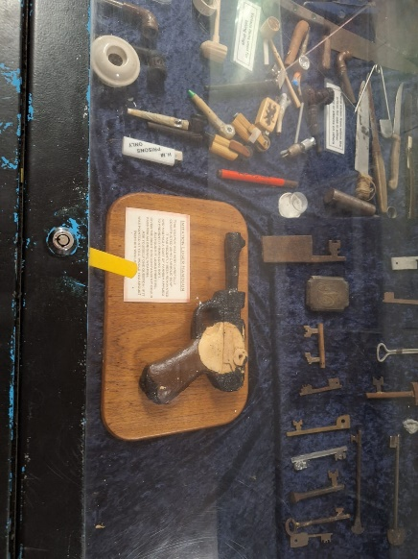
On Sunday 24th January 1932 during morning exercise around fifty men broke ranks armed with home - made coshes and a riot began. They soon had control of the yards and associated buildings, attacking anyone in their way and the outnumbered officers retreated to safety. The Administration block was set on fire and irreplaceable prison records lost. Police from Plymouth were rushed to Dartmoor supported by soldiers from Crownhill barracks. The trouble was quickly quelled, and the ringleaders later tried and convicted. Ropes, grapnels etc. were found afterwards and confirmed suspicions the riot was a cover for an (unsuccessful) escape plan.
Prisoners still make weapons; such as this gun made from carbolic soap (If it was pointed at you, would you argue?), and other weapons made from razor lades and glass
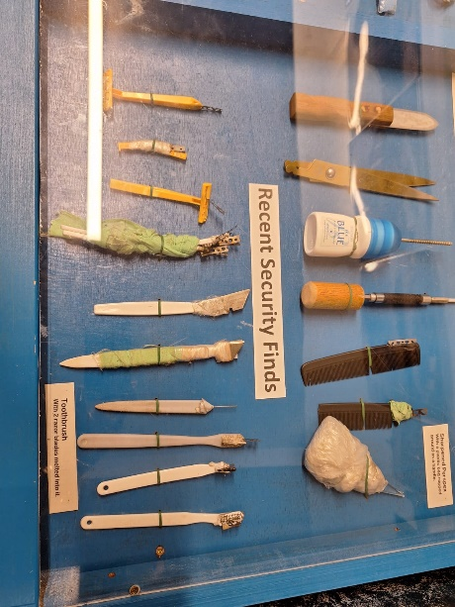
The bad old days are gone – no more quarrying, digging the barren moorland by hand under armed guards, and brutal punishments have been abolished. Dartmoor now holds low category prisoners who are encouraged to undertake training programmes to help them on their release. Skilled advisors hold discussion sessions to make them aware of how unacceptable their crimes are. Single cell accommodation still applies, and they eat in their cells. Showers and telephone communication with their families are freely available. They are not here to be punished; their punishment is loss of liberty tempered by help towards reform and rehabilitation.
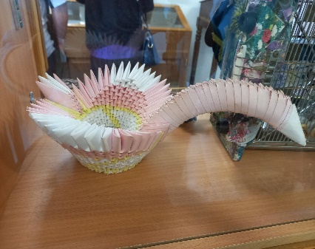
Part of the museum was closed due to Radon gas. This included the toilets, but 2 Portaloo’s had been provided in the courtyard. Definitely not for those with reduced mobility. They did pong!
There was also lots of exhibits of craft work done by inmates, from carved bone work, paintings, matchstick models, and papercraft.
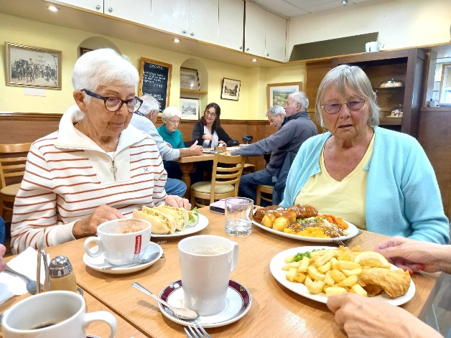
Our next stop was the “Old Police Station Café” for lunch.
We all agreed the portions were huge. However, the food was hot and tasty. (The fish and chips were small portions – They did a larger one - I still couldn’t manage it all.)
Our journey back was a reversal of the outgoing one across the moor to Yelverton, then turning east and cutting across the moor to Plympton. It was a lovey ride, dodging the plentiful sheep and some banded cows. There weren’t many ponies though.
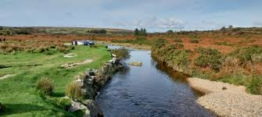
Cadover Bridge

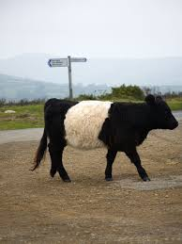

Dartmoor Belted Galloway Cow

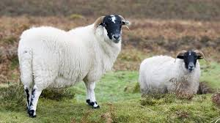

Black faced sheep

