Whodunit?
On the 8^{th of} June, 6 of us; Gill Tune, Jackie Ross, Stella Gullen, Marcia Webster, her husband Douglas, and myself (Lesley Dempsey) attended an event put on by Brixton & Yealmpton WI.
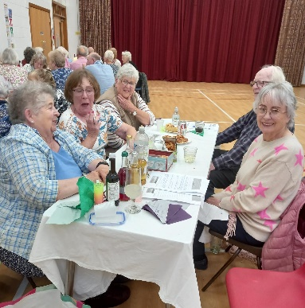
It was a bring your own supper event, which we did; mainly salads, with a few extras, - Spring rolls, cheese straws, quiche, pizza, chicken skewers and to complete it all some of Stella’s delicious Macarons.
The “play” was put on by the Moonstone Theatre Company.
It was narrated by a man playing the part of a researcher, looking into the events of a death; nay, - murder, of Emily; a suffragist, for a book her was writing.
Emily’s siter Eleanor, was a suffragette and a follower of Mrs Pankhurst.
Eleanor didn’t like Emily, who had a daughter, Charlotte. Eleanor considered Emily to be a milk sop in comparison the dashing daring do of Mrs Pankhurst and her Suffragettes.
Emily was also a police informer, and kept the force appraised of proposed demonstrations by the Suffragettes.
Eleanor was aware of this, and sometimes used Emily’s name to get out of trouble with the police; - well she had been arrested several times and force fed twice!
Charlotte, Emilys daughter, had in the past, had a passionate affaire with a police man. Emily wouldn’t allow them to marry, but the relationship culminated in the birth of a daughter Anne. (unbeknown to the Police man)
The Policeman had been on the receiving end of some roof tiles thrown by Eleanor, which broke his arm and injured his spine, which meant he was discharged from the force, and he now worked on the doors at a local cinema.
Anne had been fostered out at the insistence of her grandmother, Emily.
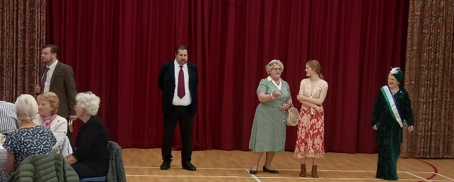
Charlotte, Emilys daughter was working as a governess/nanny to a family.
When she found out where Anne was, she went to reclaim her. Poor Anne was by then only 9 years old.
However, when Emily found out, she threatened to tell Charlottes employer, that Charlotte was an unmarried mother.
Who killed Emily?
We got it right, as did many other tables, but we did have our doubts along the way.
It was an entertaining evening, which all thoroughly enjoyed.

