2004 Operation Sunshine
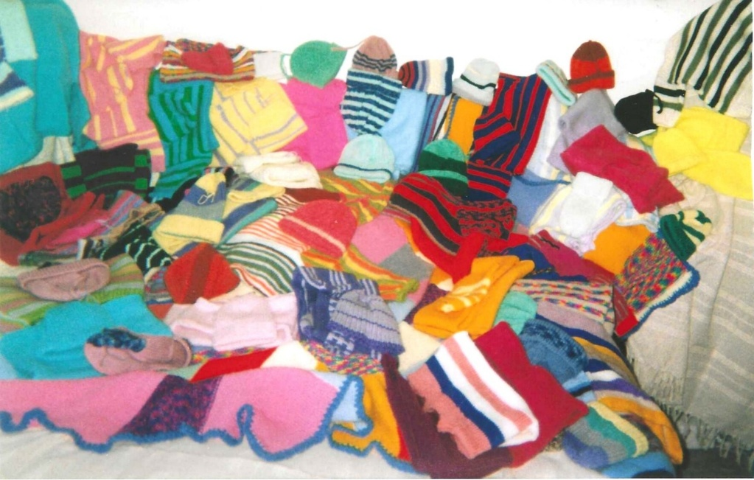

Based in Folkestone with a branch in Tavistock, operation Sunshine collected clothes, household goods, bikes, sewing machines, for needy families in East Africa. Either 2nd hand or handmade. (Otherwise they had to pay import duty). We made dresses - from old duvets or valances, Knitted jumpers, etc.
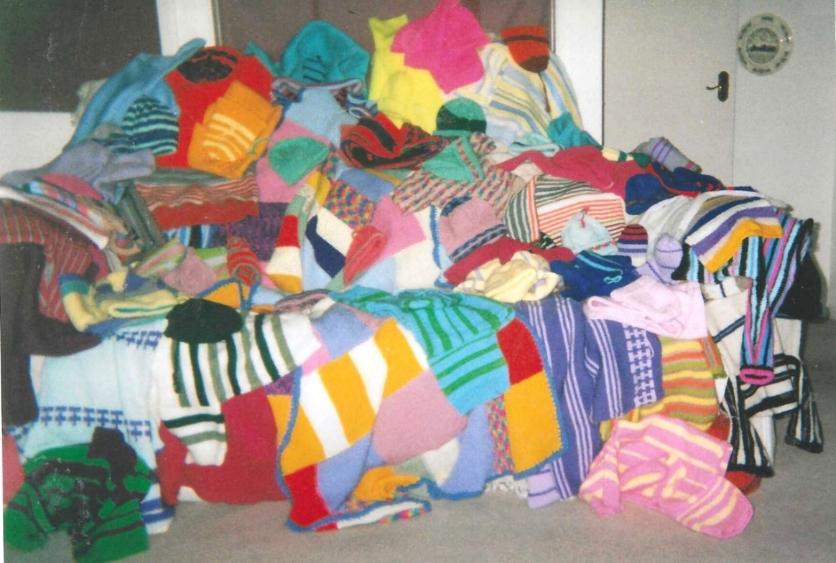
They used to send out a container load at a time. The Tavistock branch has closed down.

