WI Presidents Tea Party 2024

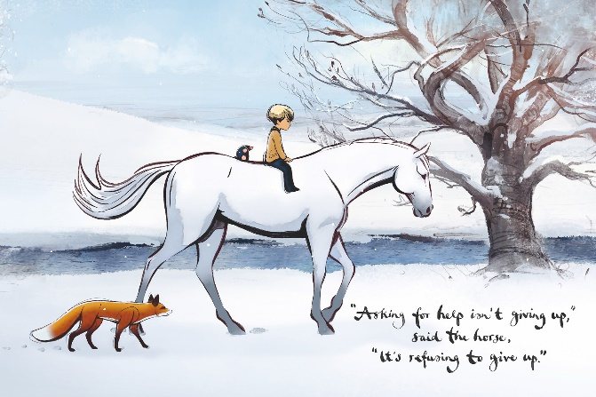
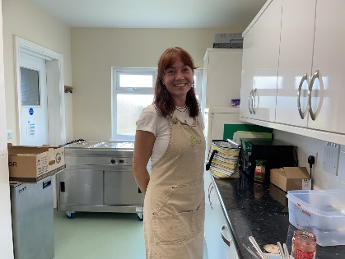
The WI celebrated their new President, Nan Lowden, in August with a tea, with scones, cake & Pimms. Nan wanted to do something different and give back to our members, rather than have them make the cakes and sandwiches.

The café on the green made the scones, and Nan had a company make the delicious cakes.
There was far too much food, but it wasn’t wasted.

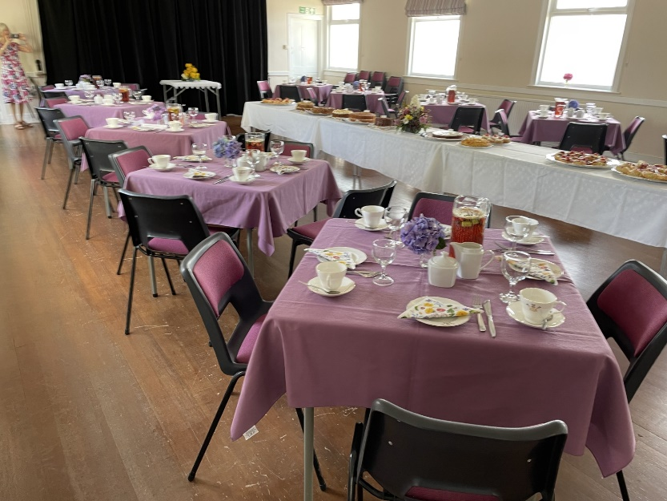
The tables were set with our best tea services.
The tables adorned with hydrangea blooms, and jugs of potent Pimms on the tables.

Nan had found some pretty napkins with wild flowers on

Now all we needed were Nan’s guests, our lovely WI members.

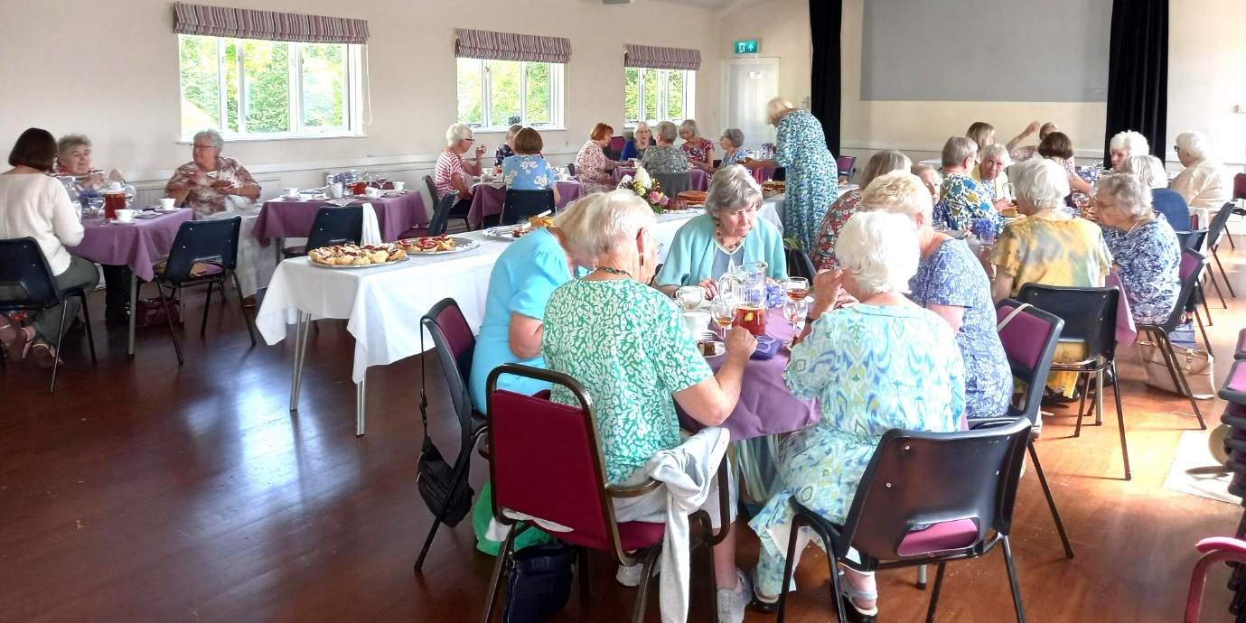
During tea, we were given a challenging quiz on flora and fauna

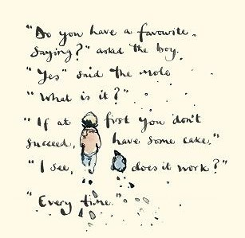
Nan also showed us a film, “The Boy, the Mole, the Fox and the Horse”; based on a book by Charlie Mackesy. It was a film about friendship, love, support and home, which Nan felt encompassed everything about our community and the WI.

Everyone went quiet, and even though some people had seen it before, it was still moving.

We had a group photo call afterwards and Lesley asked everyone to say “cake”! It seemed fitting as it was one of the sayings in the film, and we had just eaten loads of it.
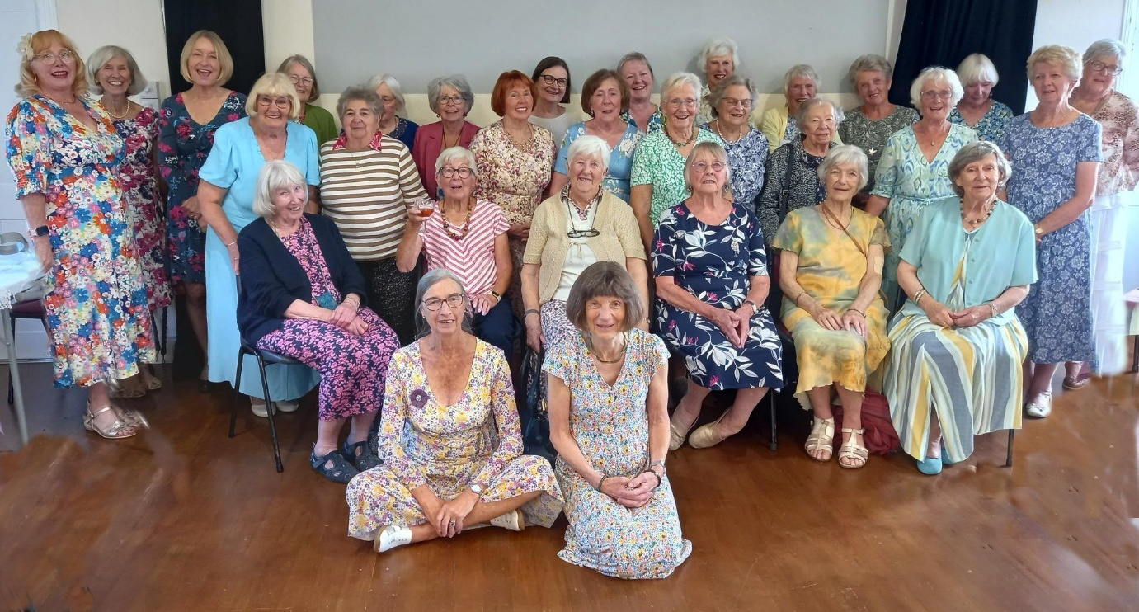
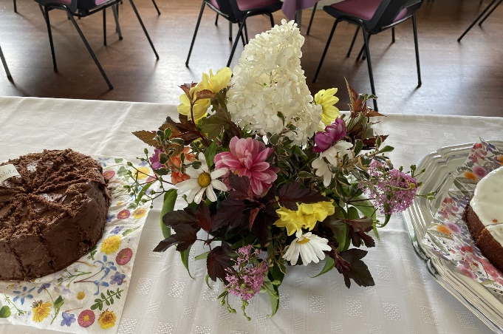
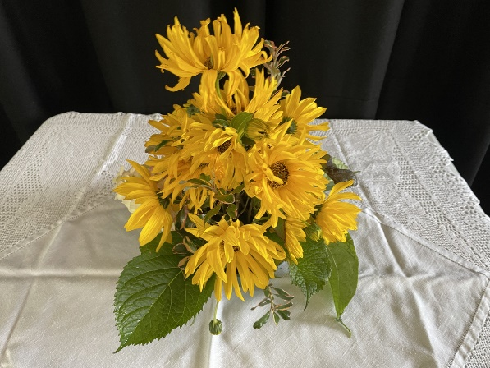
Members listed below on next page.

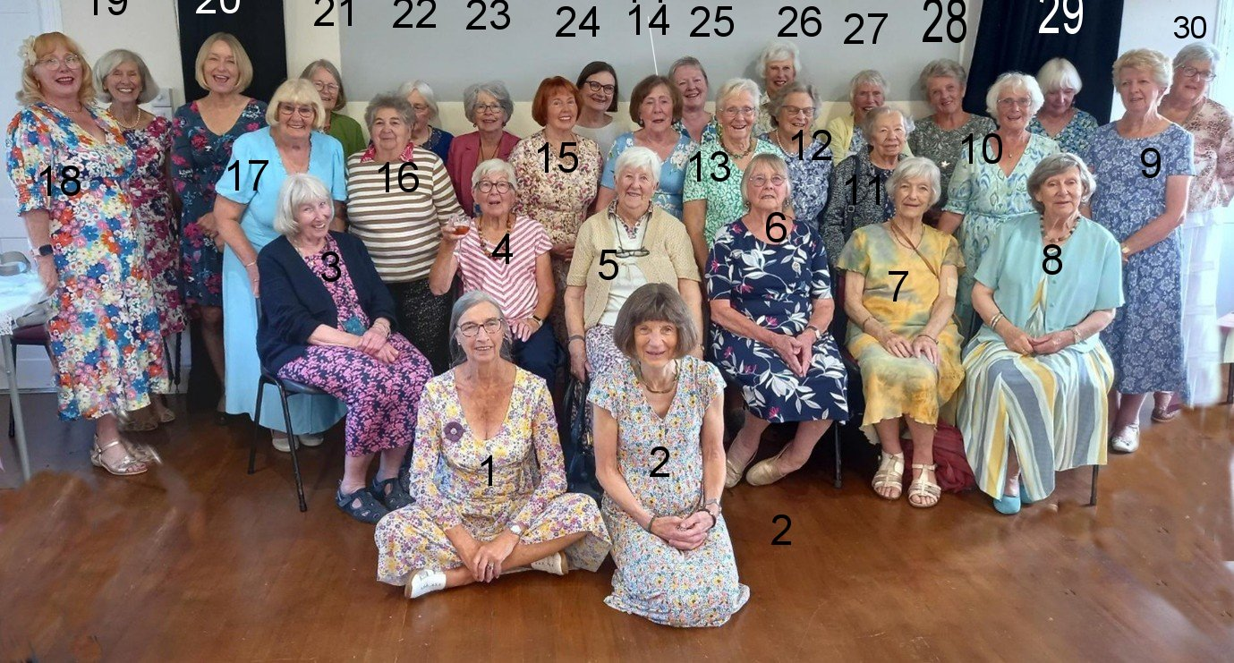

1Brenda Merritt
2 Cathy Matthews
3 Judy Iles
4 Shirley Pegg
5 Jill Johnson
6 Nan Lowden
7 Nikki McDougal
8 Jane Barnett
9 Jill Alexander
10 Joyce Stickley
Photo taken by

11 Susan Muir
12 Enid Whiteman
13 Angela MacPherson
14 Gill Tune
15 Emma Parker
16 Stella Gullen
17 Jean Ellis
18 Carrie Dixon
19 Margaret Pritchard
20 Pat Middleton
Lesley Dempsey

21 Jeanne Venning
22 Rosemary Furzeland
23 Pam Carter
24 Diana Little
25 Janet Lawrence
26 Pam Newman
27 Christine Wilson
28 Janet Cattanach
29 Barbara Geddes
30 Jackie Ross

