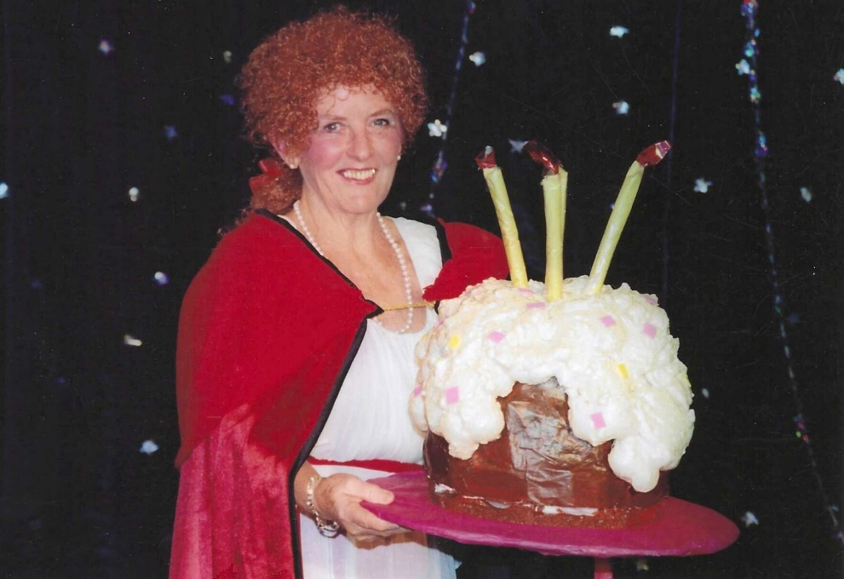
2005 Red Riding Hood

Janet Cattanach

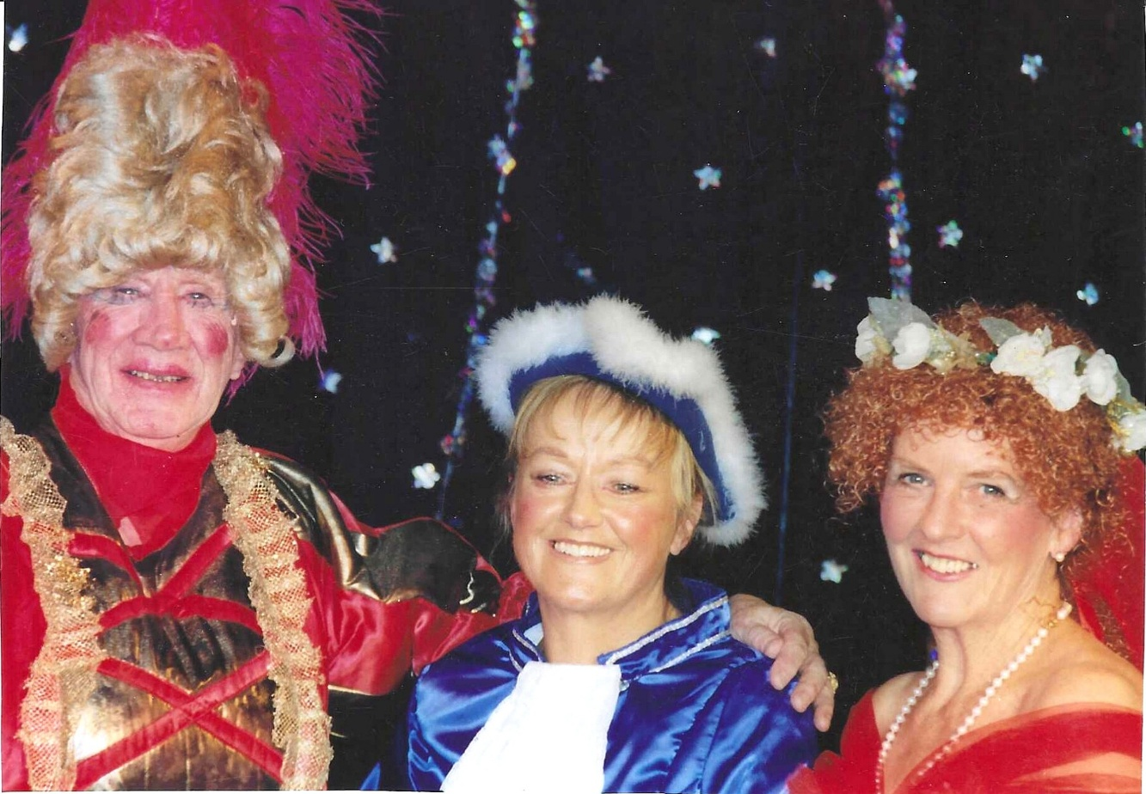

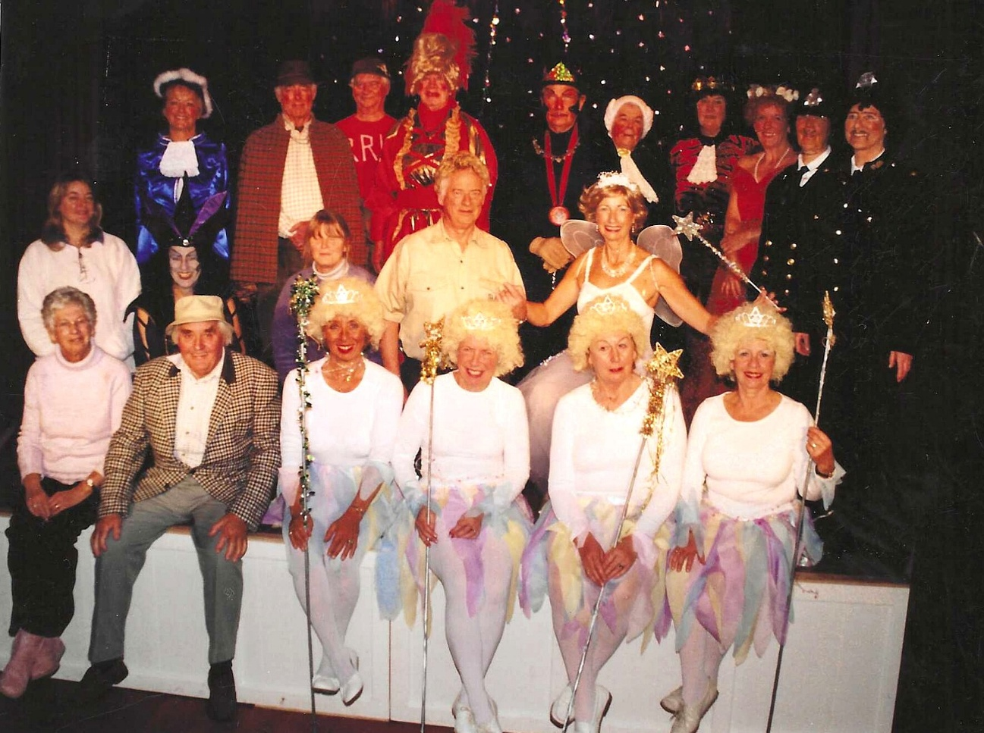

Front Row 3rd L Trish Davies; Christine Wilson;?; Pam Carter
Middle row far right Brend Merritt
Back row:

