A Visit to the Construction site of Eden Project
November 1999
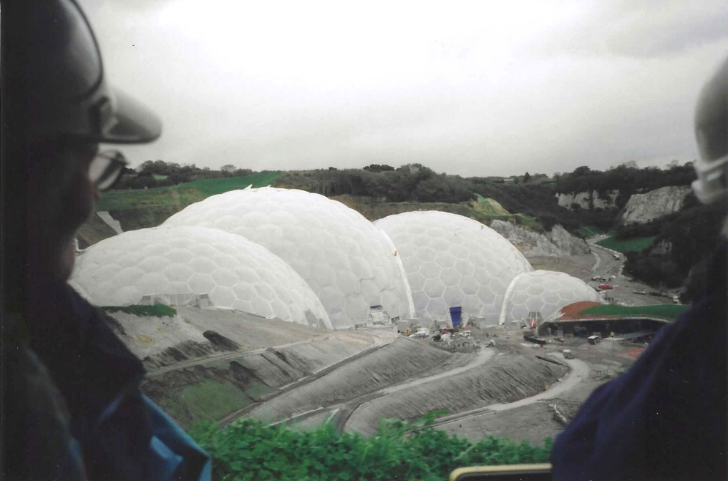

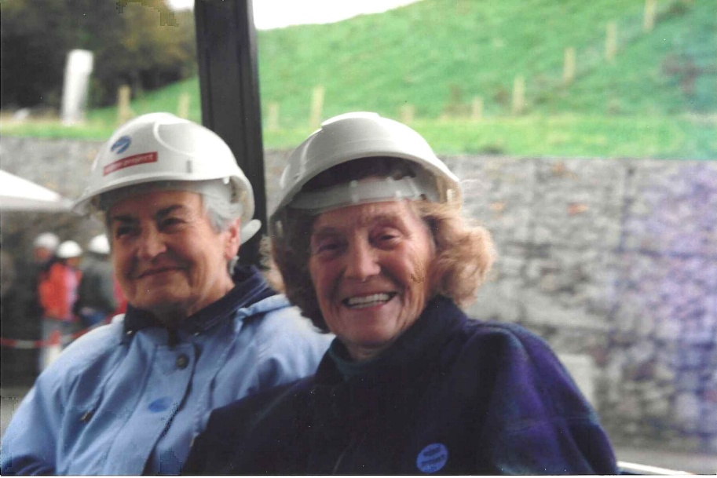

Aileen Stackhouse (left ) and Sue Sheriff

