St Francis Play Group
The WI donated the Tricycles to the play group.
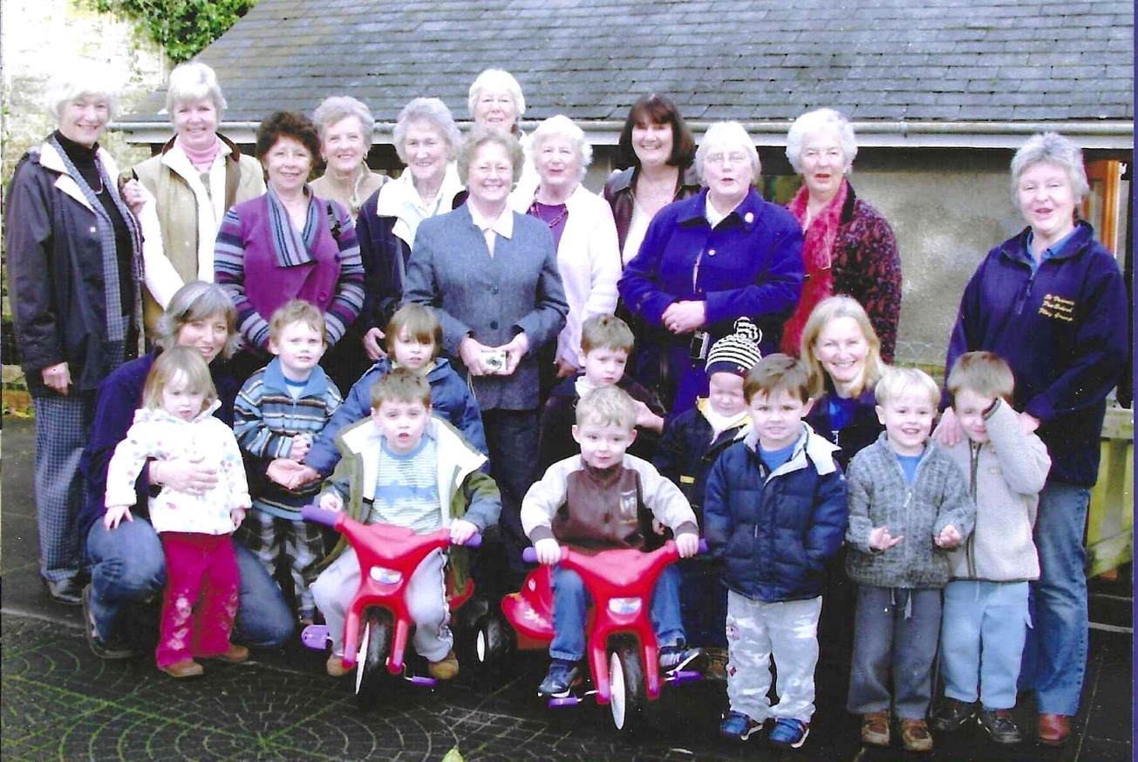
L-R Nikki McDougal; ? Pam Carter; Janet Cattanach; Betty Christie; Joan Westall; behind her is?; Sylvia Hunt; Jean Ellis; Rosemary Furzeland; ?