2006 1st April Committee

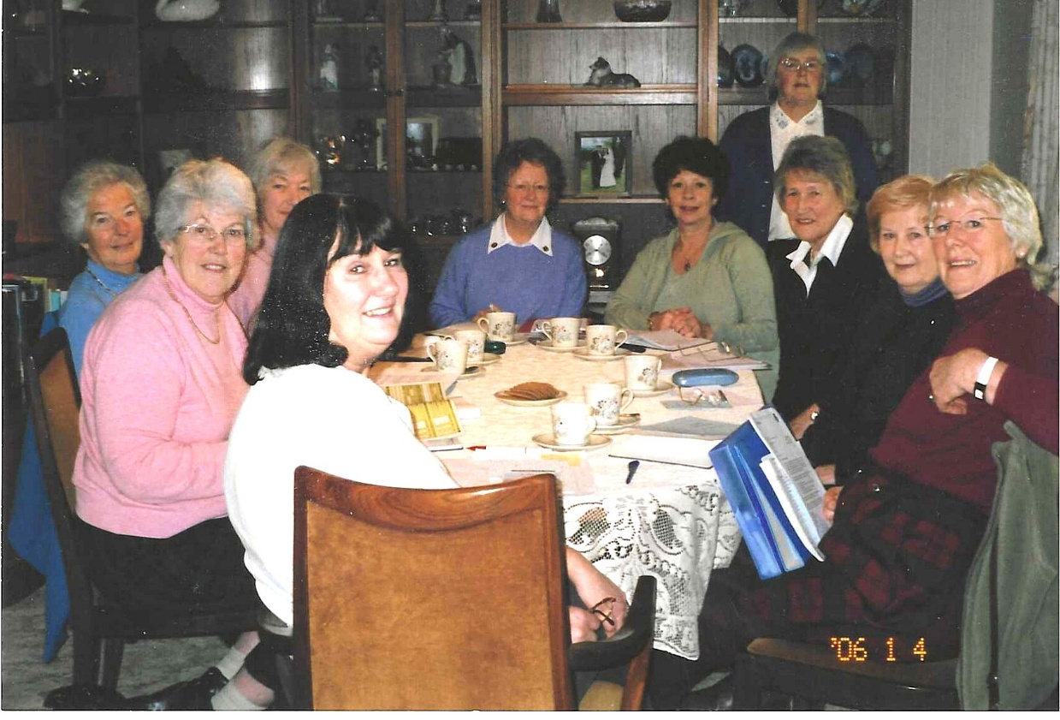

R-L : Ann Crawford; Sylvia Hunt; Rosemary Furzeland standing behind Betty Christie; Pam Carter; Joan Westall; Nicki McDougal; Joan Miller; Sheila Painton; Jean Ellis

