2008 Pam Allen’s Quilting lesson with Craft Group
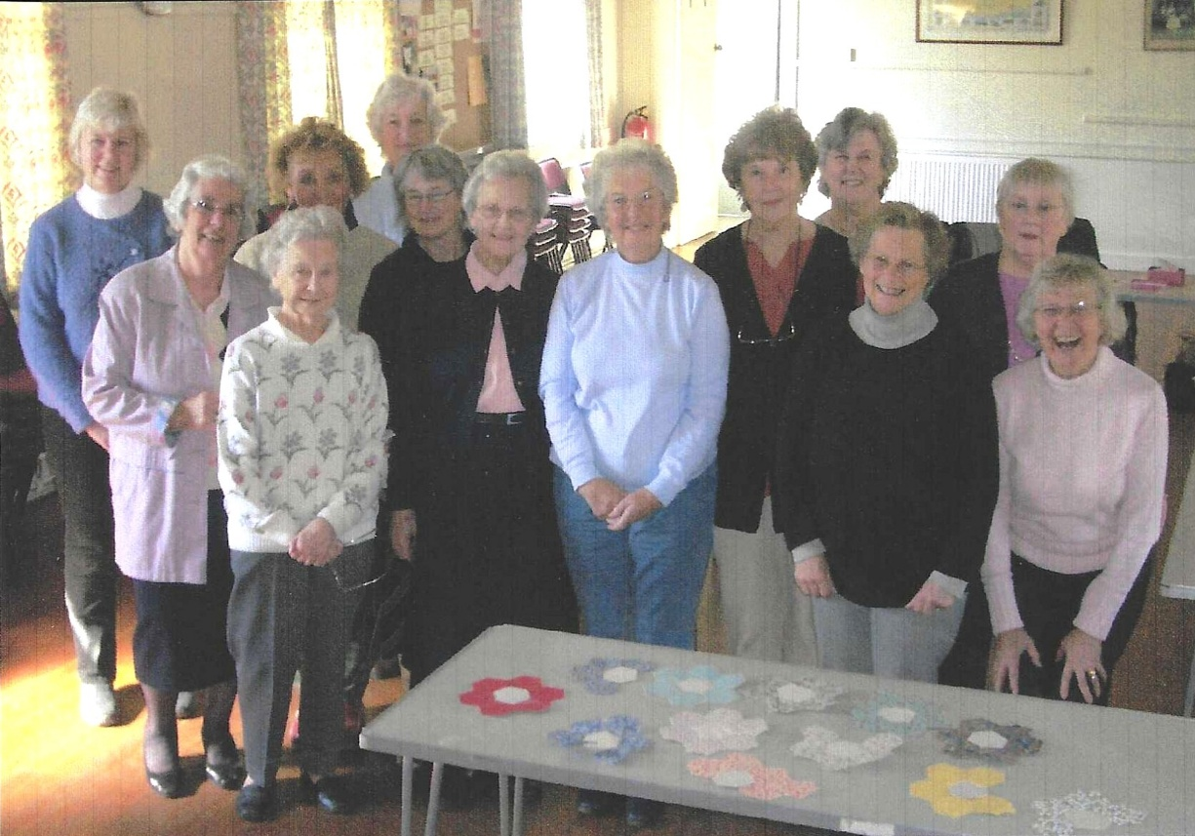

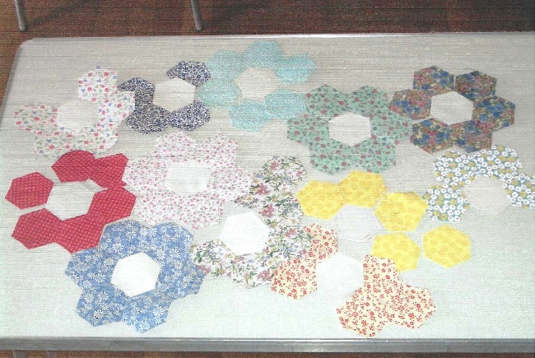

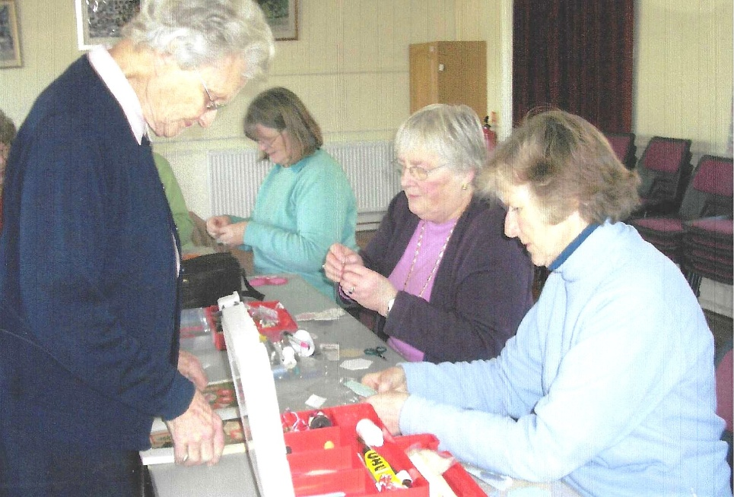
L-R: Pam Allen?;
Jeanne Venning;
Rosemary Furzeland;
Yvette Steward

