2002 Wendy’s farewell Party (committee)

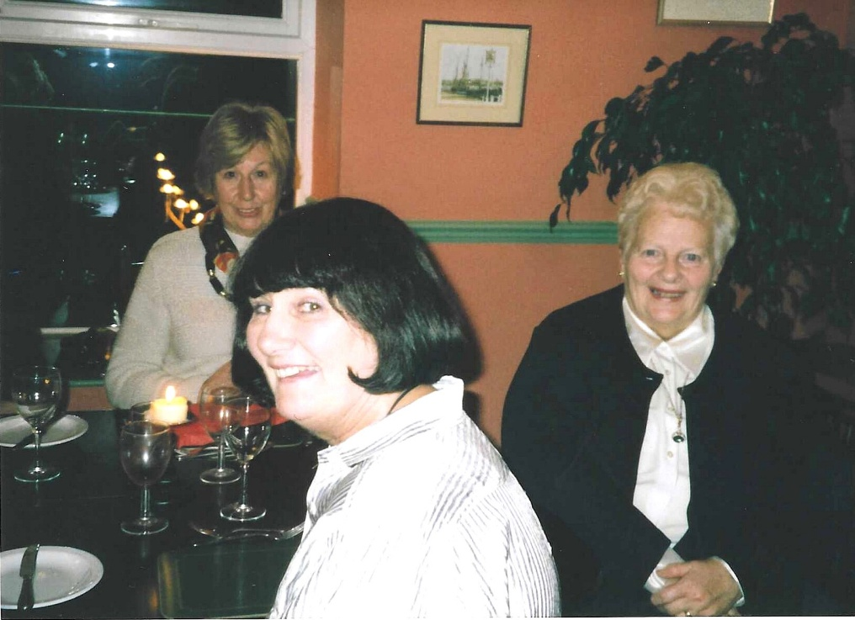

Foreground : Jean Ellis;
Wendy Kennedy (R)
Ann Evans (background)

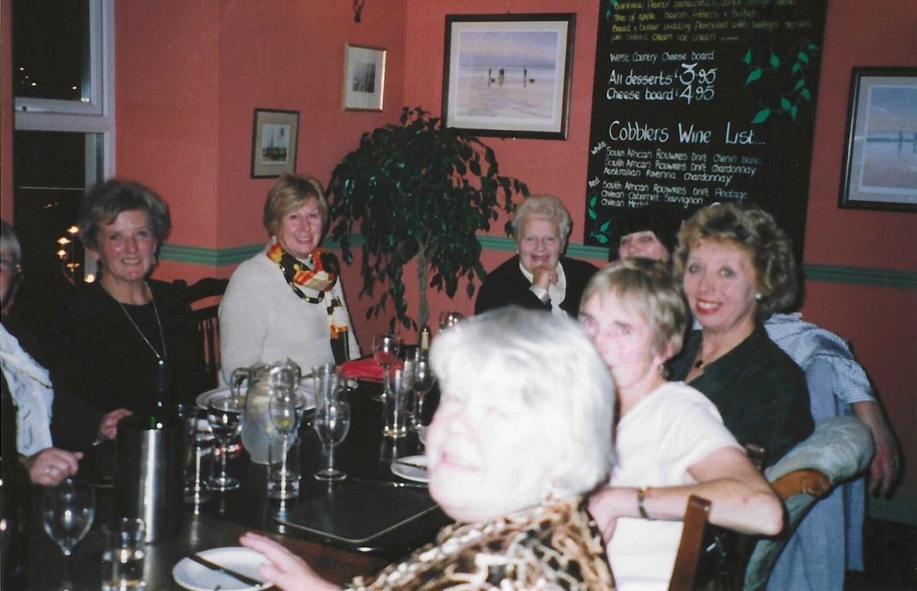

(L-R) Janet Cattanach; Ann Evans; Wendy Kennedy; Jean Ellis; Trish Davies; Pat Green; & Alison Forster

