2011 Fashion Show October
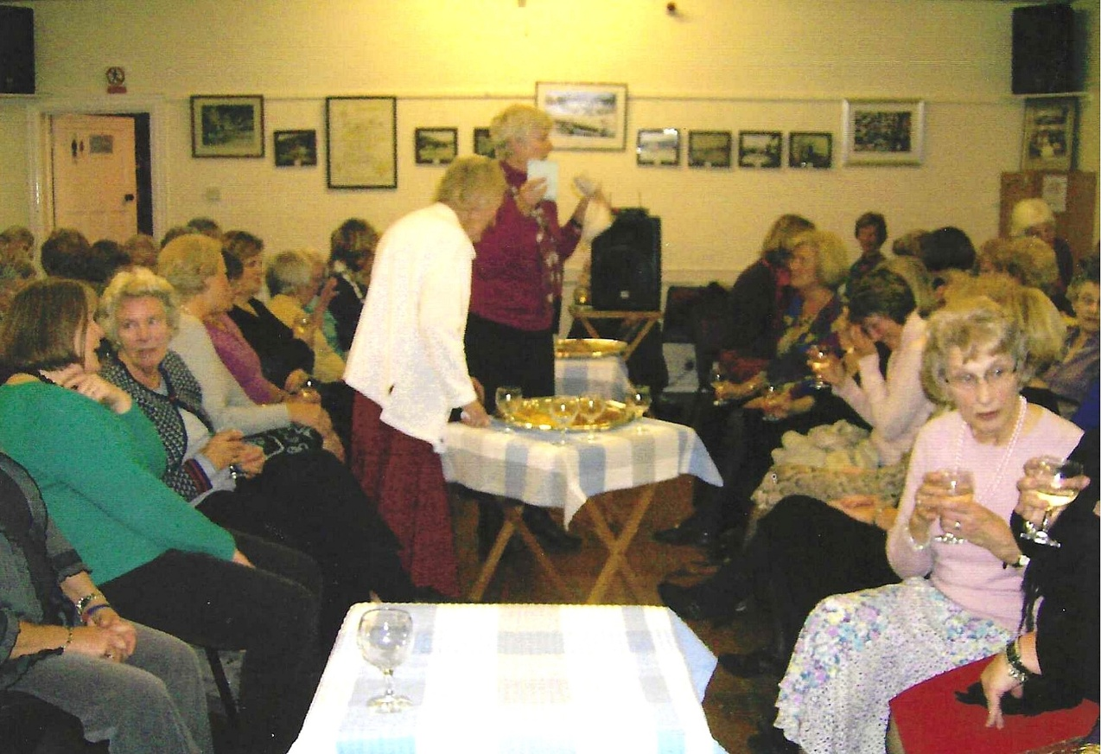
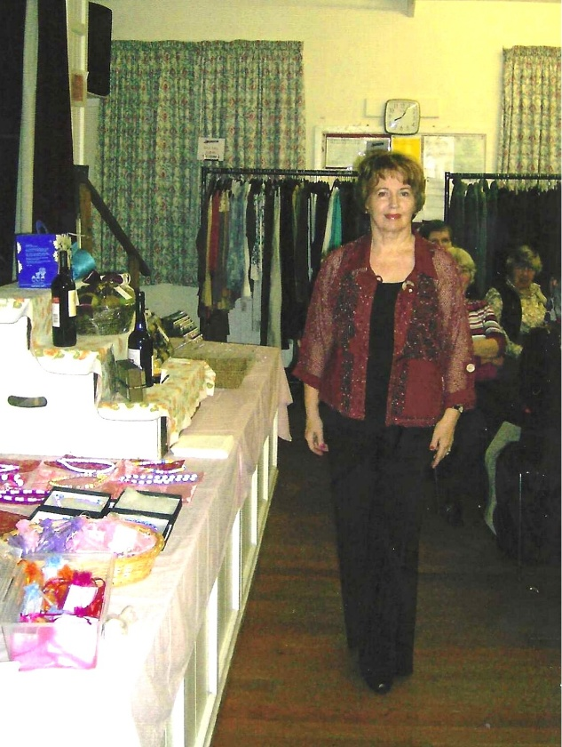
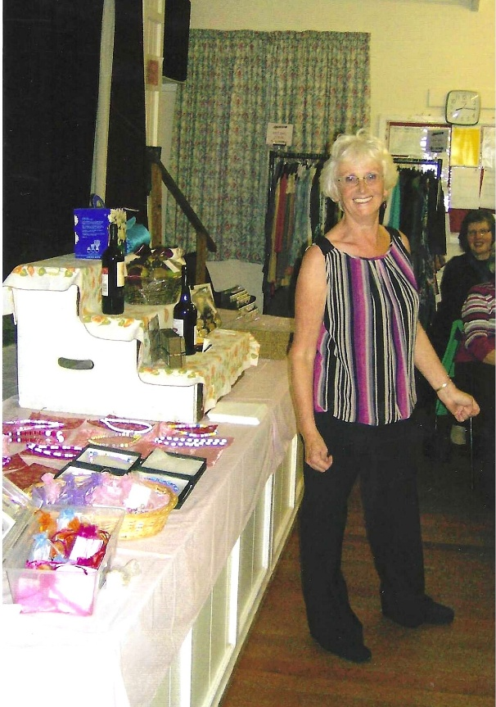
Joyce Stickley Emma Parker

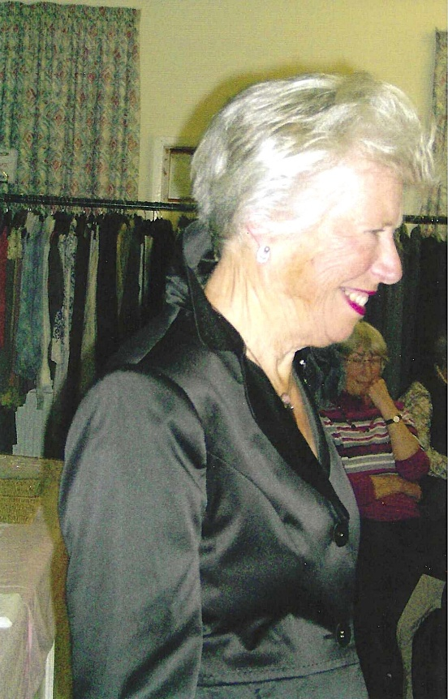
Christine Wilson

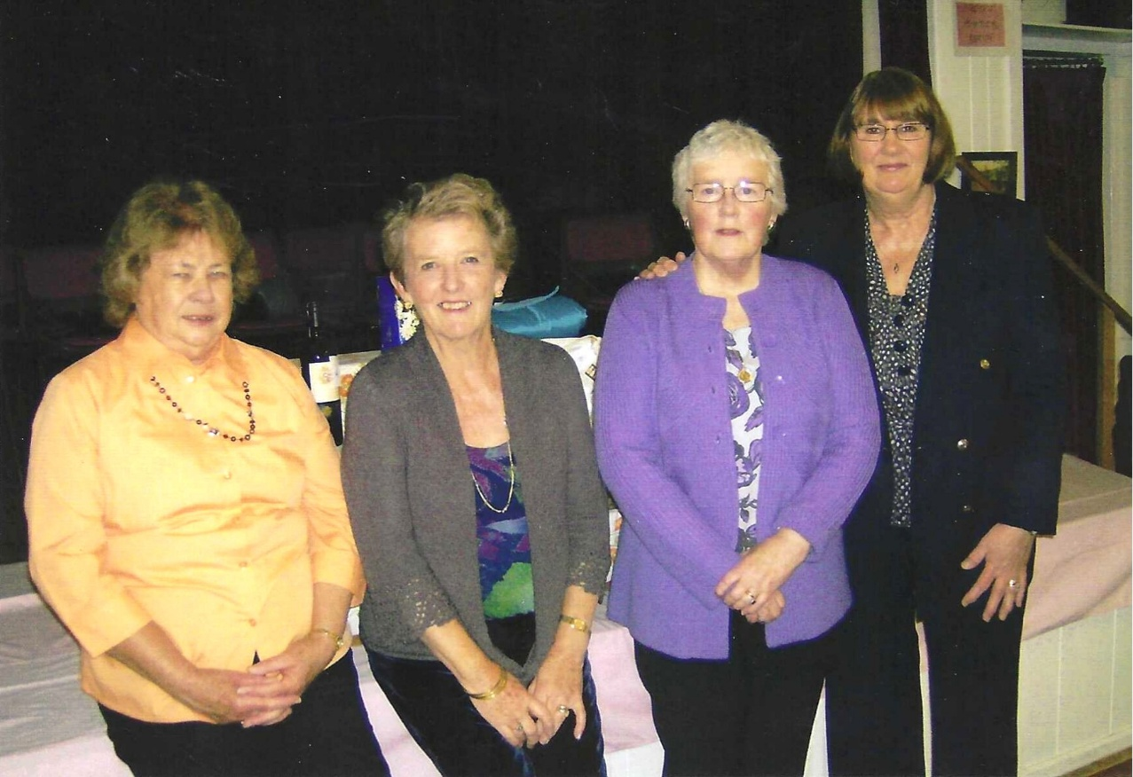

L-R: Marilyn Sherlock; ; Janet Cattanach; Rosemary Furzeland; Jean Ellis

