2011 Yealmpton Show entry
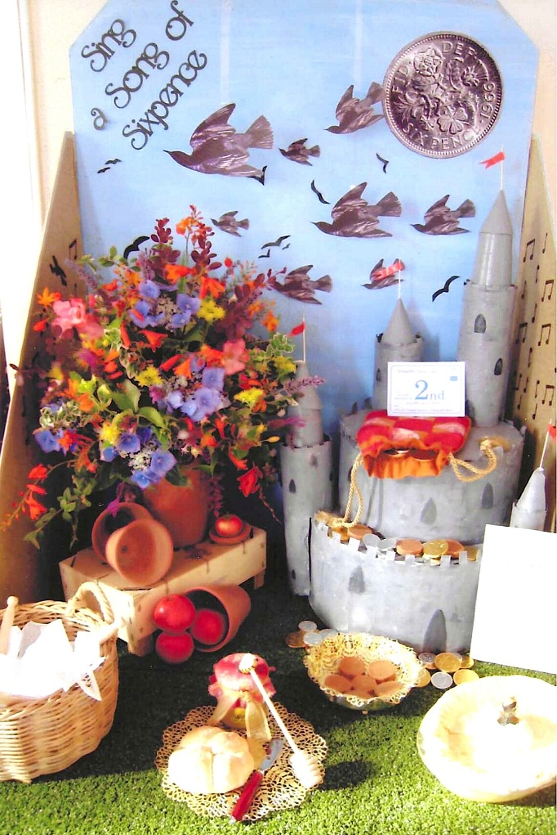

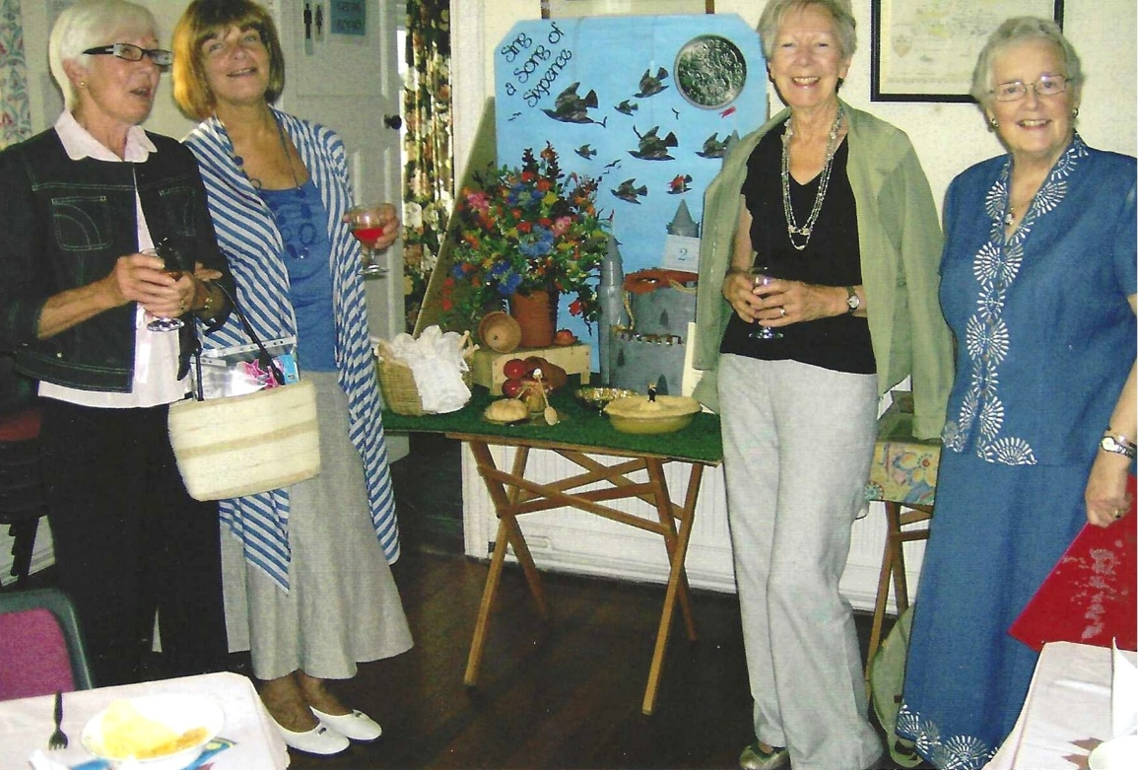

L-R ?;??; Rosemary Furzeland

