2014 Pat Fletchers 85th Birthday Party

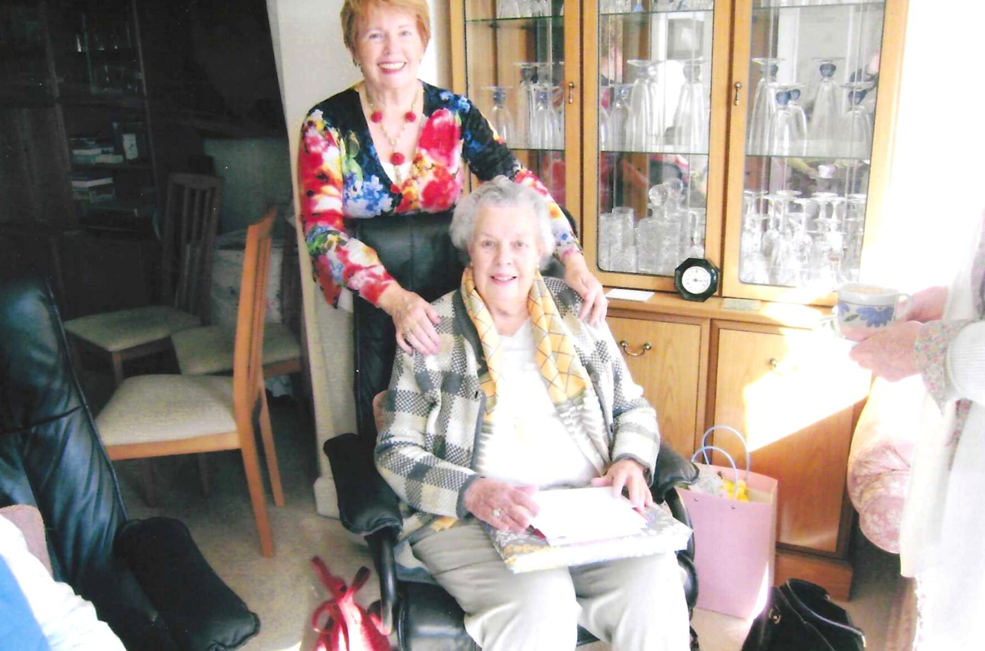
Pat Fletcher and Emma Parker

