2014 November 28th Murder Mystery
The Captains Dinner aboard the QE2.5
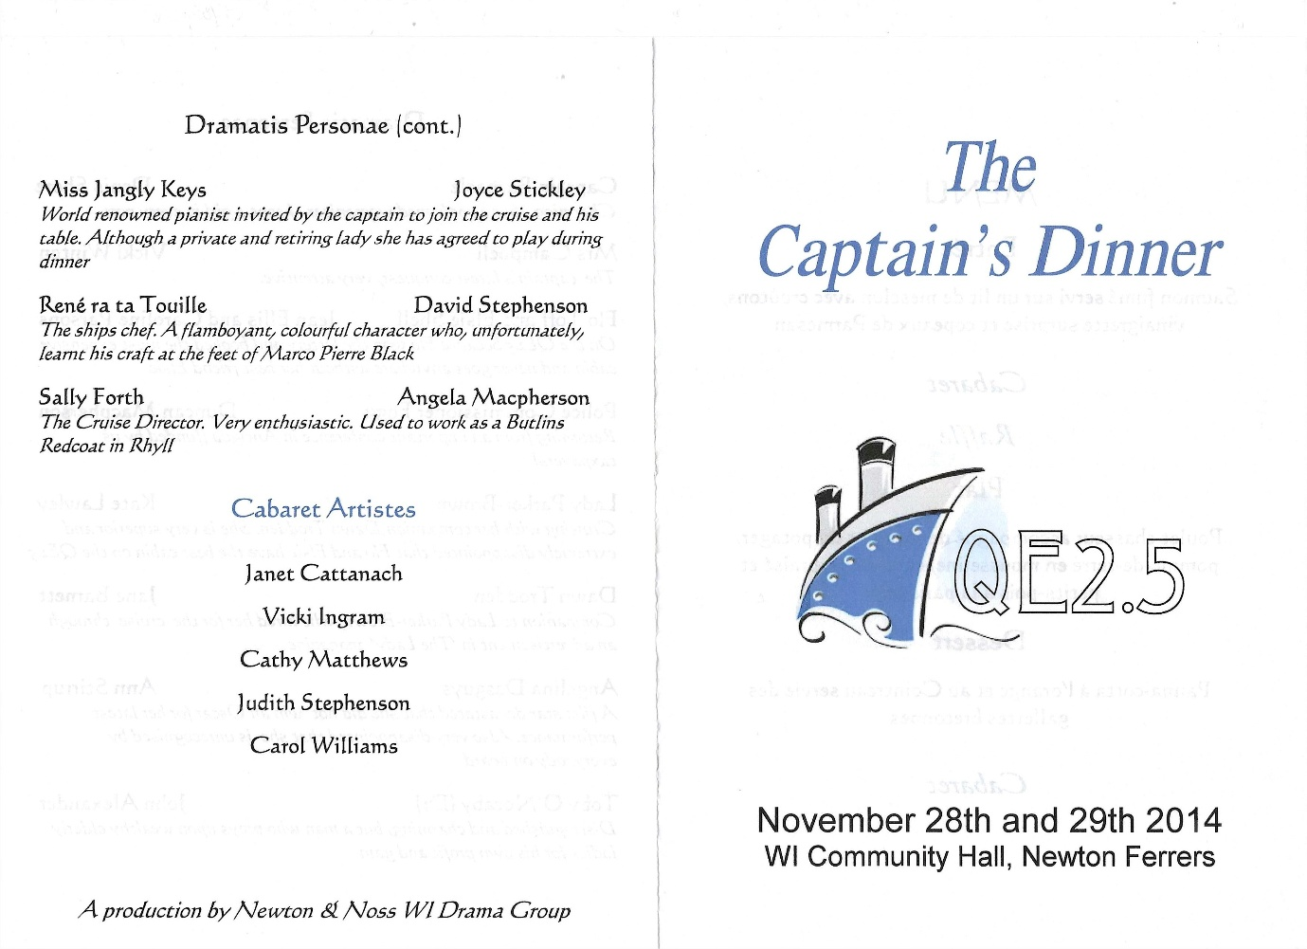
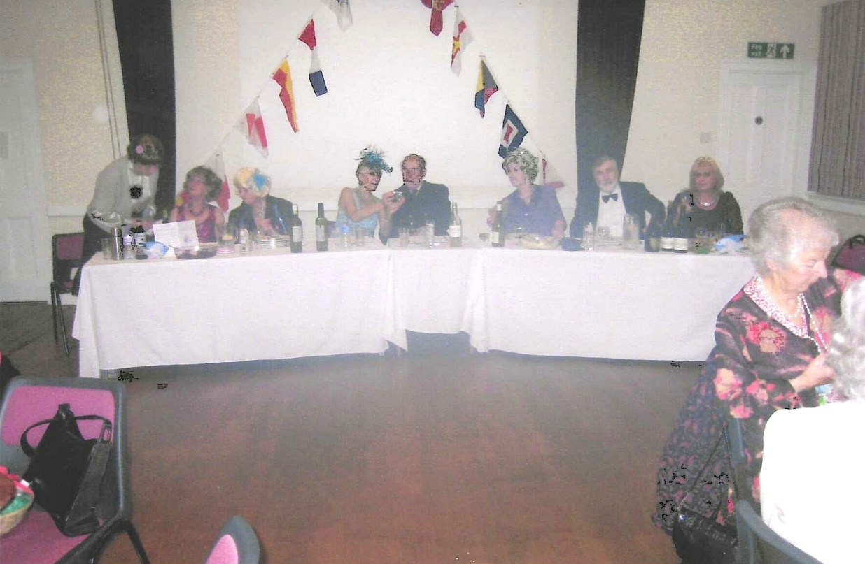
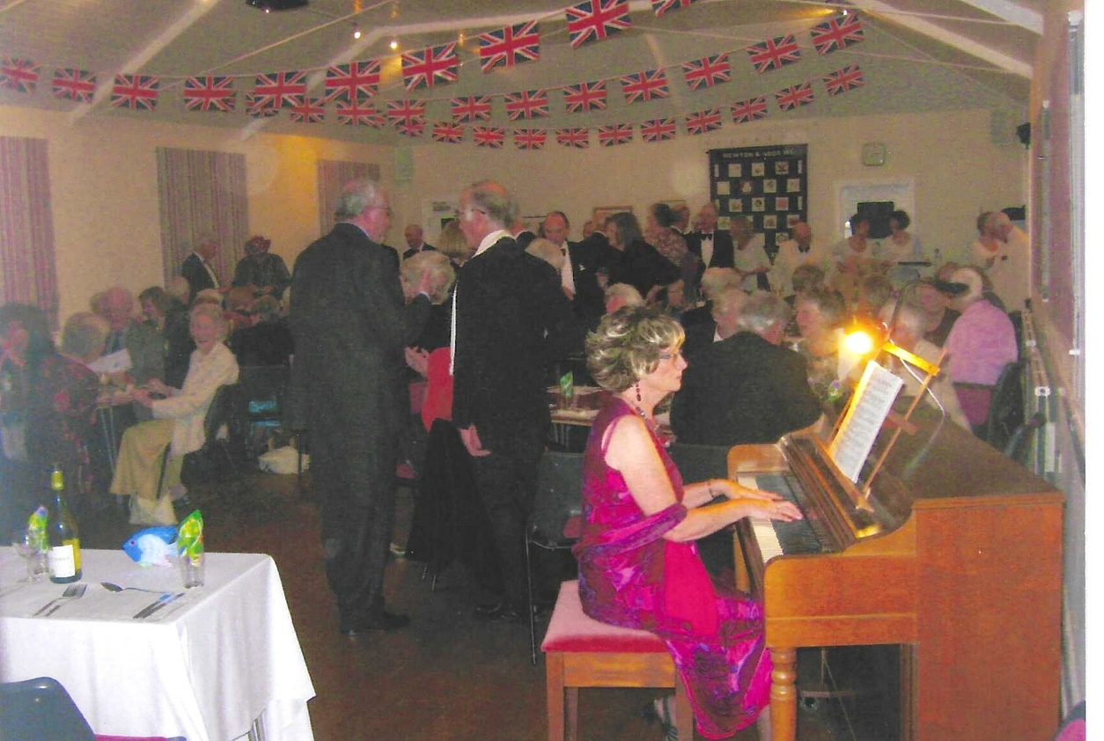
Miss Jangley Keys (Joyce Strickley)

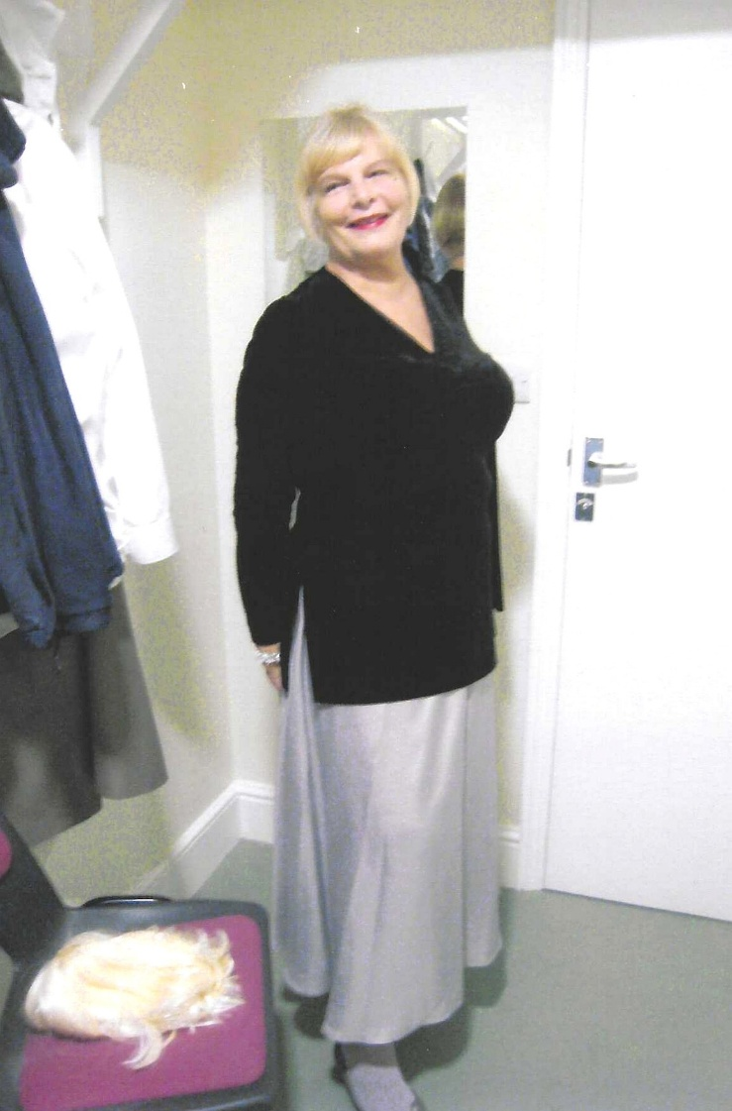

The Cabaret Singer (Carol Williams)

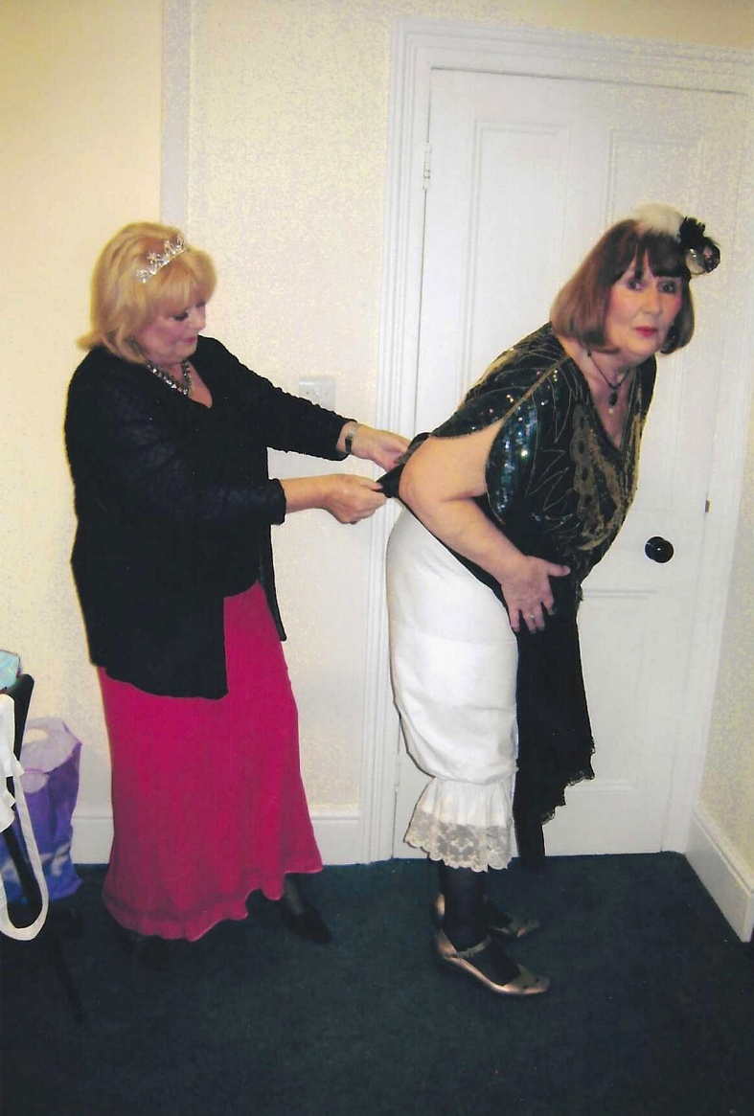

Flo Toff ( Jean Ellis) & Elsie Snell (Caroline Parsons)

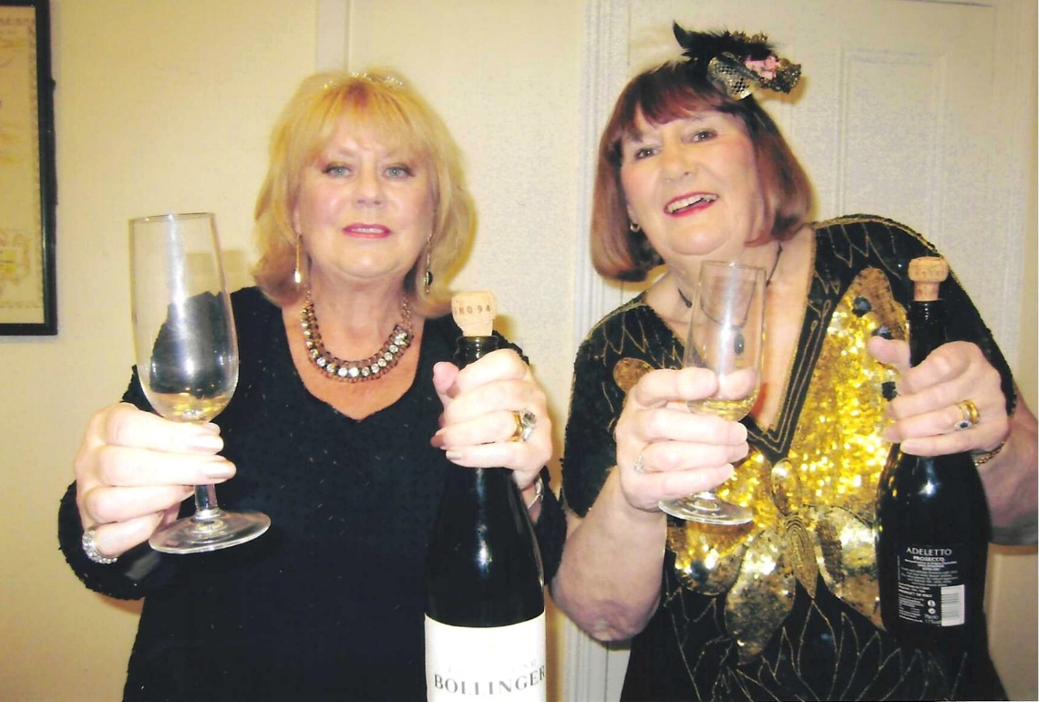

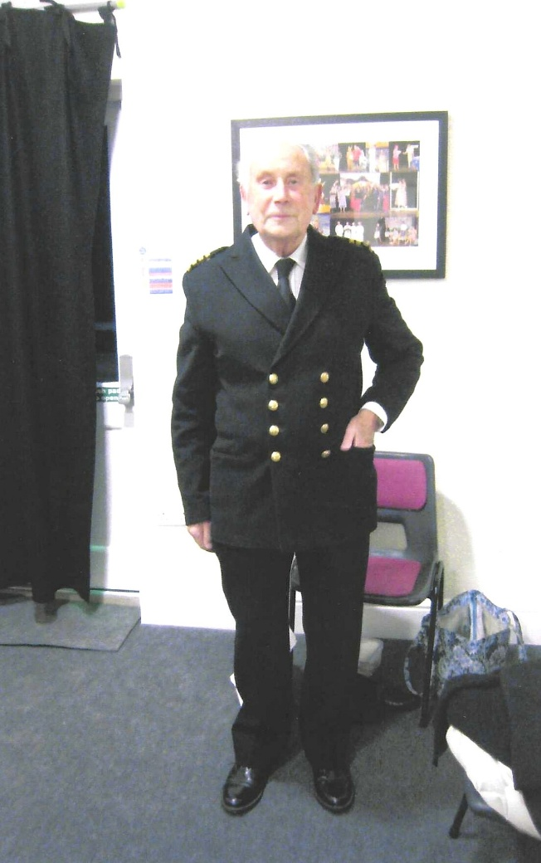

Captain Barnicle (Denis Shore)

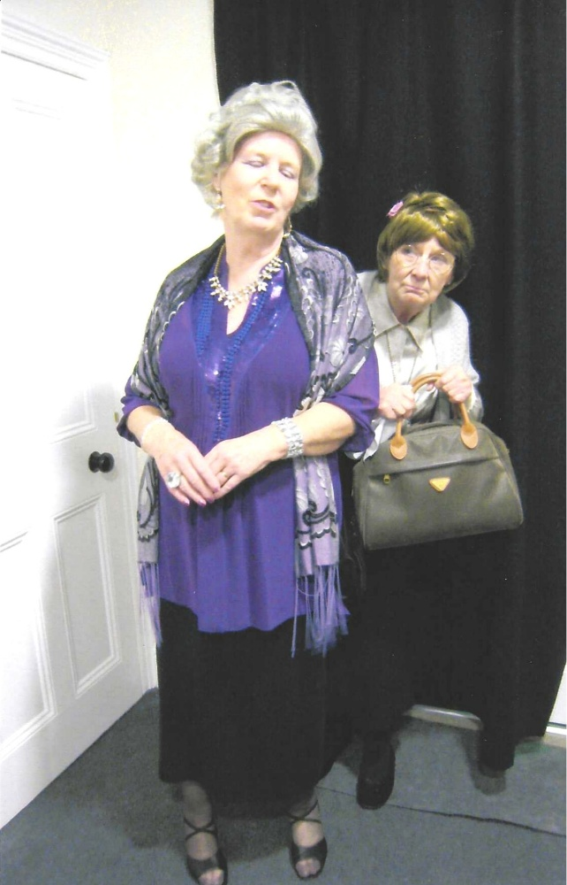

Lady Parker Brown (Kate Lawley)
& Dawn Trodden (Jane Barnett)

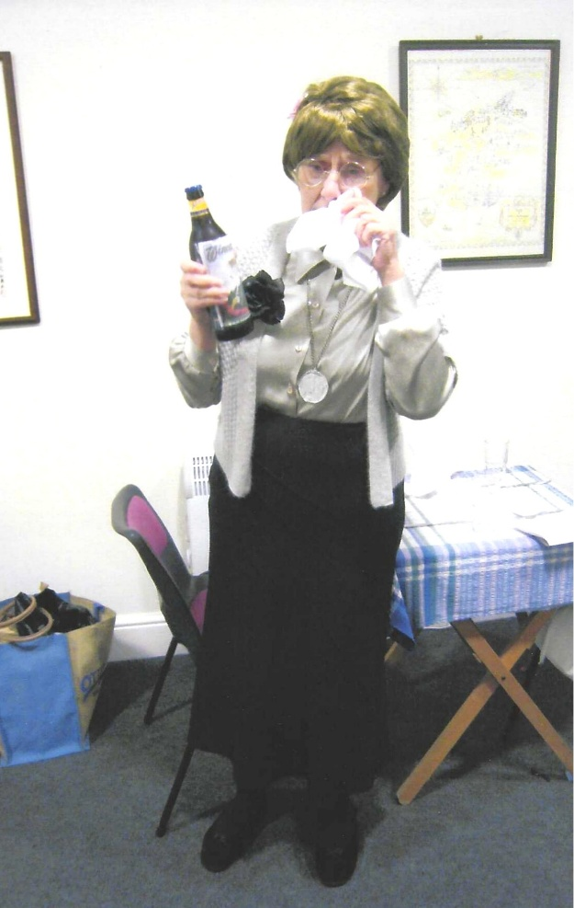

Dawn Trodden (Jane Barnett)

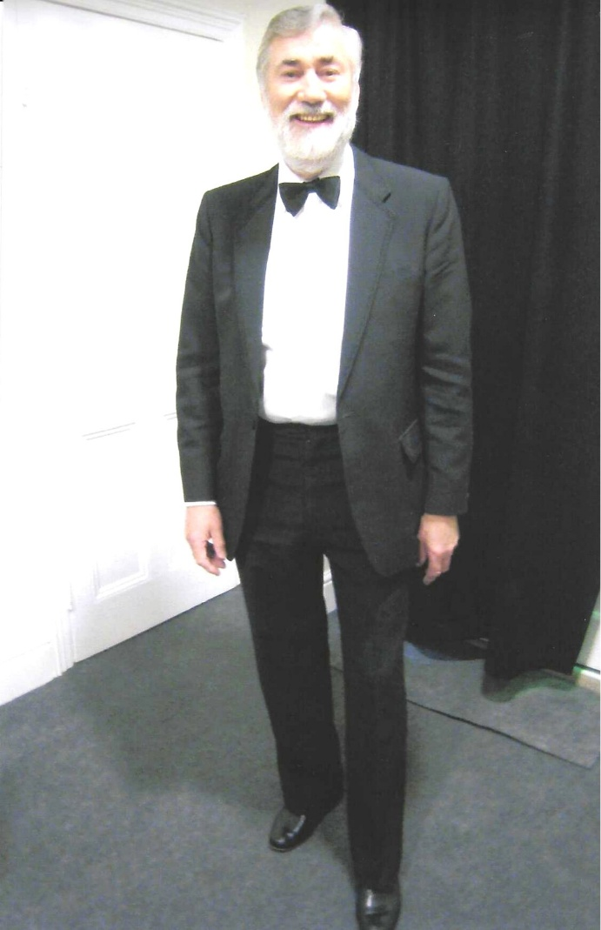

Dr Toby O’Notaby
(John Alexander)

Angelina Desguys (Ann Stirrup)

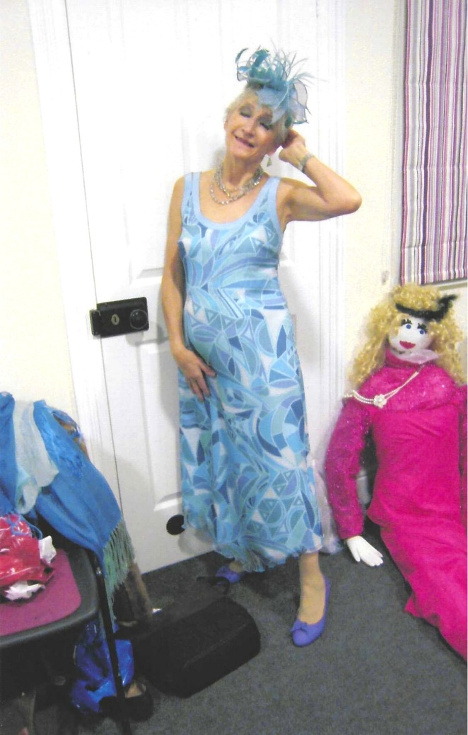

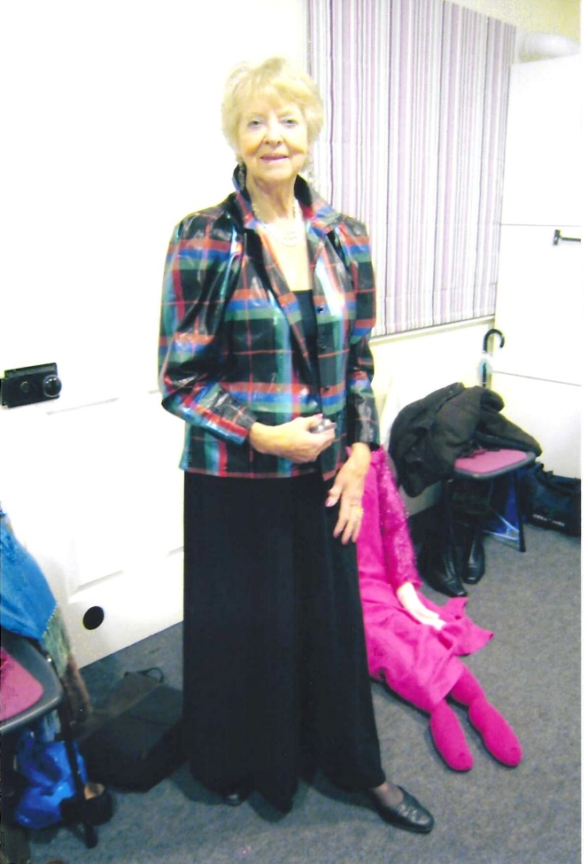
Mrs Campbell (Vicki Winton)

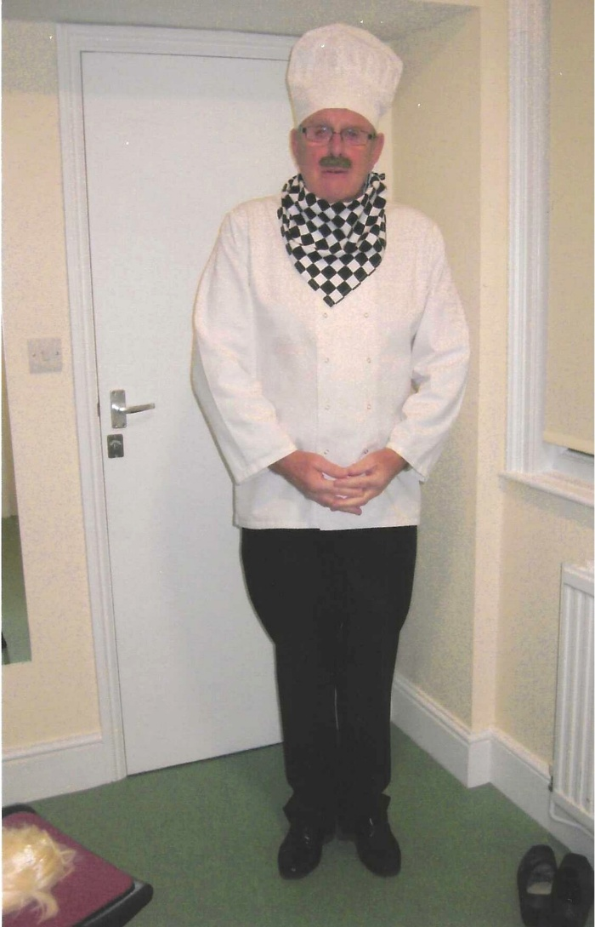

Rene Ra Ta Touille (David Stephenson)

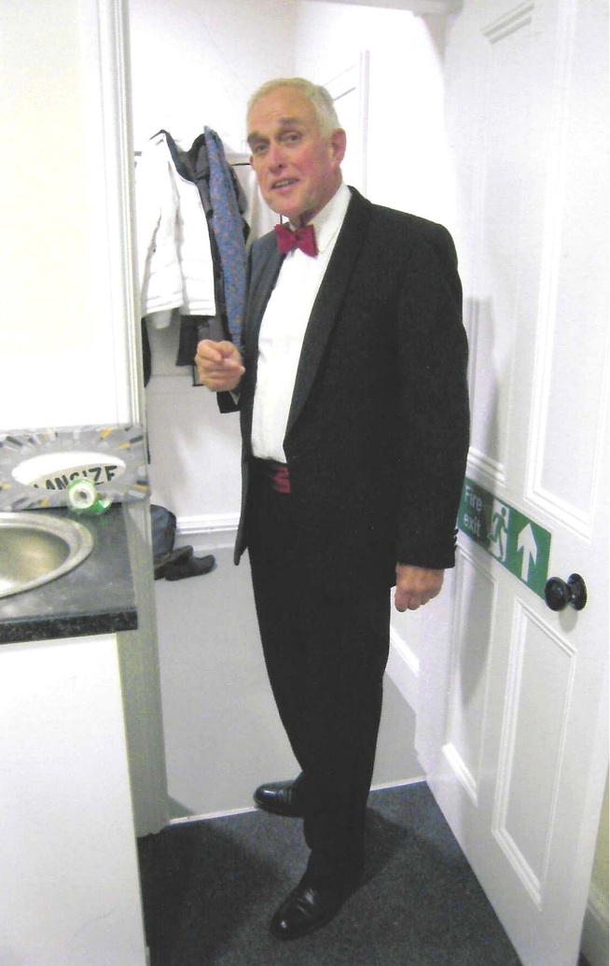

Police Commissioner Fogg
(Duncan MacPherson)

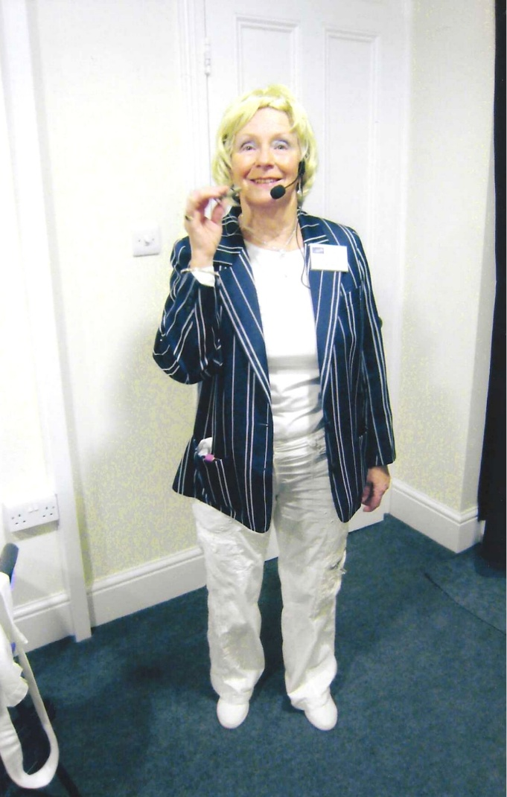

Sally Forth (Angela MacPherson)

