Dartington Gardens

The Dartington Hall estate is a 1200 acre mix of farmland, woodland, commercial spaces and residential accommodation. The medieval Hall was bought by Leonard and Dorothy Elmhirst in 1925.

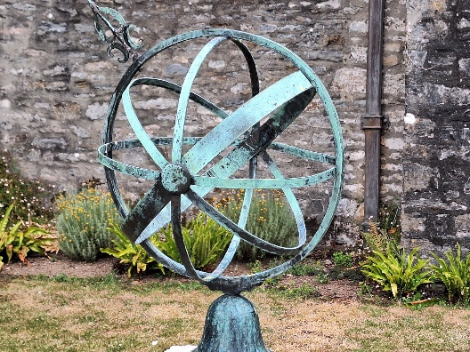
We were met by Rosemary Griggs at Dartington out of her costume (she normally dresses the part) and I didn't recognise her.

She gave us a very interesting talk on the hall and grounds.

Dartington gardens are impressive Grade II* listed gardens, which have been shaped and inspired by the custodians of this special place for over 1,000 years.

There are various sculptures around the 26 acres of tended grounds by well known artists,
including one of Henry Moore’s called “the reclining Memorial Figure” which was designed specifically for Dartington.
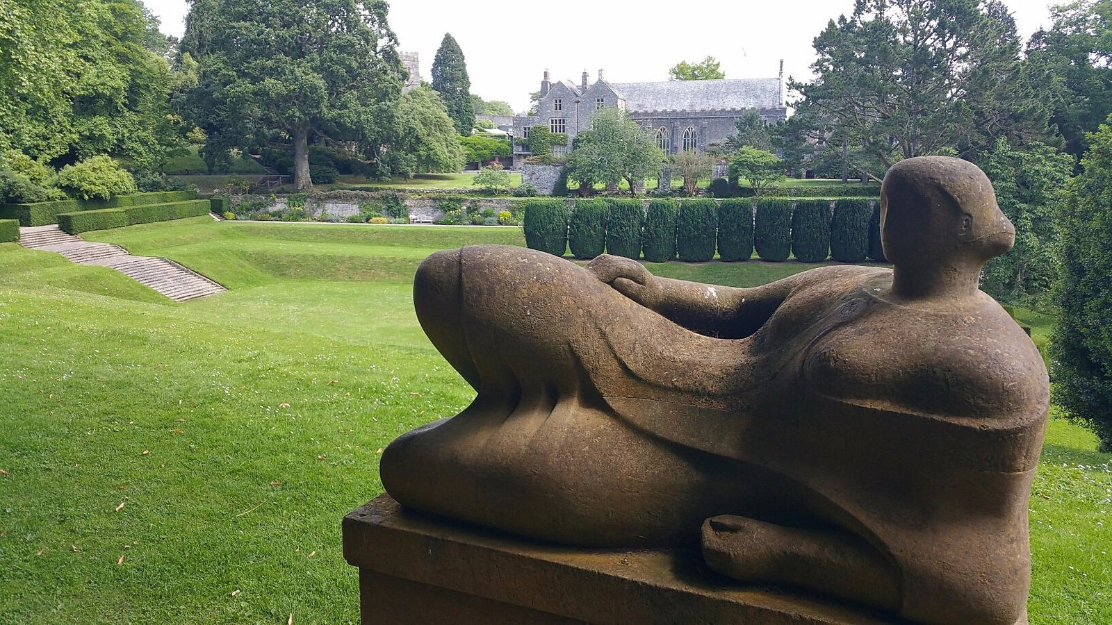
The gardens once had a formal Victorian design, but in 1925, the Elmhirsts, together with their designers, began developing the gardens to have a sense of natural wilderness, including mossy paths, and fern covered stone walls
They bought over the acclaimed garden designer Beatrix Farrand from America in the 1930’s, and the gardens are the only example of her work outside of America.

Percy Cane designed the glade, the azalea dell and a very handsome flight of steps in 1945. The 'tilt yard' (which may be the remains of a tudor pond) is surrounded by steep grass terraces. (Just behind the statue by Henry Moore).

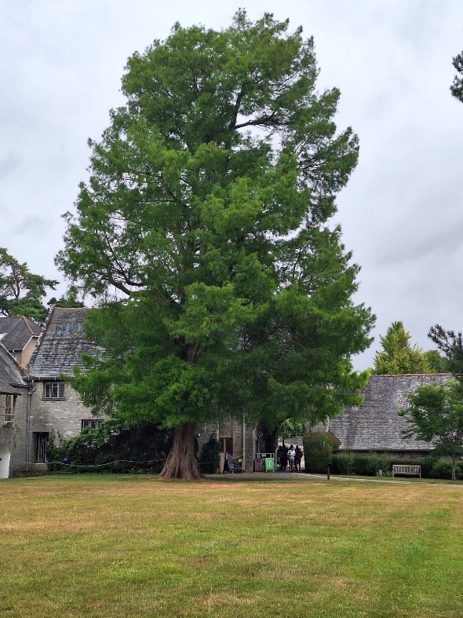
I was a bit disappointed at the lack of flowers but Rosemary said the beginning of spring is the best for the flowers. The lawns were beautiful.

The large swamp cypress that you see on entering the courtyard is over 1500 years old.
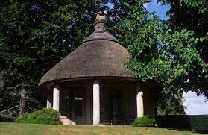
We were also shown the summerhouse which can be used for weddings etc; as can the hall.

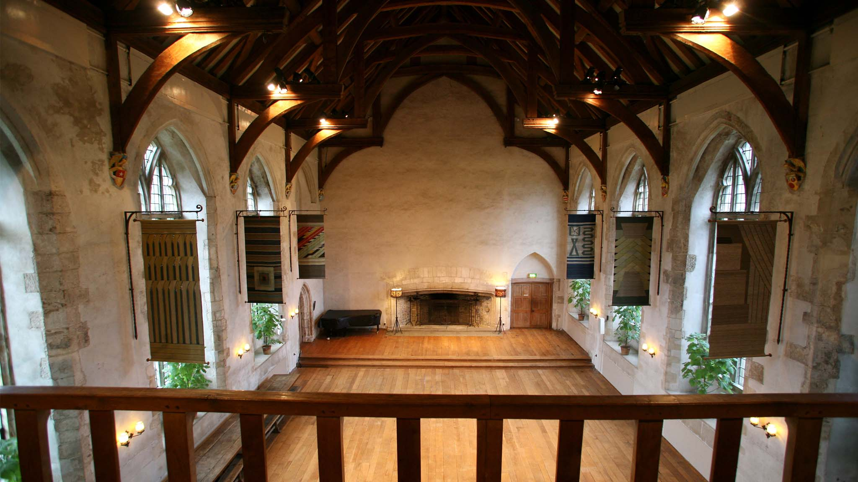

Inside are the standards of the various families who have lived there.
The restaurant is also inside the building where we enjoyed a lovely cream tea.

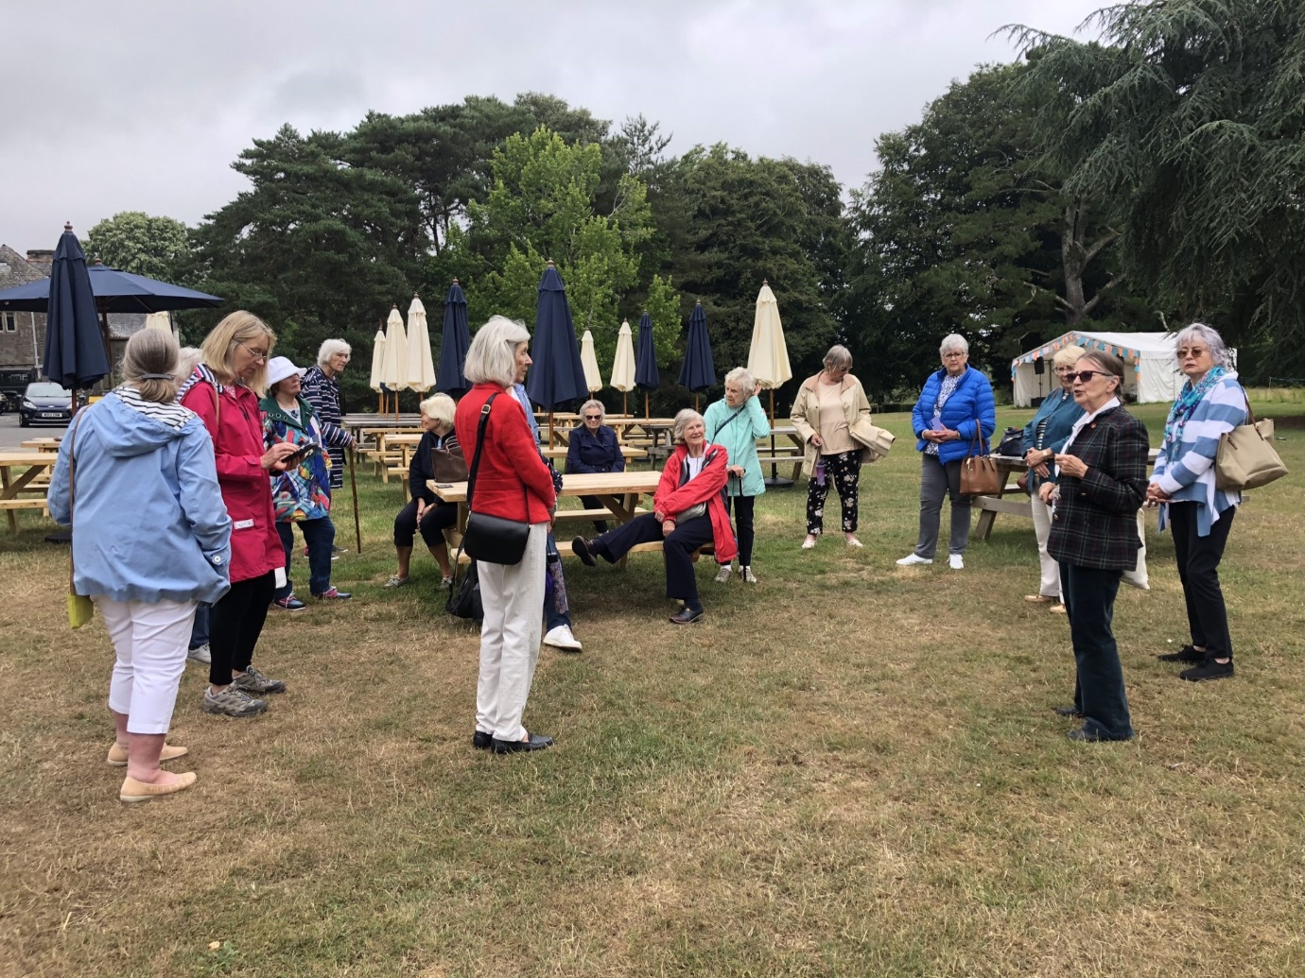
Rosemary telling us about the gardens
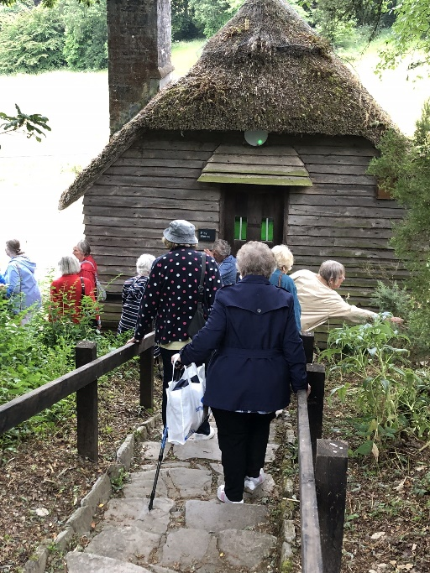

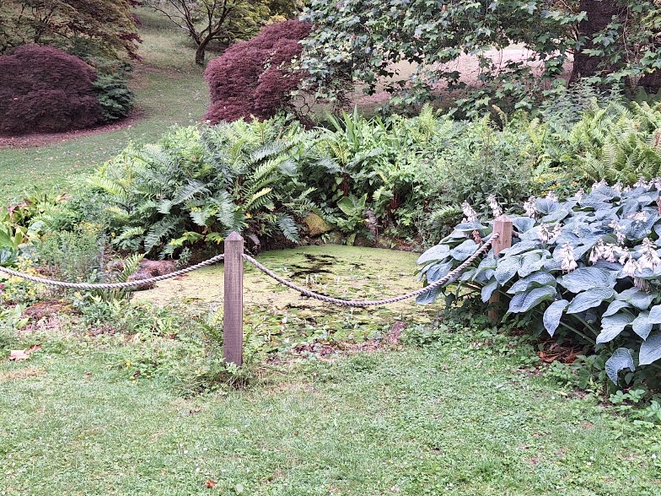
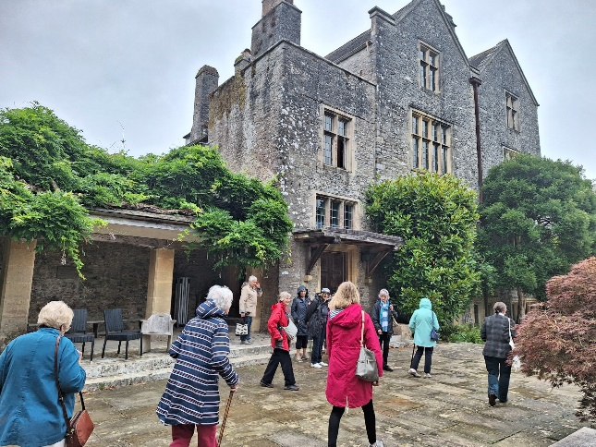

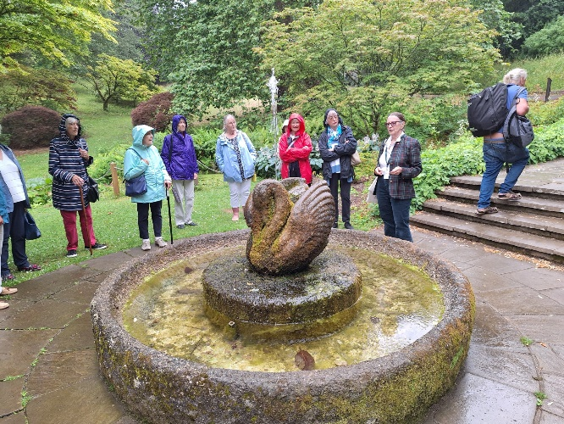

The Swan Fountain

Thanks to Jackie Ross for the narration and Jackie & Shirley Pegg for the photographs

