2011 Euro Babes
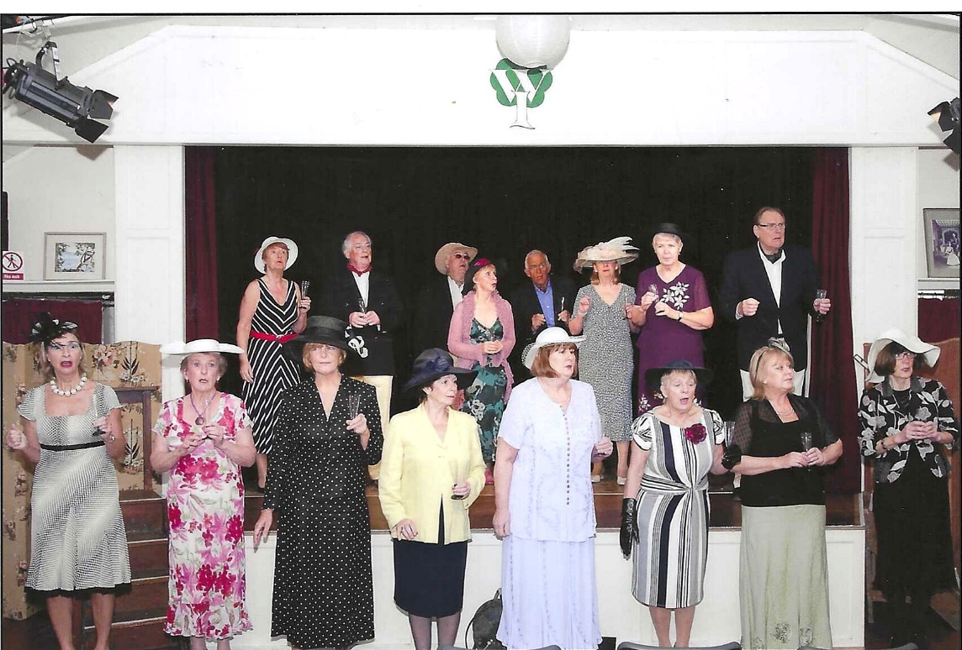
7-10th December

L-R Front row: Brenda Merritt; Janet Cattanach; Carol Williams; Pam Carter; Jean Ellis; Sheila Pearce; Caroline Parsons; Cathy Matthews
Back Row: Judith Stephenson; ? ?; Angela MacPherson; ?;?;?;?

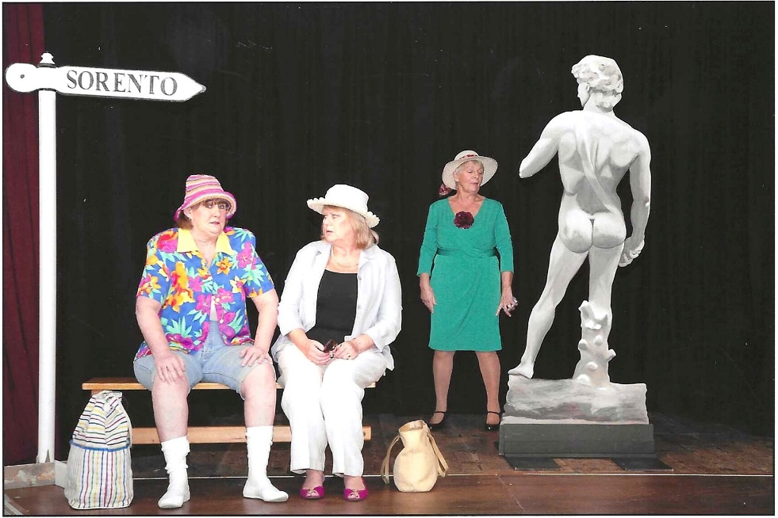

L-R: Jean Ellis; Caroline Parsons;?
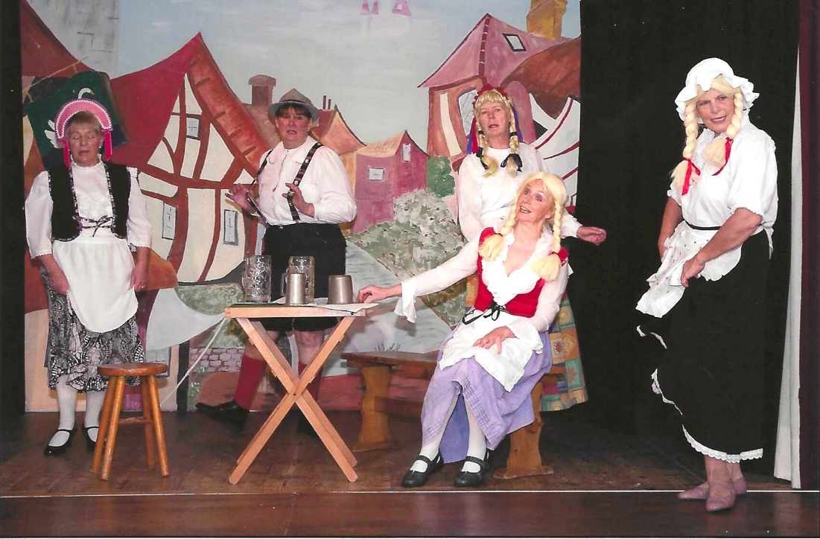

L-R: Sheila Pearce; Jean Ellis; Kate Lawley; Angela MacPherson; Carol Williams

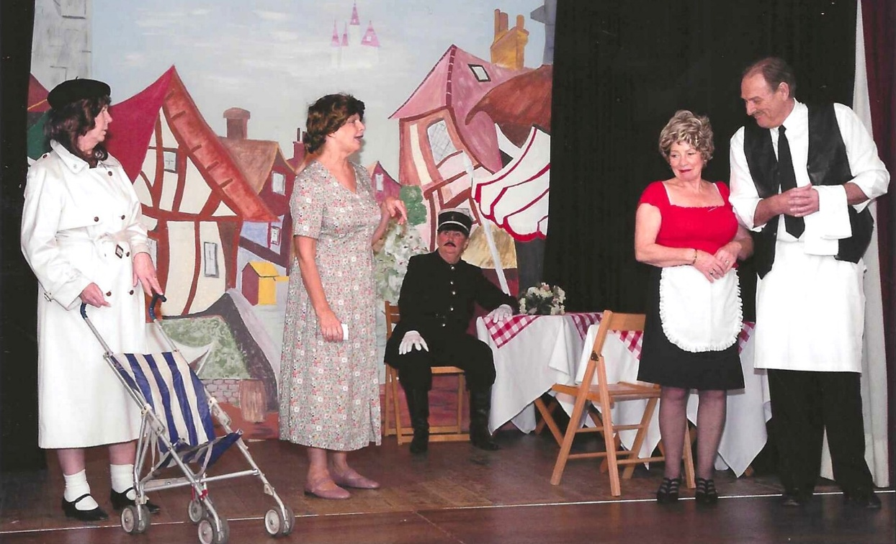

L-R Kate Lawley; Jane Barnett; John Alexander; Pam Carter; David Stephenson

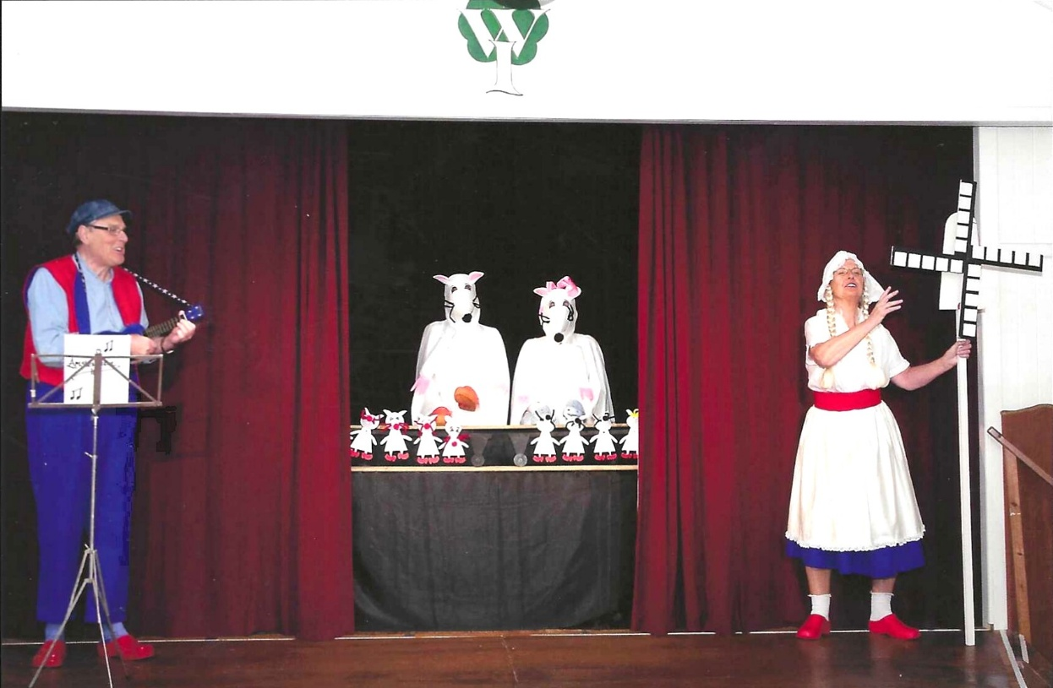
L-R David Stephenson

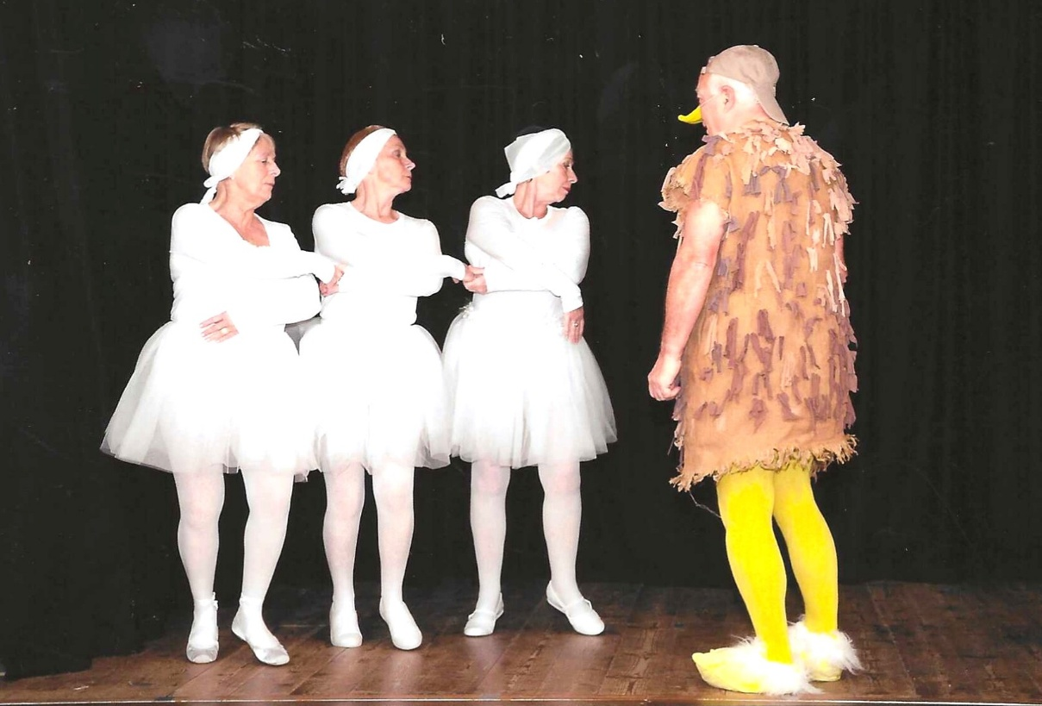
L-R Sheila Pearce; Angela MacPherson; Pam Carter & Dick Page

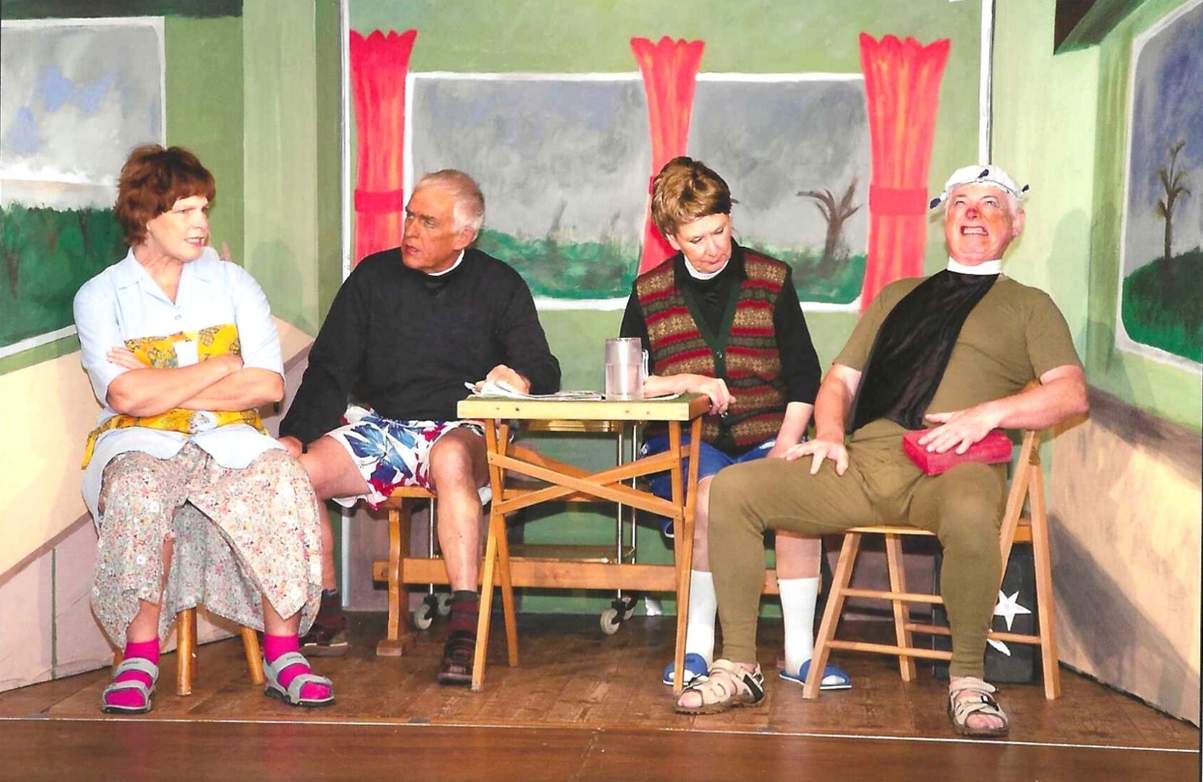
L-R Carol Williams; Duncan MacPherson; Jane Barnett & Rod Carter

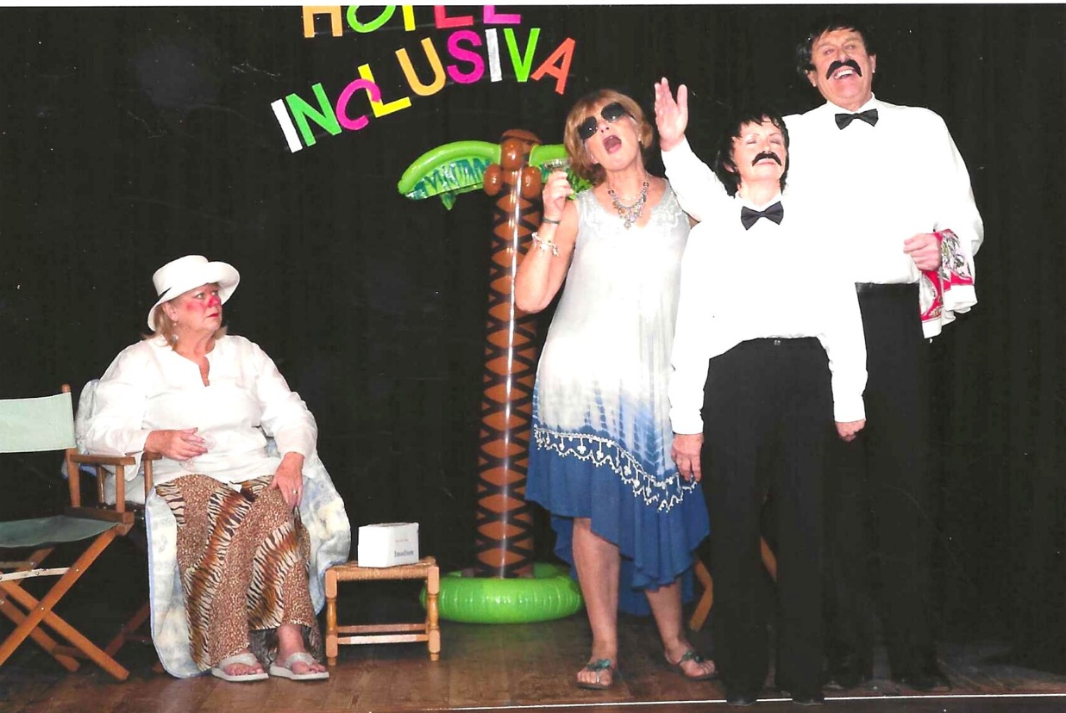
L-R Caroline Parsons; Brenda Merrit; David Stephenson ?

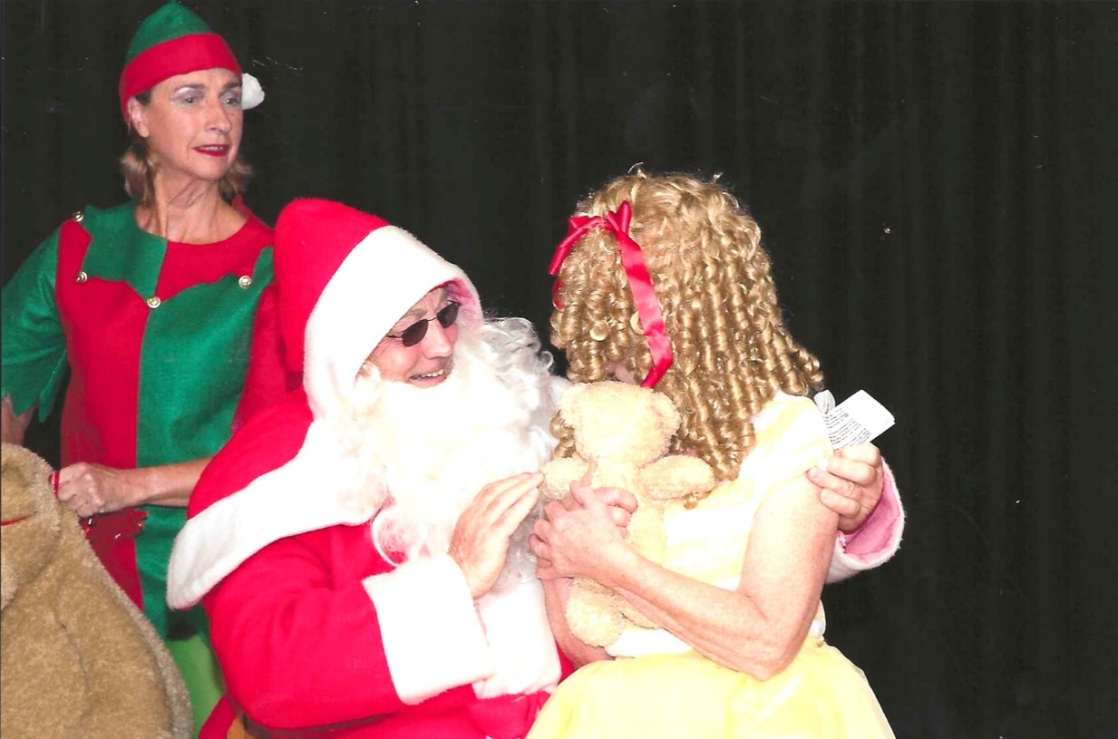
L-R: Brenda Merritt; Dick Page & Angela MacPherson

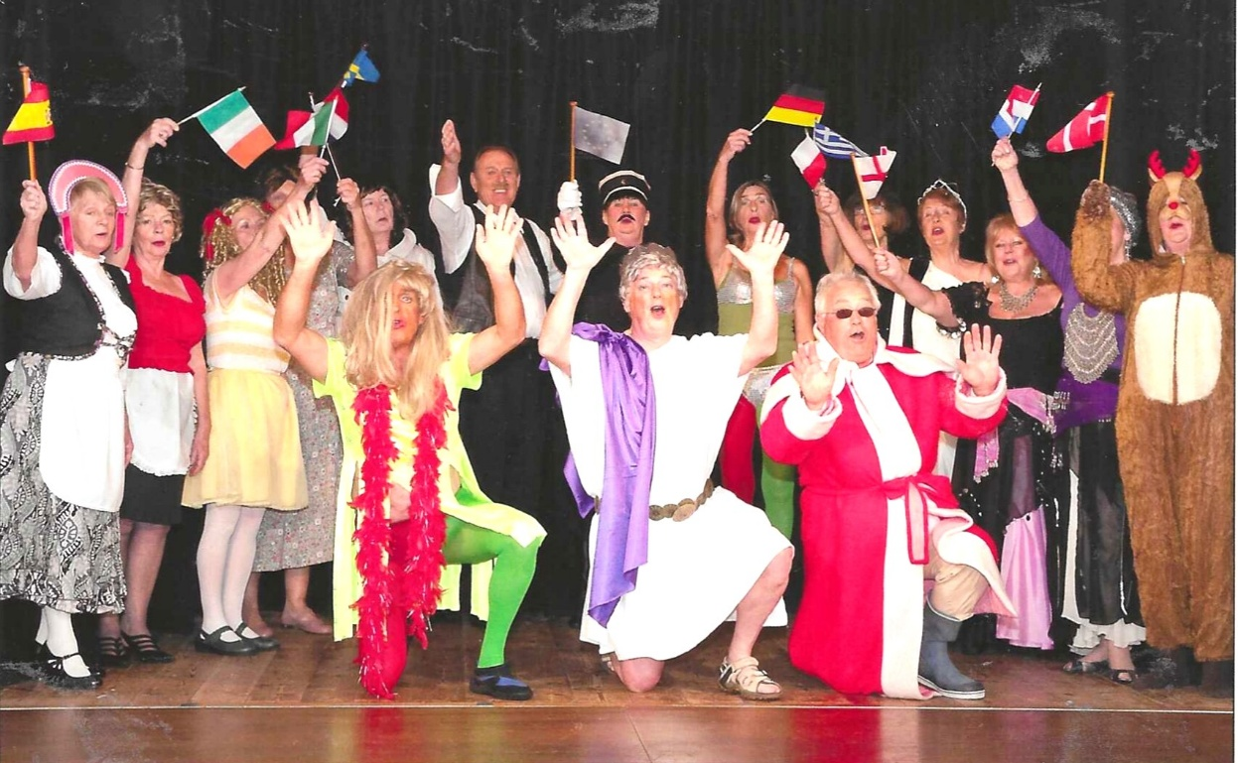
L-R: ?; Pam Carter; Angela MacPherson; Kate Lawley; David Stephenson; Jean Ellis; Brenda Merritt; Cathy Matthews; Judith Stephenson; Caroline Parsons; ??
Front Row: Duncan MacPherson; ?; Dick Page

