2008 Sleeping Beauty Pantomime

Cathy Mathews, Kate Lawley, Janet Cattanach, Ron Carr, Jane Barnett in red wig at the back; Pam Carter, Betty Christie?, Jean Ellis, Rod Carter

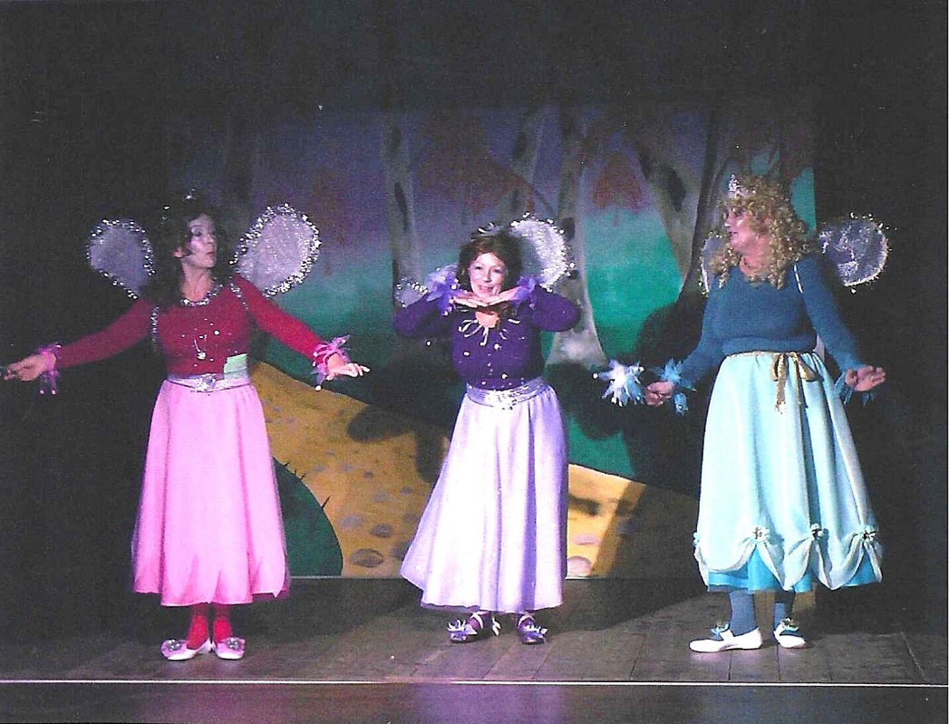

Janet Cattanach, Pam Carter, Jean Ellis

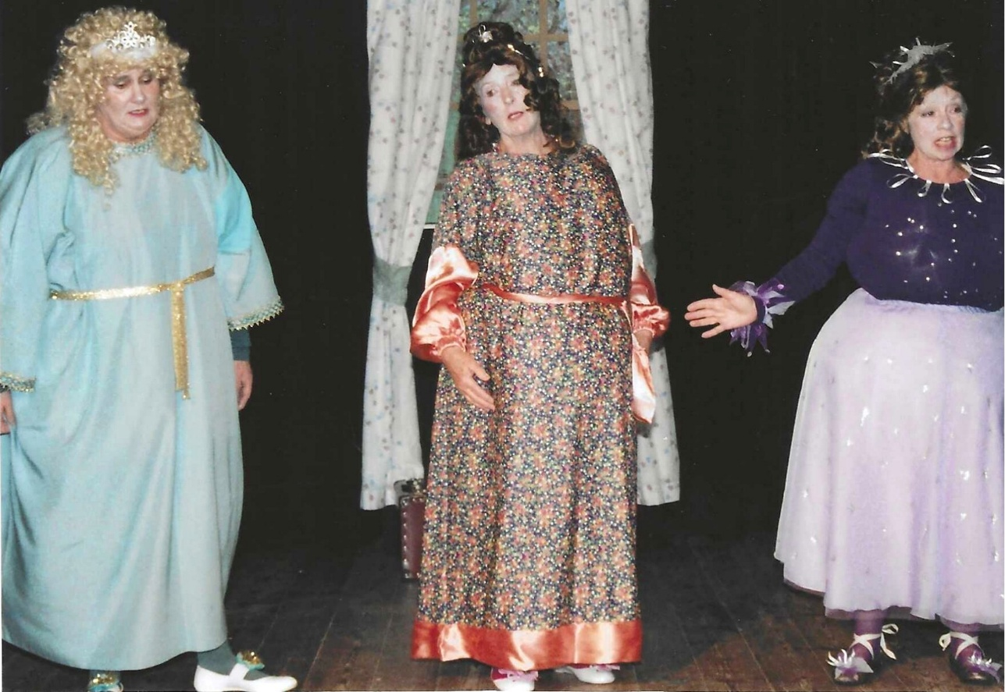

L-R : Jean Ellis, Janet Cattanach, Pam Carter
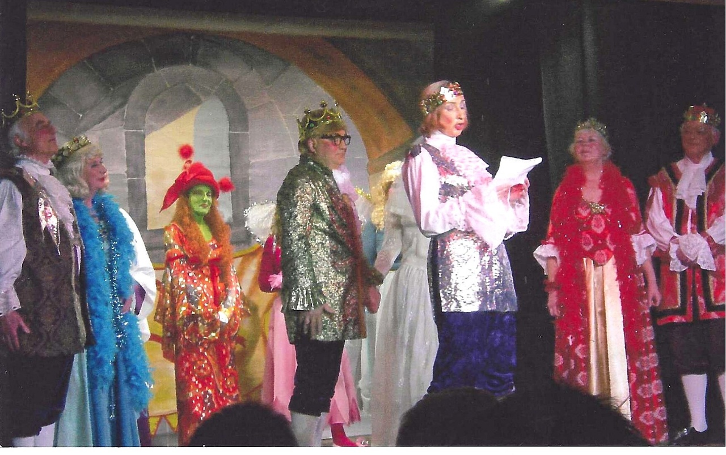

Ron Carr, ?, Hilary Walker, Dick Page, Brenda Merritt, Lesley Davenport, Rod Carter

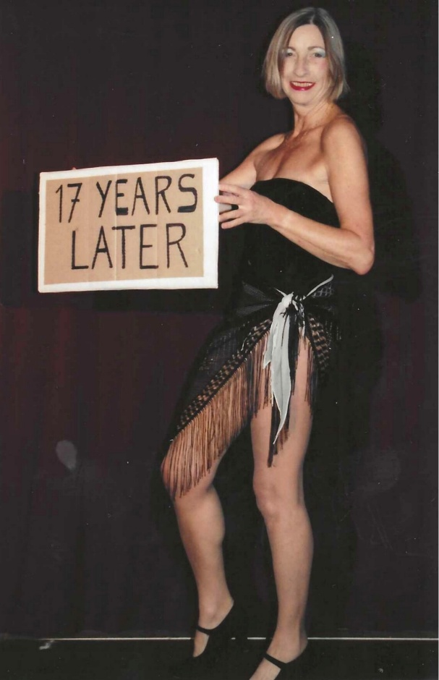

Brenda Merritt

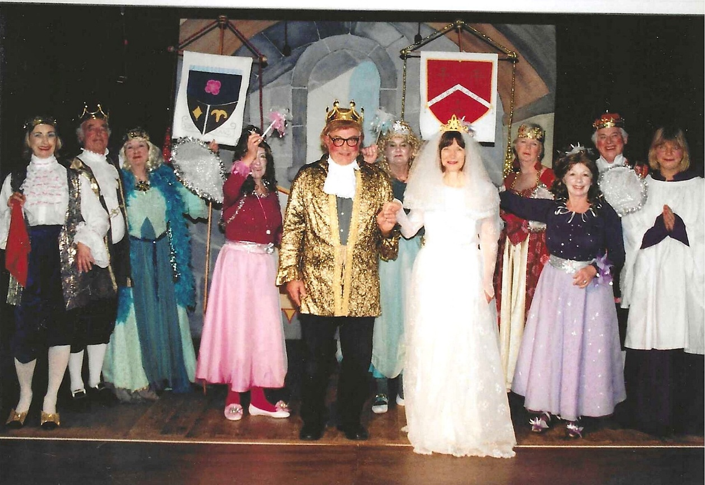

Brenda Merritt, Ron Carr, ?, Janet Cattanach?, Dick Page, Jean Ellis, Cathy Mathews, Kate Lawley, Pam Carter, Rod Carter, Carol Williams
