The Presidents Event
August 2026

On the 18th August, 43 ladies of our WI sat down for a supper. The meal was beautifully cooked by Jeanne Venning. The fruit and veg prep was done during the afternoon by the committee who worked their socks off. We owe a huge thank you to the team:-
Jeanne Venning; Hilda Julien; Gill Tune; Jackie Ross; Stella Gullen; Shirley Pegg; Bryony Lloyd; Margaret Pritchard; Carrie Dixon, & Trish Stringer, without whom, it wouldn’t have happened.

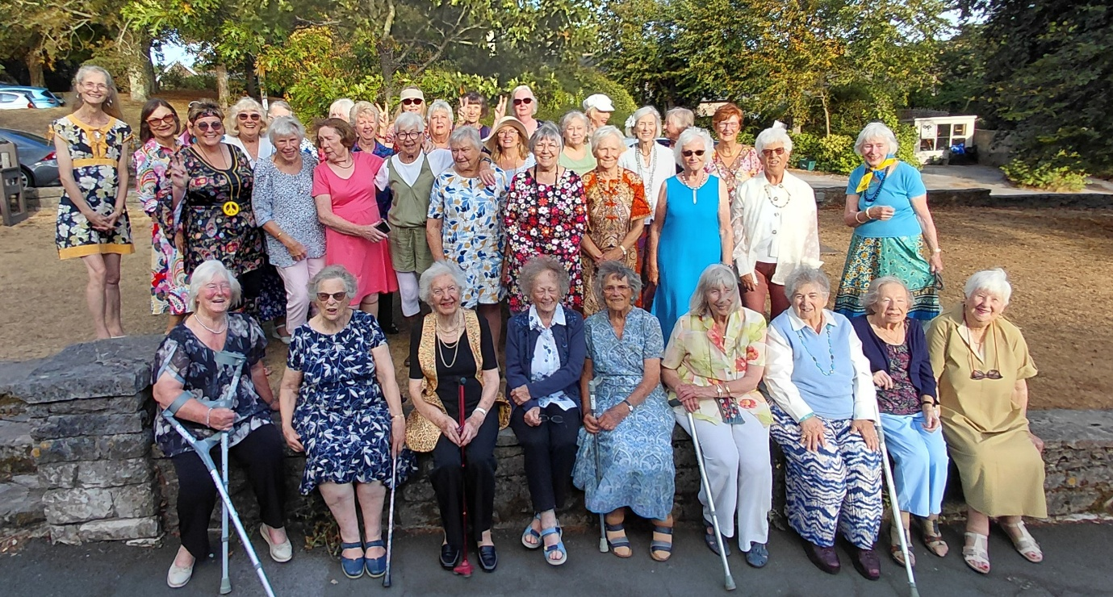

After our group photo, for which many of us dressed in the style of the 1970’s, we sat down to Melon boats; salmon fillets or vegetarian quiche; salad and potato salad. Followed by fresh fruit and meringue nests or gateau, all washed down with rose wine or elderflower cordial.
We were ably assisted by 2 lovely girls from the villages, Kiki and Emily, who speedily cleared the tables and assisted with serving, as well as assisting in the kitchen and loading the dish washer. It meant we were able to enjoy the supper too.
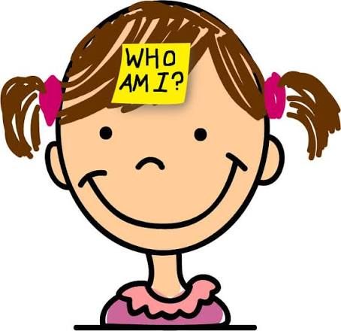
In between the main course and dessert, we had a “Who am I?” quiz. Members had sent in photos of themselves in the 1970’s. Which were displayed in rotation on the screen. Some were quite hard to guess.


Between dessert and coffee Trish Stringer did a 1970’s music quiz, That set the grey cells churning too!

One of our members, Helen, wrote “It was inspired to bring both together, see the people we used to be and realise the different perspectives we had, dancing to different music.”
We did a bit of time travel too! As well as looking back at our lives in the 1970’s we fast forwarded to 2027 as Lesley got the year wrong on the information sheets on the tables! (as well as a few spelling mistakes – Obviously a bad day in the WI office)
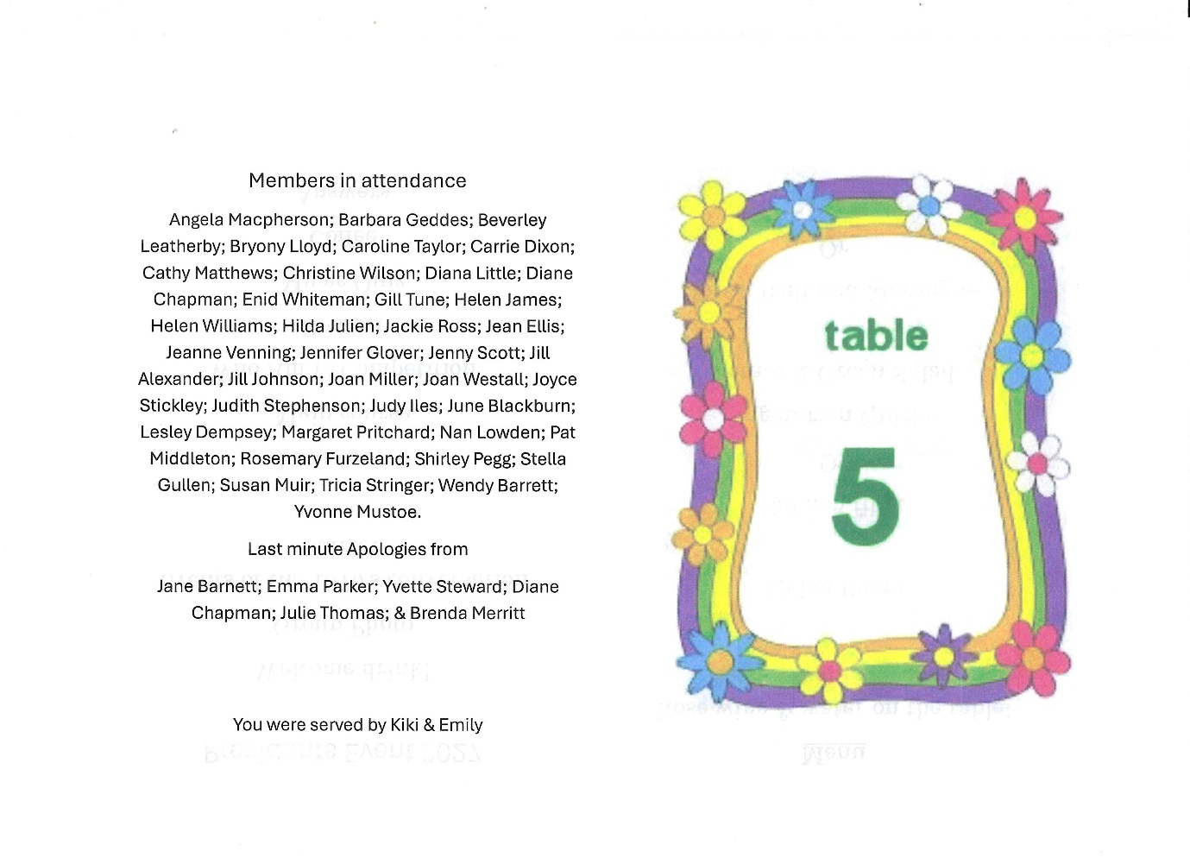

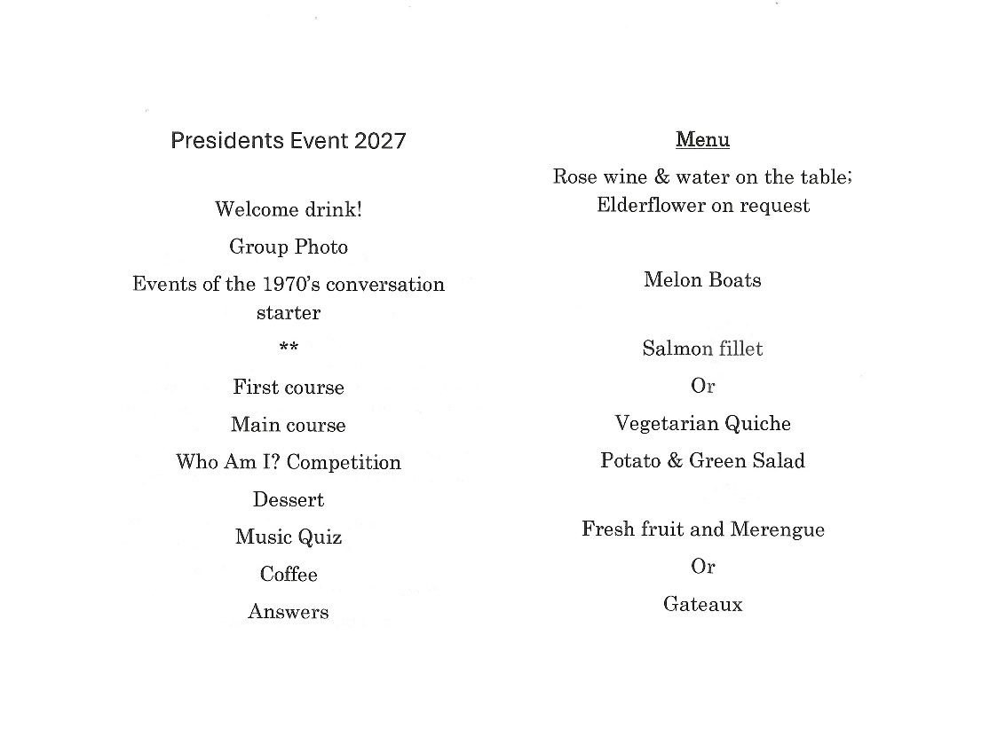

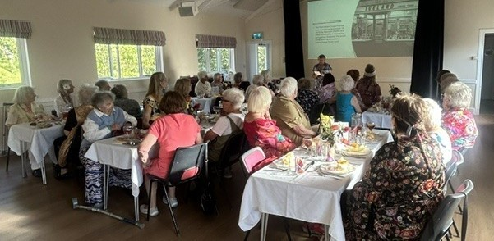
Welcome from Lesley & 1970’s & do you remember Power point presentation for a conversation starter. (this slide was Iceland opening its first store in 1970). There was sport, politics, strikes, water shortages, (who remembers “Save water, bath with a friend”), the heat wave, bombings, the Queens Jubilee, Prince Charles joining the Navy, fashion, music, Concord, Pong, toys, films & William Hague’s first speech age just 16; - to name just a few.
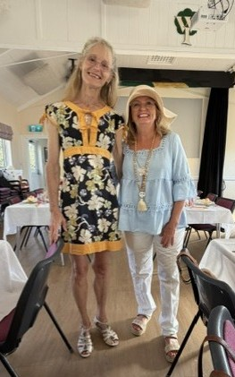
L-R Wendy Barritt, Angela Macpherson, Joyce Stickley, Jean Ellis & Margaret Pritchard
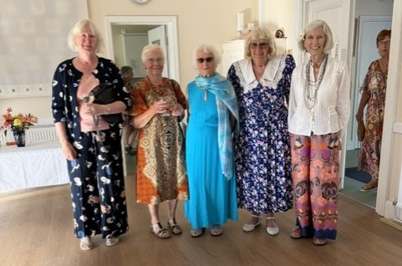

Trish Stringer & Jenny Scott

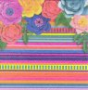
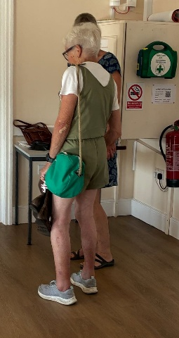
Shirley Pegg’s Hotpants

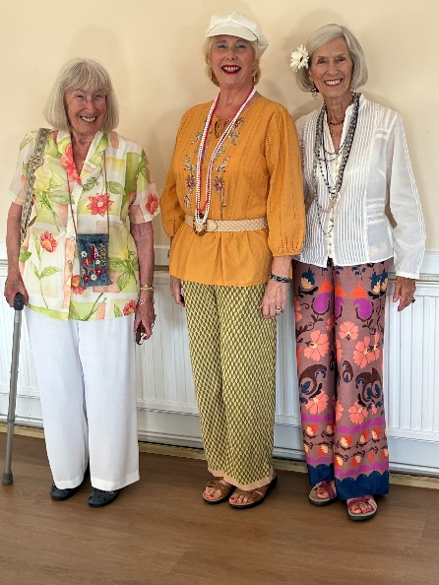
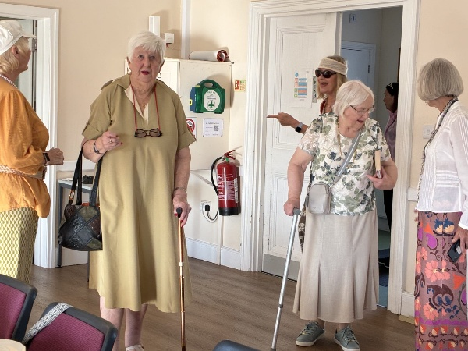

L-R Carrie Dixon, Jill Johnson, Pat Middleton
Rosemary Furzeland & Margaret Pritchard

Judy Iles; Carrie Dixon & Margaret Pritchard

Welcome address
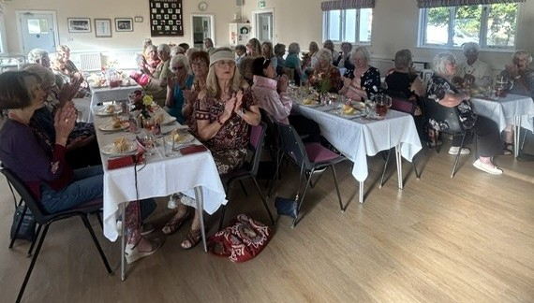

L-R Diana Little; Beverley Leatherby; Enid Whiteman; (just popping her head out) Pat Middleton; Judith Stephenson; Joyce Stickley; Cathy Matthews Jill Alexander & Rosemary Furzeland

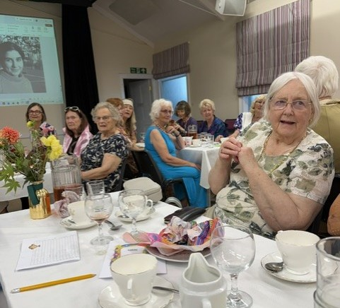

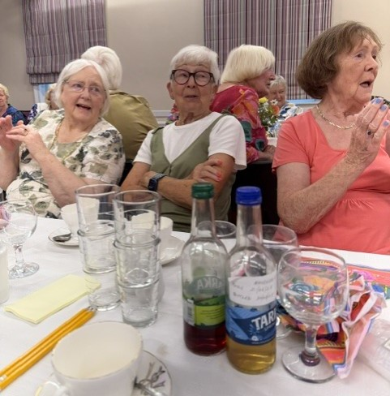
Rosemary Furzeland
Shirley Pegg &
Gill Tune
Complete with home-made after
Dinner liqueurs made by
Stella Gullen

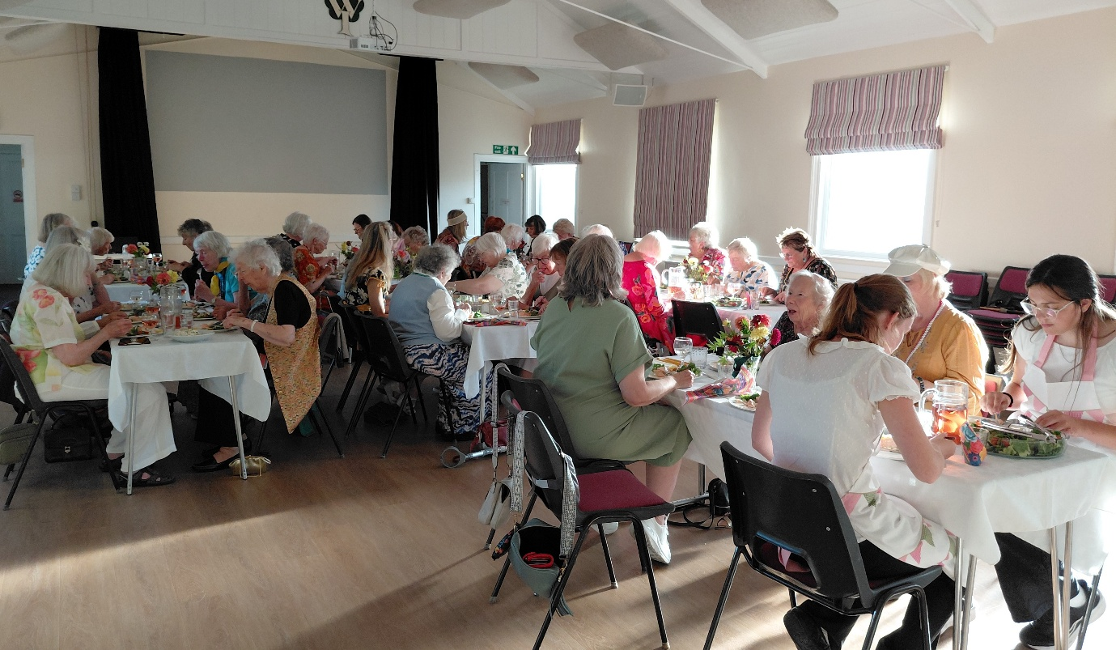

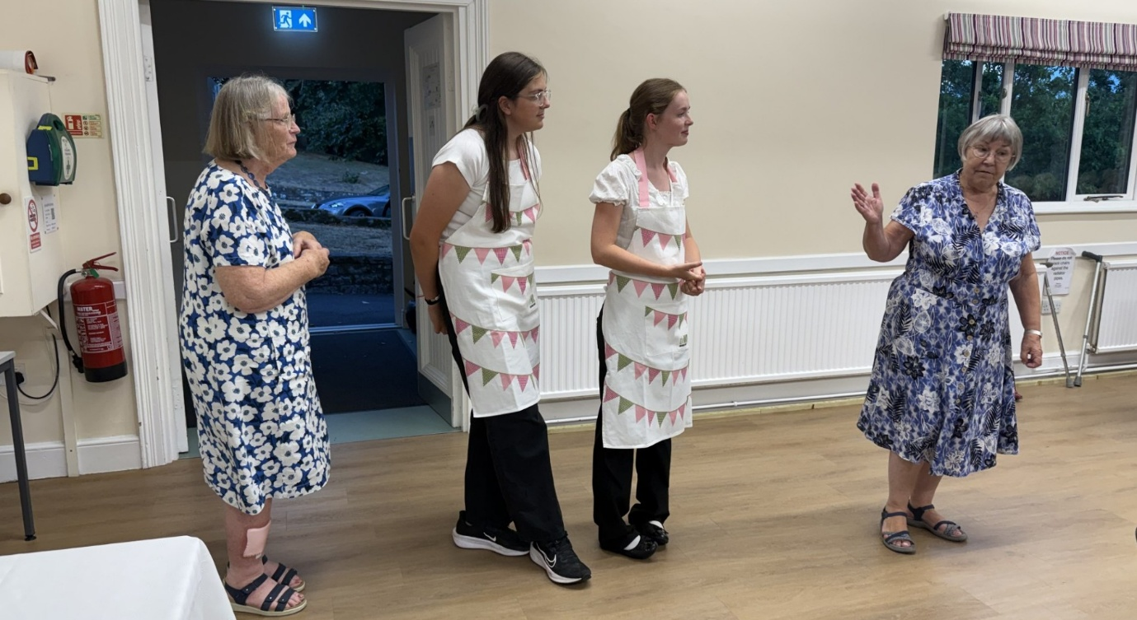

Lesley thanking (R-L) Kiki, Emily & Jeanne Venning. The girls did a fabulous job of assisting with serving and clearing; and Jeane took Lesley on a huge learning curve of shopping for many people. Jeanne is an encyclopaedia of supermarket prices. Jeanne also gave up many hours to cook our precious salmon, empty the dish washer and mop the kitchen floor. – All things members do not see.

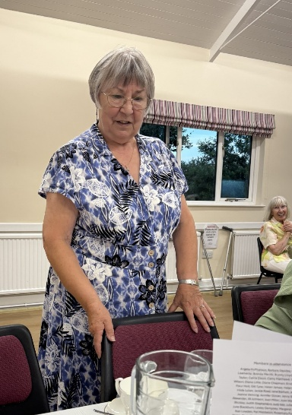

An embarrassed Lesley Dempsey, during a rousing version of “for she’s a jolly good fellow”.
During the evening she shed the nylon mini dress. (How did we live in nylon clothes? They are horrible!)

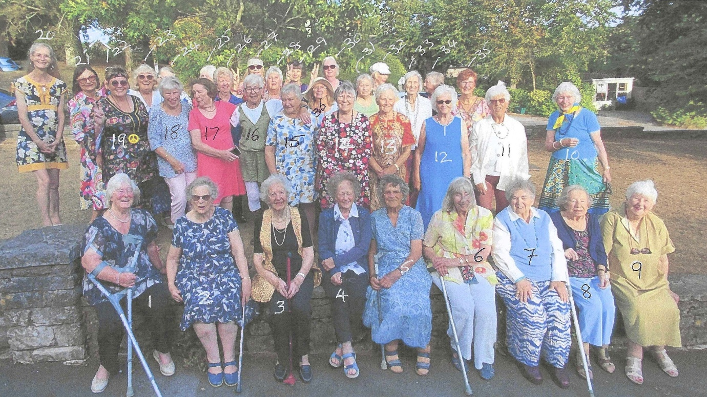
1) Jenny Glover
2) Enid Whiteman
3) Joan Westall
4) Joan Miller
5) Helen James
6) Judy Iles
7) Stella Gullen
8) Susan Muir
9) Jill Johnson
10) Caroline Taylor
11) Hilda Julien
12) Joyce Stickley

13) Angela Macpherson
14) Lesley Dempsey
15) Yvonne Musto
16) Shirley Pegg
17) Gill Tune
18) Christine Wilson
19) Bryony Lloyd
20) Tricia Stringer
21) Diana Little
22) Beverley Leatherby
23) Jean Ellis
24) Jeanne Venning

25) Barbara Geddes
26) Jill Alexander
27) Pat Middleton
28) Jackie Ross
29) Cathy Matthews
30) Wendy Barritt
31) June Blackburn
32) Carrie Dixon
33) Margaret Pritchard
34)Nan Lowden
35) Judith Stephenson
36) Jenny Scott

