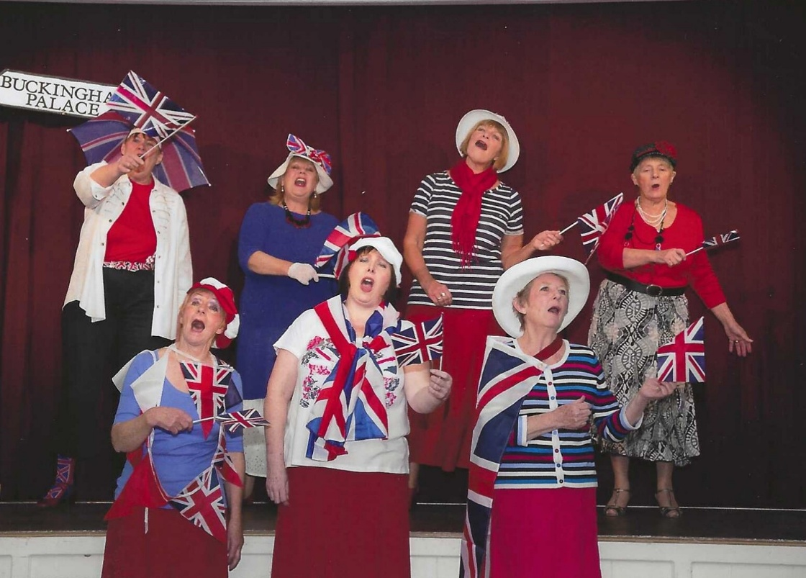
2012 A review Revue

Back Row: L-R : Jean Ellis; Caroline Parsons; Carol Williams; ?
Front Row: Angela MacPherson; Carrie Dixon; Janet Cattanach

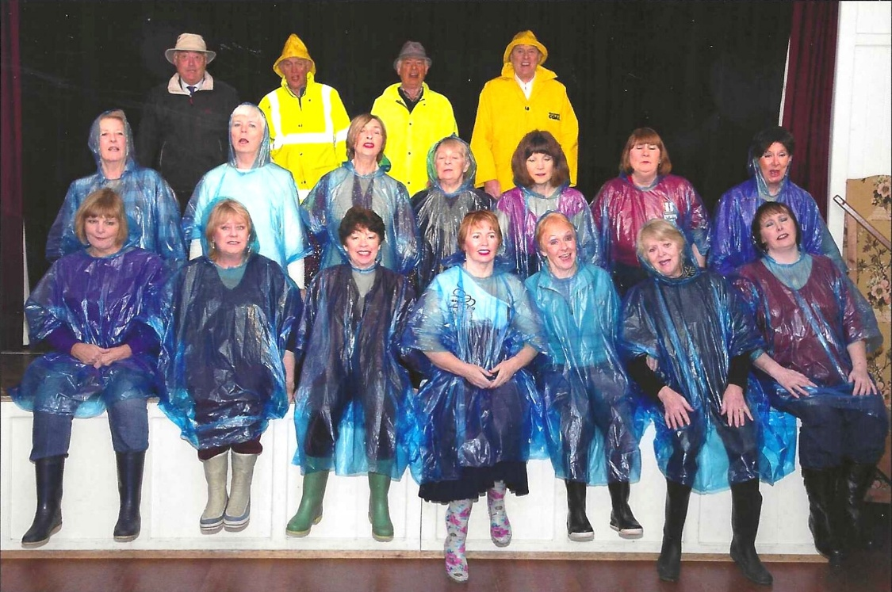

Back Row L-R
Middle Row: Janet Cattanach;?; Brenda Merritt; ? Cathy Matthews; Jean Ellis; ?
Front Row: Carol Williams; Caroline Parsons; Pam Carter; Emma Parker;Angela MacPherson;?;Carrie Dixon

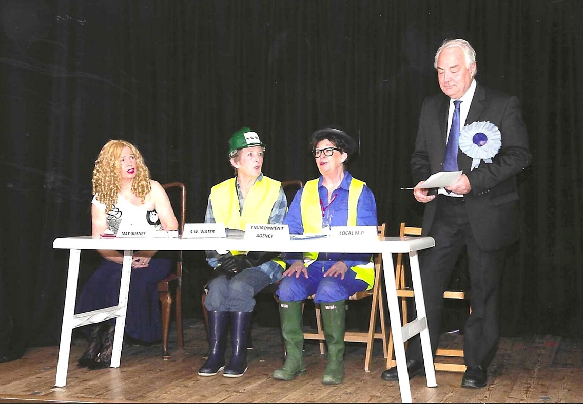

L-R: Brenda Merritt; Janet Cattanach; ?;?

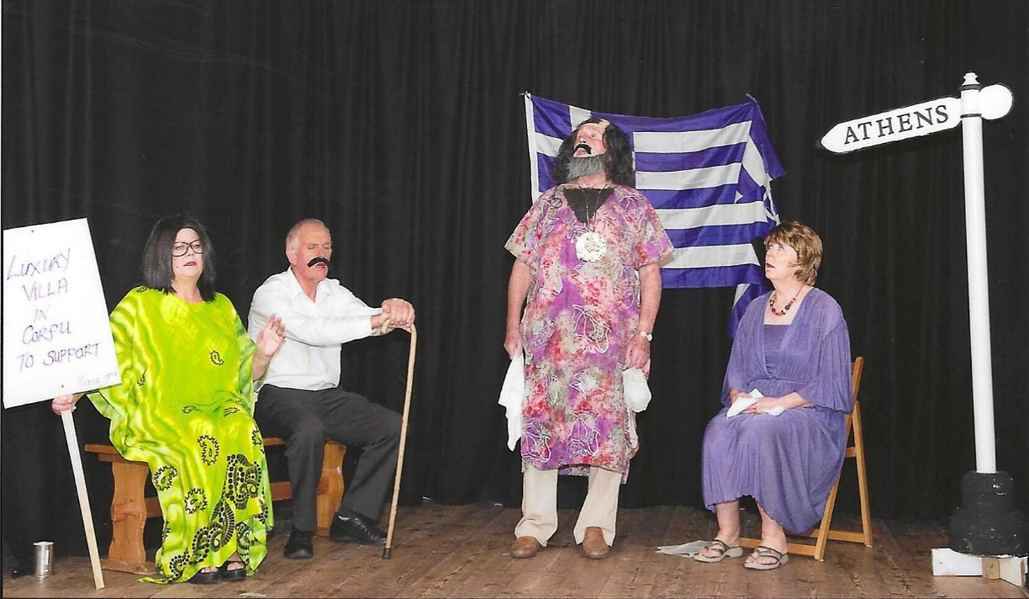

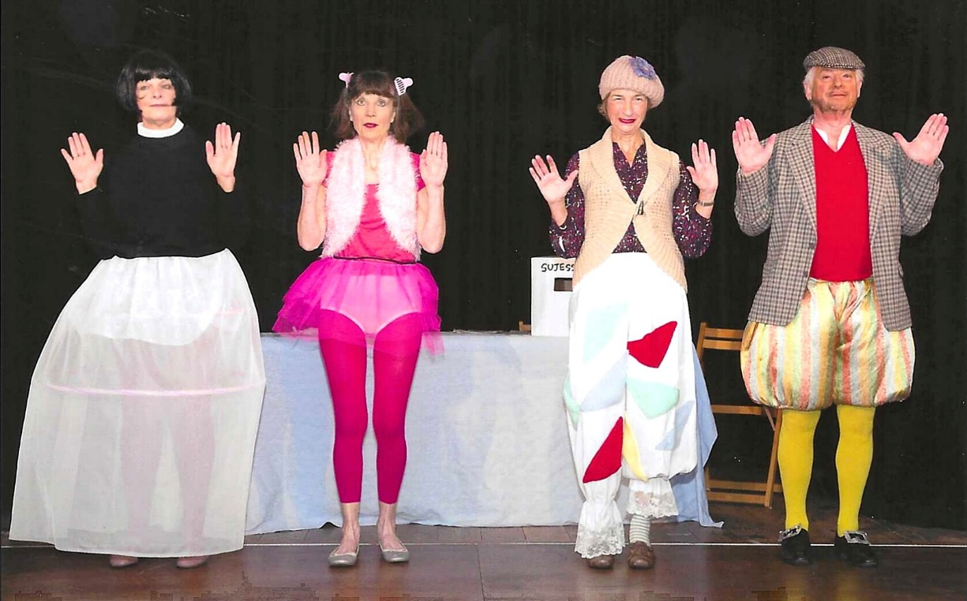

L-R: Carol Williams; Cathy Matthews; Brenda Merritt; ?

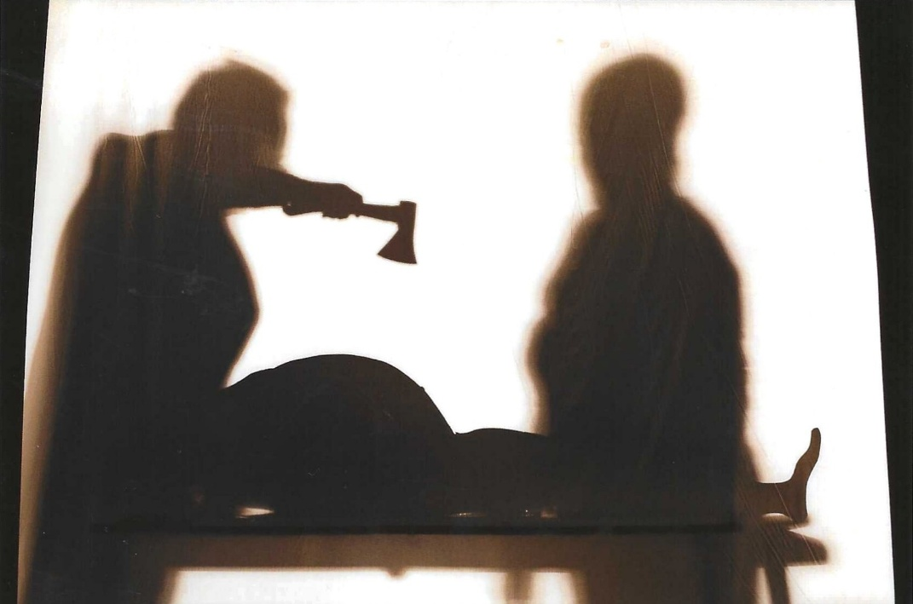

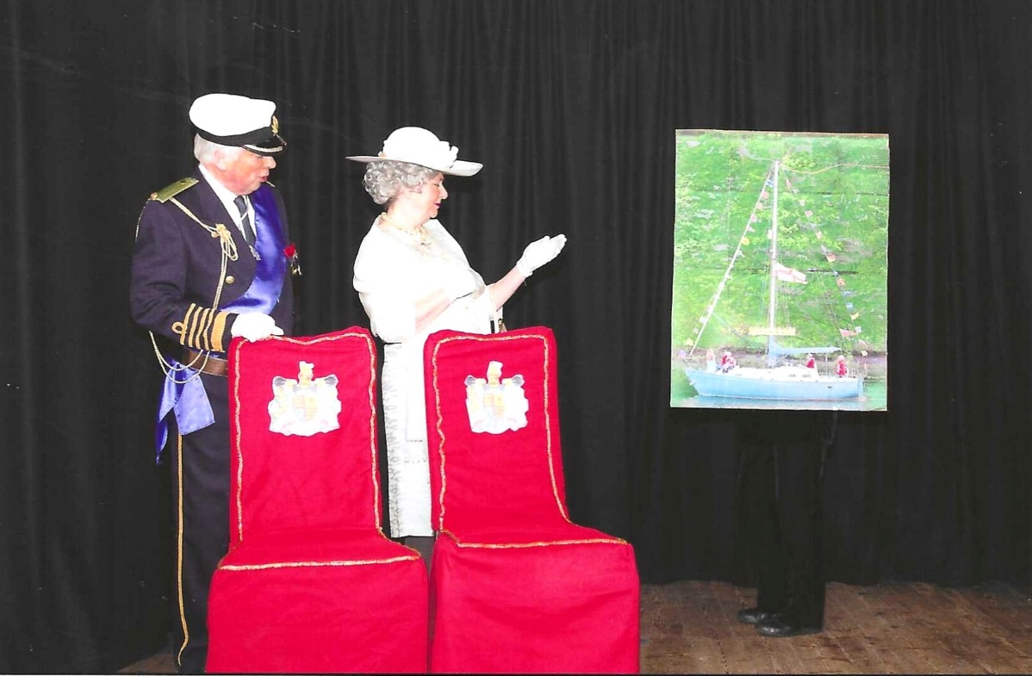

Rod Carter & Jane Barnett

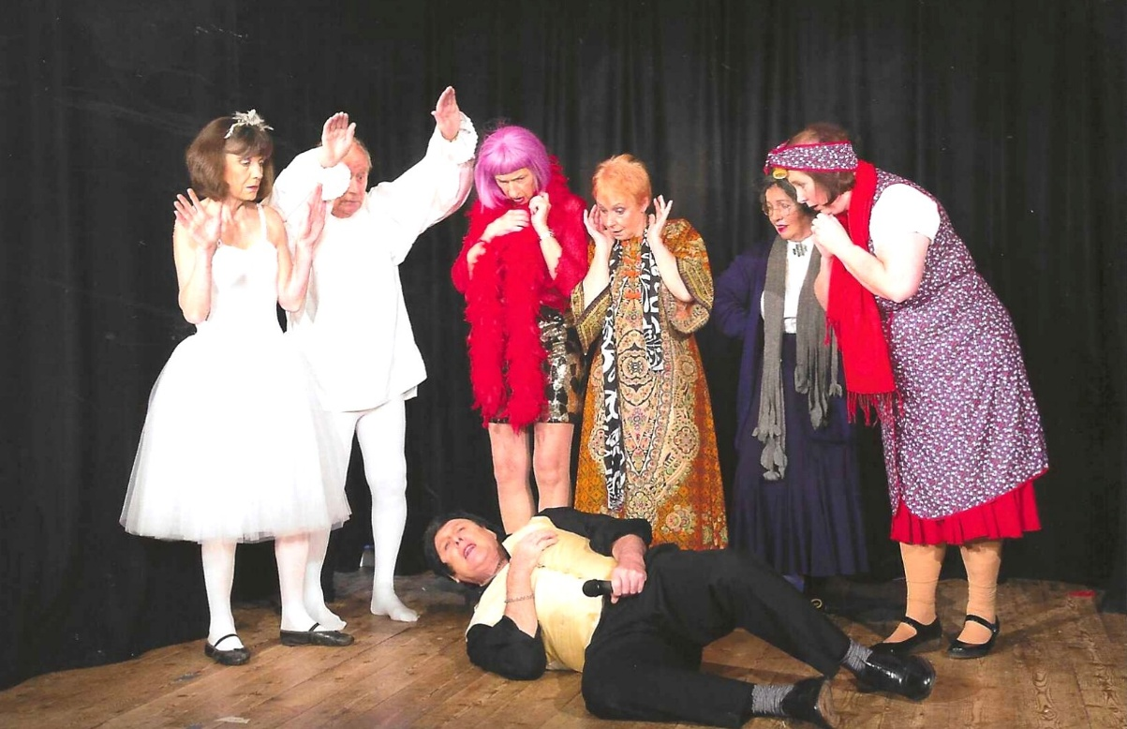

L-R: Cathy Matthews; Dick Page; Brenda Merritt; Angela MacPherson; Emma Parker; Carrie Dixon& on the floor is Duncan MacPherson

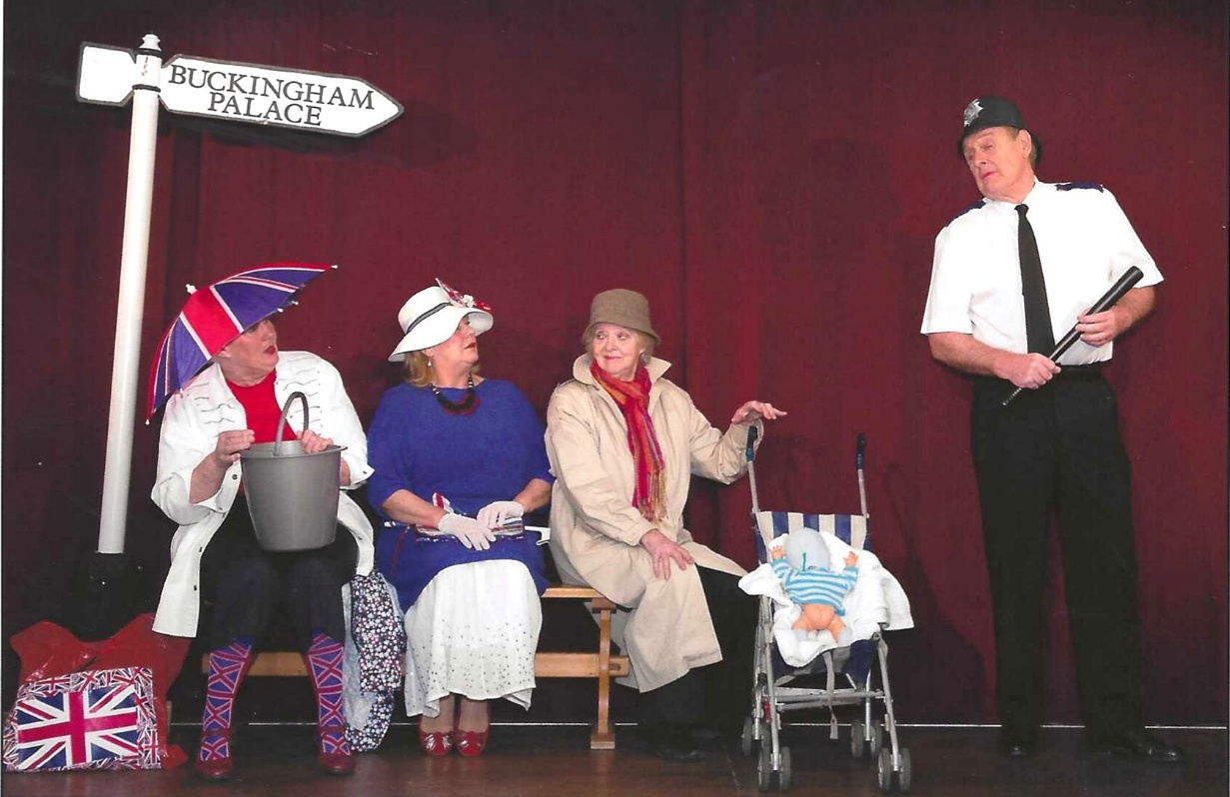

L-R: ?; Caroline Parsons; ?;?

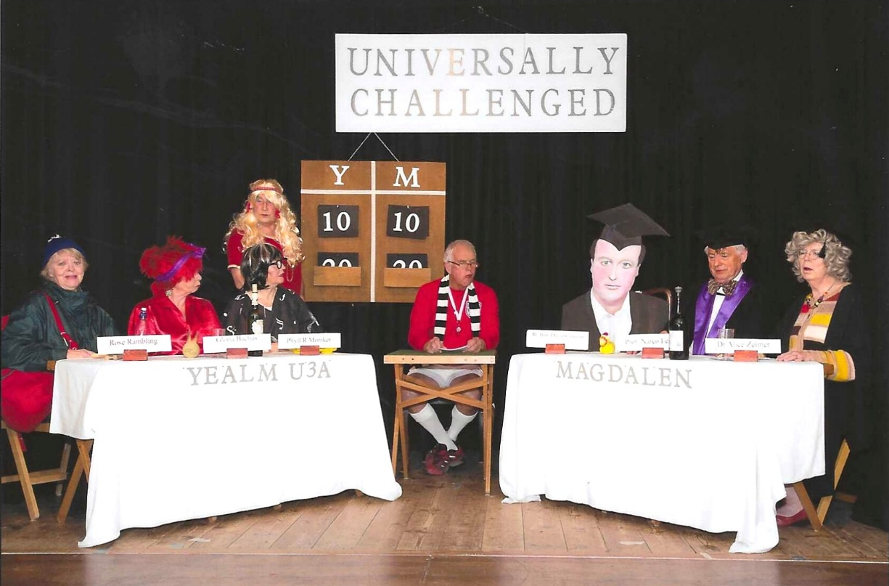

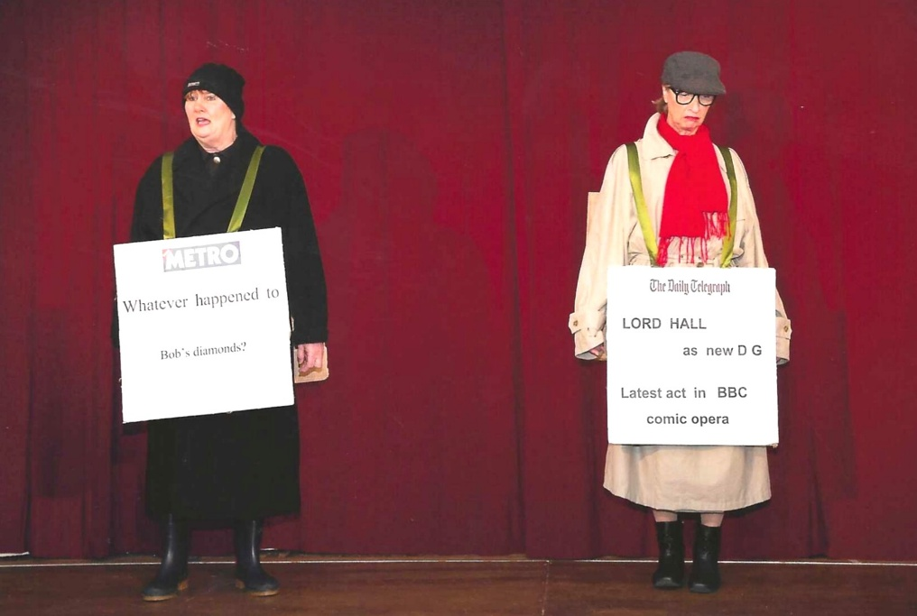

L-R: Jean Ellis & Brenda Merritt

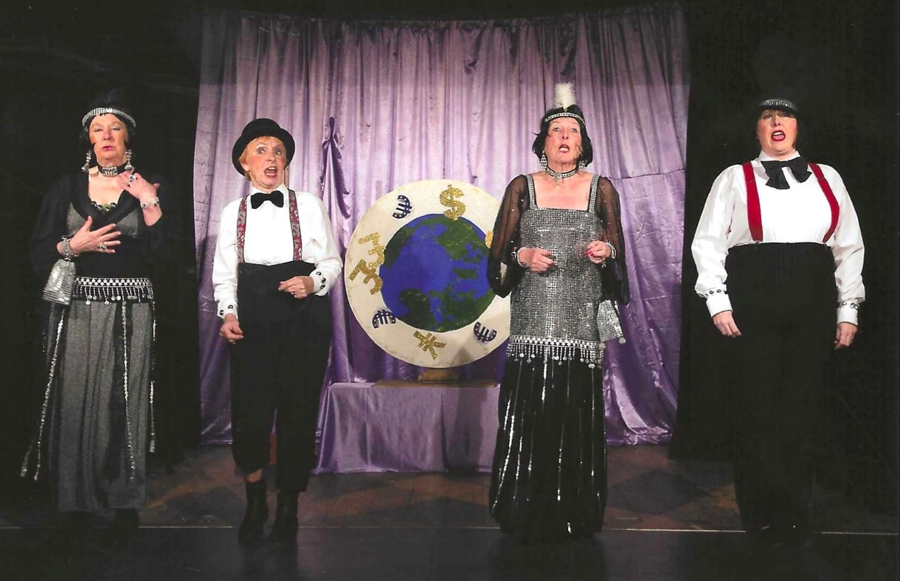

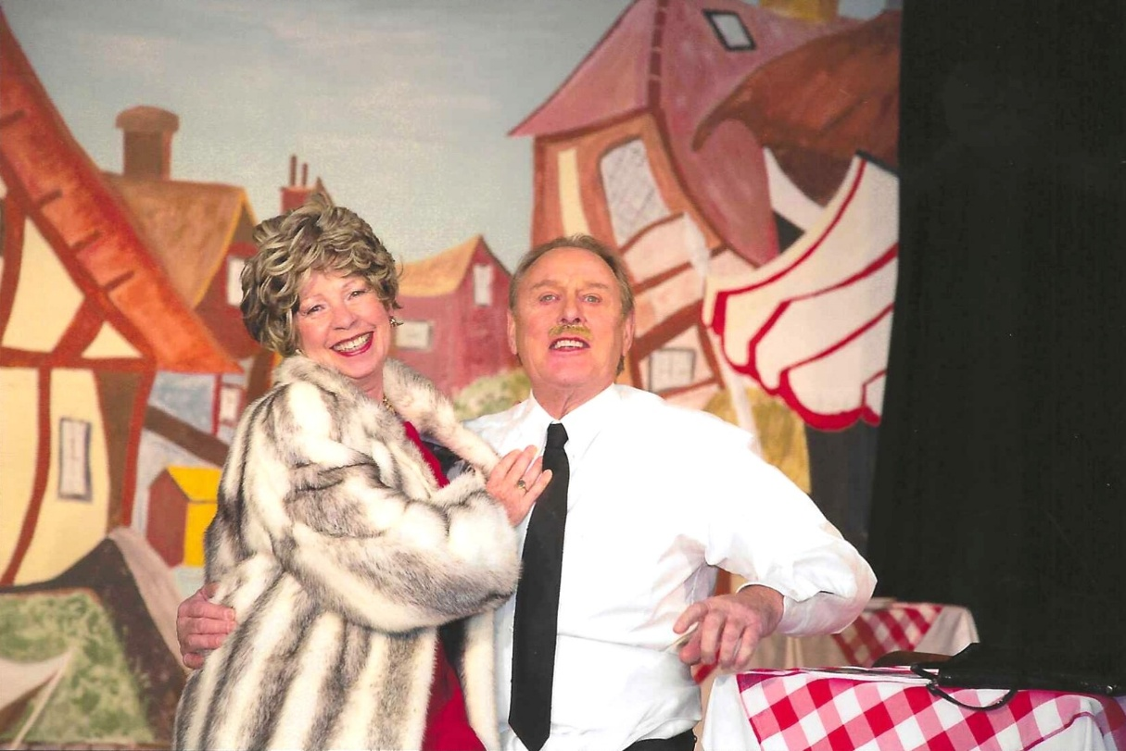

Pam Carter &

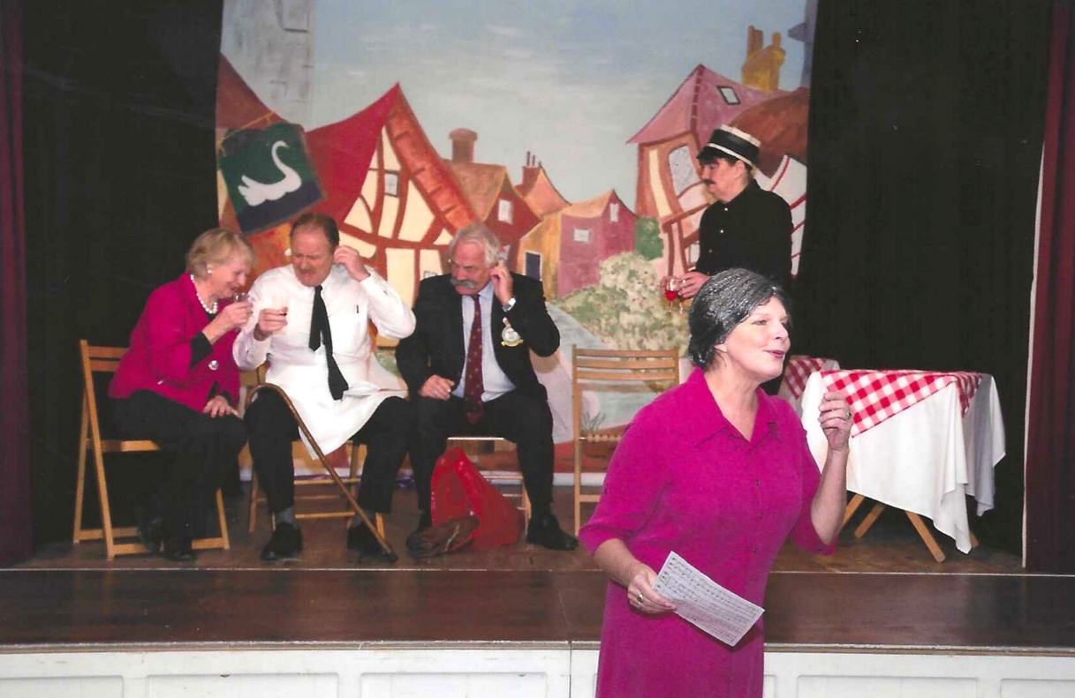

Carol Williams in front.
L-R on stage:

