2006 Tyntsfield Visit
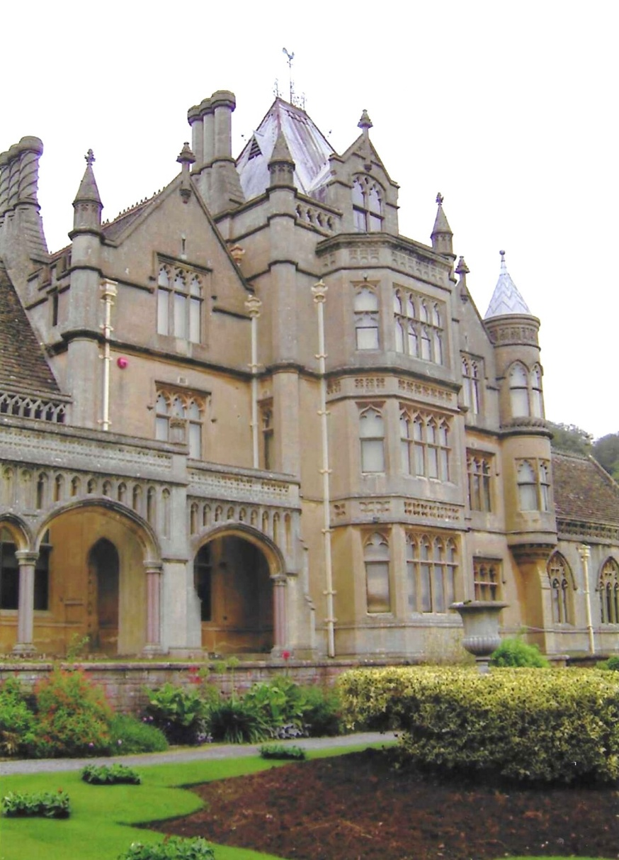

Tyntesfield is a Victorian Gothic Revival country house and estate near Wraxall, North Somerset, England. The house is a Grade I listed building named after the Tynte baronets, who had owned estates in the area since about 1500.

