2007 November Catering for the “Rural Housing Trust” Seminar
Attended by Princess Anne
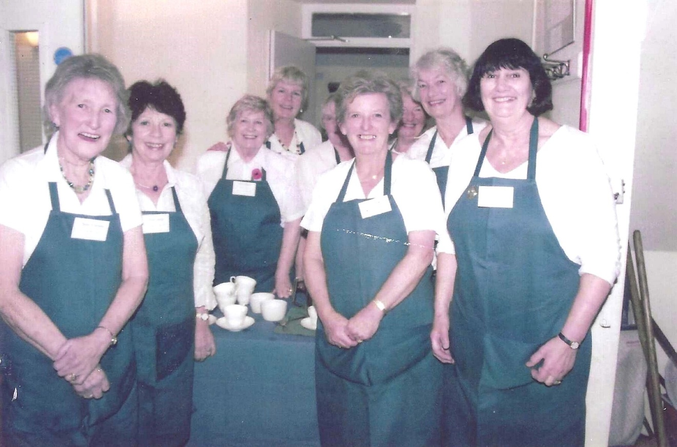
L-R Betty Christie ; Pam Carter; Sylvia Hunt; Kate Lawley; Janet Cattanach; Nikki McDougal; Jean Ellis
