2012 Knit-a-thon Preparation

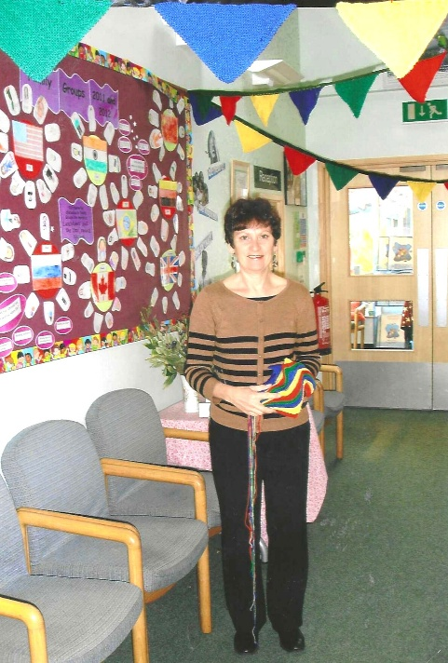

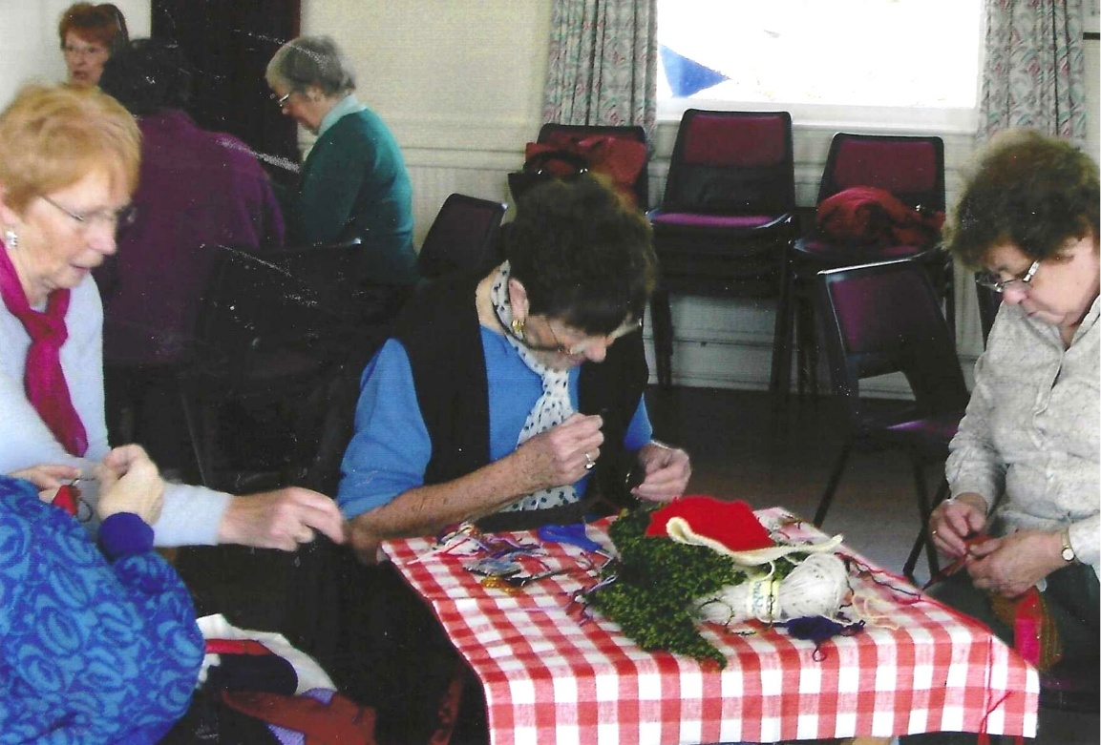

L-R: Angela MacPherson; ?;?

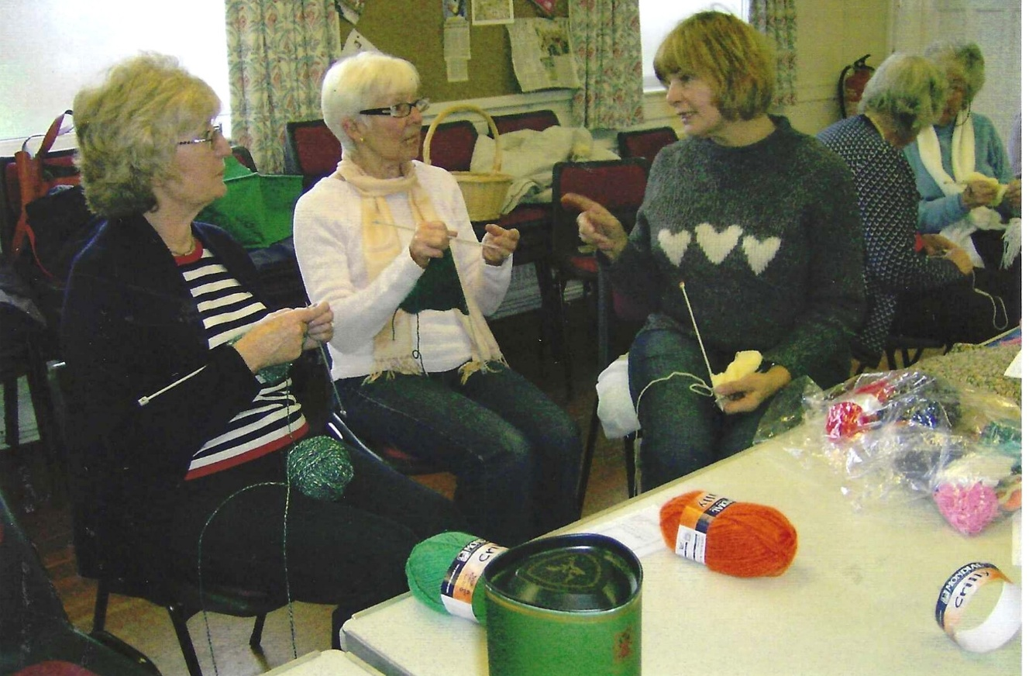
L-R: Jane Jary; Shirley Pegg; Carol Williams; Nikki McDougal; Joan Miller

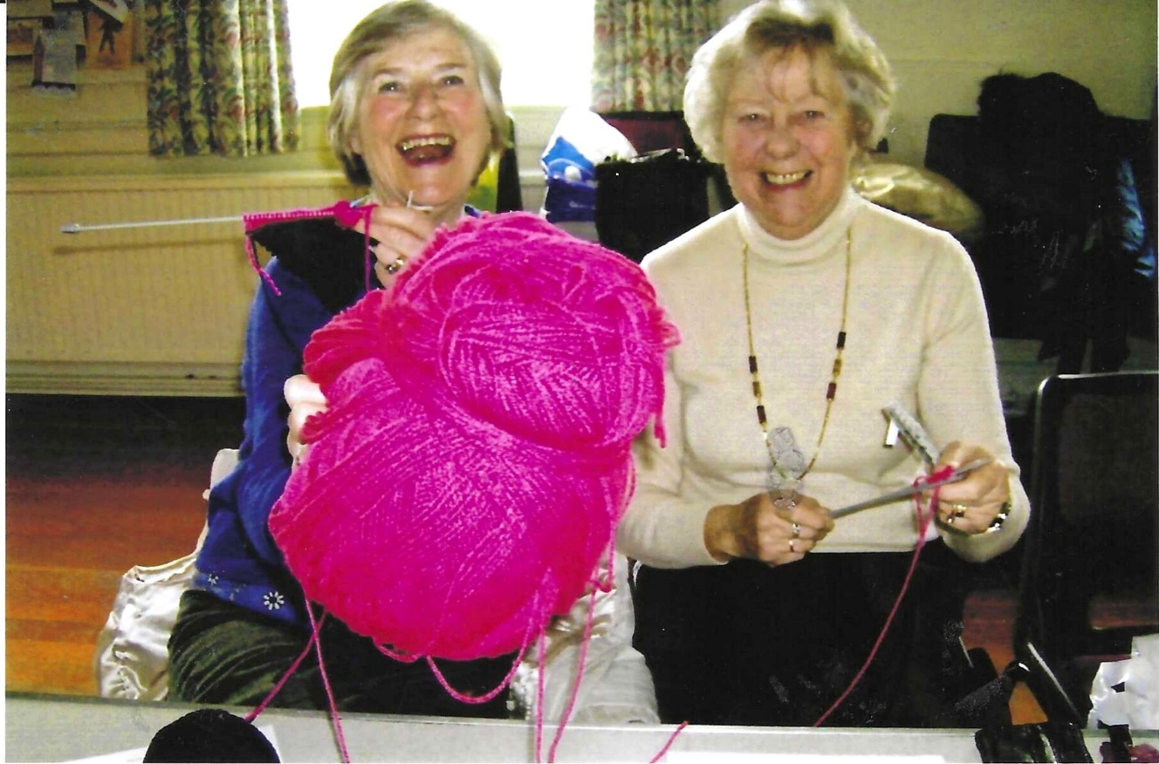
Yvette Steward & Leslie Davenport
