2010 Fashion Show
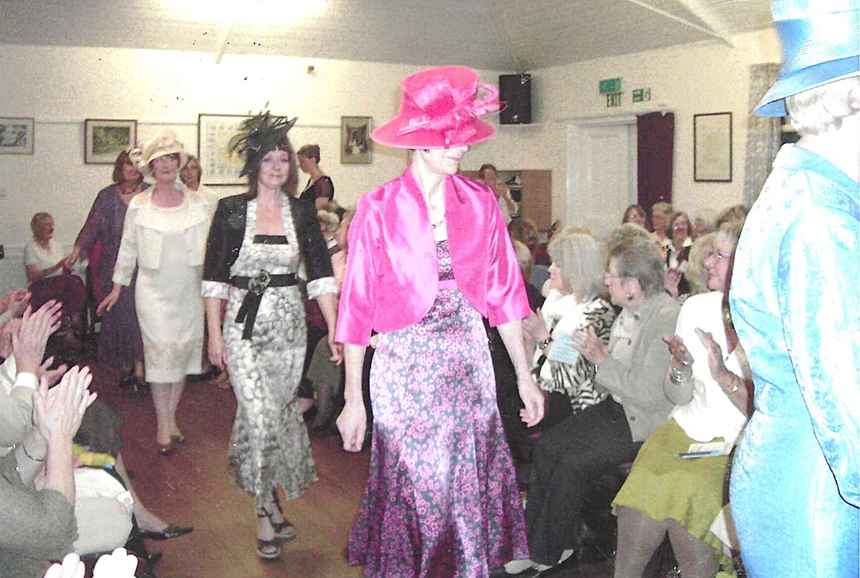
From the front:- Nikki McDougal; Cathy Matthews; Judith Stephenson

President Janet Cattanach with Emma Parker

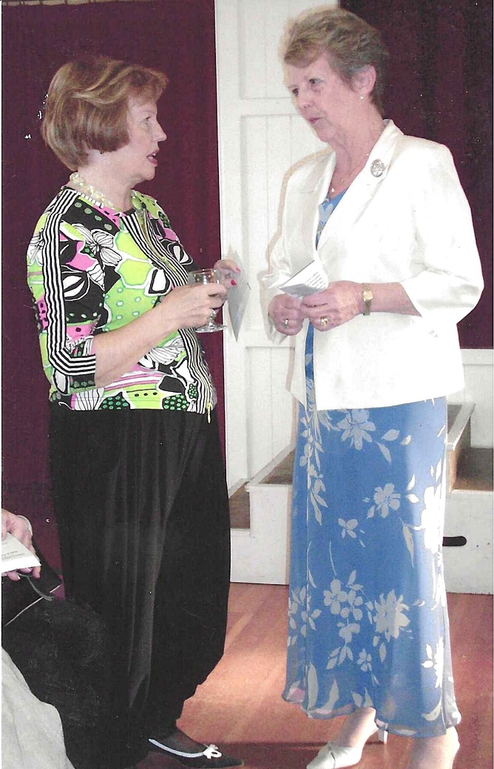

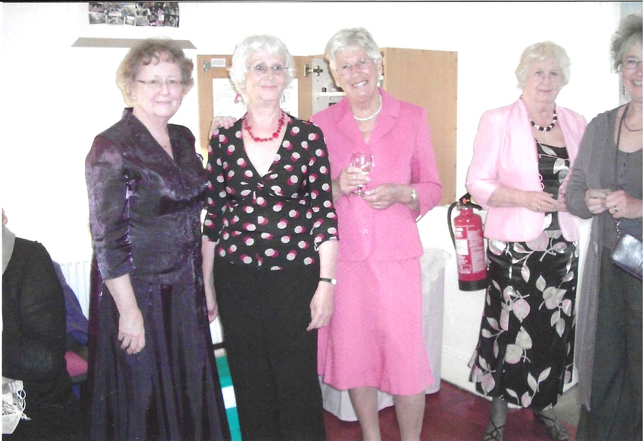
L-R:- Joan Westall; Joyce Stickley; Judy Shore ; Sylvia Hunt.

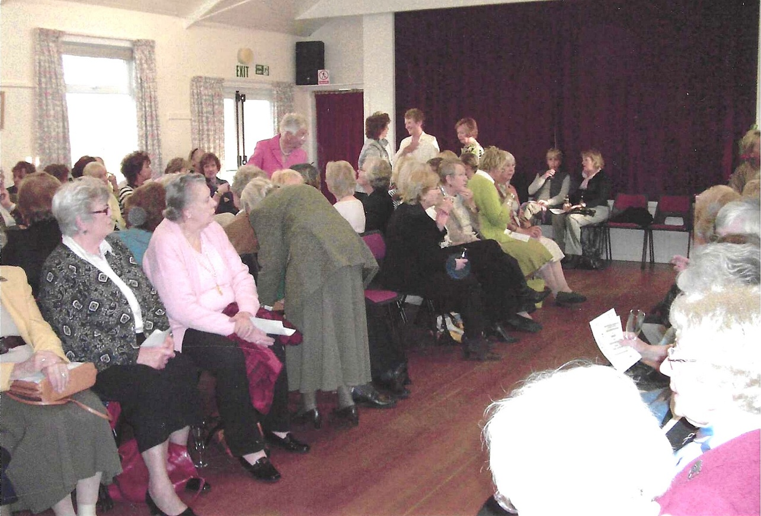

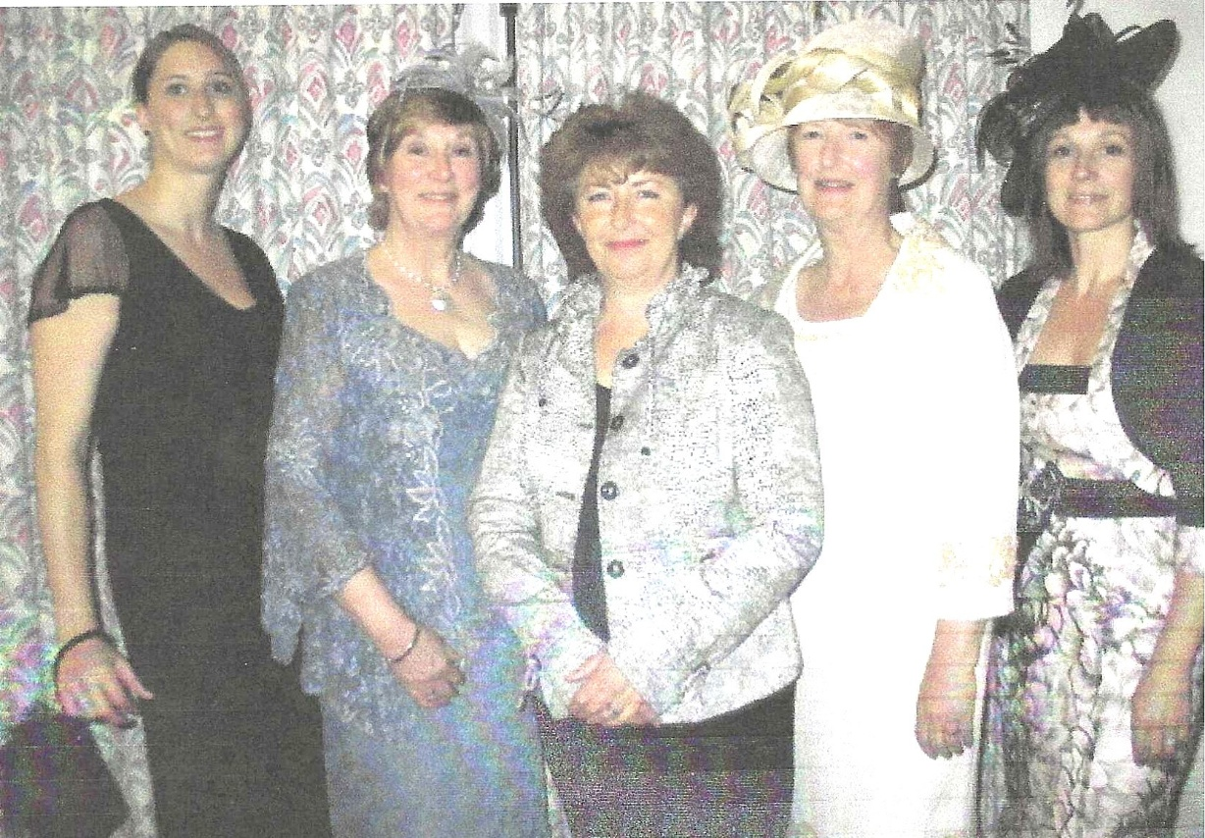

R-L Cathy Matthews; Judith Stephenson;

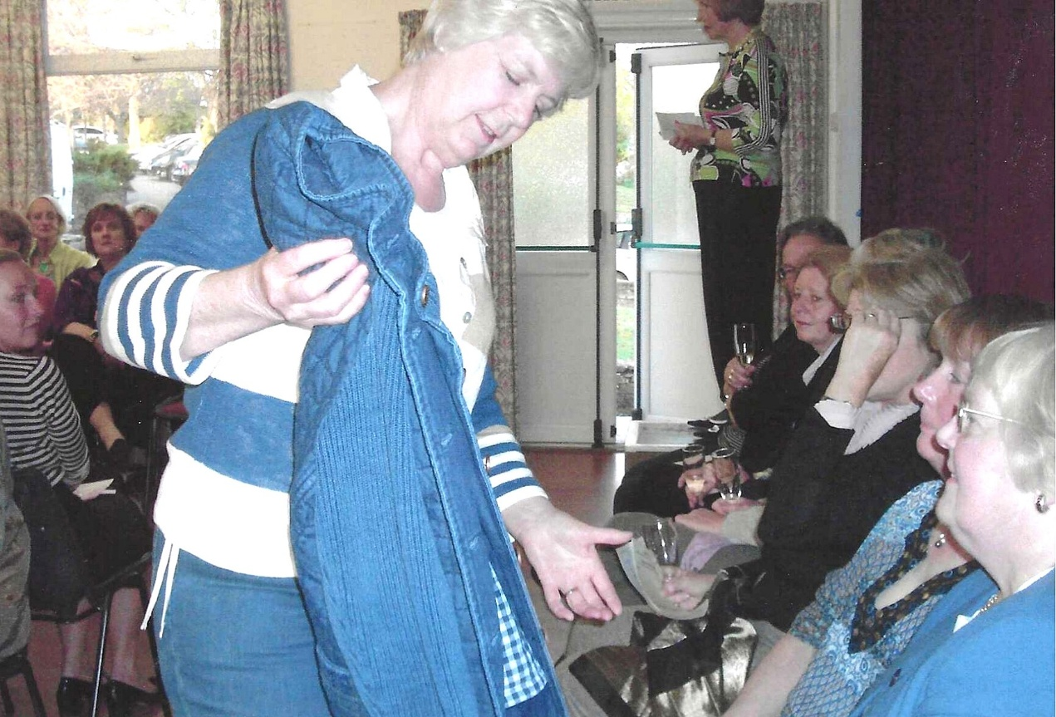

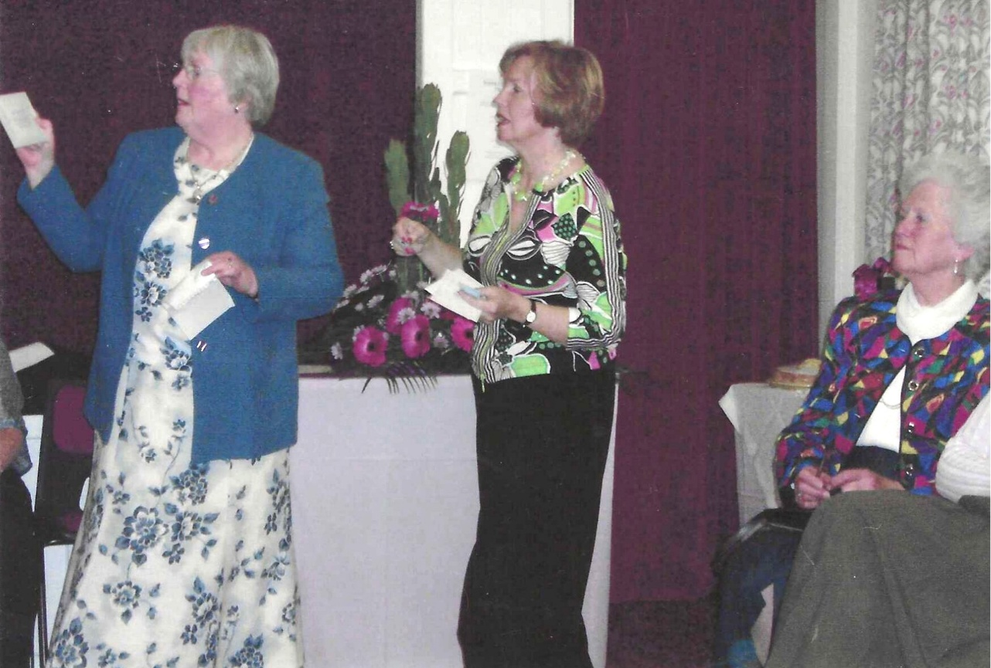
Rosemary Furzeland & Emma Parker

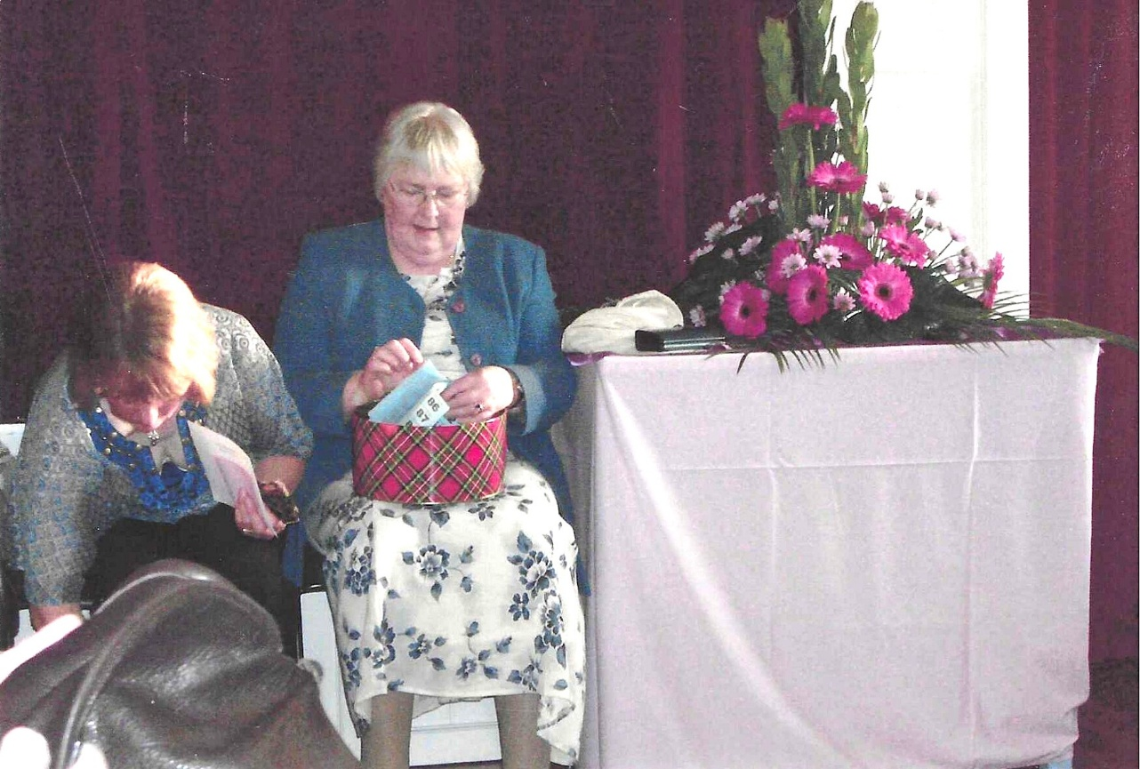

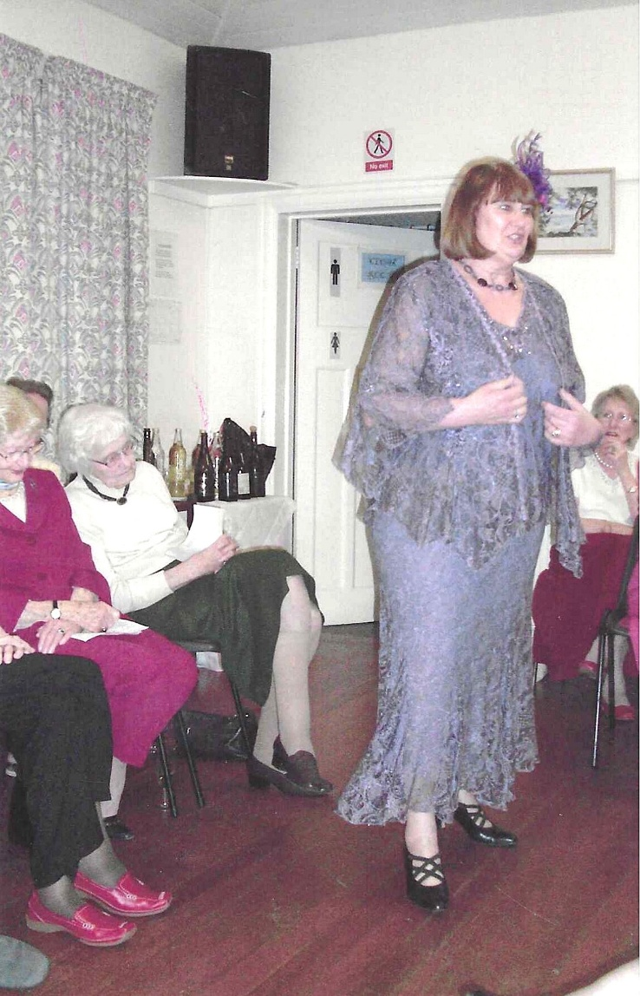

Jean Ellis

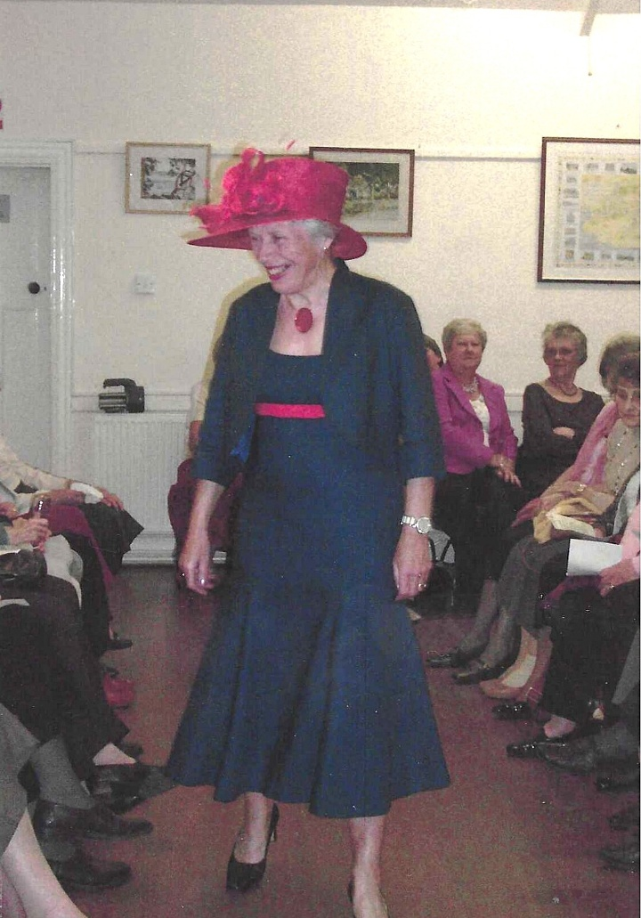
Christine Wilson

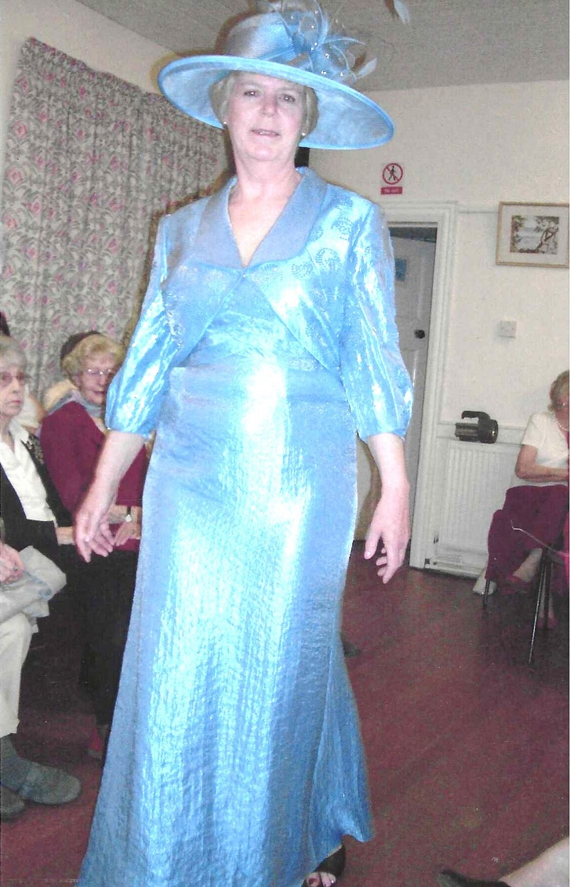
Kate Lawley

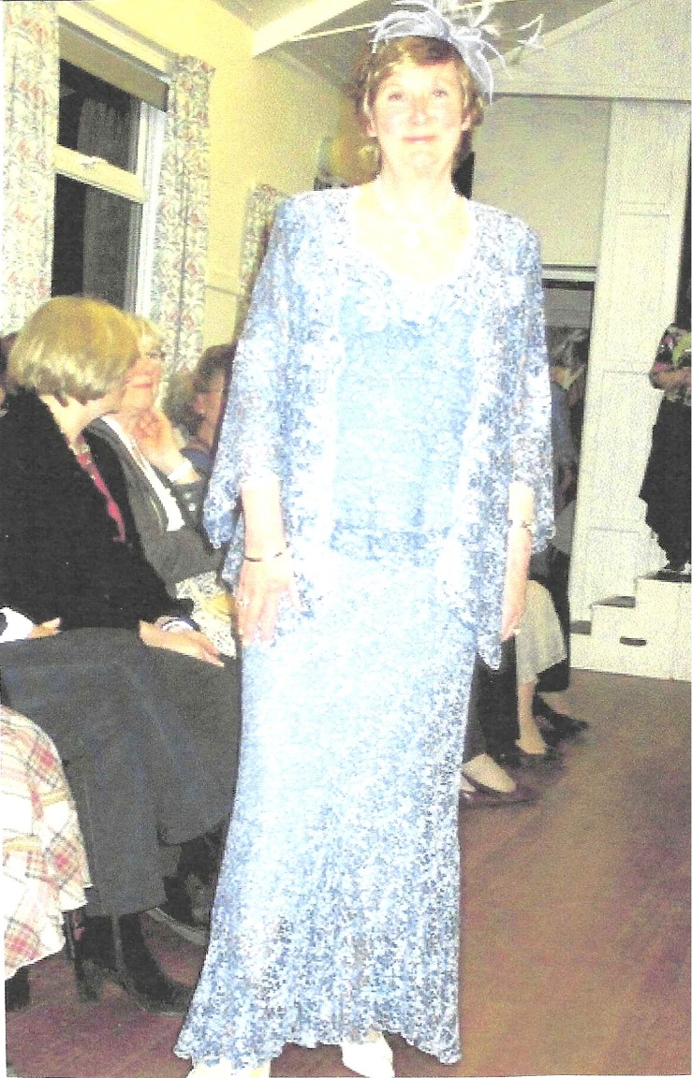

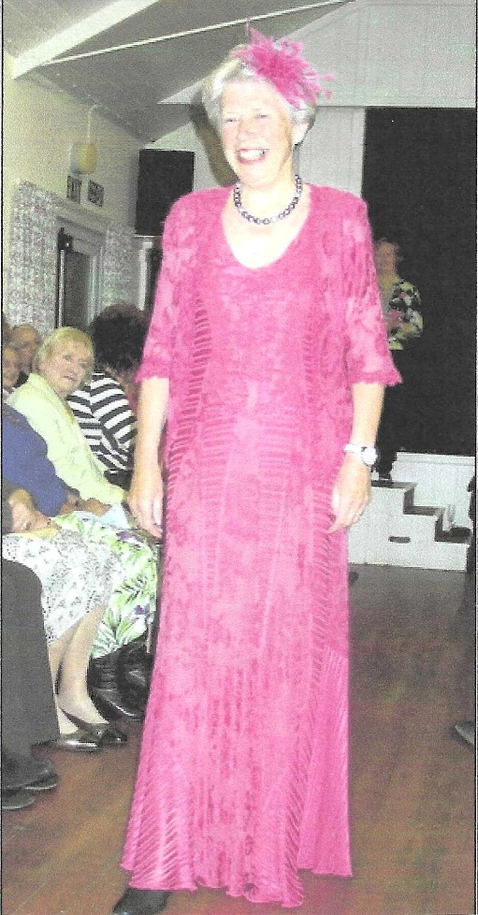

Christine Wilson

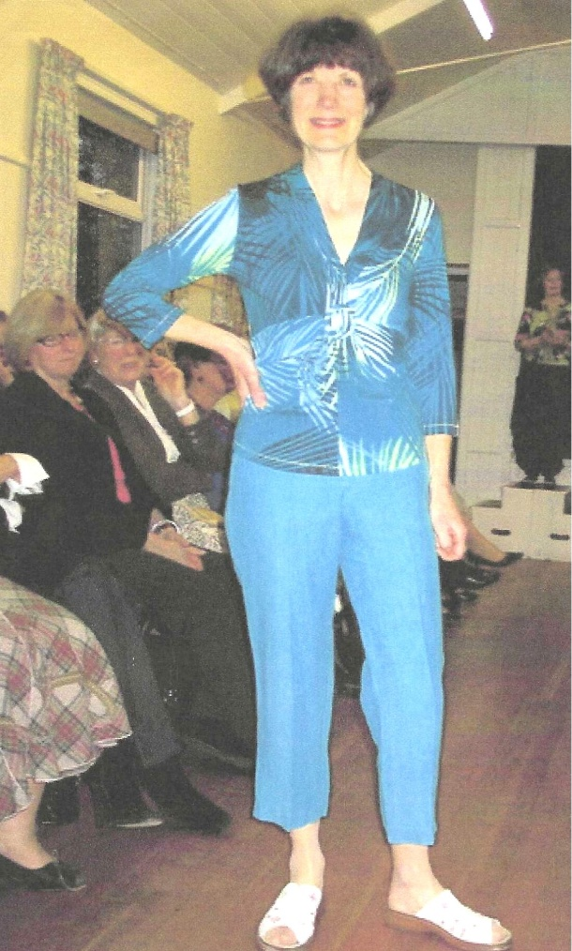

Cathy Matthews

Judith Stephenson; Jean Ellis & Brenda Merritt
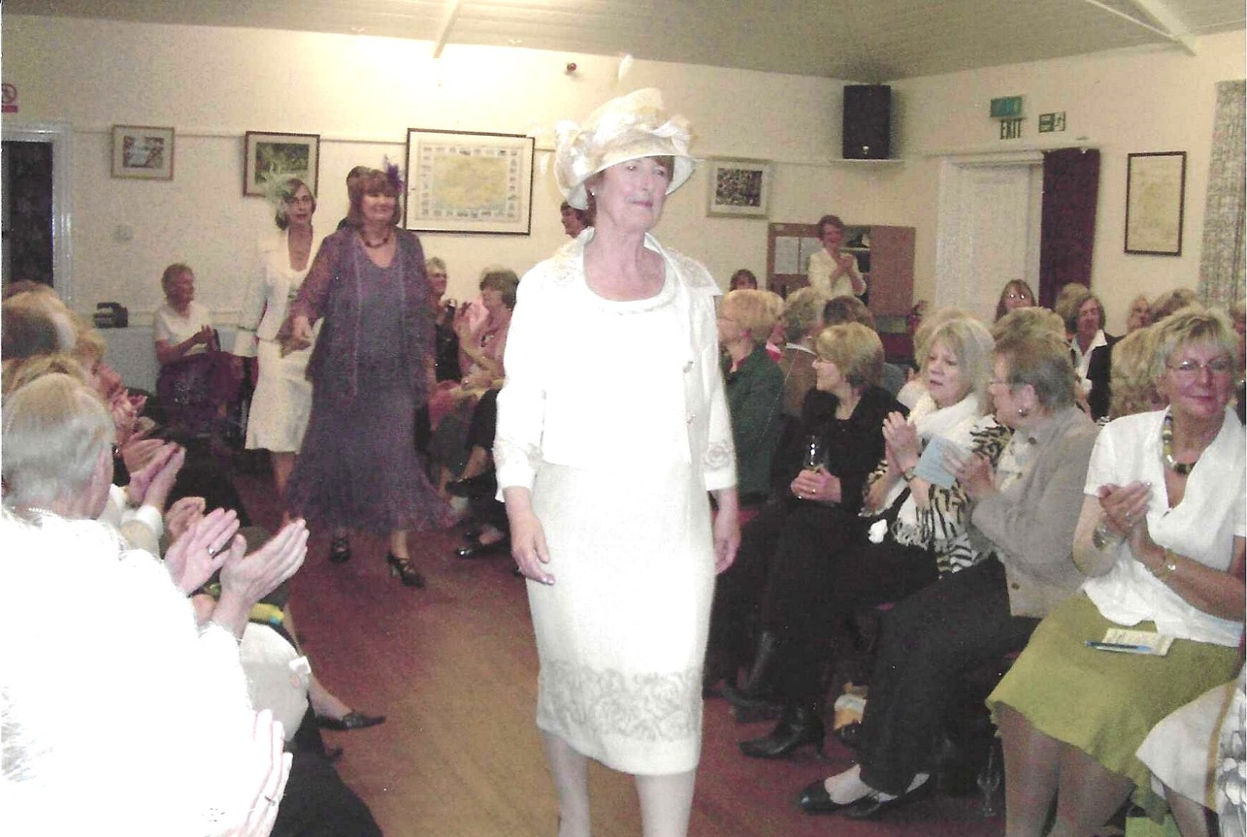
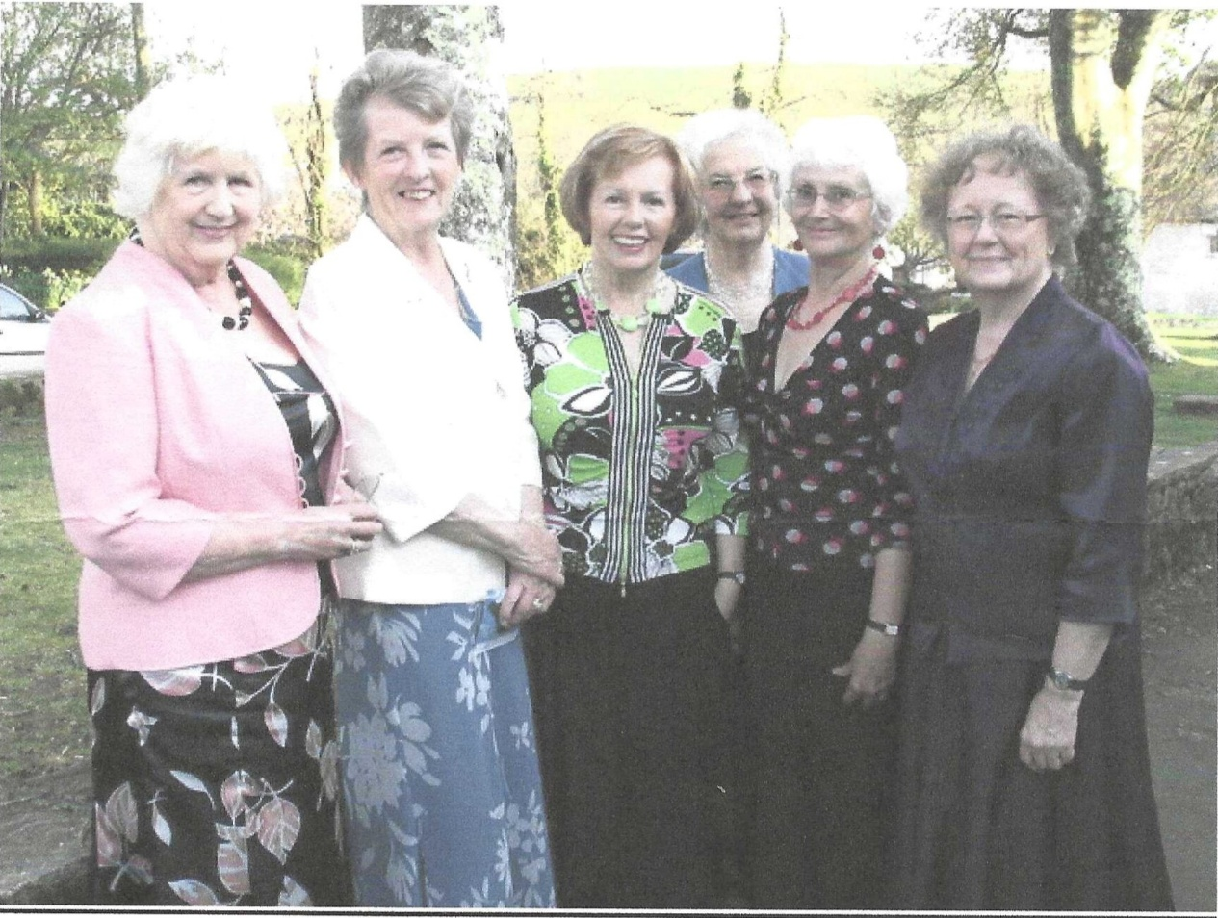
L-R Sylvia Hunt; Janet Cattanach (President); Emma Parker (compere); Joan Miller; Joyce Stickley; Joan Westall

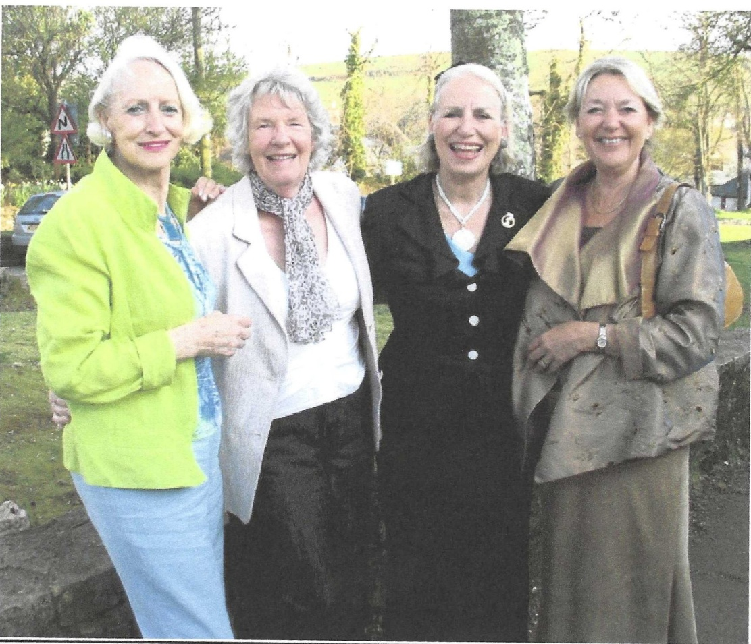
L-R: Barbara Davies; Tessa Fenner; Jenny Powlett & Susannah Bradley

L- R: Maureen Tickle; Avril Wilkes & Olwen Stone

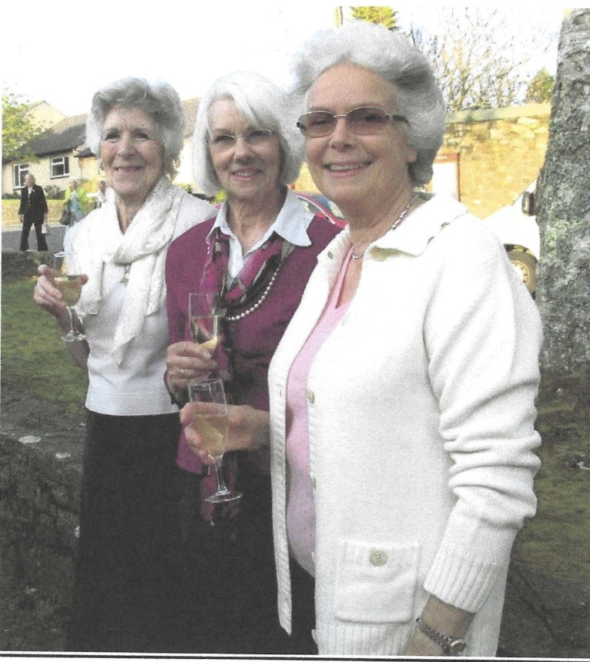

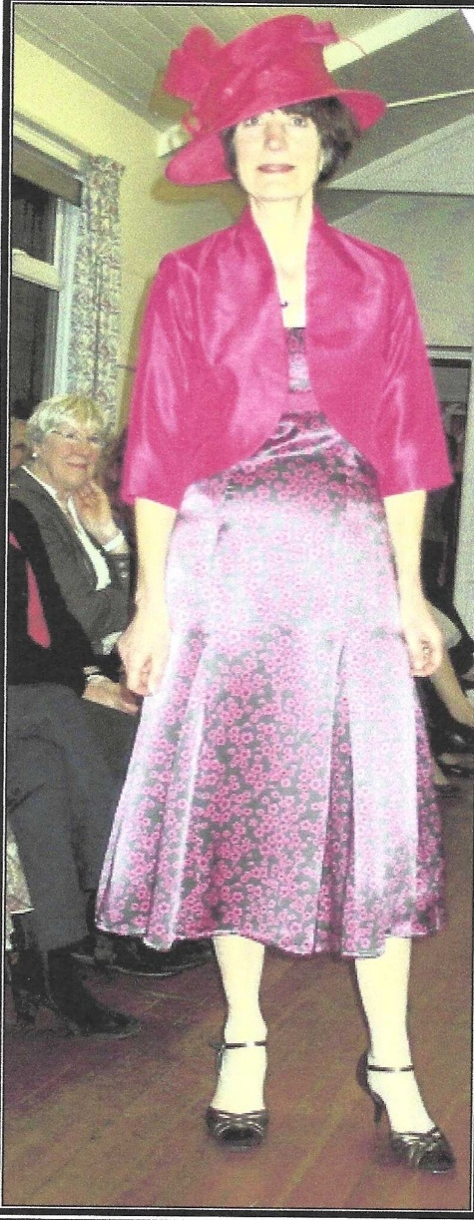
Cathy Matthews Kate Lawley
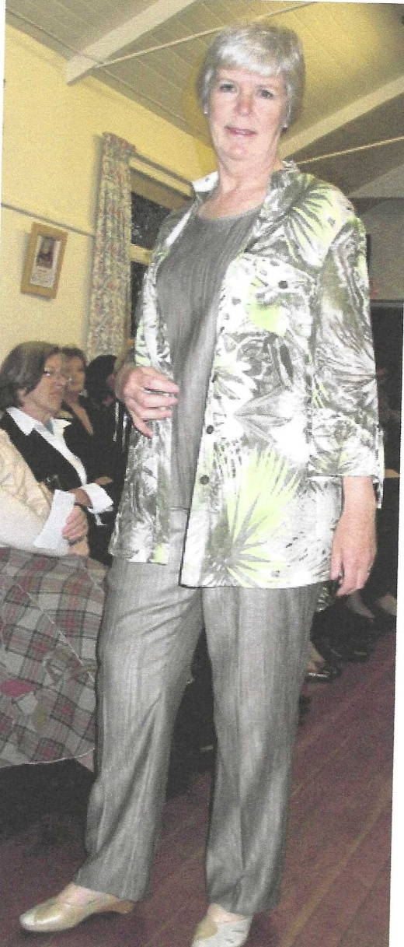

Kate Merritt
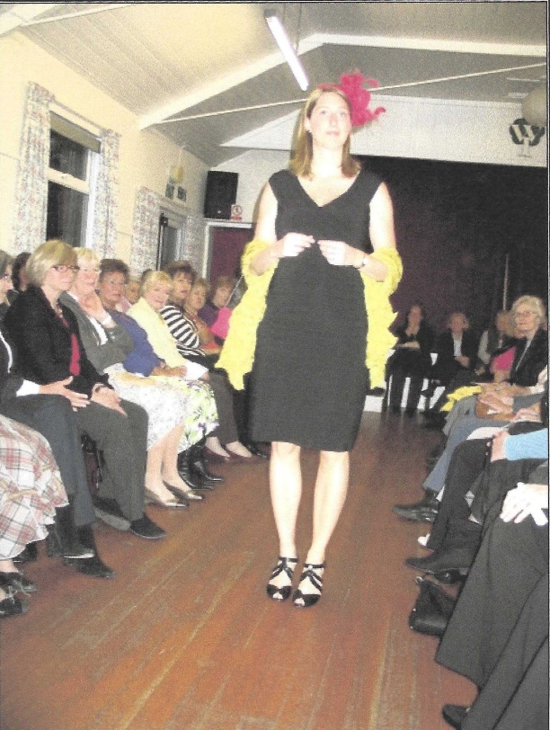

Brenda Merritt
