Afternoon Tea at St Elizabeth’s House
11th April 2025
10 of us went to St Elizabeth House for afternoon tea.
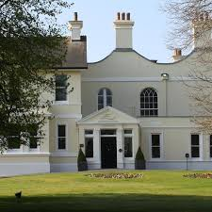
Located in the ancient stannary town of Plympton St Maurice, on the edge of Plymouth in Devon, St Elizabeth’s House is a beautiful example of a plush Georgian manor. Originally built in the 17th century it has been used as a private home and finally becoming a convent for some of the last century. Following a sympathetic upgrade and spectacular conversion, the house took on its current form as a hotel.
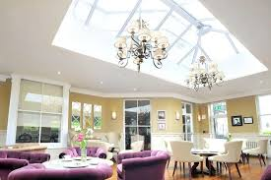
Welcoming guests from far and wide, this independent hotel is prized for its interiors and friendly service. But people also love the views and tranquillity of the gardens and acres of sweeping grounds.
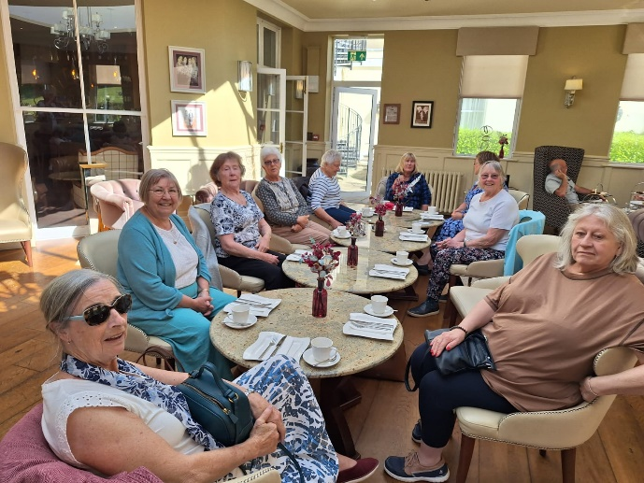
Our tea was in the relaxed elegance of the Darcy Room with its huge glass skylight, chandeliers, and delicate décor.
Afternoon tea was nicely presented, with approximately 4 finger sandwiches each (cheese & pickle, smoked salmon; crème fraiche and cucumber & home baked ham).
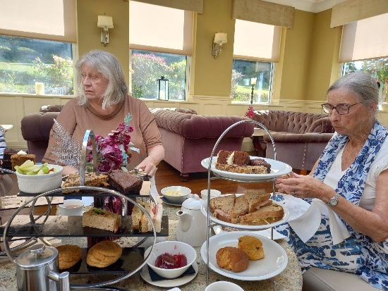
Freshly baked plain and fruit scones with Devon clotted cream & strawberry jam; and a variety of mini cakes. Tea and coffee. Brenda’s gluten free version wasn’t so dainty as she had 2 rounds of sandwiches cut diagonally.
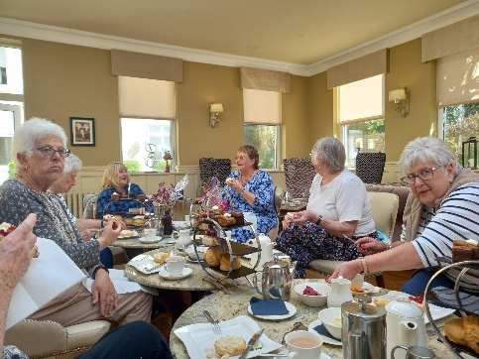

It was nice, but we thought it was a little expensive (£25), if you compare it to a lunch. 2 Courses at £23.95

