2026 A Cimema trip to the Vu.

On 16th March Gill Tune, Stella Gullen, Jackie Ross and I went on the first of our WI cinema trips.
We had lunch before the film at Fry’s Grillhouse. It was delicious food, good background music and clean. Brunch was half price until 3pm.
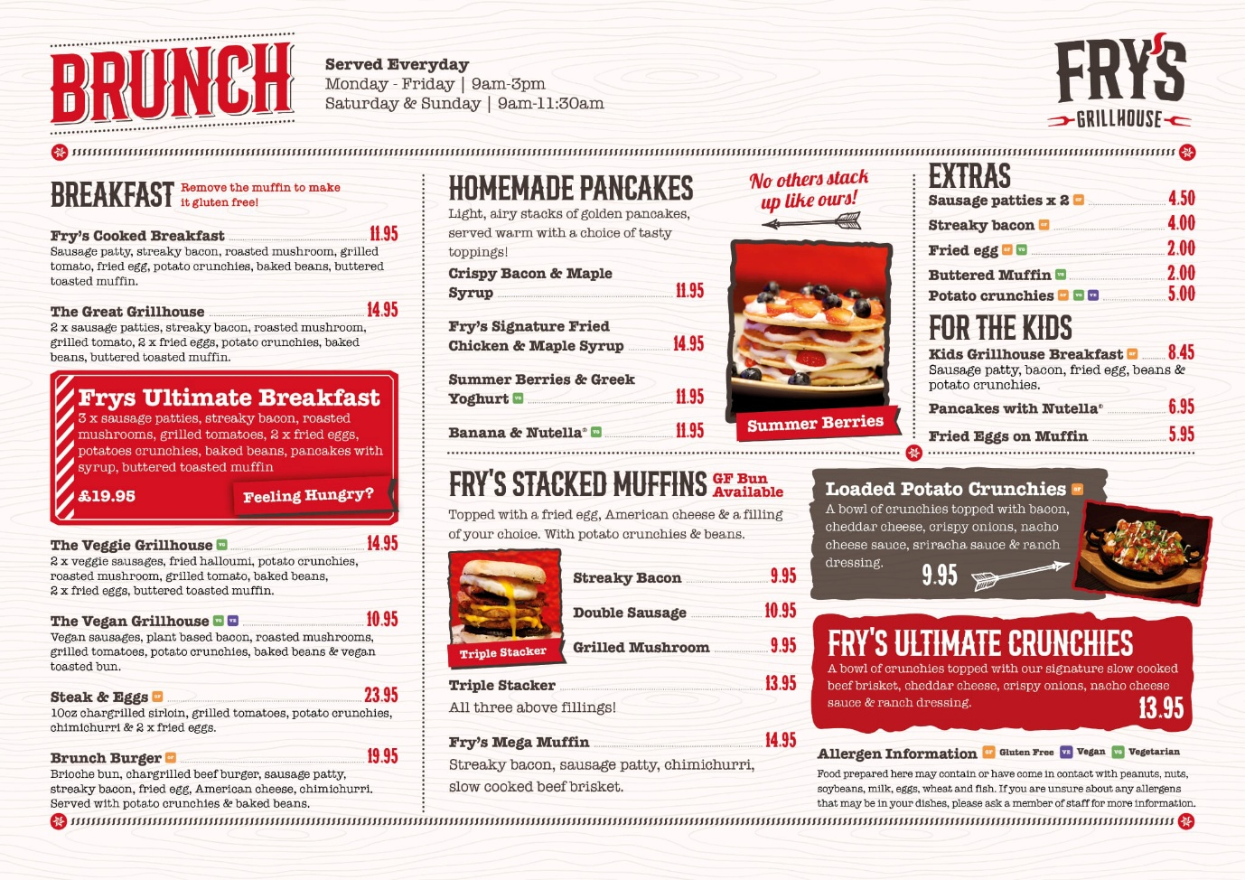
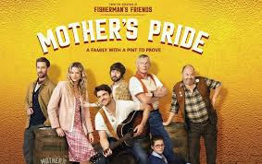
Then it was time to go into the cinema to see the film “Mothers Pride”, starring Martin Clunes. It was a comedy about a failing pub, a divided community and a grieving family whose lives are changed by brewing real ale and entering the Great British Beer Awards.
It was very funny and great to see a British film.
We all enjoyed it and had already eyed up our next cinema excursion.
Written by Lesley Dempsey

