Woolly Mammoths at Kitley & Hippopotamus in Yealmpton? -You are having me on!
Newton & Noss WI had a day out at the Box in Plymouth; and I must say it was really interesting.
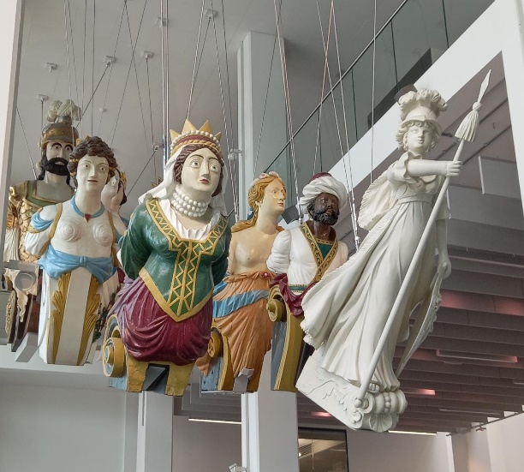
However, the Box & the Barcode are two entirely separate places on opposite sides of Drakes Circus. – Our driver, Lesley, thought she knew where she was going but didn’t!
Once at the Box however, we were greeted by a very nice man who told us where things were, and left us to wander as we desired.
The first thing we saw were the 14 huge figure heads hanging from the ceiling. They were quite impressive.
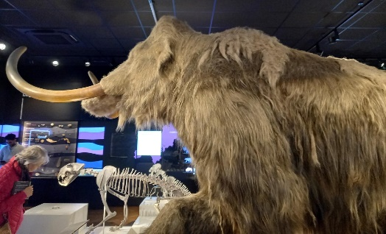
The Mammoths were on Jackie’s list of things to see., They were huge. Woolly Around 50,000 years ago Mammoths, woolly Rhinoceros, Hyena’s and bears once roamed around what is now Kitley Estate. Scattered below the Estate are a huge number of caves, which preserved thousands of fossils.
During the Ice age, there were very warm periods (I always imagined it to be extremely cold). It was warm enough for Hippopotamus to swim in Devon. Fossils of these creatures from the caves in Yealmpton, show that 125,000 years ago the temperature was much warmer than it is today.
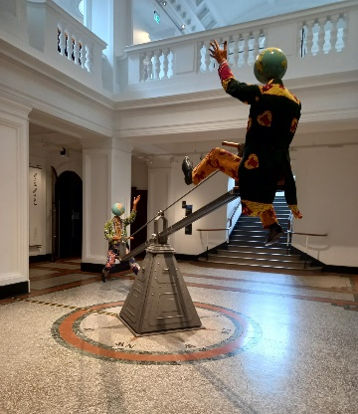
The Box wasn’t all about pre-historic creatures; There was an interesting film on Plymouth in the days of mud huts, right up to the modern day; Films about the dock yard and Navy; A corner dedicated to Women in miniature paintings; a room dedicated to Oceanography; a media lab an archive room, and an excellent café.
In the centre of the building was a see-saw. It was called “the end of the Empire”. It depicts 2 figures with globe heads on a steam punk see-saw, a symbol of Victorian industrialism & was supposed to represent the balance of power at the onset of the First World War. A visual connection between the conflicts of the West, Globalisation and the Empire.
It is well worth the visit. Museums are no longer stuffy places; but beware the children in school parties who are encouraged to run and look at things.

