2025 16th December Christmas Lunch

We had booked our Christmas Lunch at the Yealm Yacht Club again.
The food was good and plentiful and our diets and allergies were catered for.
36 of us sat down this year. A few members were ill with flue, and some had a take away lunch.
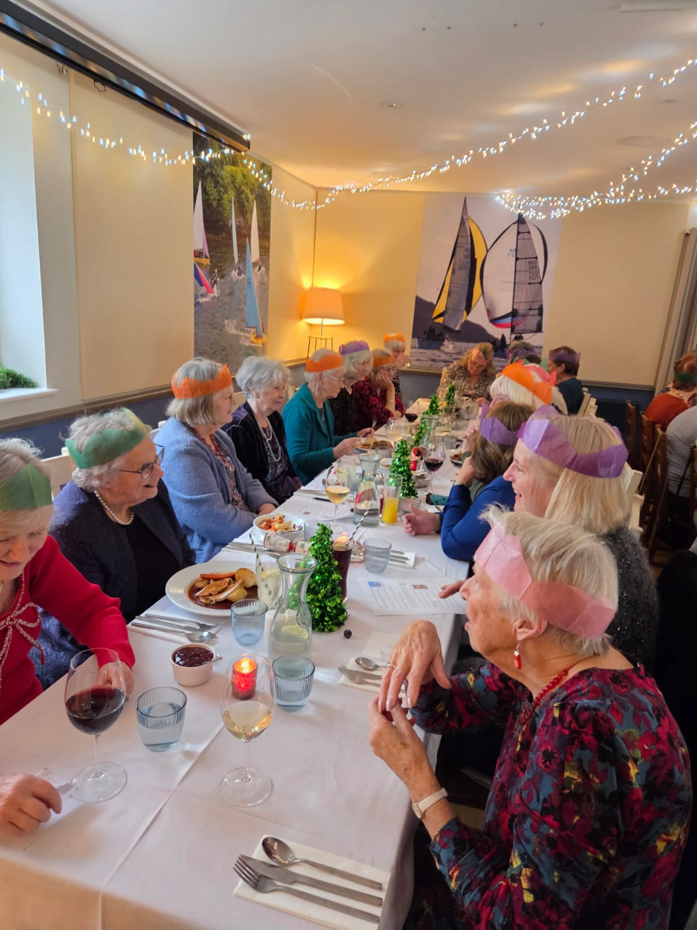
Nan bought the first round of drinks which was very kind of her.

R side Christine Wilson; Sarah Cooke; Julie Thomas
L side Yvette Steward; Enid Whiteman; Jeanne Venning; Pam Carter; Angel MacPherson; Margaret Pritchard

Lesley had set a quiz for us to think about while waiting for lunch.
The answers were given over coffee, the winning teams had 15 out of 28.

R side Brenda Merritt; Carrie Dixon; Stella Gullen; Trish Stringer; Lesley Dempsey; Joan Miller; Hilda Julien; & behind the quiz sheet is Nan. L side is June Blackburn
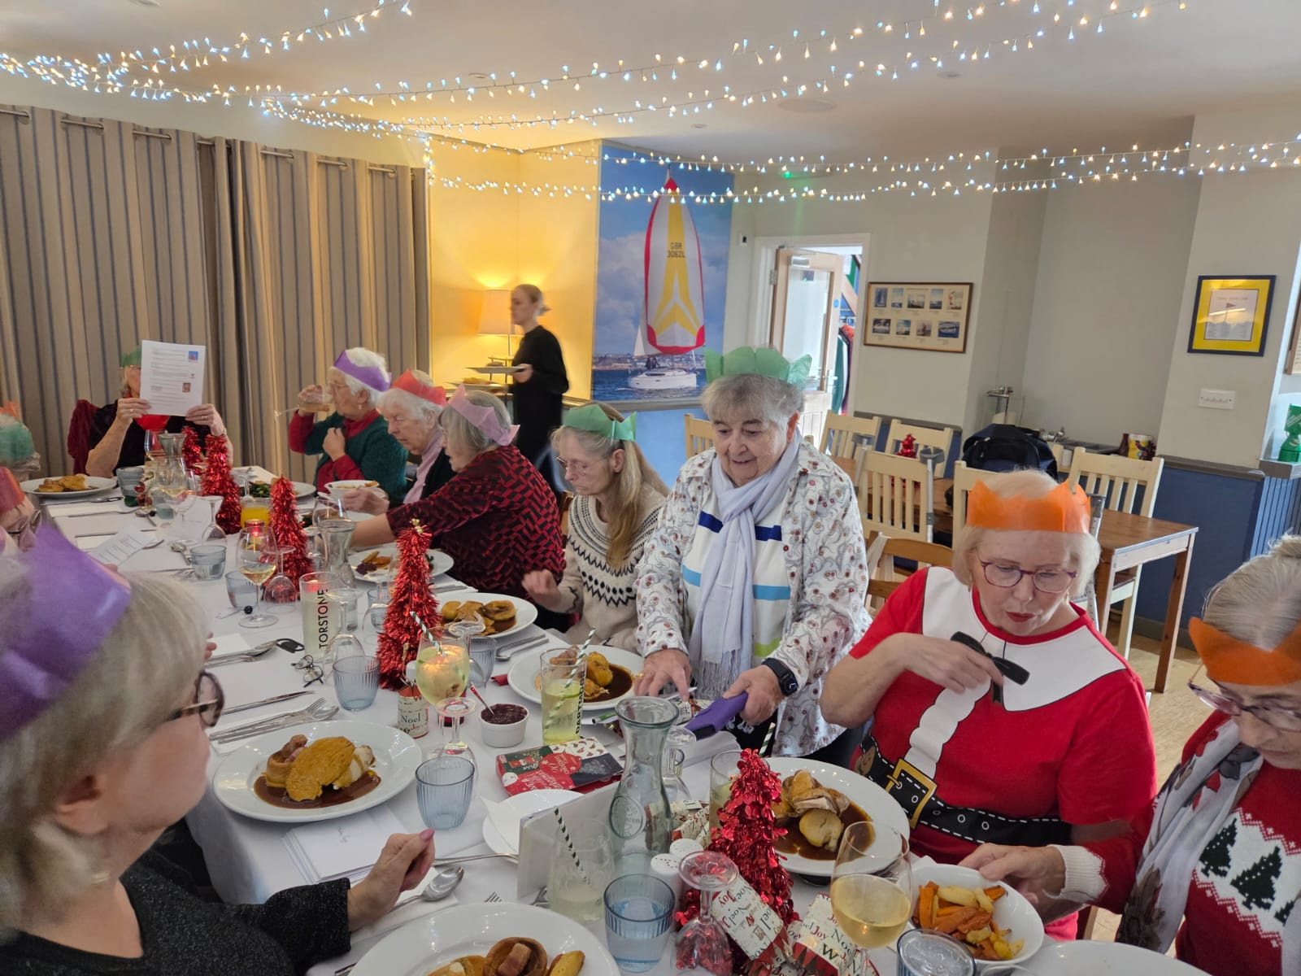
Lunch was traditional turkey with roasted potatoes, Carrots, Parsnips, savoy cabbage, brussels sprouts, & green beans. Christmas pudding garnished with a slice of preserved orange was next, and with the coffee we had mince pies

After lunch Trish Stringer read a witty Christmas poem. Jean Ellis, Carrie Dixon and Jane Barnett did a sketch about politically correct fairy stories, which had us crying with laughter.

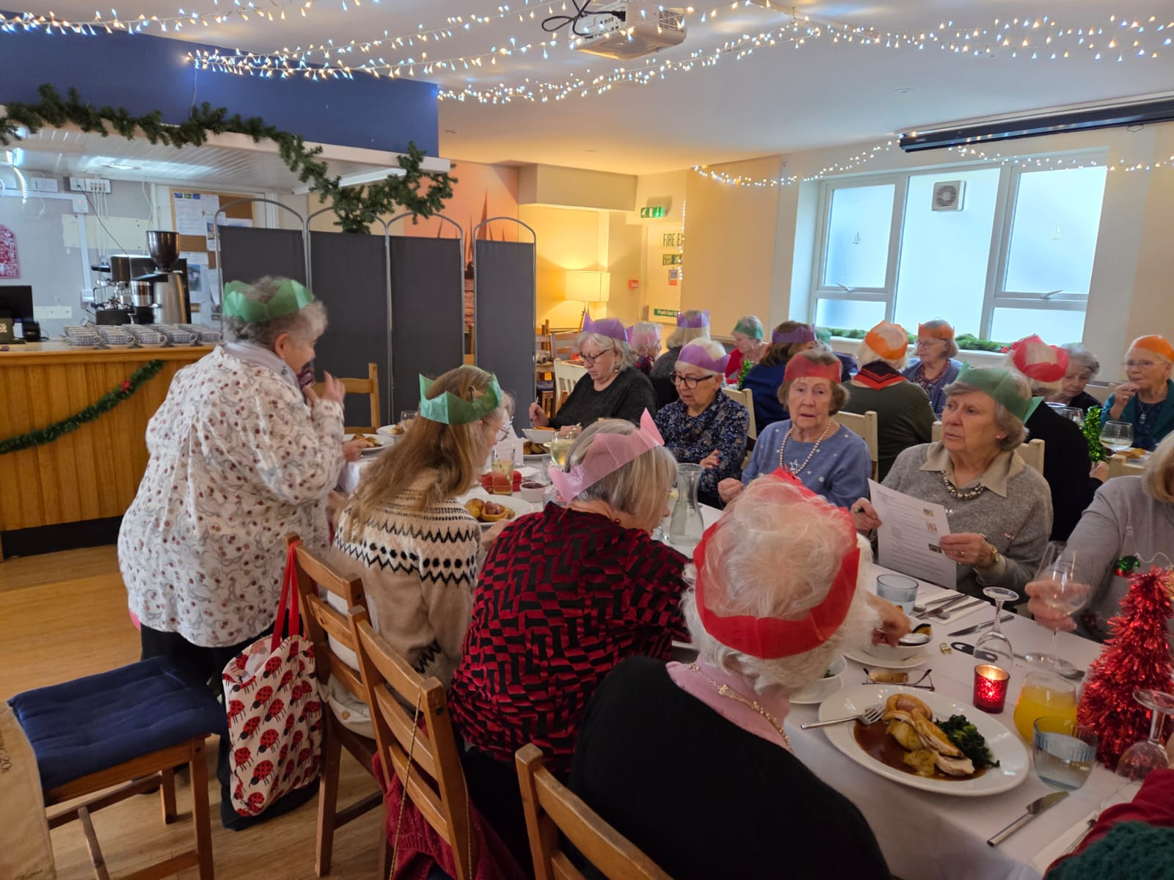
R side of table: June Blackburn; Shirley Pegg; Gill Tune; Jane Barnett & Jean Ellis’s hand.
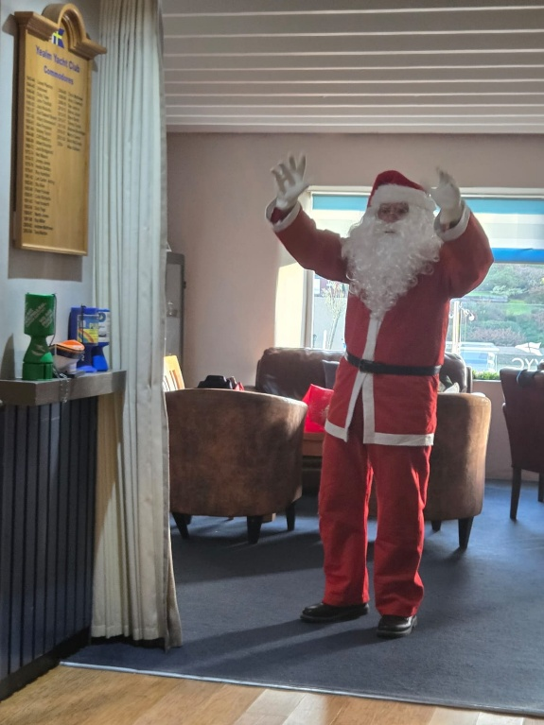
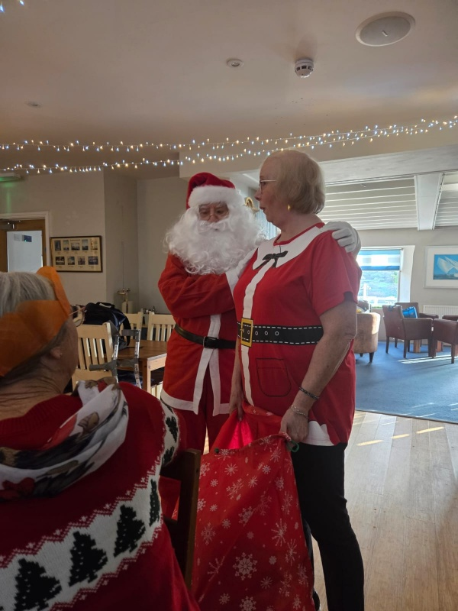

After this we sang a few carols, and then Santa appeared bearing secret gifts, assisted by Carrie.
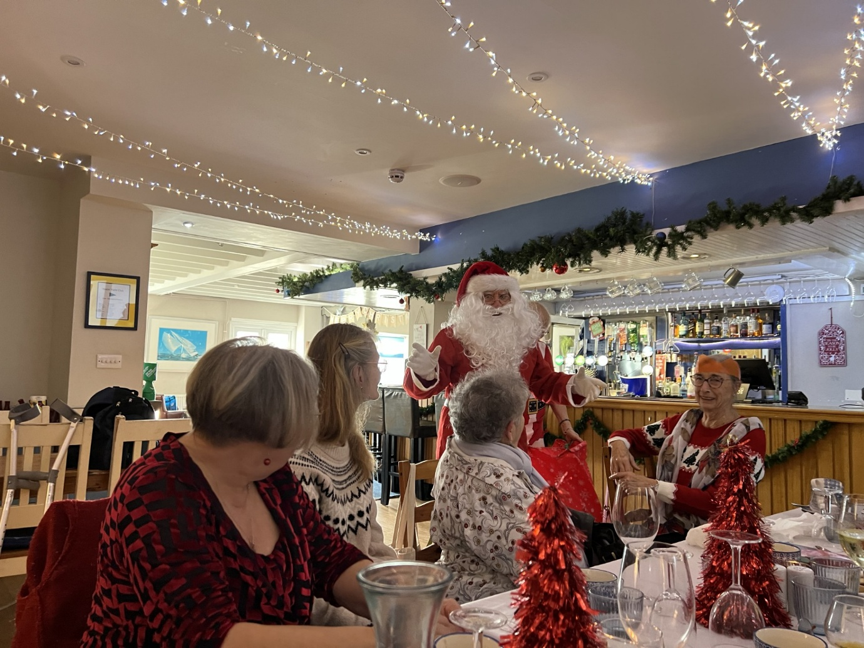
L-R Lesley Dempsey; Trish Stringer; Stella Gullen; Brenda Merritt and Santa

