Lunch at Wildwood, Royal William Yard
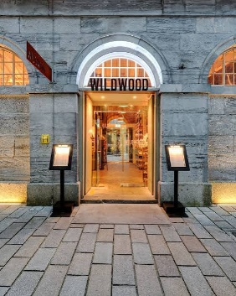
September 2026

Jackie Ross had organized a lunch deal at Wildwood on 9/9/26.
Wildwood is in the old Slaughterhouse building at Royal William Yard. It has been sympathetically decorated with reclaimed materials.
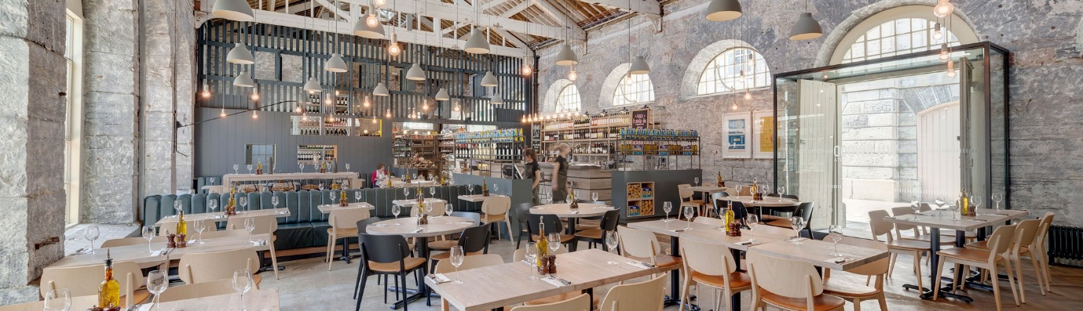
It was 2 courses for £10! – specially for over 60’s and students.
The menu looked OK, and we were surprised when we were served as the portions were generous.
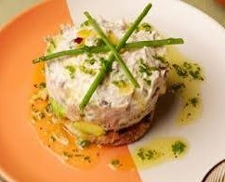
Angela and Joyce had tuna starters which they decided had tarragon in it. The tuna was on a bed of avocado; it looked really nice.
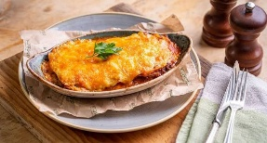
The main courses we decided on were lasagna, spaghetti bolognese and a butter chicken burger which came with exceptionally nice fries.
Desserts were really yummy, with us choosing Tiramissu, caramel profiteroles, cookies and cream cheesecake and ice creams.
Drinks were reasonably priced too. Would we go again? We all said yes!
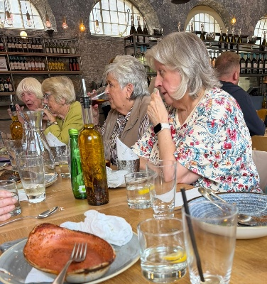
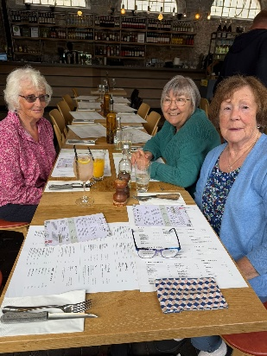
We were early, and got a head start on the others drinks wise. (Stella took the photos).
Once the others arrived conversation flowed really well, with ladies chatting to those they hadn’t had a chance to get to know.
Joyce, Lesley & Gill Barbara, Diane, Jackie & June
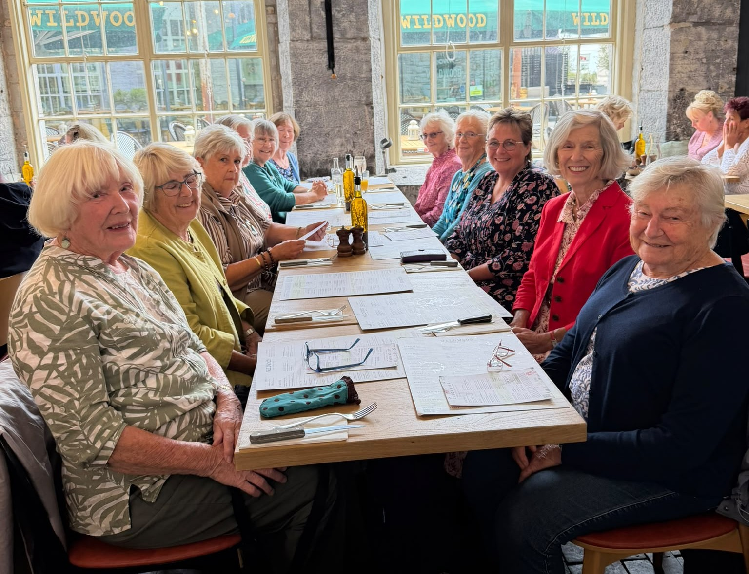
Left side front to back
Barbara Geddes; Diane Chapman; Jackie Ross; June Blackburn; Lesley Dempsey & Gill Tune
Right side front to back
Yvonne Mustoe; Maragaret Pritchard; Bryony Lloyd; Angela Macpherson; Joyce Stickley; & Stella Gullen’s empty chair.

