2024 Holy Cross Flower Festival
WI Entry

Janet Cattenach & Gill Tune worked their magic at Holy Cross today (14/06/24), staging the WI entry for the flower festival.
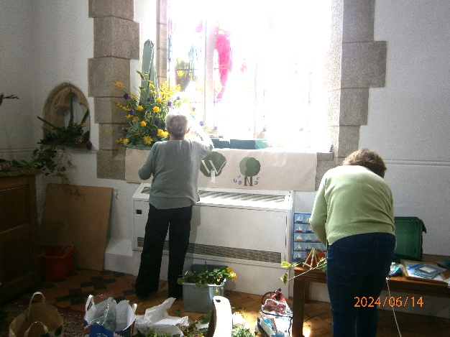
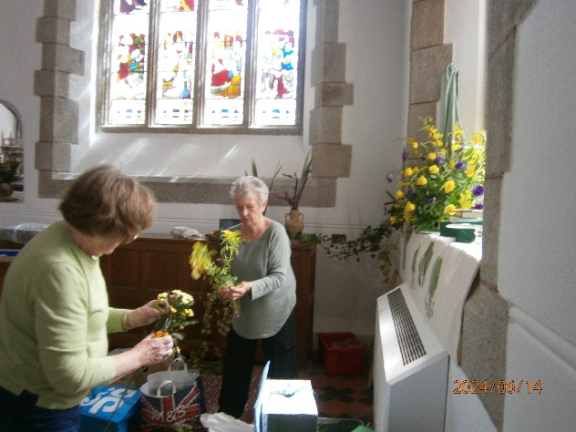
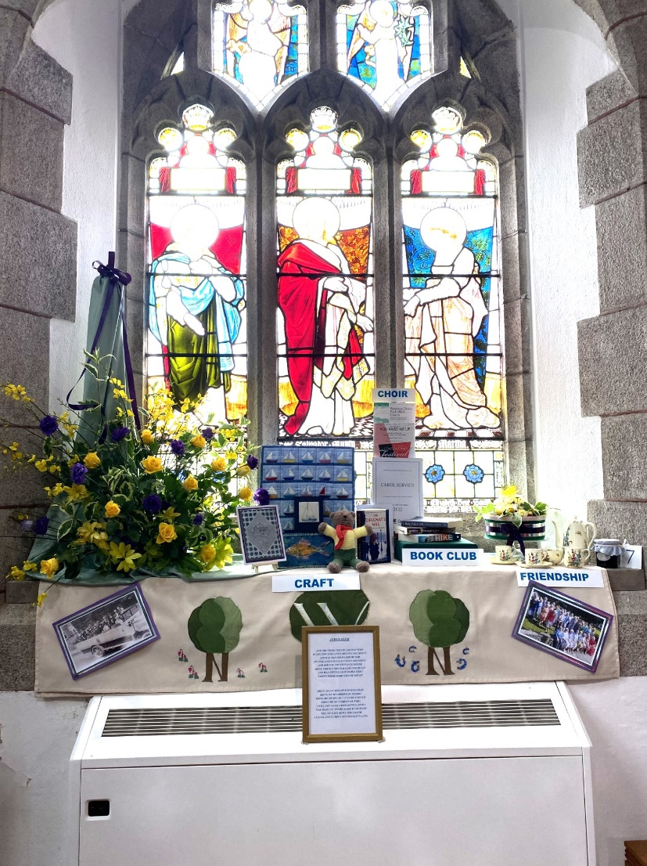
They have captured all the aspects of our WI not only with flowers, but photographs, craft work, books and music sheets.

