2009 WI Choir at Tuesday Lunch Club
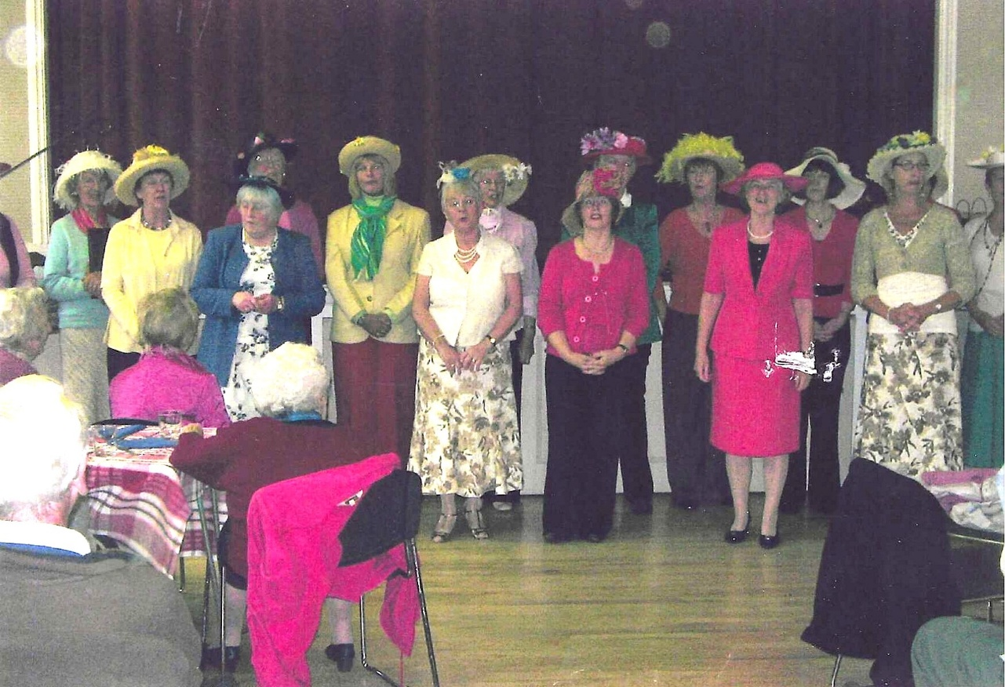
l to r …
? Jane Barnett, Rosemary Furzeland, Anne Crawford, Carol Williams, Sheila Pearce, Judy Shore, Emma Parker, Judith Stephenson, Yvette Steward, Cathy Matthews, Brenda Merritt, ?, Janet Cattenach.

