2009/10 Committee

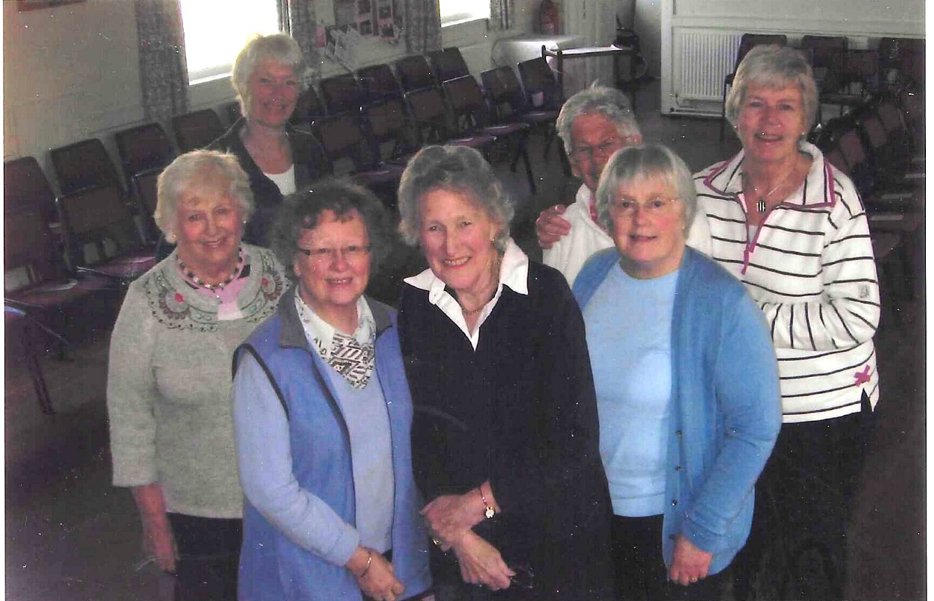
L-R front:- Sylvia Hunt; Joan Westall; Betty Christie; Rosemary Furzeland.
L-R Back:- Nikki McDougal; Judy Shore; Kate Lawley

