Olympia June 1984

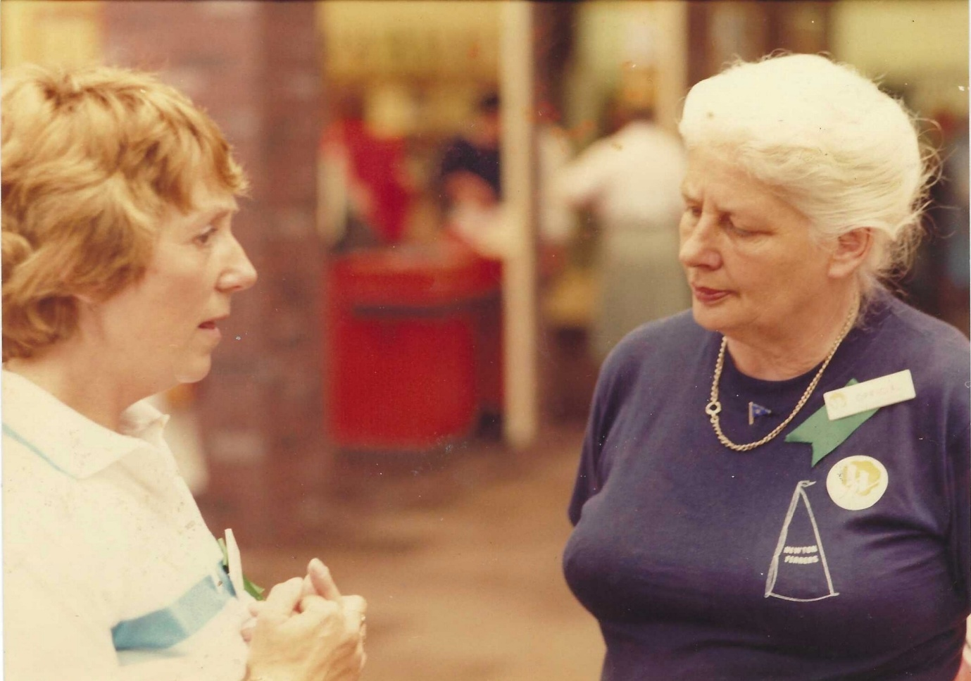

Margaret Andrews &
Norma Powner of Elvaston Inst. Derbyshire

