2015 Breeze Fashion Show 21st April

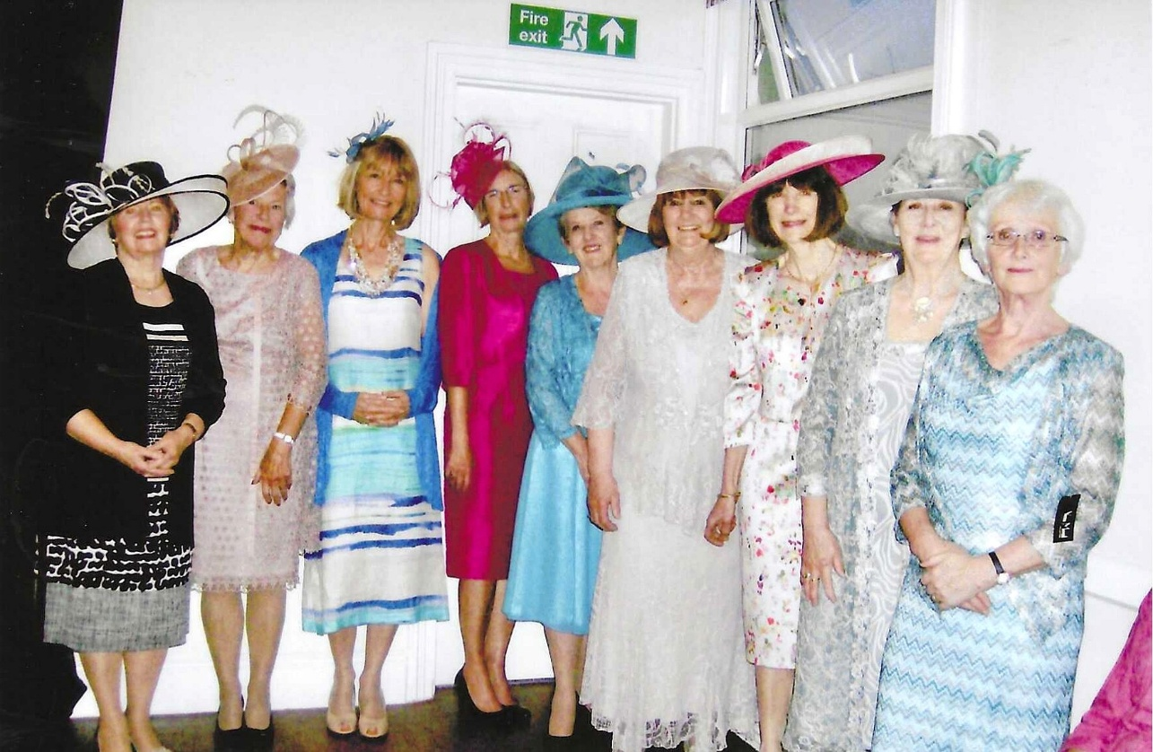
L-R Emma Parker; Christine Wilson; Pat Middleton; Brenda Merritt; Janet Cattanach; Jean Ellis; Cathy Matthews; Jane Barnett & Joyce Stickley

