The Sheep Detectives

5 of us went to the Watermark in Ivybridge to watch the screening of the Sheep Detectives.
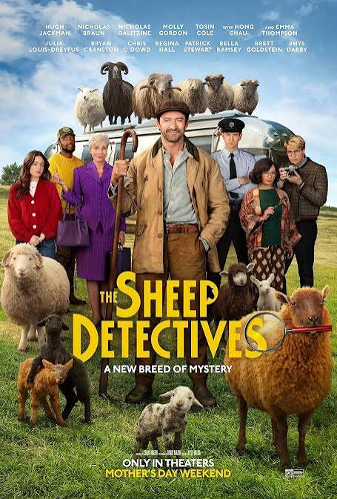
George Hardy is a shepherd who loves to read bedtime murder mysteries to his sheep, never suspecting that they can understand him.
When George is found dead under mysterious circumstances, the sheep decide to solve the crime themselves, even if it means leaving their meadow for the first time and facing the fact that the human world isn't as simple as it appears in books.
It was a witty, well made film, and we all enjoyed it.

Members who attended: Stella Gullen; Gill Tune; Jackie Ross; Bryony Lloyd & Lesley Dempsey

