Whats the event? Possibly at Mother Hubbards Yealmpton
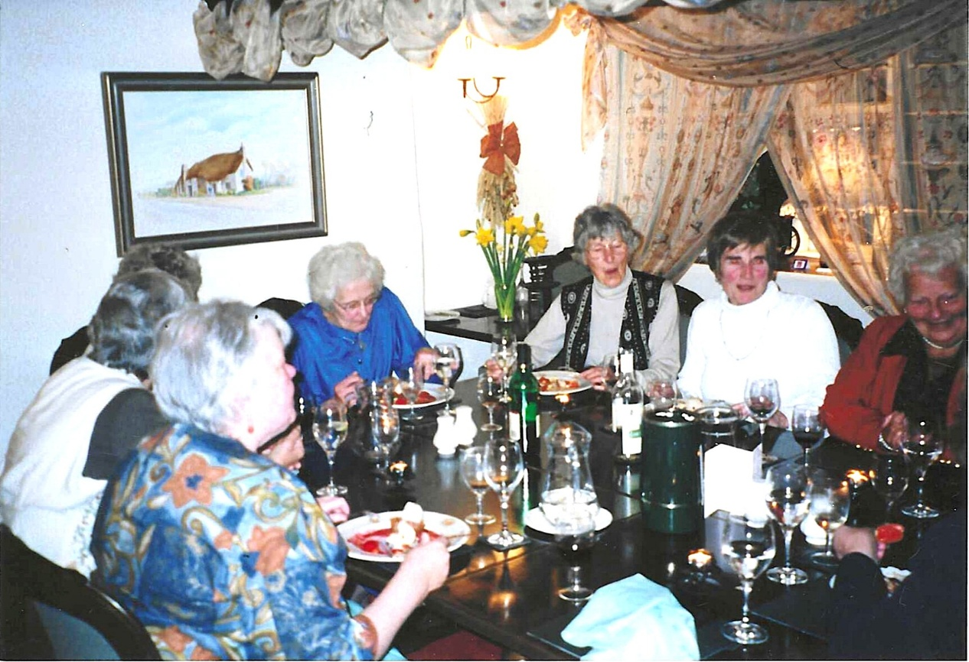

(left to right) 1 Alison Foster; 2,3,4, 5 Joan Allen; 6 Pat Green, 7

(left to right) 1 Rosemary Furzeland; 2, 3 Alison Foster; Clare Peard; Rosemary Watts
