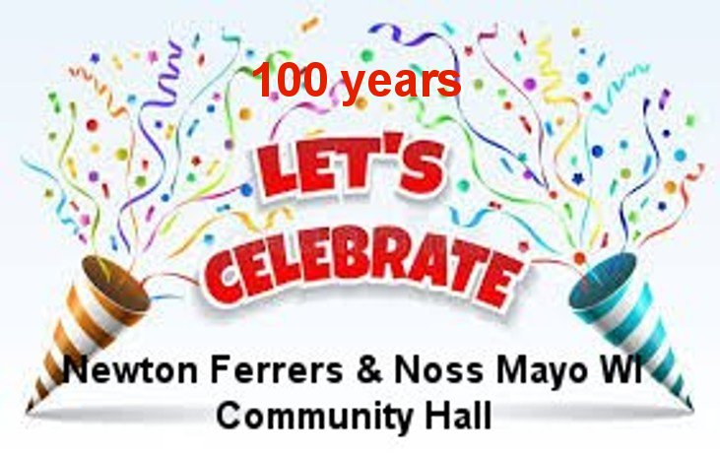
On Tuesday 14th April 2026, we celebrated 100 years of our hall.
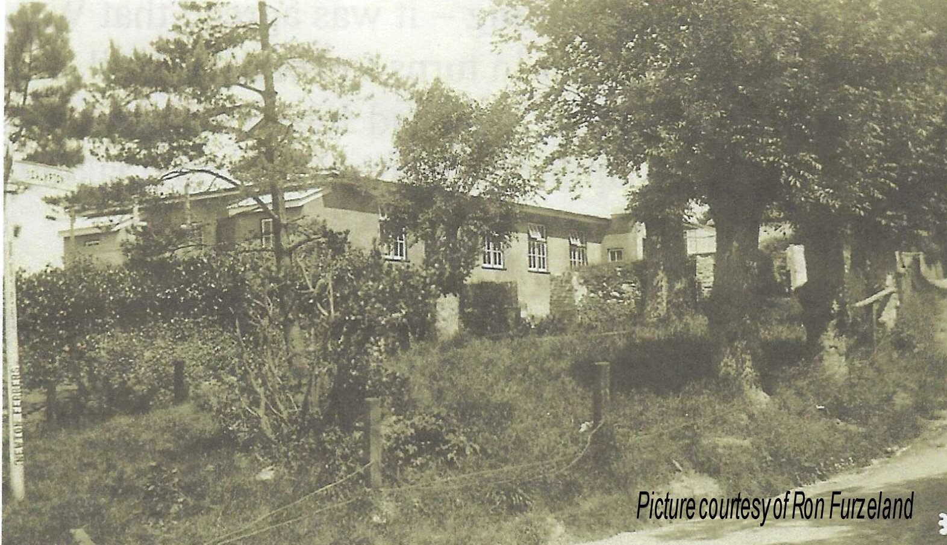
The history of the hall and how the funds were raised are documented in our archives.

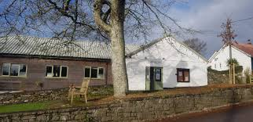
The hall has had 2 major refits since the original building in 1926; one in 1987 and the more recent one in 2014.

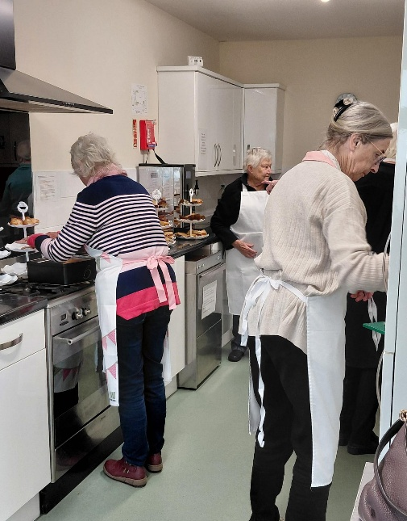
The WI ladies worked hard under the leadership of Jeanne Venning and Brenda Merritt, providing a delicious tea,
In the kitchen; Glyn Gibb, Yvonne Musto & Brenda
These ladies were joined by many others during the day, keeping up with the washing up and supply of cakes which were generously made by members.
There was a selection to suit all tastes including gluten free & dairy free.

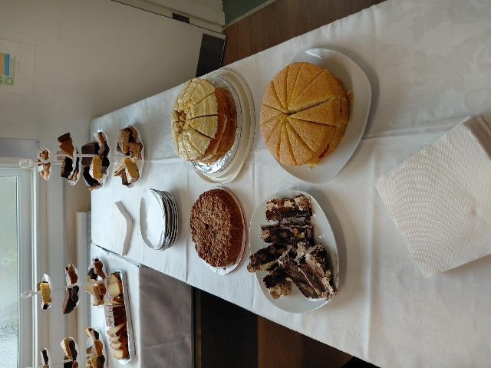
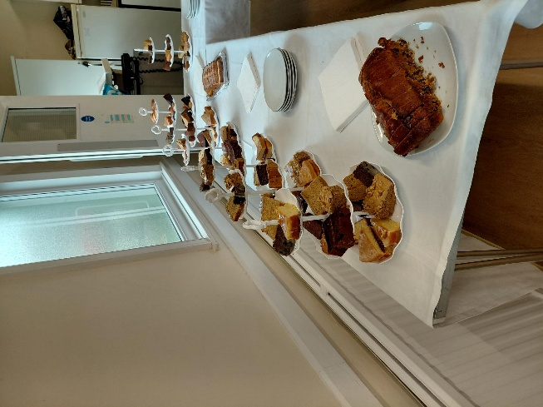

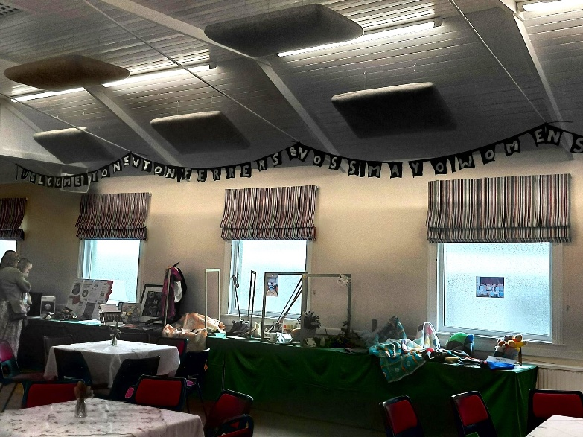
The hall had been decorated with bunting hung by Val Venning & other men folk.

There was an impressive display of crafts and projects we have undertaken.
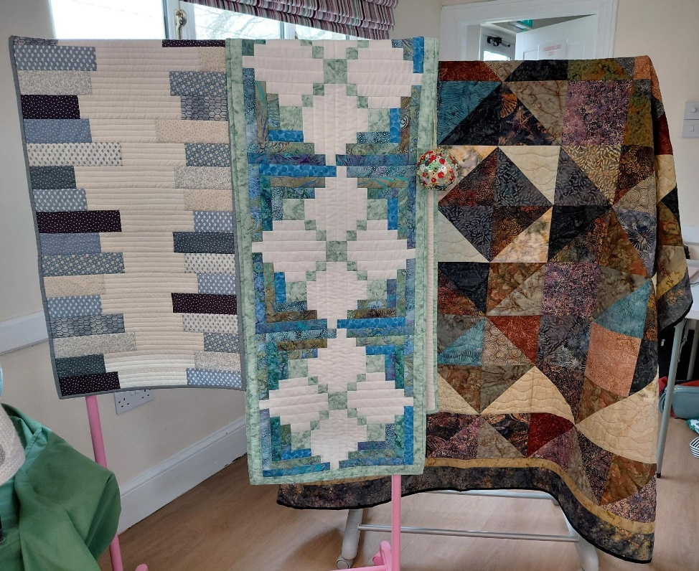
An impressive display of quilting by Jill Alexander

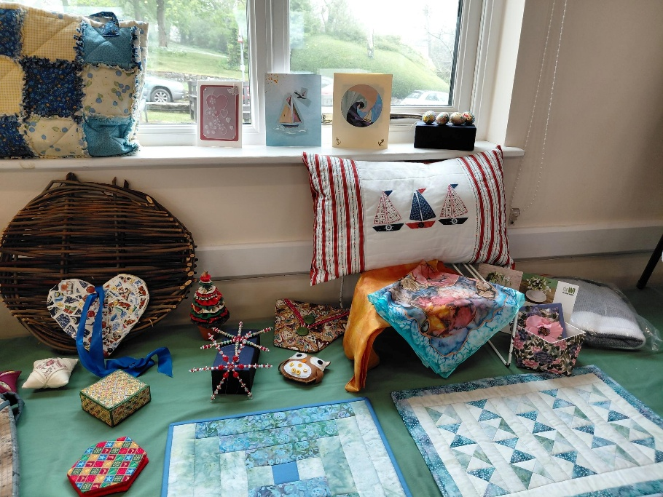

Card Making, Parchment craft, beadwork & more patchwork

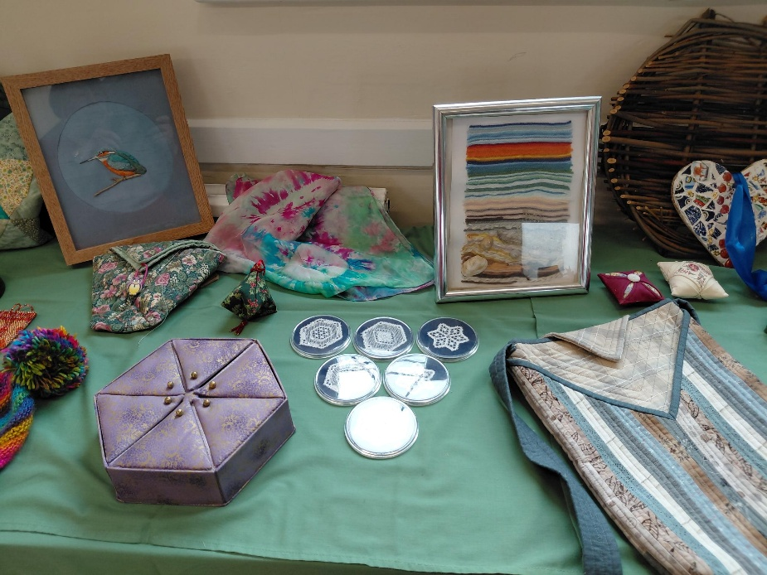
Yarn art; Embroidery, Silk scarf dying, Lace work

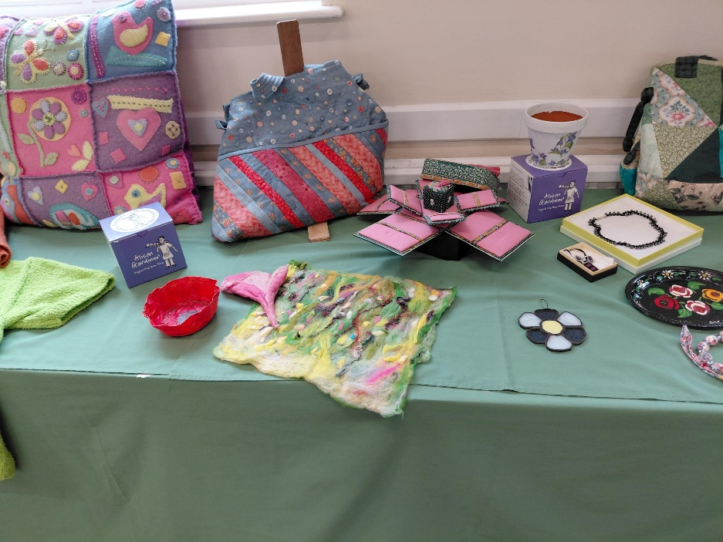

Wet felting; Stained glass; pottery painting; exploding boxes; papier- mache; felt applique patchwork & knitting

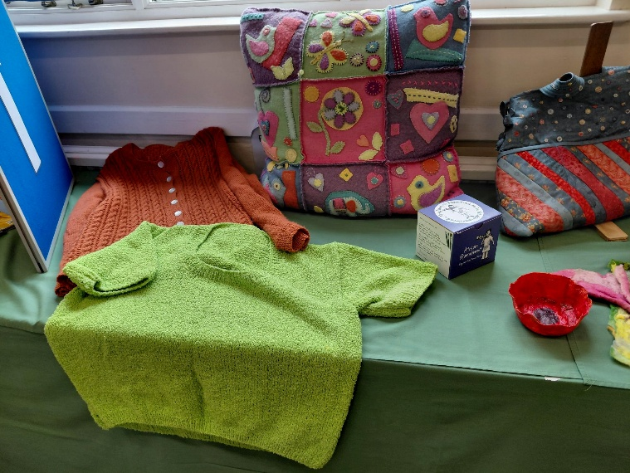

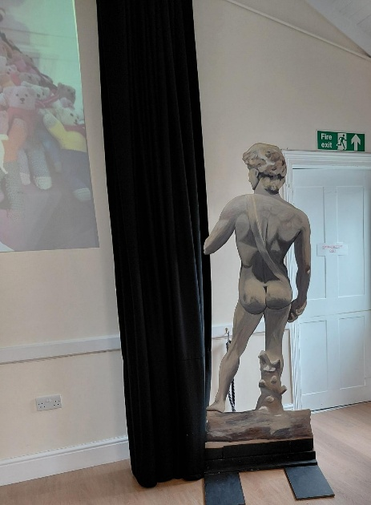
David (a prop from a review by the drama group)

The drama group display
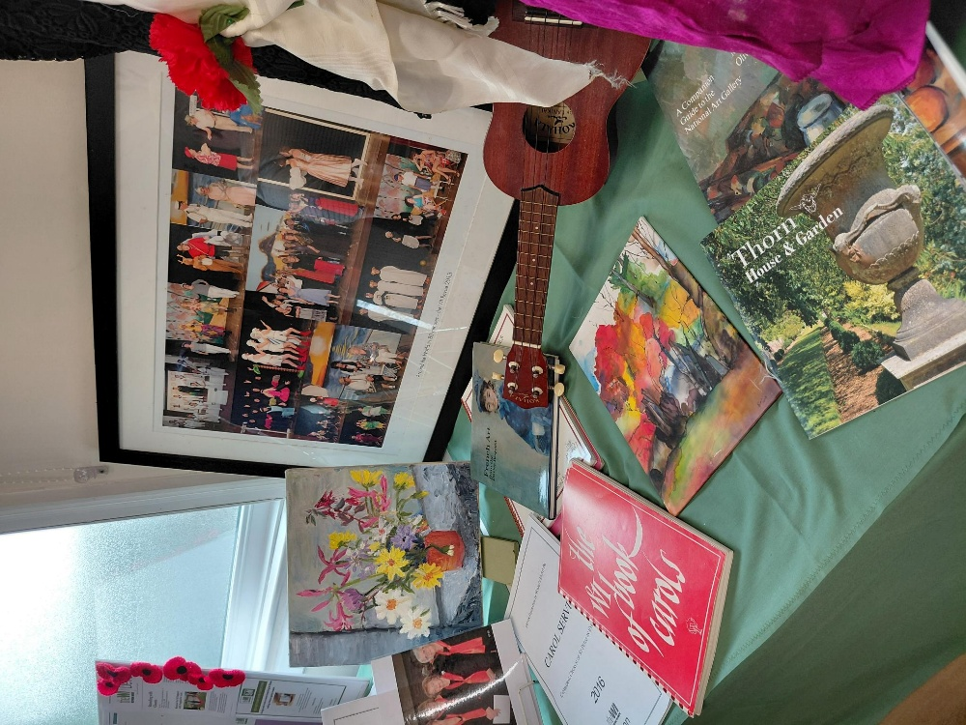

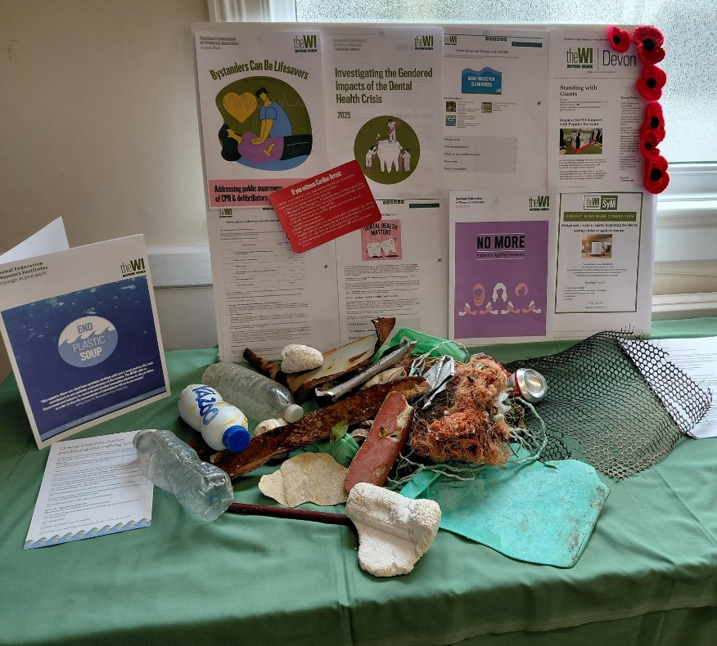

Resolutions

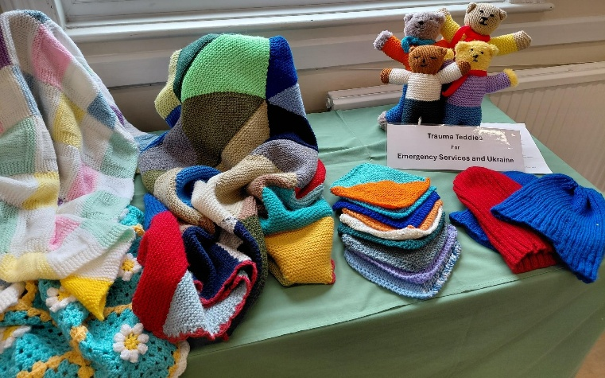
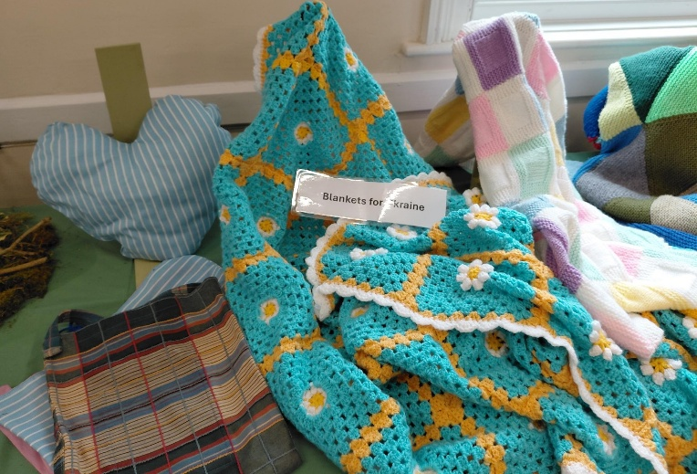
Supporting Charities

“boob bags” for Derriford, Angel blankets for the still born, and trauma teddies for the emergency services.

Blanket squares for Ukraine, clothing for Operation Sunshine.

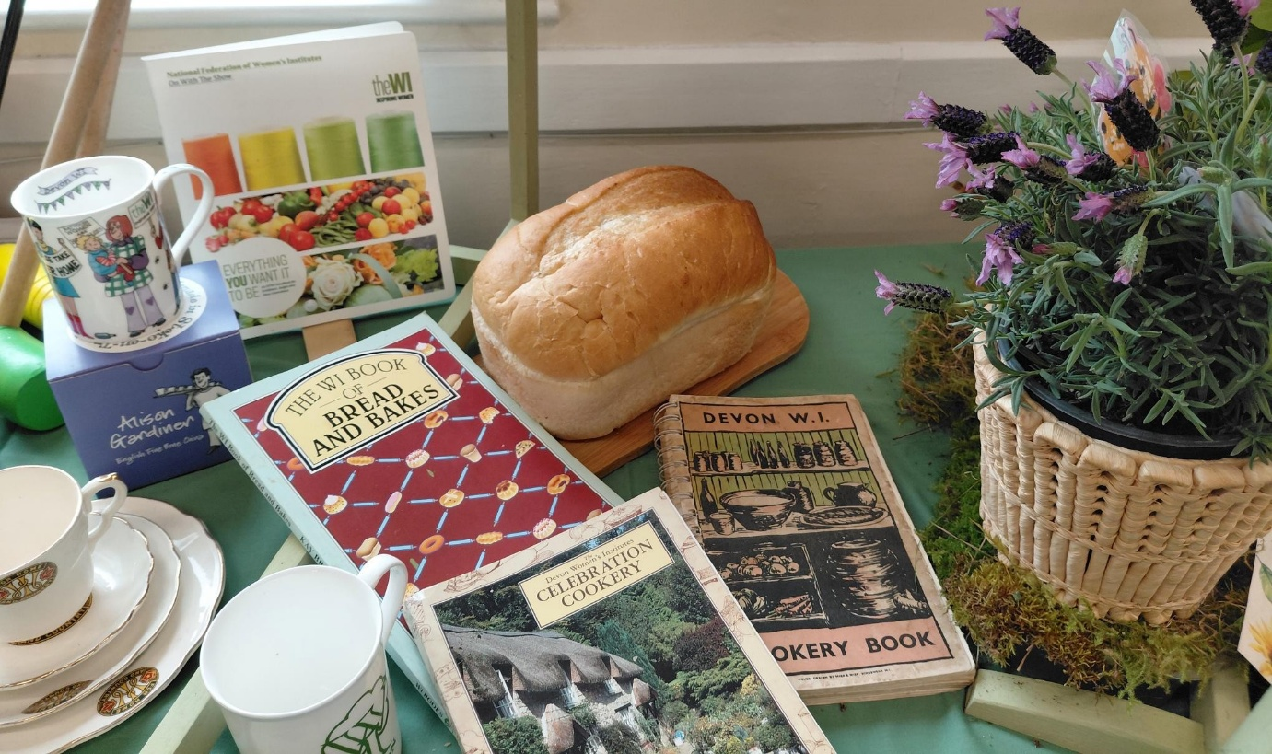
We are of course well known for baking, preserves and pickles

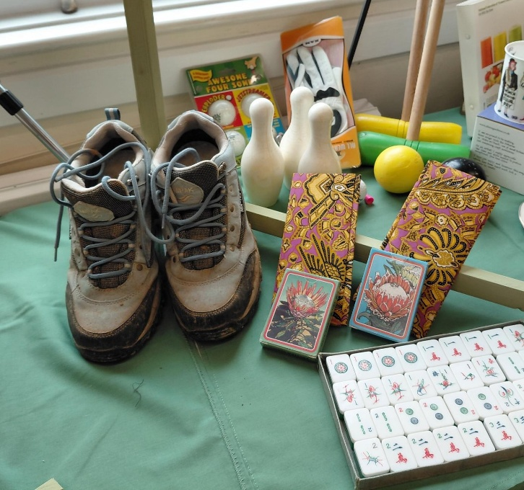
Activities include Walking, skittles, dance, mahjong, croquet, cards quizzes

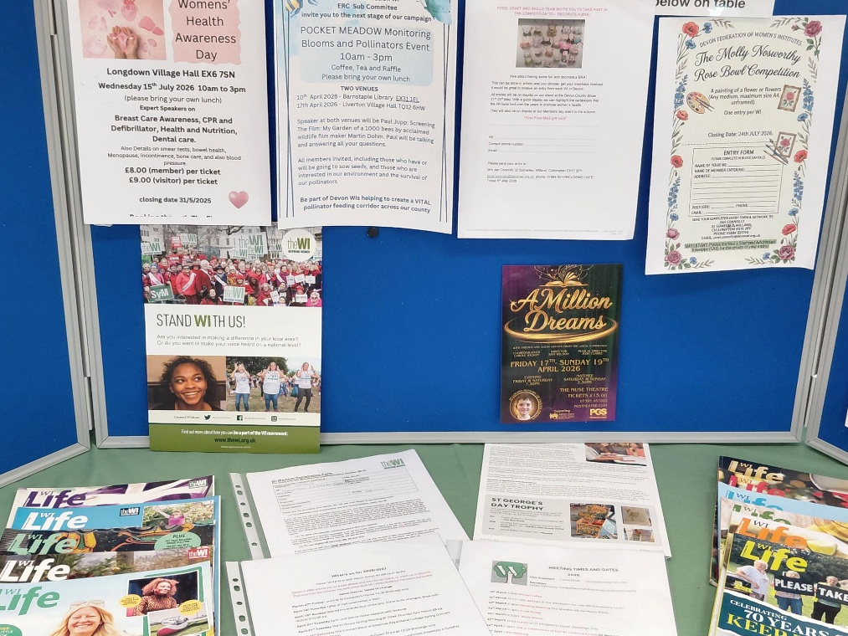
Our membership board with competition information, future visits and events

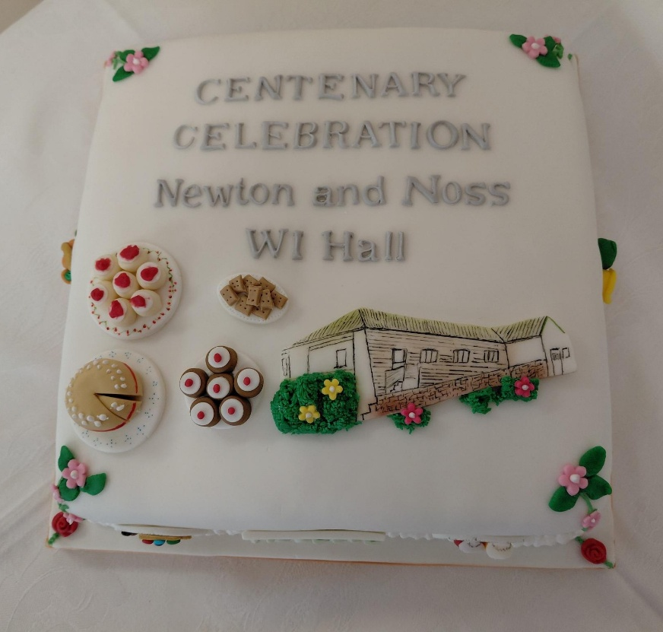

We had a celebration cake which was cut by our President Carrie Dixon with the help of her grandson, Arthur

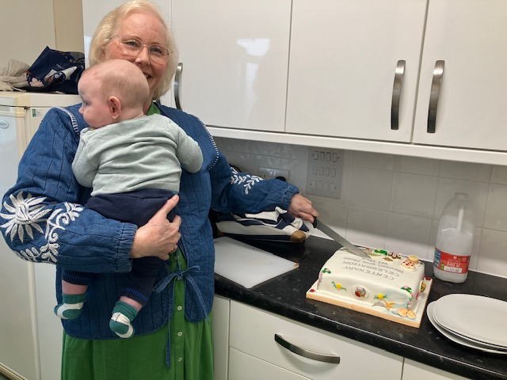

We we’re visited by other WIs including Wembury and Heybrook bay Down Thomas and Yealmpton who all enjoyed the afternoon.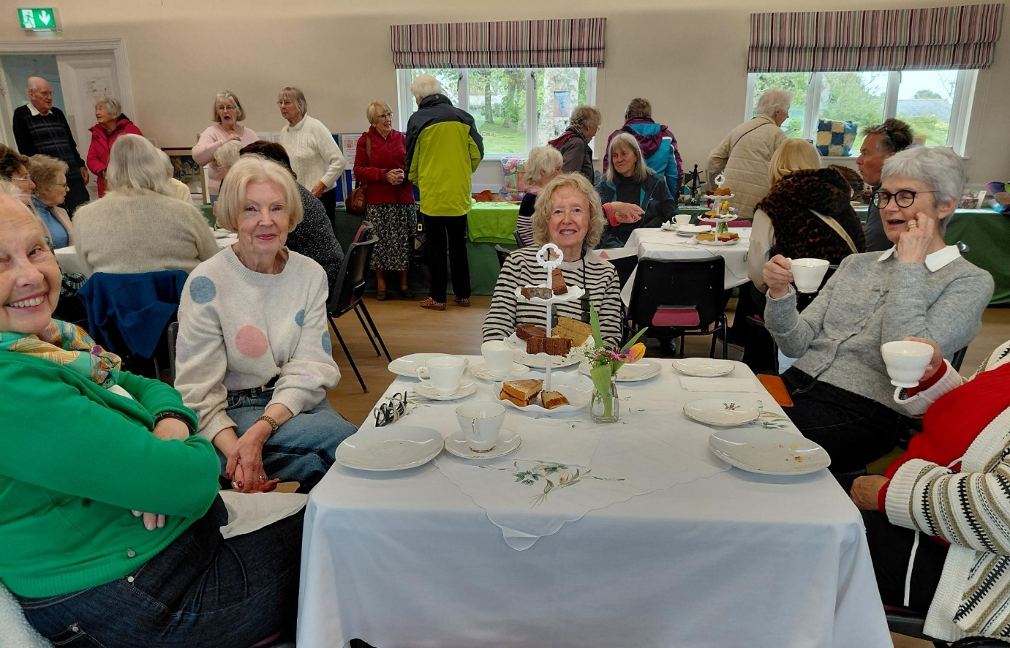
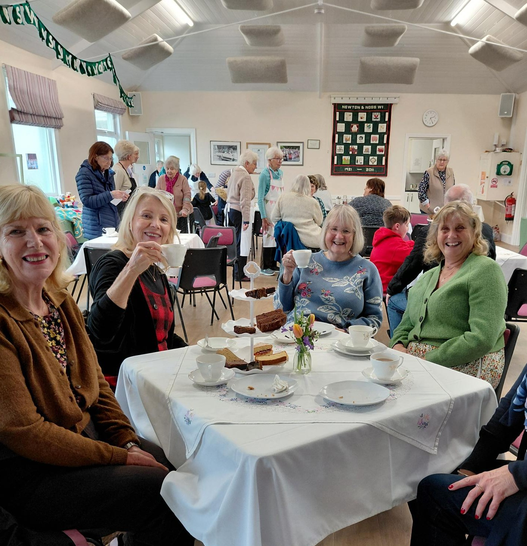
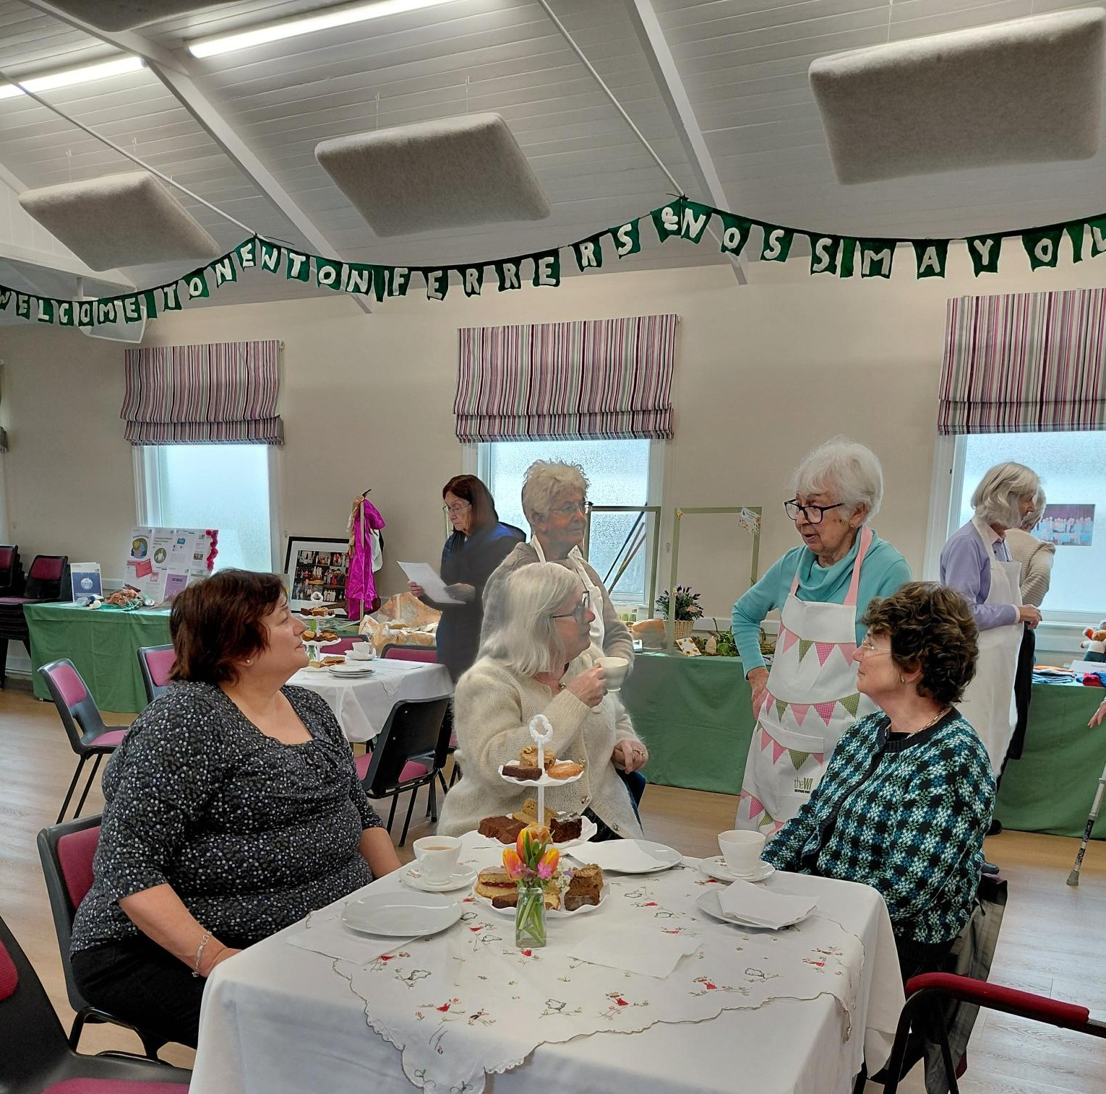
Shirley Pegg doing what she does best!
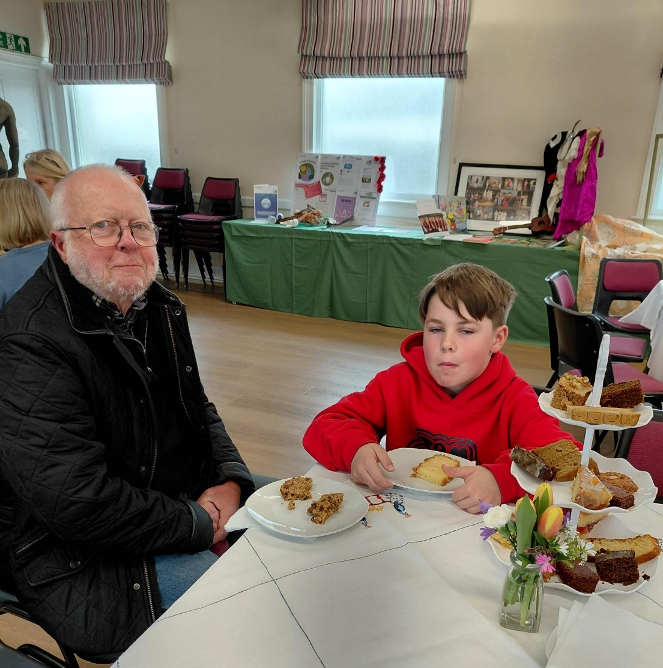
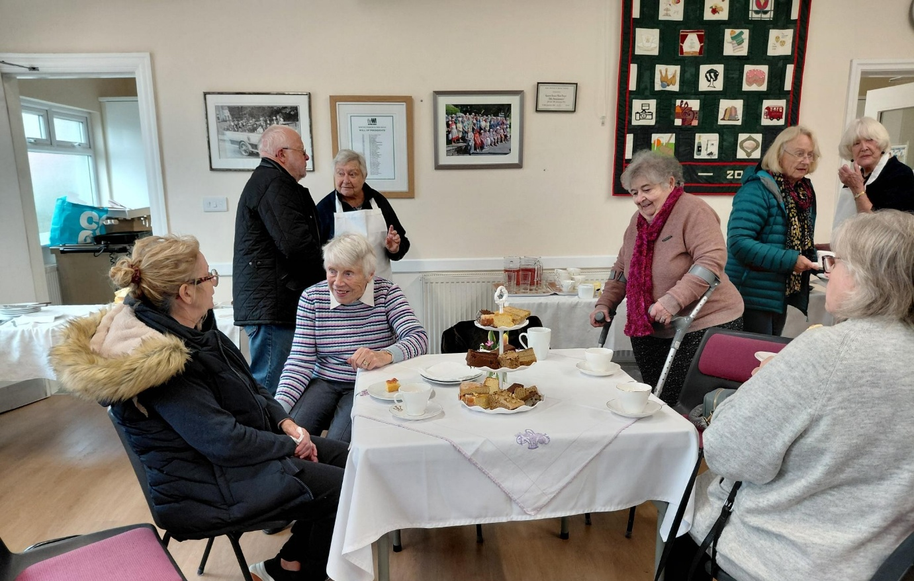
Jennifer, Christine, Stella and June
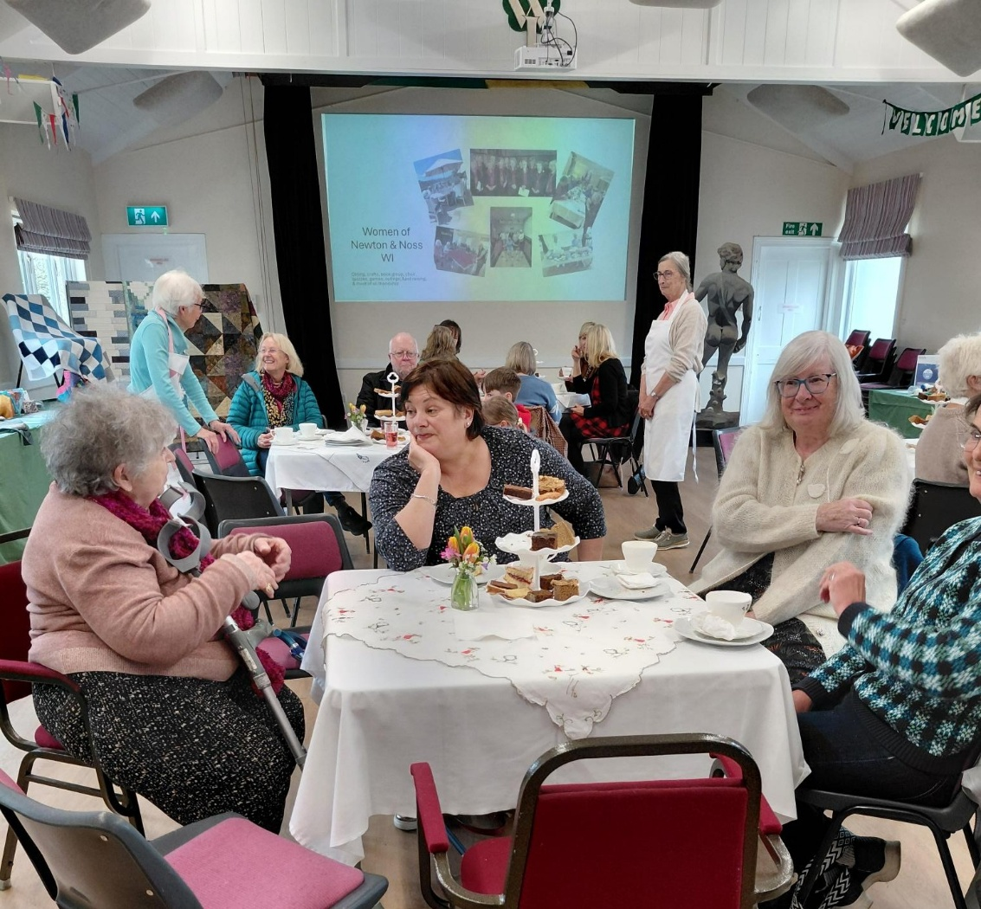
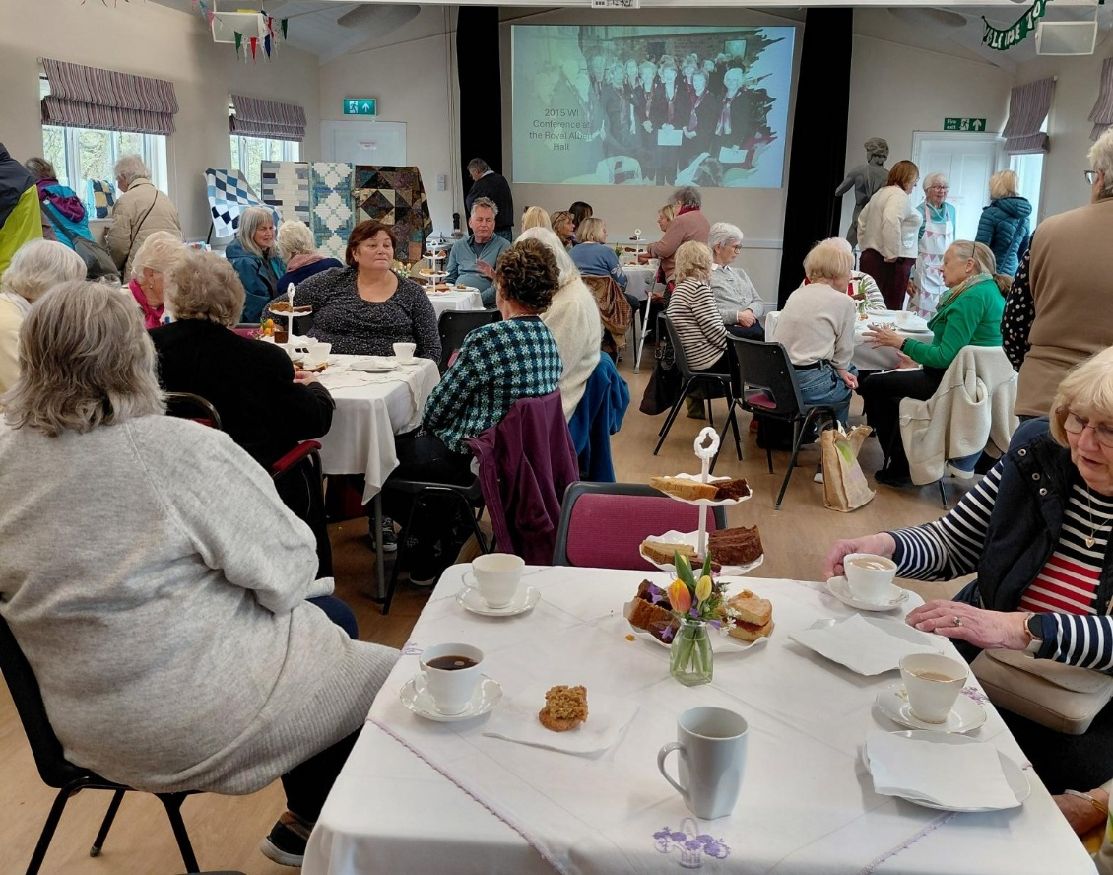
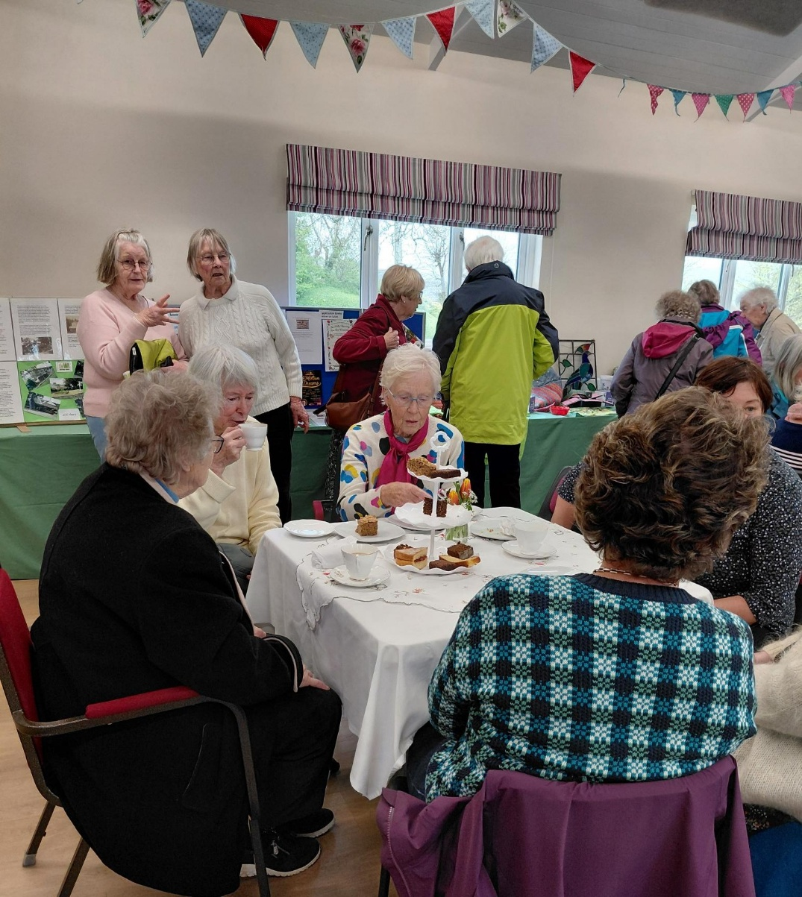

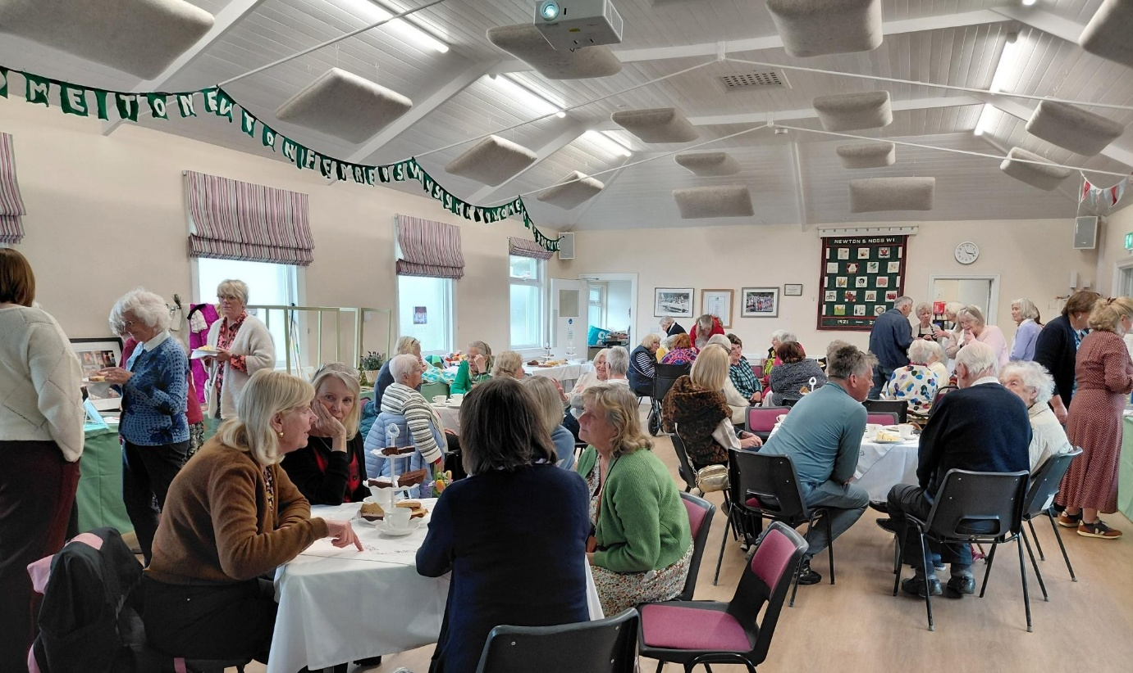
We had 3 new members sign up to join us and everyone seemed to enjoy the event.

