2010 Chelsea Flower Show
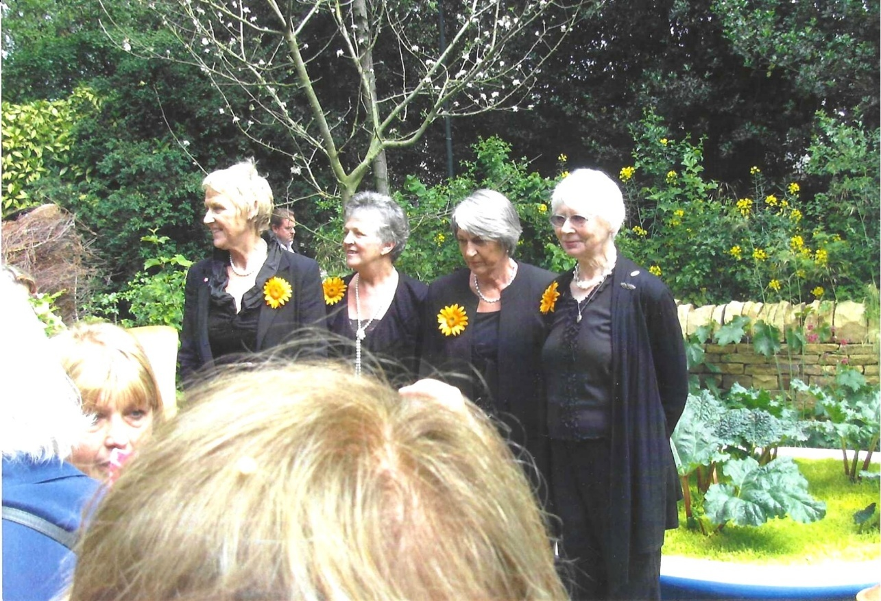

The original “Calendar Girls”
The Calendar Girls story is about 11 members of the Rylstone Women's Institute in Yorkshire who posed nude for a charity calendar in 1999 to raise money for Blood Cancer UK after their friend John Baker died from non-Hodgkin lymphoma. They replaced the traditional scenic WI calendar with photos of themselves, strategically covered by flowers, cakes, and pianos, raising millions and inspiring a hit play, film, and musical, celebrating friendship and courage against cancer.

